ANNEX 2

QUOTATION SUBMISSION FORMS
STATEMENT OF CONFIRMATION
[The supplier shall fill in this form with no alterations or substitutions to its format and content]

To: UN Women Moldova  131, 31 August 1989 Street,  MD-2012 Chisinau,  Republic of Moldova  Attention: Registry Office/Procurement | Date: [insert date of Proposal Submission]

We, the undersigned, declare that:
- We (representatives of this company, inclusive of any associated legal representatives) have examined the minimum requirements, terms and clauses and have no reservations to the RFQ including all annexes;
- We agree to abide by this RFQ and in accordance with the UN Women General Conditions of Contract (Annex IV) and will not request any changes to the existing terms, conditions and clauses;
- We offer to supply in conformity with the RfQ17/01539 National company/ organization to provide editing, design and printing services of the Manual “Gender in security and defense sector”
- We offer to supply for the sum as may be ascertained in accordance with the Quotation submitted and with the instructions under the Quotation Instruction Sheet;
- Our offer shall be valid for a period of 60 days from the date fixed for opening the RFQ, and it shall remain binding upon us and may be accepted at any time before the expiration of that period;
- We understand that UN Women is not bound to accept the lowest evaluated quotation or any other quotation that you may receive.

SIGNATURE AND CONFIRMATION OF THE RFQ
PROVIDED THAT A PURCHASE ORDER IS ISSUED BY UN WOMEN WITHIN THE QUOTATION VALIDITY PERIOD STATED ABOVE, THE UNDERSIGNED HEREBY COMMITS, SUBJECT TO THE TERMS OF SUCH PURCHASE ORDER, TO FURNISH ANY OR ALL ITEMS AT THE PRICES OFFERED AND TO DELIVER SAME TO THE DESIGNATED POINT(S) WITHIN THE DELIVERY TIME STATED ABOVE. THE UNDERSIGNED HEREBY SIGNS IN CONFIRMATION THAT THEY HAVE REVIEWED THE RFQ AND AGREE TO UN WOMEN CONTRACT MODEL AND THE GENERAL CONDITIONS OF CONTRACT.

Exact name and address of company  COMPANY NAME:  ADDRESS:  PHONE NO.: _________________________________  E-MAIL ADDRESS: _____________________________ | AUTHORIZED SIGNATURE: ___________________________________  DATE: ___________________________________  NAME: (TYPE OR PRINT) ___________________________________  FUNCTIONAL TITLE OF AUTHORIZED SIGNATORY: _________________  _________________________________________________________  E-MAIL ADDRESS: __________________________________________
This quotation submission form MUST be duly completed and returned with the QUOTATION, along with confirmation that the products are in accordance with specifications and requirements of UN Women. The quotation “MUST” be submitted in the vendor’s business letterhead stationery. Failure to do so may result in disqualification of your QUOTATION.

Quotation Format
TABLE 1 : Offer to Supply Goods Compliant with Technical Specifications and Requirements
# | Generic Description | Estimated Q-ty | Delivery deadline | Unit Price (in MDL) | Total Price (in MDL)
1 | Editing of Romanian version of the Manual “DIMENSIUNEA DE GEN ÎN SECTORUL DE SECURITATE ȘI APĂRARE” (in total 4 units) | up to 320 pages | 31 July 2017
2 | Design, layout and printing of the Manual: “DIMENSIUNEA DE GEN ÎN SECTORUL DE SECURITATE ȘI APĂRARE” –  MODULUL I: CONCEPTE FUNDAMENTALE PENTRU ÎNȚELEGEREA NOȚIUNII DE GEN  Up to 122 pages: 4 page-cover (inside & out) 118 pages inside  Format: B5  Covers: 300 gr/m2, color 4+0, laminated matt  Interior: coated paper, 90 gr/m2, 4+4,  Binding: Sewing thread with thermal glue | 500 copies / unit I | 31 July 2017
3 | Design, layout and printing of the Manual: “DIMENSIUNEA DE GEN ÎN SECTORUL DE SECURITATE ȘI APĂRARE” –  MODULUL II: POLITICI ȘI DIRECȚII DE PROMOVARE A PERSPECTIVEI DE GEN ÎN DOMENIUL PĂCII ȘI SECURITĂȚII  Up to 104 pages: 4 page-cover (inside & out) 100 pages inside  Format: B5  Covers: 300 gr/m2, color 4+0, laminated matt  Interior: coated paper, 90 gr/m2, 4+4,  Binding: Sewing thread with thermal glue | 500 copies / unit II | 31 July 2017
4 | Design, layout and printing of the Manual: “DIMENSIUNEA DE GEN ÎN SECTORUL DE SECURITATE ȘI APĂRARE” –  MODULUL III: ABORDAREA INTEGRATOARE A EGALITĂȚII DE GEN (GENDER MAINSTREAMING) ÎN SECTORUL DE APĂRARE  Up to 212 pages: 4 page-cover (inside & out) 208 pages inside  Format: B5  Covers: 300 gr/m2, color 4+0, laminated matt  Interior: coated paper, 90 gr/m2, 4+4,  Binding: Sewing thread with thermal glue | 500 copies / unit III | 31 July 2017
5 | Design, layout and printing of the Manual: “DIMENSIUNEA DE GEN ÎN SECTORUL DE SECURITATE ȘI APĂRARE” –  MODULUL IV: VIOLENȚA SEXUALĂ ȘI ÎN BAZĂ DE GEN ÎN CONDIȚII DE PACE ȘI CONFLICT  Up to 182 pages: 4 page-cover (inside & out) 178 pages inside  Format: B5  Covers: 300 gr/m2, color 4+0, laminated matt  Interior: coated paper, 90 gr/m2, 4+4,  Binding: Sewing thread with thermal glue | 500 copies / Unit IV | 31 July 2017
 | Design, layout and printing of the Cover Folder for the Manual set: “DIMENSIUNEA DE GEN ÎN SECTORUL DE SECURITATE ȘI APĂRARE” –  Format: B5+ (pocket format to insert all 4 manuals above, artistic cut)  Covers: 300 gr/m2, 4+0, laminated matt  Similar to:  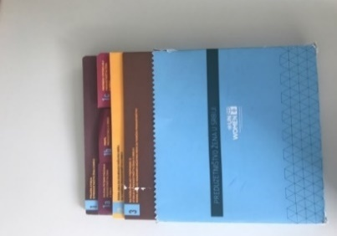  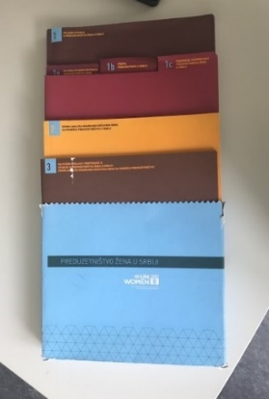 | 500 copies | 31 July 2017
TOTAL

TABLE 2: Compliance Requirements
Compliance Requirements : | Your Responses
 | Yes, we will comply | No, we cannot comply | Provide reasons for non-compliance
Payment terms 30 days upon receipt of invoice
Validity Period of Quotation: 60 days
All Provisions of the UN Women General Terms and Conditions
All other information that we have not provided automatically implies our full compliance with the requirements, terms and conditions of the RFQ.

