Annex 1
Technical Specifications

Table 1: The requested furniture, main requirements and technical specifications:
Nr. | Name | Units | Main parameters (mm) and technical specifications
 | Reception room/corridor
1 | Desk for hall monitor | 1 | (h) 750х1500х600; 3 sections, individual design
2 | Floor cupboard at the reception | 1 | (h) 600x1500x450; 3 sections with one shelf/doors with simple lock
3 | Soft pouffe | 40 | (h) 450х400х400; individual design
4 | Soft panel for columns, walls | 1 | (h) 300,δ=25 (20m); individual design
5 | Stand for magazines/booklets/leaflets | 3 | (h) 1500-1600; Metal, 5 oblique shelves, sample attached
 | Mediation room, working with the unemployed
1 | Corner office desk with 1 m extension | 1 | (h) 750х1200х1200; with cable hole, existing type
2 | Desk for working with the unemployed | 13 | (h) 750х1000х600; corner office desk, computer hole, board covered with resistant plastic
3 | Desk for working with the unemployed, people with reduced mobility (PRM) | 1 | (h) adjustable height х1000х600; corner office desk, computer hole, board covered with resistant plastic
4 | Ergonomic office chair | 15 | (h) 400х400х500; adjustable height, model attached
5 | Standard cabinet for documents | 6 | (h) 1800х1000х350; wood, with 2 doors, 2 sections, 5 shelves
6 | Closet for clothes | 3 | (h) 1800х1000х600; wood, with 2 doors, 2 sections/one with 5 shelves
7 | Wooden bookcase with 4 shelves | 1 | (h) 2000х1000х450; for toys from commercial network
8 | Playpen – soft carpet for children | 1 | (h) 20x1000х2000; sports equipment
9 | Table with 4 chairs set, for children | 1 set | (h)550; chair (h)300; commercial network
10 | Blinds/vertical/for windows | 7 | (h) 2100х2500; colour similar to interior walls
 | Guidance room
1 | Computer desk | 9 | (h) 750х1000х600; existing model, (cable hole)
2 | Desk for working with the unemployed, people with reduced mobility (PRM) | 1 | (h) adjustable height х1000х600; existing model, (cable hole)
3 | Chair for training rooms | 10 | (h) 450х400х400; existing model, orthopedic back
4 | Closet for clothes | 1 | (h)1800х1000х600; wood, with 2 doors, 2 sections/one with 5 shelves
5 | Standard cabinet for documents | 2 | (h) 1800х1000х350; wood, with 2 doors, 2 sections, 5 shelves
6 | Metal coat rack | 1 | (h) 1700-1800; coat rack for 8 persons
7 | Horizontal blinds for windows | 1 | (h) 2100х2500; colour similar to interior walls
 | Conference and training room
1 | Writing desk (conference room) | 18 | (h)750х1000х600; existing model, board covered with plastic
2 | Writing desk (conference room) for people with reduced mobility (PRM) | 2 | (h) adjustable height х1000х600; existing model, board covered with plastic
3 | Chair for training rooms | 70 | (h) 450х400х400; existing model, orthopedic back
4 | Metal coat rack | 9 | (h) 1700-1800; coat rack for 8 persons
5 | Horizontal blinds for windows | 8 | (h) 2100х2500; colour similar to interior walls
 | Administrative offices
1 | Corner office desk with 1 m extension | 2 | (h) 750х1200х1200; cable hole, existing model
2 | Corner office desk without extension | 13 | (h) 750х1200х1200; cable hole, existing model
3 | Ergonomic office chair | 16 | Adjustable height, model attached
4 | Chairs for visitors | 20 | (h) 400х400х500; existing model, wood, orthopedic back
5 | Closet for clothes | 5 | (h) 1800х1000х600; 2 sections, wood, 2 doors
6 | Standard cabinet for documents | 7 | (h) 1800х1000х350; wood, 5 shelves, 2 wooden doors, 2 glass doors
7 | Metal coat rack | 4 | (h) 1700-1800; coat rack for 8 persons
8 | Blinds/vertical/for windows | 8 | (h) 2100х2500; colour similar to interior walls
 | Kitchen and auxiliary rooms
1 | Wall closet for kitchen | 4 | (h) 800х400х350; wood, 2 shelves/2 doors/zincate net shelf
2 | Floor closet for kitchen | 4 | (h) 730х800х600; wood, 2 shelves, 2 doors, one covered board
3 | Blinds/vertical/for windows | 2 | (h) 2100х2500; colour similar to interior walls
4 | Office metal staircase, zincate | 1 | Standard – 1m ; light, commercial network
5 | Metal shelving unit, 5 shelves, h.350mm | 13 | (h) 1950х400х1000; commercial network

Table 2: Other data on specifications and technical parameters
No | Furniture units | Specifications and technical parameters
1 | - Floor cabinet at the reception  - Closet for clothes  - Cabinet for documents  - Reception desk  - Desks in training and intermediate rooms  - Corner office desk;  - Computer corner desk  - Writing desk (in classrooms),  - Coffee/magazines table  - Wall closet for kitchen  - Floor closet for kitchen  - Wooden shelving unit with 4 shelves, for children | - Main material – painted chipboard, resistant, painted, thickness δ=18.0mm;  - The writing desk in the training, guidance, mediation rooms, for the computer with corner, shall have a board covered with resistant plastic – glued at temperature, the existing model (photo attached); metal mountable legs made diam. 40 - 50mm, painted at temperature; board with thickness δ≥25mm; the computer desk shall have a cable hole;  - Corner office desk shall be made according to the existing model (photo attached);  - The reception desk shall have an individual design, (indicative model attached);  - All furniture shall have floor resistant plastic support elements;  - The shape of the handles, accessories, shall exclude the risk of trauma;  - The edges of the furniture elements: the wooden shelf; floor cupboard; kitchen closet; office desk; computer desk, etc. shall be covered with АBS with a thickness of δ=1-1,5 mm, attached with furniture glue;  - The closet for clothes shall have two sections with wooden doors, with furniture locks and round shaped aluminum handles on the outside; a section shall be with 5 shelves; one section for clothes, up shall have a wooden shelf with h=300mm, (indicative model attached);  - File cabinet: 7 units shall have 2 sections, 5 shelves, 2 wooden doors on the lower part of the facade; 2 glass doors on the upper part of the facade, (indicative model attached); 7 units shall have 2 sections, 5 shelves and 2 wooden doors on the entire facade (same indicative model);  - The pouffe and the soft wall panels for the visitors shall be individual;  - Metal supplies shall be functional and resistant in use, composed by resistant modern elements;
2 | - Office chair (ergonomic) | - soft office chair, height adjustment, black, metal foot, stable, on wheels, with the possibility of vertical adjustment;
3 | - Pouffe and soft wall panels for visitors; | - Chipboard, foam rubber δ=50mm, soft fabrikoid, color – light blue; panel – foam rubber δ=25mm;
4 | Wall closet for kitchen | - The closet will have two horizontal wooden shelves;
5 | Floor closet for kitchen | - Floor closets shall be covered with one worktop with a width not less than 600mm;
Note*
- The furniture shall have a modern design, taking into account indicative models on the photos attached;
- A 3D color design shall be developed and endorsed by the Beneficiary and the Technical Advisor Engineer of the MiDL project, before production start.
- The color of the furniture and the constructive elements (depending on the local conditions) shall be coordinated with the Beneficiary and the Technical Advisor Engineer of the MiDL project, before production and delivery to destination;
- The materials used must be accompanied by Quality Certificates and comply with the Hygiene Norms of the Republic of Moldova.
- Three units of furniture: the reception desk, the pouffe and the soft wall panel, shall be manufactured according to an individual design;
- Quality Guarantee – not less than 1 (one) year;
- On site visits: the winning company must visit the place for additional on site consultations before production starts;
- Contract implementation timeframe: not more than 90 calendar days;
- The bid shall include the costs of delivery and assembly on the site;

Table 3: Furniture models – for orientation
Sample table for the auditorium, activity rooms
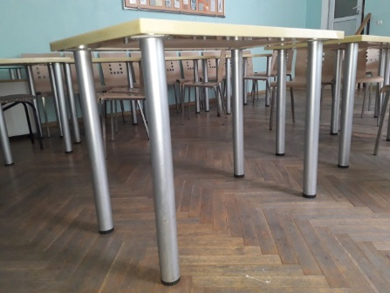 | 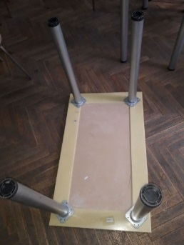 |  |  | 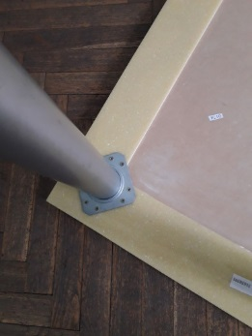
Sample chair for the activity rooms
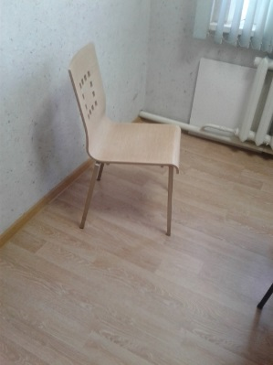 | 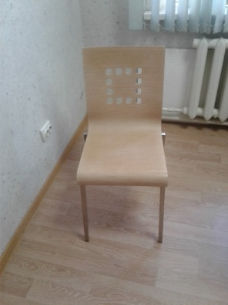 |  |  | 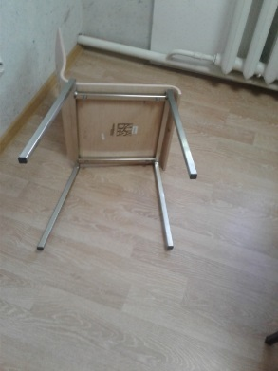
Sample furniture for the reception room
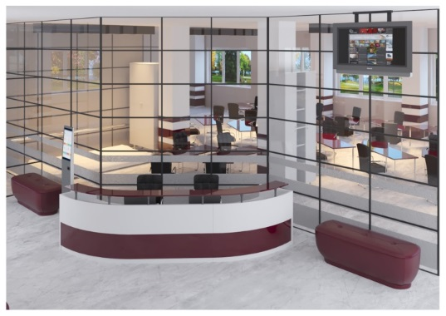 |  | 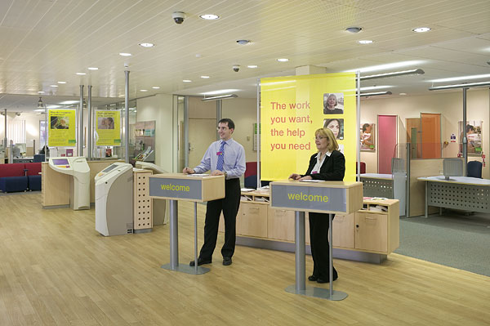
Sample file cabinet with wooden and glass doors
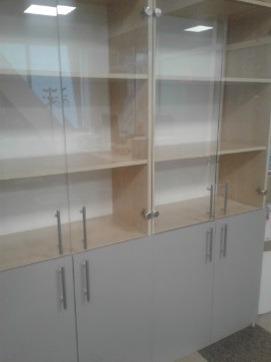 |  | 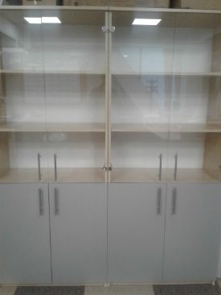
Sample closet for clothes
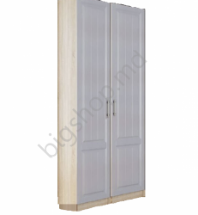 |  | 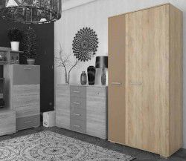
Sample corner desk
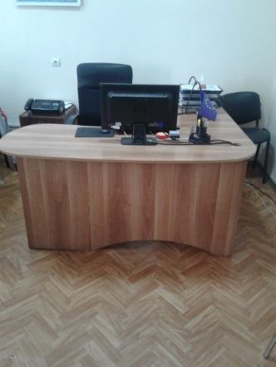 | 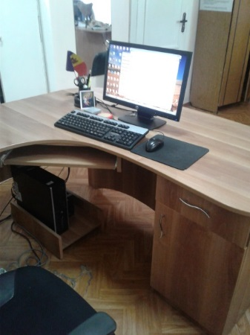 |  |  | 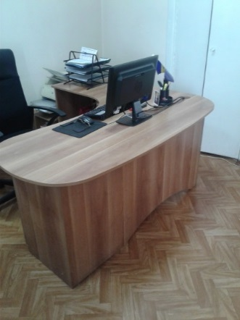
Sample ergonomic office chair |  |  | Sample stand for promotional materials
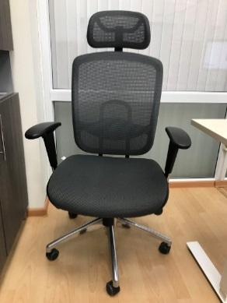 |  |  | 