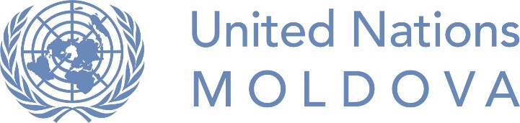

UN Moldova Internship Program for Persons Belonging to
Under-Represented Groups
Terms of Reference
UN Agency: | United Nations Development Programme (UNDP) in Moldova
Title of the internship position: | Administrative Support Intern
Program / Project / Section: | Operations Unit
Reports to (officer in charge): | Head of Operations Unit / Unit staff member
Duration and Period  of the Internship: | 1 June – 30 November 2018 (6 months), with a possibility of extension
Weekly workload (hours / week): | 10-20 hours / week

Background
UNDP Moldova Operations Unit is providing financial and human resources management, efficient procurement and logistical services, ICT and common services for UNDP and several other UN agencies in Moldova. The main role of the Unit is to provide operations, ensuring smooth functioning of programmes and projects operations, consistent and high-level services delivery and constant evaluation and readjustment of the operations to take into account changes in the operating environment as and when needed.
Summary of key responsibilities
Under the guidance and direct supervision of the Head of Operations/ staff member to which he/she is assigned, the intern is supposed to assist on a part-time basis in daily implementation of the tasks in the above-mentioned Unit.
To ensure that the intern gets the most suitable learning path, as well as efficiently contribute to the overall activity of the Unit, the following main responsibilities are envisaged:
- Provide support in conducting research and/or data collection and analysis;
- Drafting and/or writing documents/papers of topics of relevance for the Unit;
- Cataloguing, gathering and systematizing the necessary information;
- Assisting and providing logistical support in the organization of events, forums or other collaborative events;
- Perform other duties as assigned by Supervisor.

Eligibility requirements
Education:
- At least secondary education.
Minimum qualifications / skills and competencies:
- Attentive to details and fast learner;
- Good time management skills;
- Ability to cooperate efficiently with diverse groups of people;
- Core Competencies: communication skills, enthusiasm, drive for results, ability to work on computer using Word, internet browsers and e-mail;
- Core Values: proven commitment to the core values of the United Nations; in particular, is respectful of differences of culture, gender, religion, ethnicity, nationality, language, age, HIV status, disability, sexual orientation, or other status;
- Languages:
  - Fluency in Romanian OR Russian, both oral and written;
  - Fluency in English is an advantage, but IS NOT mandatory;
  - Knowledge of one or more other languages relevant for Moldova, including Bulgarian, Gagauzian, Romani, Ukrainian or sign language, is an advantage.

Who can apply for the internship?
This internship position comes as a temporary special measure and seeks to fill in under-representation in UNDP Moldova primarily of persons belonging to the following groups: persons with disabilities, ethnic minorities, especially ethnic Gagauzians, Bulgarians, Roma, Jews, people of African descent, people living with HIV, religious minorities, especially Muslim women, LGBTI.

Internship package and working conditions
- Remuneration: this internship is not a paid position.
- Workplace conditions: Intern will work inside and outside the UNDP office and will participate in all working meetings organized by the office. The intern will be provided with a fully equipped workplace at the UNDP Moldova office.
- Urban, inter-urban transportation costs (in case of an intern with reduced mobility), as well as living or other relevant costs (in case of an intern permanently residing outside Chisinau) – will be additionally discussed and agreed.

