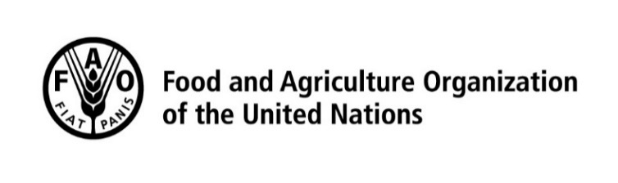
vacancy announcement No: …/2025
Issued on: |  |  |  |  |  | 14 July 2025
Deadline For Application: |  |  |  |  |  | 26 July 2025
Job Title: Project Monitoring and Evaluation Specialist |  |  | Type of requisition: |  | NPP
 |  |  |  | Duty Station: | Chisinau, Moldova
OrganizationAl Unit: | FEMOL |  |  | Duration: | 6 months, with the possibility of extension
FAO seeks gender, geographical and linguistic diversity in its staff and international consultants in order to best serve FAO Members in all regions.

Qualified female applicants and qualified nationals of non-and under-represented member countries are encouraged to apply.
Persons with disabilities are equally encouraged to apply.
All applications will be treated with the strictest confidence.
Organizational Setting: FAO is the strategic partner of the Government of the Republic of Moldova in sustainable development of the agrifood sector and is implementing both emergency and development projects in the country. The ongoing projects support the smallholder farmers with technical assistance on strengthening their resilience against current climate change and economic challenges as well as supply of quality agriculture inputs and tools.

Reporting Lines: Under the overall supervision of the FAO Representative in Moldova, the technical supervision of the Agriculture Officer at the Regional Office for Europe and Central Asia, the technical guidance of OER MEAL Unit Officer and REU Monitoring and Planning Specialist, and in collaboration with the relevant departments of the Ministry of Agriculture and Food Industry, the national coordinator will perform the following tasks and responsibilities:

Tasks and responsibilities:
The incumbent will perform the following tasks and responsibilities:
- Develop a comprehensive M&E plan, including timelines, responsibilities, methodologies, and tools for data collection and analysis.
- Ensure M&E integration into the full project cycle (planning, implementation, completion).
- Define and complete baseline and target values for performance indicators (output, outcome, impact), including gender-sensitive and disaggregated indicators (e.g., age, sex, location).
- Maintain and verify a beneficiary database, based on lists from implementing partners.
- Conduct regular field monitoring visits.
- Track and assess project progress against targets and KPIs.
- Design and implement results-based monitoring systems (e.g., dashboards), update indicators quarterly, and flag corrective actions where needed.
- Conduct outcome-level assessments (baseline and endline).
- Conduct at least quarterly project task force meetings to present monitoring updates, feedback, and recommendations.
- Design and implement Post-Distribution Monitoring (PDM), including questionnaires and reporting.
- Establish and manage a Grievance Redress Mechanism (GRM) for complaints and feedback between FAO, partners, and beneficiaries.
- Document beneficiary success stories.
- Collect and analyse relevant agricultural sector data for internal and external reporting.
- Lead and contribute to donor progress, implementation, and final project reports.
- Act as M&E resource officer within the country office; support colleagues with data, tools, and expertise.
- Organize and deliver capacity-building trainings on M&E to project teams.
- Represent the project at trainings, workshops, and events.
- Perform other related duties as required.

CANDIDATES WILL BE ASSESSED AGAINST THE FOLLOWING

Minimum Qualifications
- Bachelor degree or equivalent in Economics, International Relations, Agriculture or a related field;
- 5–10 years of relevant professional experience, preferably with international organizations or state public authorities;
- Proven experience in donor reporting, programme and project monitoring and evaluation, including working knowledge of monitoring tools, such as M&E Plan and indicator tracking table;
- Demonstrated experience in the collection of field monitoring data from primary beneficiaries;

Required skills
- Excellent presentation skills
- Excellent computer competences
- Strong interpersonal and communication skills

Required language(s)
- English

FAO Core Competencies
- Results Focus
- Teamwork
- Communication
- Building Effective Relationships
- Knowledge Sharing and Continuous Improvement

Please note that all candidates should adhere to FAO Values of Commitment to FAO, Respect for All and Integrity and Transparency.

ADDITIONAL INFORMATION
- FAO does not charge a fee at any stage of the recruitment process (application, interview meeting, processing).
- Applications received after the closing date will not be accepted.
- For other issues, visit the FAO employment website: http://www.fao.org/employment/home/en/

HOW TO APPLY
To apply, please send your CV with all relevant details to FAO-Moldova@fao.org by 26 July 2025 inclusive.
FAO IS A NON-SMOKING ENVIRONMENT

