ANNEX B: TERMS OF REFERENCE
FOR
Rehabilitation of the WASH facilities in selected seven educational institutions

- Anenii Noi (IPLT A.Puskin)
- Cirnateni, Causeni (IPLT cu profil arte Grigore Grigoriu)
- Grozești, Nisporeni (IPLT Prometeu)
- Ialoveni (IP Scoala Primara Ion Creanga)
- Isacova Orhei (IP Gimnaziul Isacova),
- Orhei (IPLT M. Lomonosov)
- Tataresti Straseni (IP Gimnaziul Tataresti)

BACKGROUND
    - UNICEF Moldova supports the Moldovan authorities in strengthening the capacities to provide WASH services in schools and improve early Intervention systems and services for children from Moldova and refugee children from Ukraine.
    - To that aim, UNICEF Moldova will rehabilitate and reconstruct climate-resilient, energy-efficient and environment-friendly WASH infrastructure in seven (7) educational institutions, as detailed in a Scope of the Work below.
    - This Project is expected to benefit 1,800 children by providing access to safe water and sanitation services annually, which is a fundamental right that safeguards health and human dignity.
    - These Terms of Reference aim to guide a bidding exercise to identify suitable construction companies for procuring construction and repair services required by ToR and attached BoQs.

DEFINITION
  - Rehabilitation of the WASH facilities refers to the demolition & reconstruction work within the existing building, mentioned below as generic items. They will vary based on the specific needs of each building. The range of works will include the demolition of the existing facilities (separation walls, the dismantling of the old tiles and plaster, removing of the wooden moulding elements, the dismantling of the sanitary equipment and elements, e.g., sinks, toilet seats)
  - Reconstruction of the WASH facilities is the process of equipping and performing renovation works of the existing spaces and includes the following areas: electricity, ventilation, water and sanitation plumbing, indoor renovation and repairs. The spectrum of works would include installation of the electric cables for lighting and sockets, plastering of the and preparatory works for tiles, floor coverage with the recommended waterproof materials, installation of the tiles on the walls and floors, installation of the sanitary equipment( sinks/washing basins, toilet seats, soap dispensers, toilet paper dispensers, mirrors, hand dryers, faucets with all the required pipes and fittings, installation of separators/partitions/ cubicles, installation of doors, etc.
The works should be planned according to the WASH in schools Sanitary Norms and UNICEF best practices. After the work completion, WASH facilities must be fully functional.

SCOPE OF WORK
  - Objective: The objective of these Terms of Reference is to guide a bidding exercise to identify suitable Contractors to execute the Works described below within the agreed quality, budget and timeline. The general aim of the Project is to improve the WASH facilities and services, contributing to improved access to quality education in the schools listed below.
  - Nature of works and location: This Project includes rehabilitation of the WASH facilities in seven (7) educational institutions: Anenii Noi (IPLT A.Puskin), Cirnateni, Causeni (IPLT cu profil arte Grigore Grigoriu), Grozești, Nisporeni (IPLT Prometeu), Ialoveni (IP Scoala Primara Ion Creanga), Isacova Orhei (IP Gimnaziul Isacova), Orhei (IPLT M. Lomonosov), Tataresti Straseni (IP Gimnaziul Tataresti)
  - Division of project into lots: The Project is geographically divided into four (4) lots as shown in Table 1:
Lot 1 includes sites in Orhei District/Rayon
Lot 2 includes sites in Strășeni and Nisporeni District/Rayon
Lot 3 includes sites in Anenii Noi and Căușeni District/Rayon
Lot 4 includes sites in Ialoveni District/Rayon.

Table 1: List of lots and scope of work
LOT | School Name | Village/ town and District | # of wash facilities to be renovated | Link to the BoQ
1 | Orhei  (IPLT M. Lomonosov) | Orhei | 2 sanitary blocks with a total of 8 WC units,8 Washstands, 3 Urinals units | ANNEX E: TECHNICAL DOCUMENTS per lots
 | Isacova Orhei  (IP Gimnaziul Isacova), | Isacova Orhei | 5 sanitary blocks with a total of 13 WC units  9 Washstands | ANNEX E: TECHNICAL DOCUMENTS per lots
2 | Tataresti Straseni  (IP Gimnaziul Tataresti) | Tataresti Straseni | 2 sanitary blocks with a total of 6 WC units, 5 Washstands, 1 Urinals units | ANNEX E: TECHNICAL DOCUMENTS per lots
 | Grozești, Nisporeni  (IPLT Prometeu) | Grozești, Nisporeni | 3 sanitary blocks with a total of 9 WC units, 5 Washstands, 1 Urinals units | ANNEX E: TECHNICAL DOCUMENTS per lots
3 | Anenii Noi  (IPLT A.Puskin) | Anenii Noi | 2 sanitary blocks with a total of 10 WC units, 6 Washstands, 4 Urinals units | ANNEX E: TECHNICAL DOCUMENTS per lots
 | Cirnateni, Causeni  (IPLT cu profil arte Grigore Grigoriu) | Cîrnățeni, Căușeni | 6 sanitary blocks with a total of 17 WC units, 12 Washstands, 2 Urinals units | ANNEX E: TECHNICAL DOCUMENTS per lots
4 | Ialoveni (IP Scoala Primara Ion Creanga) | Ialoveni | 2 sanitary blocks with a total of 10 WC units, 4 Washstands, 2 Urinals units | ANNEX E: TECHNICAL DOCUMENTS per lots

  - Management of lots: The Potential Bidder is eligible to submit bids to as many lots as they want based on their capacity, qualifications, experience and business objectives. UNICEF reserves the right to award multiple lots to one or more Contractors based on their technical and financial merits, and to the Contract distribution option that is in UNICEF’s best interest. The recommendation for the award of each lot will be based on the best value for money principle.
  - General specifications: The Works will be carried out in accordance with the Bill of Quantities and Technical Specifications provided under Annex E: Technical Documents and in accordance with all construction standards and Sanitary Norms for educational institutions applicable in the Republic of Moldova.
  - Site visit: Potential Bidders shall visit the sites they are interested in prior to submitting their offers to get familiar with site conditions that may affect their Proposals. Potential Bidders are expected to make their own arrangements to visit the site and on their own expense. UNICEF shall accept no excuse or claim whatever from the Selected Contractor for not knowing or being able to properly evaluate the site condition and assess the equipment, local material, local labour, etc. requirements for the Works to be carried out. Questions should be submitted in writing to UNICEF in accordance with instruction provided under the RFP.
  - Greening and accessibility: All construction and rehabilitation works implemented directly or indirectly by UNICEF shall be in line with the Organization’s commitments towards Accessible Buildings and achieving Climate Neutrality by 2020, as per PROCEDURE/DFAM/2020/001 on Eco-efficiency and Inclusive Access in UNICEF Premises and Operations, CF/EXD/2017-004 on Accessibility in UNICEF’s Programme-Relegated Construction, and Decision Memo: UNICEF Climate Neutral Strategy, 26 May 2015.

EXPECTED DELIVERABLES AND TIMEFRAME
  - The timely completion of these construction Works is of utmost importance for UNICEF.
  - The Intended Substantial Completion Date should be no later than two (2) calendar months from the Start Date. Upon UNICEF’s acceptance of Works at Substantial Completion, the Certificate of Substantial Completion will be issued.
  - The Defects Liability Period is six (6) calendar months counted as from the issuance date of the Certificate of Substantial Completion.
  - UNICEF will issue one payment upon satisfactory completion of the Renovation works per each construction site/educational institution. The invoice should have attached a copy of the works report approved and signed by the Construction Company’s site Manager, School Manager and UNICEF Construction Engineer.
  - The reports shall bear the signatures of the Construction Company’s site Manager, Local public Authority site supervisor on site and UNICEF Construction Engineer.

Table 2: Deliverables and Timeframe
Deliverable # | Scope of deliverable | Suggested payment distribution | Timeframe
1 | Complete renovation works as per the BoQ, final  completion and contract closure | One payment per each Construction site | By the end of the second month

ELIGIBILITY AND QUALIFICATION
  - The Potential Bidder shall provide all the information and documentation requested in this section with its Proposal. Failure to submit the information below will disqualify the Potential Bidder.
  - Documents to be submitted in the Technical Proposal:
  - The Potential Bidder must be registered construction company in the Republic of Moldova and have no conflict of interest to the Project. Technical Proposals shall include copies of original documents defining the constitution or legal status of the company, place of registration, and principal place of business, and license if applicable.
  - A statement that the company (including all members of a joint venture and Sub-Contractor) is not associated, nor has been associated in the past, directly or indirectly, with the Project Manager or any other entity that has prepared the design, specifications, and other documents for the Project or being proposed as the Project Manage for the Contract.
  - Copy of curriculum vitae (Maximum two (2) pages) of key personnel to be involved in the Project, such as Contract/Project Manager. UNICEF may verbally interview the key personnel before the commencement of the Project.
  - Reports on the financial standing of the Potential Bidder, such as profit and loss statements and auditor’s reports for the past three years.
  - Evidence of adequacy of working capital for the signed Contract (access to line(s) of credit and availability of other financial resources).
  - Proposed Project Implementation Plan of Works showing the proposed implementation methods, quality control strategy, schedule for all the activities in the Works.
  - The Potential Bidder must provide sufficient information in their Proposal to demonstrate compliance with the requirements defined by UNICEF. The forms listed below contains the eligibility and minimum qualifying criteria that UNICEF will use to evaluate Proposal for the award of Contract.
    - Information to be submitted in the Technical Proposal (ANNEX C):
  - Technical Proposal Submission (Form 1)
  - Technical Proposal Letter (Form 2)
  - Potential Bidder General Information (Form 3)
  - Potential Bidder’s Contact Details (Form 4)
  - List of Proposed Key Personnel (Form 5)
  - List of Machine and Equipment (Form 6)
  - Potential Bidder’s Financial Information/ Adequacy of Working Capital (Form 7)
  - Works in Hand and their Financial Values (Form 8)
  - Litigations (Form 9)
  - Proposed Project Implementation plan of Works (Form 10)
    - Information to be submitted in the Financial Proposal (ANNEX D):
  - Financial Proposal Letter (Form 11)
  - Summary of Financial Proposal (Form 12)
  - Completed Bill of Quantities (Form 13)
  - Errors in the Proposals
  - In the event of any discrepancy between the copies of the Proposals, the original shall govern. The original and each copy of the Technical and Financial Proposal shall be prepared in indelible ink and shall be signed by the authorized Contractor’s representative.
  - The Proposal shall contain no interlineations or overwriting except as necessary to correct errors made by the Bidders themselves. Any such correction shall be initialled by the person or persons signing the Proposal.

EVALUATION PROCESS AND METHOD
  - Following closure of the RFP, the Proposals will be evaluated by the evaluation team in 3 steps following the Proposal Evaluation Process stated in the RFP document. The evaluation will be restricted to the contents of the Proposals and the reference checks.
  - The technical merits of each Technical Proposal will be evaluated using the rating system in Table 3 (below) on the basis of the Proposal Evaluation Approach stated in the RFP document.

Table 3 Technical Evaluation Criteria
CRITERIA | MAXIMUM POINTS
Technical Evaluation | 70
- Capability (skills, expertise and experience) of the Potential Bidder and Key Personnel  - Sufficient capacity and workforce per Lot and location (assessed based on the list of personnel proposed for the execution of the Works  - Experience in providing similar services/ similar works (minimum 3 years), as per the list of similar nature competed in past three (3) years with reference  - Experience providing related services to other international organizations or commercial entities  - The number and the corresponding value of related assignments undertaken in the country | 20
- 2. Capacity (resources and availability) of the Potential Bidder:  - Financial capacity of the of the company (assessed based on the financial reports for the last 2 years)  - Availability of the needed equipment to execute the works (evaluated based on the list of equipment (owned or leased).  The equipment proposed should be sufficient to achieve the timely completion of the Works, with consideration for concurrent operations where more than one site is proposed | 20
- 3. Proposed Solution (Approach, Methodology, Schedule, Quality and time Control plan)  - Proposed Implementation Plan showing the overall approach to be adopted in the execution of the Works  - Detailed quality control plan to be used in the execution of the Works, addressing anticipated risks, handling of materials, workmanship and record keeping on site to track daily progress.  - Understanding of, and responsiveness to, UNICEF requirements, social and environmental responsibility | 30

PROJECT MANAGEMENT
  - Project Management and Coordination
  - UNICEF will oversee the Works and the administration of the Contract, including the certification of payments through an appointed Project Management, or any other competent person, entity or firm appointed by UNICEF and notified to the Selected Contractor, to act in replacement of the Project Manager.
  - UNICEF will supervise and inspect the Works during its execution through its Project Manager, or its representative. The Project Manager, or its representative, will provide instructions and clarify technical queries during the execution of Works in consultation with UNICEF.
  - UNICEF, through its Project Manager or its representative, will regularly check the progress of Works and notify the Selected Contractor of any defects that are found. Such checking shall not affect the Selected Contractor’s responsibilities.
  - If the Selected Contractor has not corrected a defect within the time agreed with UNICEF’s Project Manager or its representative, the Selected Contractor will be liable for Liquidated Damages.
  - Communications between parties shall be valid only when in writing. Notice shall be valid only when it is delivered.
  - Management Meetings
  - Either UNICEF’s Project Manager, its representative or the Selected Contractor may require the others to attend a management meeting. The business of a management meeting shall be to review the plans for remaining Works and to deal with matters raised under the procedure for “Delays and Extension of time” set out under UNICEF Contract for rehabilitation.
  - UNICEF’s Project Manager or its representative shall record the meetings and provide copies of the record to those attending the meeting and to UNICEF, including action points and responsible for each action point.
  - Payment Certificates
  - The Bill of Quantities is used to calculate the Contract Price for each Deliverable. The Selected Contractor will be paid for each deliverable accepted by UNICEF and following the price for each Deliverable agreed in the Contract.
  - UNICEF will certify acceptance of partial, substantial, and final Works through its Project Management, or its representative. No payments will be processed prior to a written certificate of its satisfactory acceptance. Payments will be issued within a period defined in the Contract and following UNICEF’s procedures.

ANNEX C: TECHNICAL PROPOSAL FORMS
The following Annexes and information there within are considered an integral part of this submission and must be provided for the Proposal to be considered. The information should be provided according to the sample format.

Form 1: Technical Proposal Submission

This PROPOSAL FORM must be completed, signed and returned to UNICEF. Proposal must be made in accordance with the instructions contained in this Request for Proposal.

INFORMATION
Any request for information concerning this invitation, must be forwarded in writing by email or by fax, to the person who prepared this document, with specific reference to the RFP number.

DECLARATION
The undersigned, having read the Terms of Reference, the UNICEF Contract for Construction Works, the UNICEF General Terms and Conditions, and RFP# LRPS-2023-9186742 set out in the attached document, hereby offers to supply the services specified in Terms of Reference at the price or prices quoted in the Schedule of Prices, in accordance with the specifications stated and subject to the Terms and Conditions set out or specified in the RFP# LRPS-2023-9186742

Name of authorized representative: _______________________________________

Title: _______________________________________

Signature: _______________________________________

Date: _______________________________________

Supplier Name: _______________________________________

Postal Address: _______________________________________

Telephone No.: _______________________________________

Fax No.: _______________________________________

Email Address: _______________________________________

Validity of Offer (not less than 90 days): _______________________________________

Currency of Offer: _______________________________________

Form 2: Technical Proposal Letter

Date: ___________

To: UNICEF Moldova, 131, 31 August 1989, MD-2012, Chisinau, Moldova

Dear Madam/Sir,

We, the undersigned, offer to provide rehabilitation of the WASH facilities in 7 (seven) educational institutions as specified in Terms of Reference in accordance with your Request for Proposal (RFP#_) LRPS-2023-9186742 dated 07.11.2023 and our Proposal dated [---------------]. We are hereby submitting our Proposal, which includes this Technical Proposal and a Financial Proposal sealed under separate envelopes.

If negotiations are held during the period of validity of the Proposal, we undertake to negotiate based on the proposed staff. Our Proposal is binding upon us and subject to the modifications resulting from Contract negotiations.

We understand that you are not bound to accept any Proposal you receive.

Yours sincerely,

Authorized Signature:
Name and Title of Signatory:
Name of Construction Company
Address:
Form 3: Potential Bidder General Information

Potential Bidder General Information
Description | Information | Remarks
 | (to be filled by the Potential Bidder)
Company legal name
Company founded year
Registration number / Company tax number (IDNO)
Company license number and
expiry date
(for the required services if applicable)

Legal Status |  | Provide certified copies of Registration
VAT Registration Nr.

Form 4: Potential Bidder’s Contact Details,

Name and Title of Contact Person
Address of Contact Person
Telephone/Cell number of Contact Person
Email of Contact Person

Form 5: Staff Qualification and Experience

Qualifications and experience of key management and technical personnel proposed for this Project. Signed CVs (Max. two (2) pages) of all proposed key staff must accompany the submission, and it should be noted that substitution of staff during Project implementation shall be subject to the approval of UNICEF. (Key Personnel of all sub-Contractors must also be listed along with the name of the sub-Contracting Companies). A detailed organization chart of the company, including the location and staffing of existing offices must also be attached to the offer.

Construction Management Staff
A. Key Professionals
Name | Position | Task
B. Support Staff
Name | Position | Task

Form 6: List of Machine and Equipment

No | List of machine and Equipment | Quantity | Remark (rent, own, year of production, condition)
1
2
3
4
5
7
8

Form 7: Potential Bidder’s Financial Information/ Adequacy of Working Capital

IMPORTANT: Please provide attached copies of Financial Reports for the last two (2) years.

Adequacy of Working Capital

Source of credit line |  | Amount | Remarks
 |  |  | Provide documentary evidence
Total

Form 8: Works in hand & their Financial Value

Works in Hand

Employer name & contact details |  | Description of Works/Services | Start date | End date | Amount
 | Total:

Form 9: Litigations

Information on any current litigation in which the Firm(s) is involved.
Other Party(ies) | Cause of Dispute | Amount Involved

Form 10: Proposed Project Implementation Plan

The proposed Project Implementation Plan of Works and schedule of activities must be submitted with this Technical Proposal. The work plan and schedule should be prepared in detail to the extent possible and include time allocated to sites- and periodic progress review meetings and preparation of agreed progress reports.
The Potential Bidder may be asked to provide clarification or present the Proposed Plan to UNICEF as part of the Proposal evaluation process. The Selected Contractor will submit the final Project Implementation Plan for UNICEF’s approval within [fourteen (14)] calendar days of the Effective Date of the signed Contract (see 4.3). The Project Implementation Plan submitted by the Selected Contractor and accepted by UNICEF will be part of the agreement signed with the Selected Contractor. Penalties for delays will be strictly enforced as per the General Terms and Conditions.

The Proposed Implementation plan shall include:
- implementation methods,
- quality control strategy,
- schedule for all activities in a bar chart format, personnel plan in line with scheduled Deliverables and payment,
- analysis of anticipated Project risks, and their approach to mitigate and control such risks,
- proposed approach to mitigate negative social and environmental impact on local community by the Project, approach to address labor’s rights and their health and safety

ANNEX D: FINANCIAL PROPOSAL FORMS

Form 11: Financial Proposal Letter

Date: ___________

To: UNICEF Moldova, 131, 31 August 1989, MD-2012, Chisinau, Moldova

Dear Madam/Sir,

We, the undersigned, offer to provide the rehabilitation of the WASH facilities in 7 (seven) educational institutions as specified in Terms of Reference, Annex B and Annex-E following your Request for Proposal dated [], and our Technical Proposal for [to be included the LOTS ],

Our attached Financial Proposal is for the sum of (---------------------------------------------------------------------------------------------------------------------------amount in figures and words). This amount is inclusive of all taxes payable under the applicable law.

Our Financial Proposal shall be binding on us subject to the modifications resulting from Contract negotiations, up to the expiration of the validity of the Proposal.

We understand that you are not bound to accept any Proposal you receive.

Yours sincerely,

Authorized Signature:
Name and Title of Signatory:
Name of Construction Company
Address:

Form 12: Sample of Financial Proposal (from BOQ)

Complete the BOQs for appropriate LOT NUMBER shared in Annex-E and provide the summary below in Table (or only for applicable Lot).

Table-12.1: Summary of Financial Proposal for LOTs
Lot # | School Name | Village/ town and District | Work Type | Total Value  (MDL)
1 | Orhei  (IPLT M. Lomonosov) | Orhei | Rehabilitation of 2 sanitary blocks with a total of 8 WC units,8 Washstands, 3 Urinals units
 | Isacova Orhei  (IP Gimnaziul Isacova), | Isacova Orhei | Rehabilitation of 5 sanitary blocks with a total of 13 WC units and 9 Washstands
2 | Tataresti Straseni  (IP Gimnaziul Tataresti) | Tataresti Straseni | 5 sanitary blocks with a total of 13 WC units  9 Washstands
 | Grozești, Nisporeni  (IPLT Prometeu) | Grozești, Nisporeni | Rehabilitation of 2 sanitary blocks with a total of 6 WC units, 5 Washstands, 1 Urinals units
3 | Anenii Noi  (IPLT A.Puskin) | Anenii Noi | Rehabilitation of 2 sanitary blocks with a total of 10 WC units, 6 Washstands, 4 Urinals units
 | Cirnateni, Causeni  (IPLT cu profil arte Grigore Grigoriu) | Cîrnățeni, Căușeni | Rehabilitation of 6 sanitary blocks with a total of 17 WC units, 12 Washstands, 2 Urinals units
4 | Ialoveni (IP Scoala Primara Ion Creanga) | Ialoveni | Rehabilitation of 2 sanitary blocks with a total of 10 WC units,  4 Washstands, 2 Urinals units
 |  | Total Value | (Excl VAT/ VTA cota 0)

[Add and modify table as required]

Notes:
- UNICEF will assume that the Potential Bidder has factored in its offer all causes that may influence the prices.
- All prices are inclusive of all fees, sub-Contractor fees, documentation reproduction, legal fees, contingencies, and administrative fees, all taxes, or any other fees necessary to the Potential Bidder to achieve the Objective of the RFP.
- All amounts should be quoted in MDL Moldovan Leu
- The Selected Contractor shall be paid only upon delivery of complete renovation services per each lot, provided UNICEF acceptance of the work or deliverable.
- Include the Bank, branch, and account information. Indicate names of persons operating the agency account. All payments will be done through bank transfer.

Form 13: Completed Price Bill of Quantities (BoQ)
(as part of Financial Proposal)

ANNEX E: TECHNICAL DOCUMENTS
(Specifications per LOTs and institutions)

List of estimative works - Installation of sanitary facilities within an existing building

Lot 1
  - Orhei (IPLT M. Lomonosov)

№  crt. | Simbol norme si cod resurse | Tipe of works | U.M | Volum

1 | 2 | 3 | 4 | 5
 |  | Chapter 1. Sanitary block 1
1 | RpCM33A | Dismantling the wall tiles | m2 | 54,840
2 | RpCM33A | Dismantling tiles - Flooring | m2 | 17,800
3 | RpCF10A | Dismantling the separation stone walls | m3 | 1,800
4 | RpVA35A | Dismantling the ventilation ducts made of black, galvanized or aluminum sheet, having the perimeter of the rectangular or circular section of 250 - 700 mm | m2 | 5,000
5 | CI22B | Ceramic tiles (on walls, pillars, pilasters and jambs) fixed with glue (dry mixture), tile sizes: up to 200 x 200 mm | m2 | 54,840
6 | CG47C | Floors made of ceramic tiles, including the backing layer of adhesives (dry mix), tile sizes: up to 300 x 300 mm | m2 | 17,800
7 | RpSC24A | Installation of the toilet bowl, fully equipped, made of semi-porcelain, sanitary porcelain, etc. including for the disabled, placed on the floor, with the water tank mounted at height or half height, having the internal siphon type S | Units | 4,000
8 | RpSC21A | Installing the semi-porcelain sink, sanitary porcelain, etc. including for the disabled, having a drainpipe made of plastic material, mounted on brackets fixed on the walls made of brick or b.c.a. | Units | 4,000
9 | CK12A | Metal cover made of steel profiles | m2 | 1,000
10 | SE39A | Stainless steel hand dryer | Units | 2,000
11 | SE39A | Installation of the semi-crystal sanitary mirror with polished edges, avid dimensions of 400 x 500 x 600 mm, mounted on a brick wall or b.c.a. | Units | 2,000
12 | SE39A | Stainless steel soap dispenser | Units | 2,000
13 | SC09A | Sanitary porcelain urinal mounted on a brick or b.c.a. wall. | Units | 3,000
14 | VC05A | Installation of axial fans, with leaf-clover vanes, in axial, low-pressure explosion-proof construction, both directly driven with a coupling, with a flow rate of 2000-10,800 mc/h with an electric motor of 0.37 - 1.1 kw | Units | 1,000
15 | IB06C | Steel radiators, monobloc. 1501 - 2000 mm | Units | 1,000
16 | CK25A | Doors made of plastic profiles, including the necessary fittings and accessories for doors mounted in masonry of any kind in constructions with a height of up to 35 m inclusive, in one leaf, with a frame surface of up to 7 m2 inclusive | m2 | 7,980
17 | RpSD35A | Installation of the standing mixer tap for the sink, regardless of the closing method, including for the disabled, having a diameter of 1/2" | Units | 4,000
18 | SE44B | Electric water heater, with a capacity of 110 l and a weight of 50 kg, mounted on consoles fixed to the wall | Units | 1,000
19 | RpSA23A | Installation of plastic pipe joined by polyfusion welding, in distance channels in industrial constructions and in residential and social cultural buildings, having a diameter of 25 mm | m | 5,000
20 | RpCU05G | Execution of the channels for pipes or ties in 26-50 cm thick brick walls | buc | 4,000
21 | RpVA34A | Replacement of special parts made of unplasticized PVC grids | m2 | 4,000
22 | RpCJ35A | Dismantling of the interior plastering (walls and celling) | m2 | 20,000
23 | CF50A | Interior plasters of 5 mm thickness, executed by hand, with a dry mixture based on plaster, on walls and partition walls, mechanical preparation of the mortar. | m2 | 20,000
24 | CF57A | Manual application of "Eurofin" gypsum-based putty 1.0 mm thick on the surfaces of walls, columns and ceilings | m2 | 20,000
25 | CN06A | Interior application of the paint based on vinyl copolymers in aqueous emulsion, applied in 2 layers on the existing screed, executed by hand | m2 | 20,000
26 | CK25A | Doors made of plastic profiles, including the necessary fittings and accessories for doors mounting in any kind in constructions with a height of up to 35 m inclusive, in one leaf, with a frame surface of up to 7 m2 inclusive | m2 | 1,920
27 | CK27A | Plastic profiles for constructions up to 35 m high from fixed panels mounted on the walls | m2 | 5,2
28 | CK27A | Plastic profiles for constructions up to 35 m high from fixed panels mounted on the walls | m2 | 9,8
 |  | Chapter 2. Sanitary block 2
29 | RpCM33A | Dismantling the wall tiles | m2 | 60,630
30 | RpCM33A | Dismantling tiles - Flooring | m2 | 17,800
31 | RpCF10A | Dismantling the separation stone walls | m3 | 2,230
32 | RpCO56A | Dismantling: wooden carpentry (doors, windows, shutters, boxes, blinds, etc.) | m2 | 16,000
33 | CI22B | Mounting ceramic plates (for walls, pillars, pilasters and jambs) fixed with glue (dry mixture), plate sizes: up to 200 x 200 mm | m2 | 60,630
34 | CG47C | Floors made of ceramic tiles, including the backing layer of adhesives (dry mix), tile sizes: up to 300 x 300 mm | m2 | 17,800
35 | RpSC24A | Installation of the toilet bowl, fully equipped, made of semi-porcelain, sanitary porcelain, etc. including for the disabled, placed on the floor, with the water tank mounted at height or half height, having the internal siphon type S | Units | 4,000
36 | RpSC21A | Installing the semi-porcelain sink, sanitary porcelain, etc. including for the disabled, having a drain pipe made of plastic material, mounted on brackets fixed on the walls made of brick or b.c.a. | Units | 4,000
37 | SE39A | Stainless steel hand dryer | Units | 2,000
38 | SE39A | Installation of the semi-crystal sanitary mirror with polished edges, avid dimensions of 400 x 500 x 600 mm, mounted on a brick wall or b.c.a. | Units | 2,000
39 | SE39A | Stainless steel soap dispenser | Units | 2,000
40 | VC05A | Installation of axial fans, with leaf-clover vanes, in axial, low-pressure explosion-proof construction, both directly driven with a coupling, with a flow rate of 2000-10,800 mc/h with an electric motor of 0.37 - 1.1 kw | Units | 1,000
41 | IB06C | Steel radiators, monobloc, dimension 1501 - 2000 mm | Units | 1,000
42 | RpSD35A | Installation of the standing mixer tap for the sink regardless of the closing method, including for the disabled, having a diameter of 1/2" | Units | 4,000
43 | SE44B | Electric water heater, with a capacity of 110 l and a weight of 50 kg, mounted on consoles fixed to the wall | Units | 1,000
44 | RpSA23A | Installation of plastic pipe joined by polyfusion welding, in distance channels in industrial constructions and in residential and social cultural buildings, having a diameter of 25 mm | m | 5,000
45 | RpCU05G | Execution of the channels for pipes or ties in 26-50 cm thick brick walls | Units | 5,000
46 | CF50A | Interior plasters of 5 mm thickness, executed by hand, with a dry mixture based on plaster, on walls and partition walls, mechanical preparation of the mortar. | m2 | 20,000
47 | CF57A | Manual application of "Eurofin" gypsum-based putty 1.0 mm thick on the surfaces of walls, columns and ceilings | m2 | 20,000
48 | CN06A | Interior application of the paint based on vinyl copolymers in aqueous emulsion, applied in 2 layers on the existing screed, executed by hand | m2 | 20,000
49 | CK25A | Doors made of plastic profiles, including the necessary fittings and accessories for doors mounted in masonry of any kind in constructions with a height of up to 35 m inclusive, in one leaf, with a frame surface of up to 7 m2 inclusive | m2 | 1,920
50 | CK27A | Plastic profiles for constructions up to 35 m high from fixed panels mounted on the walls | m2 | 7,980
51 | CK27A | Plastic profiles for constructions up to 35 m high from fixed panels mounted on the walls | m2 | 10,080
52 | RpCU09C | Transports by manual means carried directly at a distance of 60 m with a load of up to 50 kg (for 1 m transported vertically, 10 horizontally is considered) | t | 3,50
53 | TRI1AA03C1 | Loading materials from group A - heavy, in dust by throwing - from the ramp or field, in the car, category 1 | t | 3,50
54 | TsI50A5 | Transporting the soil with a dump truck at a distance of 5 km | t | 3,50

Lot 1
  - ISACOVA ORHEI (IP GIMNAZIUL ISACOVA)

No. | Name of the service | U.M. | Quantity |  | Value (lei) MDL
 |  |  |  |  | Materials |  |  |  | Manpower
 |  |  |  |  | Per U.M. |  | Total |  | Per U.M. | Total
 | General Demolition works
1 | Dismantling of windows | m² | 2.50
2 | Demolition of old tiles and plaster from the walls including tpransportsation of the materials from the site | m2 | 216.00
3 | Dismantling of the existing WC, Sink | unit | 17.00
4 | Dismantling of the existing pipes and ventilation tubes | m | 74.00
 | Floor
2 | Demolition of old tiles | m² | 45.20
3 | Demolition of old plaster from the ceiling surface | m2 | 45.20
 | Doors/windows
4 | Dismantling of the existing doors | m² | 13.75
 | General rehabilitation works
 | Interior cladding
5 | Cement-based plaster on walls | m² | 216.00
6 | Floor leveling with mortar 30-70 mm | m² | 45.20
7 | Suspended ceilings made of water-repellent plasterboard (12.5 mm), on the metal casing | m² | 45.20
 | Sanitar equipment
8 | PP sewer pipe DN110, including fittings | m | 37.00
9 | PP sewer pipe DN50, including fittings | m | 26.00
10 | Cold / hot water networks - PPR pipe Dn20,  including fittings | m | 78.00
11 | Porcelain pedestal sink equipped with siphon 350x400 estimative | un. | 9.00
12 | Basin mixer tap (crane) | un. | 9.00
13 | Fully equipped toilet unit (WC) | un. | 13.00
14 | Fully equipped toilet unit (urinals) | un. | 0.00
15 | Innox Hand drayer | un. | 5.00
16 | Innox Soap dosator | un. | 5.00
17 | Mirror 600x500 | un. | 9.00
 | Electric equipment/ventilation
18 | Electrical networks - copper cable 3x2.5, protection tube dn16, distribution boxes (2 pc.) | m | 94.00
19 | Differential circuit breaker | buc. | 4.00
20 | Simple switch, including dose | buc. | 4.00
21 | Electric Socket, including dose | buc. | 12.00
22 | Electric Lapm -25 w | buc. | 9.00
23 | Axial wall ventilator D=100 mm | buc. | 5.00
 | Interior finishing works
24 | Wall cladding with ceramic tiles | m² | 132.50
25 | Tiling the floor with ceramic tiles | m² | 45.20
26 | Plastering of non-plated surfaces with 2 layers -walls | m² | 83.50
27 | Plastering of floor surfaces with 2 layers - floor | m2 | 45.20
28 | Putty based on plaster 1 mm, including priming the surfaces | m² | 132.50
29 | 2 layers of washable paint - Floor | m² | 45.20
30 | 2 layers of washable paint -Walls | m² | 83.50
31 | PVC Walls including fixing elements and acces doors | m2 | 32.50
32 | PVC door | m2 | 11.50
33 | PVC Windows | m2 | 3.50
Total (VTA cota 0)
Transport of materials, % |  |  |  | 10%
Mechanismes, %
Total
Social and medical assurance |  |  |  | 24%
Total
Direct costs, % |  |  |  | 14.5%
Total
Quote of benefit, % |  |  |  | 6%
Total
GRAND TOTAL

Drawings (4 floors)

ISACOVA ORHEI (IP GIMNAZIUL ISACOVA)

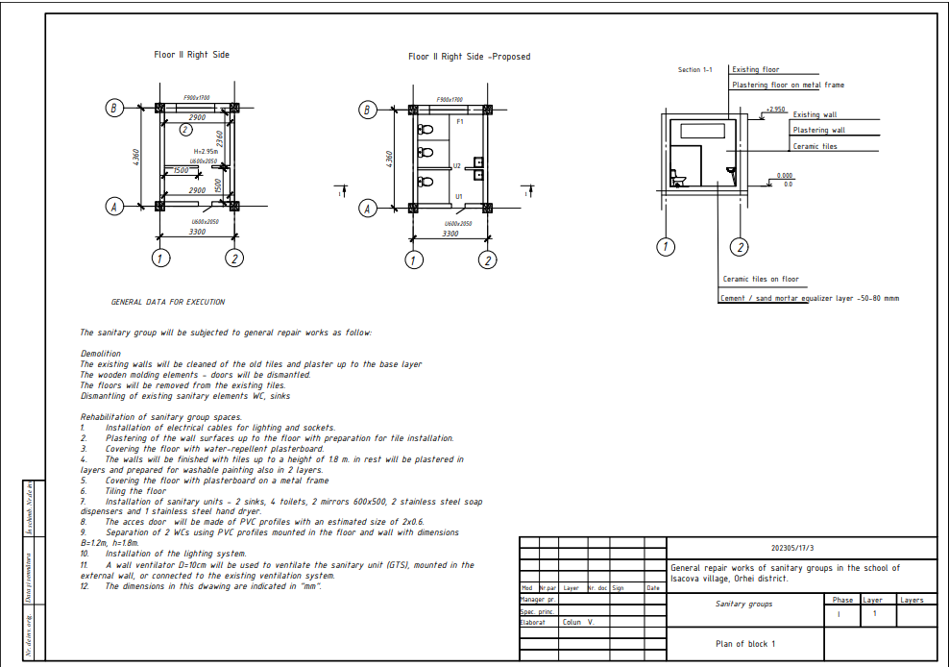

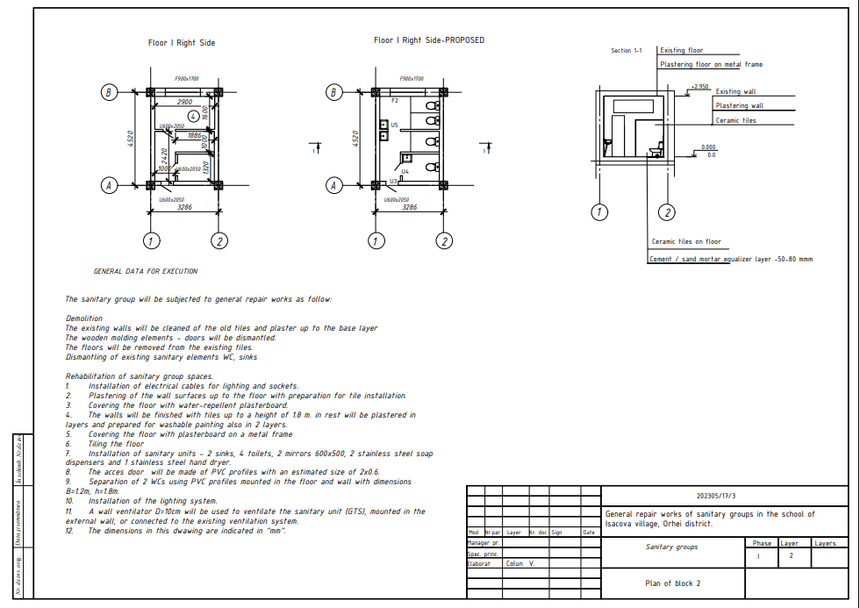

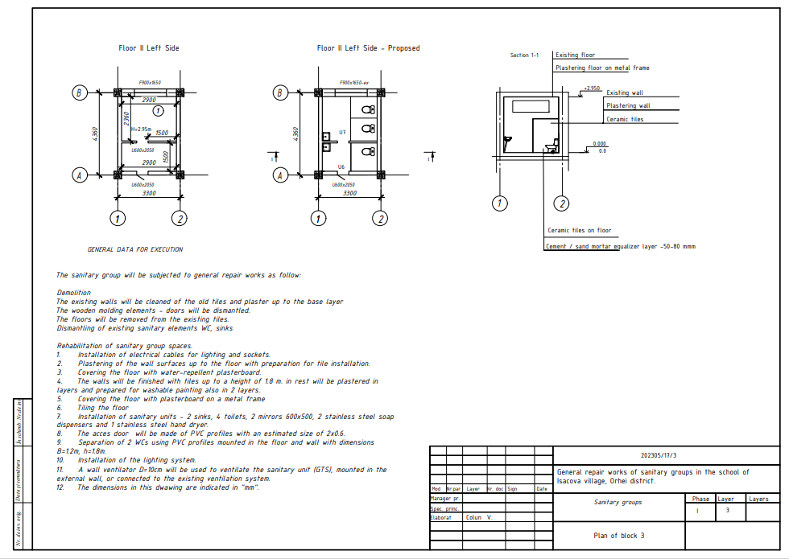

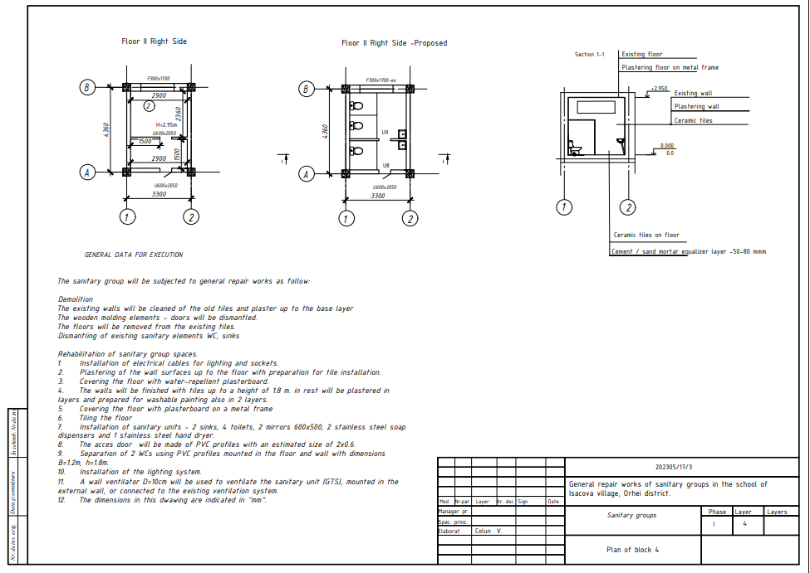

LOT 2

2.1. Tataresti Straseni, (IP Gimnaziul Tataresti)

No. | Name of the service | U.M. | Quantity |  | Value (lei) MDL
 |  |  |  |  | Materials |  | Manpower
 |  |  |  |  | Per U.M. | Total | Per U.M. | Total
 | General Demolition works
1 | Dismantling of windows | m² | 7.80
2 | Demolition of old tiles and plaster from the walls including tpransportsation of the materials from the site | m2 | 122.50
3 | Dismantling of the existing WC, Sink | unit | 8.00
4 | Dismantling of the existing pipes and ventilation tubes | m | 32.00
 | Floor
2 | Demolition of old tiles | m² | 19.80
3 | Demolition of old plasfer from the ceiling surface | m2 | 19.80
 | Doors/windows
4 | Dismantling of the existing doors | m² | 11.20
 | General rehabilitation works
 | Interior cladding
5 | Cement-based plaster on walls | m² | 122.50
6 | Floor leveling with mortar 30-70 mm | m² | 19.80
7 | Suspended ceilings made of water-repellent plasterboard (12.5 mm), on the metal casing | m² | 19.80
 | Sanitar equipment
8 | PP sewer pipe DN110, including fittings | m | 14.50
9 | PP sewer pipe DN50, including fittings | m | 17.00
10 | Cold / hot water networks - PPR pipe Dn20,  including fittings | m | 37.00
11 | Porcelain pedestal sink equipped with siphon 350x400 estimative | un. | 5.00
12 | Basin mixer tap (crane) | un. | 5.00
13 | Fully equipped (on floor -oriental)toilet unit (WC) | un. | 6.00
14 | Fully equipped toilet unit (urinals) | un. | 1.00
15 | Innox Hand drayer | un. | 4.00
16 | Innox Soap dosator | un. | 4.00
17 | Mirror 600x500 | un. | 4.00
 | Electric equipment/ventilation
18 | Electrical networks - copper cable 3x2.5, protection tube dn16, distribution boxes (2 pc.) | m | 69.00
19 | Differential circuit breaker | buc. | 2.00
20 | Simple switch, including dose | buc. | 2.00
21 | Electric Socket, including dose | buc. | 6.00
22 | Electric Lapm -25 w | buc. | 7.00
23 | Axial wall ventilator D=100 mm | buc. | 4.00
 | Interior finishing works
24 | Wall cladding with ceramic tiles | m² | 65.50
25 | Tiling the floor with ceramic tiles | m² | 19.80
26 | Plastering of non-plated surfaces with 2 layers -walls | m² | 57.00
27 | Plastering of floor surfaces with 2 layers - floor | m2 | 19.80
28 | Putty based on plaster 1 mm, including priming the surfaces | m² | 65.50
29 | 2 layers of washable paint - Floor | m² | 19.80
30 | 2 layers of washable paint -Walls | m² | 57.00
31 | PVC Walls including fixing elements | m2 | 5.20
32 | PVC door | m2 | 7.50
33 | PVC Windows | m2 | 7.50
Total (VTA cota 0)
Transport of materials, % |  |  |  | 10%
Mechanismes, %
Total
Social and medical assurance |  |  |  | 24%
Total
Direct costs, % |  |  |  | 14.5%
Total
Quote of benefit, % |  |  |  | 6%
Total
GRAND TOTAL

Drawings Tataresti Straseni, (IP Gimnaziul Tataresti)

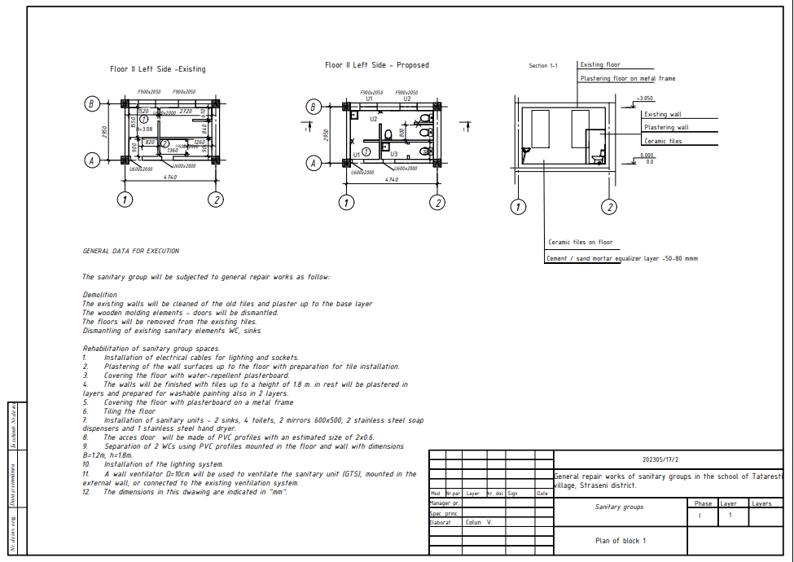

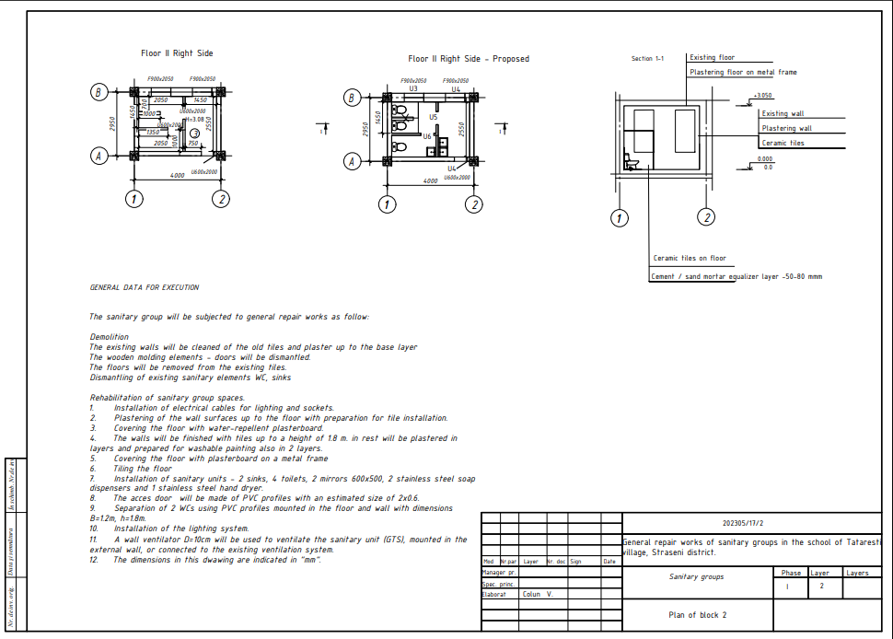

LOT 2

2.2 Grozești, Nisporeni, (IPLT Prometeu)

№  crt. | Simbol norme si cod resurse | Tipe of works | U.M | Volum

1 | 2 | 3 | 4 | 5
 |  | Chapter 1. Sanitary block for teachers
1 | RpCG29A | Dismantling of the separation walls (6-8 cm thick brick walls | m2 | 9,15
2 | RpCJ35A | Dismantling internal or external plastering on the walls | m2 | 30,20
3 | RpCO56A | Dismantling: joinery PVC doors | m2 | 3,60
4 | RpCK42C | Removal of the tile floors. | m2 | 6,20
5 | RpEB12A | Dismantling of fixed or medium-sized electrical conductors and cords, apparently mounted or hidden in protective tubes or pipes, aerial or on walls, floors or consoles, having a section of 1-2-3-4-5x0.75 mmp at 1-2 -3-4-5x2.5 mmp | m | 15,00
6 | RpEF23A | Dismantling of lighting fixtures of any type. | Unit | 3,00
7 | RpEE24A | Dismantling electrical appliances for strong current: unipolar (switches, switches, sockets for removal or replacement, button for remote operation) | Unit | 5,00
8 | RpVA35A | Dismantling the ventilation ducts made of black, galvanized or aluminum sheet, having the perimeter of the rectangular or circular section of 250 - 700 mm | m2 | 2,00
9 | RpCU09C | Transports by manual means carried directly at a distance of 60 m with a load of up to 50 kg (for 1 m transported vertically, 10 horizontally is considered) | t | 4,00
10 | TRI1AA03C1 | Loading materials from group A - heavy, in dust by throwing - from the ramp or field, in the car, category 1 | t | 4,00
11 | TsI50A5 | Transporting the soil with a dump truck at a distance of 5 km | t | 4,00
12 | RpEB01A | Installation of conductors, made of aluminum or copper, in tubes, protective elements, buried, having a section up to 16 mmp | m | 28,00
13 | CF15A k=2,5 | Interior and exterior plasters, executed by hand, with M 100-T cement mortar of 2 cm medium thickness, on concrete or brick walls, with flat surfaces | m2 | 30,20
14 | CN53A | Priming the interior surfaces of the walls and ceilings | m2 | 30,20
15 | CF50B | Interior plastering of 5 mm thickness, executed by hand, with a dry mixture based on plaster, on walls and partitions, manual preparation of the mortar. | m2 | 30,20
16 | CF57A | Manual application of gypsum-based putty 1.0 mm thick on the surfaces of walls, columns and ceilings | m2 | 30,20
17 | RpCJ06C | Repairs of interior plastering, around frames and sills, on doors and windows, 2 cm thick, chipped, executed with cement-lime mortar brand 25 T, having straight spalls, between 25 - 35 cm wide | m | 4,70
18 | RpCU05A | Execution of breaches for pipes or tie rods, for reinforcements, in walls or slabs of brick masonry up to 15 cm thick | Unit | 3,00
19 | RpCU07C | Sweeping the gaps in the floors, with cement mortar, after the installations | Unit | 3,00
20 | RpSB13E | Installation of a plastic pipe for sewerage, joined with a rubber gasket, mounted apparently or buried under the floor, having a diameter of 110 mm | m | 12,00
21 | RpSB14E | Installation of the connecting part made of plastic material for sewerage, joined with the rubber seal, having a diameter of 110 mm | Unit | 8,00
22 | RpSB13C | Installation of a plastic pipe for sewerage, joined with a rubber gasket, mounted apparently or buried under the floor, having a diameter of 50 mm | m | 3,50
23 | RpSB14C | Installation of the connecting part made of plastic material for sewerage, joined with the rubber seal, having a diameter of 50 mm | Unit | 4,00
24 | RpSA19B | Installation of the plastic pipe joined by polyfusion welding, in industrial constructions, with a diameter of 20 mm | m | 28,00
25 | CG01A | Support layer for floors made of M 100-T cement mortar, 3 cm thick with a finely chipped face | m2 | 6,20
26 | CG22A | Plain concrete floors class C 10/8 (Bc 10/B 150) 10 cm thick, in a continuous field, screed, cast in place, in rooms with an area of more than 16 square meters | m2 | 6,20
27 | CC03C | Installation of welded nets at heights less than or equal to 35 m, on slabs | kg | 6,20
28 | CK25A | Doors made of plastic profiles, including the necessary fittings and accessories for doors mounted in masonry of any kind in constructions with a height of up to 35 m inclusive, in one leaf, with a frame surface of up to 7 m2 inclusive | m2 | 1,40
29 | VA05A | Installation (on the construction site) of the ventilation tubes, ready-made, with a diameter of 150 mm | m | 10,60
30 | RpVA05A1 | Installation (on site) of ready-made ventilation ducts, installation of special parts for ventilation ducts | m | 2,65
31 | CK50A | Moisture resistant suspended ceilings executed on site from plasterboard, thickness 9.5 mm on the galvanized profile structure: flat ceiling surfaces | m2 | 6,20
32 | CN53A | Priming the interior surfaces of the walls and ceilings | m2 | 22,40
33 | CF50B | Interior plasters of 5 mm thickness, executed by hand, with a dry mixture based on plaster, on walls and partitions, manual preparation of the mortar. | m2 | 16,20
34 | CF52B | Interior plasters of 5 mm thickness, executed by hand, with dry mixture based on gypsum, on the ceiling, manual preparation of the mortar | m2 | 6,20
35 | CF57A | Manual application of the gypsum-based putty 1.0 mm thick on the surfaces of walls, columns and ceilings | m2 | 28,60
36 | CN53A | Priming the interior surfaces of the walls and ceilings | m2 | 28,60
37 | CN06A | Interior paintings using based on vinyl copolymers in aqueous emulsion, applied in 2 layers on the existing screed, executed by hand | m2 | 28,60
38 | CI06C | Glazed, unglazed, matte or glossy tile boards of the same color and format with dimensions from 15 x 15 cm to 30 x 30 cm, executed on flat surfaces on walls and pillars, including the jambs and edges, with alternating joints, in rooms with an area of more than 10 square meters, fixed with glue for the installation | m2 | 16,00
39 | CG17D1 | Floors made of ceramic tiles including the support layer of adhesive mortar, executed on surfaces: equal to or smaller than 16 m2 | m2 | 6,20
40 | RpEE01A | Installation of 10-25 A unipolar or bipolar switches, of normal construction, waterproof or sealed in metal or porcelain casing, mounted buried or visible on wooden or plastic dowels, connected to copper or aluminum conductors | Unit | 1,00
41 | RpEE03A | Installation of bipolar sockets, normal construction in bakelite or aminoplast, single, double, waterproof construction, sealed, metal sealed or similar, mounted buried under the plaster or apparently on wooden or plastic dowels | Unit | 1,00
42 | RpEF02A | Installation of multiple lighting fixtures, for tubular fluorescent lamps, any type, ceiling or wall, including the support device, type CGA 140-485 fully equipped | Unit | 3,00
43 | RpSC24A | Installation of the toilet bowl, fully equipped, made of semi-porcelain, sanitary porcelain, etc. including for the disabled, placed on the floor, with the water tank mounted at height or half height, having the internal siphon type S | Unit | 2,00
44 | RpSC21A | Installing the semi-porcelain sink, sanitary porcelain, etc. including for the disabled, having a drain pipe made of plastic material, mounted on brackets fixed on the walls made of brick or b.c.a. | Unit | 1,00
45 | RpSD34A | Installation of the faucet for the sink regardless of the closing method, including for the disabled, having a diameter of 1/2" | Unit | 1,00
46 | RoSD18A | Installation of the service valve, single or double with connection, regardless of the closing method, having a diameter of 3/8" - 1/2" | Unit | 4,00
47 | RpSC30A | Installation of the semi-crystal sanitary mirror with polished edges, avid dimensions of 400 x 500 x 600 mm, mounted on a brick wall or b.c.a. | Unit | 1,00
48 | SE59A | Automatic hands dryer, mounted on a brick or b.c.a. wall. | Unit | 1,00
49 | SE59A | Automatic liquid soap dispenser, mounted on a brick or b.c.a. wall. | Unit | 1,00
50 | CL20A | Ready-made ventilation grids made of black sheet, with manually adjustable blinds, painted and mounted in masonry | Unit | 2,00
51 | CK22C | Aluminum profiles for constructions with heights up to 35 m from fixed panels and door leaves | m2 | 6,60
 |  | Chapter 2 Sanitary block for girls
52 | RpCG29A | Dismantling of 6-8 cm thick brick or BCA masonry walls | m2 | 6,55
53 | RpCJ35A | Dismantling of internal or external plastering on the walls | m2 | 64,00
54 | RpCO56A | Dismantling wooden carpentry | m2 | 3,35
55 | RpCK41A | Removing the floors from the split ceilings, cabinets, etc | m2 | 11,80
56 | RpEB12A | Dismantling of fixed or medium-sized electrical conductors and cords, apparently mounted or hidden in protective tubes or pipes, aerial or on walls, floors or consoles, having a section of 1-2-3-4-5x0.75 mmp at 1-2 -3-4-5x2.5 mmp | m | 15,00
57 | RpEF23A | Dismantling of lighting fixtures of any type. | Unit | 3,00
58 | RpEE24A | Dismantling electrical appliances for strong current: unipolar (switches, switches, sockets for removal or replacement, button for remote operation) | Unit | 2,00
59 | RpVA35A | Dismantling the ventilation ducts made of black, galvanized or aluminum sheet, having the perimeter of the rectangular or circular section of 250 - 700 mm | m2 | 2,00
60 | RpSB01C | Dismantling of cast iron pipes and fittings, for sewerage, with a diameter of 100 mm | m | 5,00
61 | RpSC06A | Dismantling the toilet bowl, fully equipped | Unit | 4,00
62 | RpCU09C | Transports by manual means carried directly at a distance of 60 m with a load of up to 50 kg (for 1 m transported vertically, 10 horizontally is considered) | t | 5,50
63 | TRI1AA03C1 | Loading materials from group A - heavy, in dust by throwing - from the ramp or field, in the car, category 1 | t | 5,50
64 | TsI50A5 | Transporting the soil with a dump truck at a distance of 5 km | t | 5,50
65 | RpEB01A | Installation of masked conductors, made of aluminum or copper, in tubes, protective elements, buried, having a section up to 16 mmp | m | 34,00
66 | CF15A k=2,5 | Interior and exterior plasters, executed by hand, with M 100-T cement mortar of 2 cm medium thickness, on concrete or brick walls, with flat surfaces | m2 | 39,10
67 | CN53A | Priming the interior surfaces of the walls and ceilings | m2 | 39,10
68 | CF50B | Interior plasters of 5 mm thickness, executed by hand, with a dry mixture based on plaster, on walls and partitions, manual preparation of the mortar. | m2 | 39,10
69 | CF57A | Manual application of the gypsum-based putty 1.0 mm thick on the surfaces of walls, columns and ceilings | m2 | 39,10
70 | RpCJ06C | Repairs of interior plastering, around frames and sills, on doors and windows, 2 cm thick, chipped, executed with cement-lime mortar brand 25 T, having straight spalls, between 25 - 35 cm wide | m | 5,20
71 | RpCU05A | Execution of accesses for pipes or tie rods, for reinforcements, in walls or slabs of brick masonry up to 15 cm thick | Unit | 2,00
72 | RpCU07C | Sweeping the gaps in the floors, with cement mortar, after the installations | Unit | 2,00
73 | RpSB13E | Installation of a plastic pipe for sewerage, joined with a rubber gasket, mounted apparently or buried under the floor, having a diameter of 110 mm | m | 13,50
74 | RpSB14E | Installation of the connecting part made of plastic material for sewerage, joined with the rubber seal, having a diameter of 110 mm | Unit | 10,00
75 | RpSB13C | Installation of a plastic pipe for sewerage, joined with a rubber gasket, mounted apparently or buried under the floor, having a diameter of 50 mm | m | 12,50
76 | RpSB14C | Installation of the connecting part made of plastic material for sewerage, joined with the rubber seal, having a diameter of 50 mm | Unit | 10,00
77 | RpSA19B | Installation of the plastic pipe joined by polyfusion welding, in industrial constructions, with a diameter of 20 mm | m | 30,00
78 | CG22A | Plain concrete floors class C 10/8 (Bc 10/B 150) 10 cm thick, in a continuous field, screed, cast in place, in rooms with an area of more than 16 square meters | m2 | 10,78
79 | CC03C | Installation of welded nets at heights less than or equal to 35 m, on slabs | kg | 10,78
80 | CG01A | Support layer for floors made of cement mortar M 100-T 3 cm thick with a finely chipped surface | m2 | 10,78
81 | CK23A | Plastic windows with one or more sashes in buildings with heights up to 35 m inclusive, with a frame area up to 1.00 m2 inclusive | m2 | 0,80
82 | CK26C | Sills mounted on windows or doors made of plastics | m | 1,50
83 | CK25A | Doors made of plastic profiles, including the necessary fittings and accessories for doors mounted in masonry of any kind in constructions with a height of up to 35 m inclusive, in one leaf, with a frame surface of up to 7 m2 inclusive | m2 | 1,40
84 | CK50A | Moisture Resistant Suspended ceilings made on site from plasterboard, 9.5 mm thick on a galvanized profile structure: flat ceiling surfaces | m2 | 10,78
85 | CN53A | Priming the interior surfaces of the walls and ceilings | m2 | 31,76
86 | CF50B | Interior plasters of 5 mm thickness, executed by hand, with a dry mixture based on plaster, on walls and partitions, manual preparation of the mortar. | m2 | 20,98
87 | CF52B | Interior plasters of 5 mm thickness, executed by hand, with dry mixture based on gypsum, on the ceiling, manual preparation of the mortar | m2 | 10,78
88 | CF57A | Manual application of the gypsum-based putty 1.0 mm thick on the surfaces of walls, columns and ceilings | m2 | 23,95
89 | CN53A | Priming the interior surfaces of the walls and ceilings | m2 | 31,76
90 | CN06A | Interior painters with paint based on vinyl copolymers in aqueous emulsion, applied in 2 layers on the existing screed, executed manually | m2 | 31,76
91 | CI06C | Glazed, unglazed, matte or glossy flour plywood with boards of the same color and format with dimensions from 15 x 15 cm to 30 x 30 cm, executed on flat surfaces on walls and pillars, including the jambs and edges, with alternating joints in rooms with an area of more than 10 square meters, fixed with glue for the installation of plywood | m2 | 34,28
92 | CG17D1 | Floors made of ceramic tiles including the support layer of adhesive mortar, executed on surfaces: equal to or smaller than 16 m2 | m2 | 10,78
93 | RpEE01A | Installation of 10-25 A unipolar or bipolar switches, of normal construction, waterproof or sealed in aminoplast, bakelite, metal or porcelain casing, mounted buried or visible on wooden or plastic dowels, connected to copper or aluminum conductors | Unit | 1,00
94 | RpEE03A | Installation of bipolar sockets, normal construction in bakelite or aminoplast, single, double, waterproof construction, sealed, metal sealed or similar, mounted buried under the plaster or apparently on wooden or plastic dowels | Unit | 1,00
95 | RpEF02A | Installation of multiple lighting fixtures, for tubular fluorescent lamps, any type, ceiling or wall, including the support device, type CGA 140-485 fully equipped, | Unit | 3,00
96 | CK22C | Aluminum profiles for constructions with heights up to 35 m from fixed panels and door leaves | m2 | 13,68
97 | RpSC24A | Installation of the toilet bowl, fully equipped, made of semi-porcelain, sanitary porcelain, etc. including for the disabled, placed on the floor, with the water tank mounted at height or half height, having the internal siphon type S | Unit | 4,00
98 | RpSC21A | Installing the semi-porcelain sink, sanitary porcelain, etc. including for the disabled, having a drain pipe made of plastic material, mounted on brackets fixed on the walls made of brick or b.c.a. | Unit | 2,00
99 | RpSD34A | Installation of the faucet for the sink or washing machine, regardless of the closing method, including for the disabled, having a diameter of 1/2" | Unit | 3,00
100 | RoSD18A | Installation of the service valve, single or double with connection, regardless of the closing method, having a diameter of 3/8" - 1/2" | Unit | 8,00
101 | RpSC30A | Installation of the semi-crystal sanitary mirror with polished edges, avid dimensions of 400 x 500 x 600 mm, mounted on a brick wall or b.c.a. | Unit | 2,00
102 | SE59A | Automatic Hand dryer | Unit | 1,00
103 | SE59A | Automatic liquid soap dispenser, mounted on a brick or b.c.a. wall. | Unit | 2,00
104 | CL20A | Ready-made ventilation grilles made of black sheet, with manually adjustable blinds, painted and mounted in masonry | Unit | 1,00
 |  | Chapter 3. Sanitary Block second floor, for boys
105 | RpCG29A | Dismantling of 6-8 cm thick brick or BCA masonry walls | m2 | 6,55
106 | RpCJ35A | Dismantling of internal or external plastering on the walls | m2 | 49,04
107 | RpCO56A | Dismantling: wooden joinery (doors) | m2 | 2,55
108 | RpCO56A | Removals: PVC joinery (windows) | m2 | 0,80
109 | RpCK42C | Removal of tile floors. | m2 | 10,78
110 | RpEB12A | Dismantling of fixed or medium-sized electrical conductors and cords, apparently mounted or hidden in protective tubes or pipes, aerial or on walls, floors or consoles, having a section of 1-2-3-4-5x0.75 mmp at 1-2-3-4-5x2.5 mmp | m | 25,00
111 | RpEF23A | Dismantling of lighting fixtures of any type. | Unit | 3,00
112 | RpEE24A | Dismantling electrical appliances for strong current: unipolar (switches, switches, sockets for removal or replacement, button for remote operation) | Unit | 2,00
113 | RpVA35A | Dismantling the ventilation ducts made of black, galvanized or aluminum sheet, having the perimeter of the rectangular or circular section of 250 - 700 mm | m2 | 2,00
114 | RpCU09C | Transports by manual means carried directly at a distance of 60 m with a load of up to 50 kg (for 1 m transported vertically, 10 horizontally is considered) | t | 5,50
115 | TRI1AA03C1 | Loading materials from group A - heavy, in dust by throwing - from the ramp or field, in the car, category 1 | t | 5,50
116 | TsI50A5 | Transporting the soil with a dump truck at a distance of 5 km | t | 5,50
117 | RpEB01A | Installation of masked conductors, made of aluminum or copper, in tubes, protective elements, buried, having a section up to 16 mmp | m | 35,00
118 | CF15A k=2,5 | Plastering executed manually, with M 100-T cement mortar of 2 cm medium thickness, on concrete or brick walls, with flat surfaces | m2 | 49,04
119 | CN53A | Priming the interior surfaces of the walls and ceilings | m2 | 49,04
120 | CF50B | Interior plasters of 5 mm thickness, executed by hand, with a dry mixture based on plaster, on walls and partitions, manual preparation of the mortar. | m2 | 49,04
121 | CF57A | Manual application of gypsum-based putty 1.0 mm thick on the surfaces of walls, columns and ceilings | m2 | 49,04
122 | RpCJ06C | Repairs of interior plastering, around frames and sills, on doors and windows, 2 cm thick, chipped, executed with cement-lime mortar brand 25 T, having straight spalls, between 25 - 35 cm wide | m | 5,20
123 | RpCU05A | Execution of penetrations for pipes or tie rods, for reinforcements, in walls or slabs of brick masonry up to 15 cm thick | Unit | 1,00
124 | RpCU07C | Sweeping the gaps in the floors, with cement mortar, after the installations | Unit | 1,00
125 | RpSB13E | Installation of a plastic pipe for sewerage, joined with a rubber gasket, mounted apparently or buried under the floor, having a diameter of 110 mm | m | 8,00
126 | RpSB14E | Installation of the connecting part made of plastic material for sewerage, joined with the rubber seal, having a diameter of 110 mm | Unit | 6,00
127 | RpSB13C | Installation of a plastic pipe for sewerage, joined with a rubber gasket, mounted apparently or buried under the floor, having a diameter of 50 mm | m | 8,00
128 | RpSB14C | Installation of the connecting part made of plastic material for sewerage, joined with the rubber seal, having a diameter of 50 mm | Unit | 10,00
129 | RpSA19B | Installation of the plastic pipe joined by polyfusion welding, in industrial constructions, with a diameter of 20 mm | m | 25,00
130 | CG22A | Plain concrete floors class C 10/8 (Bc 10/B 150) 10 cm thick, in a continuous field, screed, cast in place, in rooms with an area of more than 16 square meters | m2 | 10,78
131 | CC03C | Installation of welded nets at heights less than or equal to 35 m, on slabs | kg | 10,78
132 | CG01A | Support layer for floors made of cement mortar M 100-T 3 cm thick with a finely chipped surface | m2 | 10,78
133 | CK23A | Plastic windows with one or more sashes in buildings with heights up to 35 m inclusive, with a frame area up to 1.00 m2 inclusive | m2 | 0,80
134 | CK26C | Sills mounted on windows or doors made of plastics | m | 1,50
135 | СF59B | Cladding the surfaces with a layer of Moisture resistant PGC with the execution of the simple flat metal casing, with a height of up to 4 m: inclined surfaces without insulation | m2 | 5,60
136 | CK50A | Moisture Resistant suspended ceilings made on site from plasterboard, 9.5 mm thick on a galvanized profile structure: flat ceiling surfaces | m2 | 10,78
137 | CN53A | Priming the interior surfaces of the walls and ceilings | m2 | 31,76
138 | CF50B | Interior plasters of 5 mm thickness, executed by hand, with a dry mixture based on plaster, on walls and partitions, manual preparation of the mortar. | m2 | 20,98
139 | CF52B | Interior plasters of 5 mm thickness, executed by hand, with dry mixture based on gypsum, on the ceiling, manual preparation of the mortar | m2 | 10,78
140 | CF57A | Manual application of gypsum-based putty 1.0 mm thick on the surfaces of walls, columns and ceilings | m2 | 31,76
141 | CN53A | Priming the interior surfaces of the walls and ceilings | m2 | 31,76
142 | CN06A | Interior painters with paint based on vinyl copolymers in aqueous emulsion, applied in 2 layers on the existing screed, executed manually | m2 | 31,76
143 | CI06C | Glazed, unglazed, matte or glossy flour plywood with boards of the same color and format with dimensions from 15 x 15 cm to 30 x 30 cm, executed on flat surfaces on walls and pillars, including the jambs and edges, with alternating joints, in rooms with an area of more than 10 square meters, fixed with glue for the installation of plywood | m2 | 29,09
144 | CG17D1 | Floors made of ceramic tiles including the support layer of adhesive mortar, executed on surfaces: equal to or smaller than 16 m2 | m2 | 10,78
145 | RpEE01A | Installation of 10-25 A unipolar or bipolar switches, of normal construction, waterproof or sealed in aminoplast, bakelite, metal or porcelain casing, mounted buried or visible on wooden or plastic dowels, connected to copper or aluminum conductors | Unit | 1,00
146 | RpEE03A | Installation of bipolar sockets, normal construction in bakelite or aminoplast, single, double, waterproof construction, sealed, metal sealed or similar, mounted buried under the plaster or apparently on wooden or plastic dowels | Unit | 1,00
147 | RpEF02A | Installation of multiple lighting fixtures, for tubular fluorescent lamps, any type, ceiling or wall, including the support device, type CGA 140-485 fully equipped | Unit | 3,00
148 | CK22C | aluminum profiles for constructions with heights up to 35 m from fixed panels and door leaves | m2 | 11,88
149 | RpSC24A | Installation of the toilet bowl, fully equipped, made of semi-porcelain, sanitary porcelain, etc. including for the disabled, placed on the floor, with the water tank mounted at height or half height, having the internal siphon type S | Unit | 3,00
150 | RpSC26A | Installation of the sanitary porcelain urinal mounted on a brick wall or b.c.a. | Unit | 1,00
151 | RpSC21A | Installing the semi-porcelain sink, sanitary porcelain, etc. including for the disabled, having a drain pipe made of plastic material, mounted on brackets fixed on the walls made of brick or b.c.a. | Unit | 2,00
152 | RpSD34A | Installation of the faucet for the sink or washing machine, regardless of the closing method, including for the disabled, having a diameter of 1/2" | Unit | 2,00
153 | RoSD18A | Installation of the service valve, single or double with connection, regardless of the closing method, having a diameter of 3/8" - 1/2" | Unit | 4,00
154 | RpSC30A | Installation of the semi-crystal sanitary mirror with polished edges, avid dimensions of 400 x 500 x 600 mm, mounted on a brick wall or b.c.a. | Unit | 2,00
155 | SE59A | Automatic hand dryer mounted on a brick or b.c.a. wall. | Unit | 1,00
156 | SE59A | Automatic liquid soap dispenser, mounted on a brick or b.c.a. wall. | Unit | 2,00
157 | CL20A | Ready-made ventilation grilles made of black sheet, with manually adjustable blinds, painted and mounted in masonry | Unit | 1,00

LOT 3
3.1 Anenii Noi, (IPLT A.Puskin)

№ | Simbol norms and Code | Type of works | U M | Volume
1 | 2 | 3 | 4 | 5
 |  | 1. Rehabilitation works
1 | RpCO56A | Dismantling: wooden carpentry (doors, windows, shutters, boxes, blinds etc.) | m2 | 2,80
2 | RpCM33A | Removal of tile, stoneware, ceramic veneers | m2 | 78,00
3 | RpCK42C | Removal of cold floors made of concrete slabs, marble, stone, sandstone, ceramic tiles, etc. | m2 | 37,60
4 | RCsU05C | Execution of accesses for pipes or tie-rods in stone or reinforced concrete walls or slabs up to 15 cm | Unit | 4,00
5 | CK50A | Suspended ceilings executed on site from plasterboard, thickness 9.5 mm on the galvanized profile structure: flat ceiling surfaces | m2 | 37,60
6 | CN53A | Priming the interior surfaces of the walls and ceilings | m2 | 37,60
7 | CF52B | Interior plasters of 5 mm thickness, executed by hand, with dry mixture based on gypsum, on the ceiling, manual preparation of the mortar | m2 | 37,60
8 | CF57A | Manual application of gypsum-based putty 1.0 mm thick on the surfaces of walls, columns and ceilings | m2 | 37,60
9 | CN53A | Priming the interior surfaces of the walls and ceilings | m2 | 37,60
10 | CN06A | Interior painters with paint based on vinyl copolymers in aqueous emulsion, applied in 2 layers on the existing screed, executed by hand | m2 | 37,60
11 | CK25A | Doors made of plastic profiles, including the necessary fittings and accessories for doors mounted in masonry of any kind in constructions with a height of up to 35 m inclusive, in one leaf, with a frame surface of up to 7 m2 inclusive | m2 | 2,80
12 | CK22C | Aluminum profiles for constructions with heights up to 35 m from fixed panels and door leaves | m2 | 36,80
13 | RpCJ06B | Repairs of interior plastering, around frames and window sills, on doors and windows, 2 cm thick, chipped, executed with 25 T brand cement-lime mortar, having straight slats, between 15 - 25 cm wide | m | 16,40
14 | RpCJ12A | Interior and exterior plasters, executed with M 100-T cement mortar of 2 cm medium thickness, on concrete or brick walls, with flat surfaces | m2 | 102,00
15 | CN53A | Priming the interior surfaces of the walls and ceilings | m2 | 23,30
16 | CF50B | Interior plasters of 5 mm thickness, executed by hand, with a dry mixture based on plaster, on walls and partitions, manual preparation of the mortar. | m2 | 23,30
17 | CN53A | Priming the interior surfaces of the walls and ceilings | m2 | 23,30
18 | CN06A | Interior painters with paint based on vinyl copolymers in aqueous emulsion, applied in 2 layers on the existing screed, executed by hand | m2 | 23,30
19 | CI22B | Ceramic plates (for walls, pillars, pilasters and jambs) fixed with glue (dry mixture), plate sizes: from 400 x 400 mm  Installation of axial window fans, type VF 315 - VF 900, weighing 3.6 - 8.2 kg with 0.25 - 0.55 kw motor | m2 | 78,70
20 | VC07A | Installation of axial window fans, type VF 315 - VF 900, weighing 3.6 - 8.2 kg with 0.25 - 0.55 kw motor | Unit | 2,00
21 | CG22A | Plain concrete floors class C 10/8 (Bc 10/B 150) 10 cm thick, in a continuous field, screed, cast in place, in rooms with an area of more than 16 square meters | m2 | 37,60
22 | CG01A | Support layer for floors made of cement mortar M 100-T 3 cm thick with a finely chipped surface | m2 | 37,60
23 | CG47D | Ceramic tile floors, including the backing layer of adhesives (dry mix), tile sizes: over 300 x 300 mm | m2 | 37,60
24 | TrI1AA01C2 | Loading materials from group A - heavy and small by throwing - from the ramp or field, in a category 2 car | t | 5,30
25 | TsI50B5 | Transporting the soil with a dump truck at a distance of 15 km | t | 5,30
 |  | 2. Water, sewage and heating
26 | SB08E | Plastic pipe for sewage, joined with a rubber gasket, mounted apparently or buried under the floor, having a diameter of 110 mm l -1m | m | 18,00
27 | SB08E | Plastic pipe for sewerage, joined with a rubber gasket, mounted apparently or buried under the floor, having a diameter of 110 mm l - 0.25m | m | 7,50
28 | SB09E | Connecting part made of plastic material for sewerage, joined with a rubber gasket, having a diameter of 110 mm teu 110x110x110 mm 90 | Unit | 12,00
29 | SB09E | Connecting piece made of plastic material for sewerage, joined with a rubber gasket, having a diameter of 110 mm reduction 110x50 | Unit | 6,00
30 | SB09E | Connecting part made of plastic material for sewerage, joined with a rubber gasket, having a diameter of 110 mm, plug 110 | Unit | 4,00
31 | SB09E | Plastic connecting piece for sewerage, joined with rubber gasket, having a diameter of 110 mm elbow 110x45 | Unit | 18,00
32 | SB09E | Connecting piece made of plastic material for sewerage, joined with a rubber gasket, having a diameter of 110 mm, plug 110 mm | Unit | 4,00
33 | SB08C | Plastic pipe for sewerage, joined with a rubber gasket, mounted apparently or buried under the floor, having a diameter of 50 mm l- 2m | m | 12,00
34 | SB08C | Plastic pipe for sewerage, joined with a rubber gasket, mounted apparently or buried under the floor, having a diameter of 50 mm l- 2m | m | 10,00
35 | SB08C | Plastic pipe for sewerage, joined with a rubber gasket, mounted apparently or buried under the floor, having a diameter of 50 mm l - 1m | m | 10,50
36 | SB09C | Plastic connection piece for sewerage, joined with a rubber gasket, having a diameter of 50 mm, 50 mm plug | Unit | 4,00
37 | SB09C | Plastic connection piece for sewerage, joined with rubber gasket, having a diameter of 50 mm sleeve 50 mm | Unit | 4,00
38 | SB09C | The connecting part made of plastic material for sewerage, joined with a rubber gasket, having a diameter of 50 mm elbow 50x90 | Unit | 12,00
39 | SC04A | Semi-porcelain sink, sanitary porcelain, etc. including for the disabled, having a drain pipe made of plastic material, mounted on brackets fixed on the walls made of brick or b.c.a. | Unit | 6,00
40 | SD07C | Pass valve with valve and plug, with or without discharge, for steel pipe, having a diameter of 1" d 15mm | Unit | 6,00
41 | SD04A | Mixer tap with tilting arm stand for sink regardless of the closing method, including for the disabled, having a diameter of 1/2" for the sink | Unit | 6,00
42 | SB09C | Plastic connection piece for sewage, joined with rubber gasket, having a diameter of 50 mm siphon | Unit | 4,00
43 | SC07A | Toilet bowl, fully equipped, made of semi-porcelain, sanitary porcelain, etc. including for the disabled, placed on the floor, with the water tank mounted at height or half height, having the internal siphon type S  Sanitary porcelain urinal mounted on a brick or b.c.a. wall. | Unit | 10,00
44 | SC09A | Sanitary porcelain urinal mounted on a brick or b.c.a. wall | Unit | 4,00
45 | SD07C | Pass valve with valve and plug, with or without discharge, for steel pipe, having a diameter of 1" d 15mm | Unit | 14,00
46 | SA15B | Plastic pipe joined by polyfusion welding, in connecting pipes, to sanitary objects, to residential and social-cultural objects, having a diameter of 20 mm | m | 20,00
47 | SA15B | Plastic pipe joined by polyfusion welding, in connecting pipes, to sanitary objects, to residential and social-cultural objects, having a diameter of 25 mm | m | 52,00
48 | SD07C | Pass valve with valve and sleeve, with or without discharge, for steel pipe, having a diameter of 25 mm | buc | 4,00
49 | SC13A | Semi-crystal sanitary mirror with polished edges, avid dimensions of 400 x 500 x 600 mm, mounted on a brick wall or b.c.a. | Unit | 4,00
50 | SE59A | Hand dryer and automatic liquid soap dispenser, mounted on a brick or b.c.a. wall. | Unit | 4,00
 |  | 3. Electrical networks
51 | RpED01A | Installation of cables for electricity, VVGNG 3*1.5 | m | 70,00
52 | RpEB03D | Installation of copper cords with PVC insulation, MYYM symbol, with two or three copper conductors, on plastered walls or ceilings, including sockets, connections in sockets and execution of the trench in the plaster, having a section of 3x2.5 mmp | m | 60,00
53 | RpEF02B | Installation of multiple lighting fixtures for fluorescent lamps, including the support device for LED tubes | Unit | 6,00
54 | RpEE14E | Installation of unipolar switches - simple drum type switch - symbol 0145 | Unit | 2,00
55 | RpEE03A | Installation of bipolar sockets, normal construction in bakelite or aminoplast, single, double, waterproof construction, sealed, metal sealed or similar, mounted buried under the plaster or apparently on wooden or plastic dowels | Unit | 6,00

LOT 3
3.2. Cirnateni, Causeni, (IPLT cu profil arte Grigore Grigoriu)

No. | Name of the service | U.M. | Quantity | Value (lei) MDL
 |  |  |  | Materials |  | Manpower
 |  |  |  | Per U.M. | Total | Per U.M. | Total
 | General Demolition works
1 | Dismantling of windows | m² | 0.00
2 | Demolition of old tiles and plaster from the walls including tpransportsation of the materials from the site | m2 | 328.00
3 | Dismantling of the existing WC, Sink | unit | 13.00
4 | Dismantling of the existing pipes and ventilation tubes | m | 49.50
 | Floor
2 | Demolition of old tiles | m² | 66.00
3 | Demolition of old plasfer from the ceiling surface | m2 | 66.00
 | Doors/windows
4 | Dismantling of the existing doors | m² | 18.45
 | General rehabilitation works
 | Interior cladding
5 | Cement-based plaster on walls | m² | 328.00
6 | Floor leveling with mortar 30-70 mm | m² | 65.90
7 | Suspended ceilings made of water-repellent plasterboard (12.5 mm), on the metal casing | m² | 65.90
 | Sanitar equipment
8 | PP sewer pipe DN110, including fittings | m | 76.50
9 | PP sewer pipe DN50, including fittings | m | 48.00
10 | Cold / hot water networks - PPR pipe Dn20,  including fittings | m | 126.00
11 | Porcelain pedestal sink equipped with siphon 350x400 estimative | un. | 12.00
12 | Basin mixer tap (crane) | un. | 12.00
13 | Fully equipped toilet unit (WC) | un. | 13.00
14 | Fully equipped toilet unit | un. | 6.00
15 | Innox Hand drayer | un. | 6.00
16 | Innox Soap dosator | un. | 12.00
17 | Mirror 600x500 | un. | 12.00
 | Electric equipment/ventilation
18 | Electrical networks - copper cable 3x2.5, protection tube dn16, distribution boxes (2 pc.) | m | 199.00
19 | Differential circuit breaker | buc. | 6.00
20 | Simple switch, including dose | buc. | 6.00
21 | Electric Socket, including dose | buc. | 18.00
22 | Electric Lapm -25 w | buc. | 16.00
23 | Axial wall ventilator D=100 mm | buc. | 11.00
 | Interior finishing works
24 | Wall cladding with ceramic tiles | m² | 199.00
25 | Tiling the floor with ceramic tiles | m² | 65.50
26 | Plastering of non-plated surfaces with 2 layers -walls | m² | 129.50
27 | Plastering of floor surfaces with 2 layers - floor | m2 | 91.90
28 | Putty based on plaster 1 mm, including priming the surfaces | m² | 199.00
29 | 2 layers of washable paint - Floor | m² | 65.50
30 | 2 layers of washable paint -Walls | m² | 129.50
31 | PVC Walls including fixing elements | m2 | 48.80
32 | PVC door | m2 | 9.85
Total (VTA cota 0)
Transport of materials, % |  |  | 10%
Mechanismes, %
Total
Social and medical assurance |  |  | 24%
Total
Direct costs, % |  |  | 14.5%
Total
Quote of benefit, % |  |  | 6%
Total
GRAND TOTAL

Drawings Cirnateni, Causeni, (IPLT cu profil arte Grigore Grigoriu)

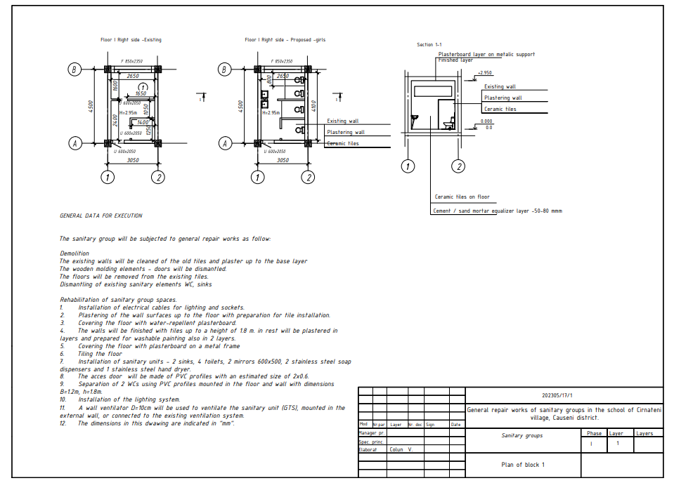

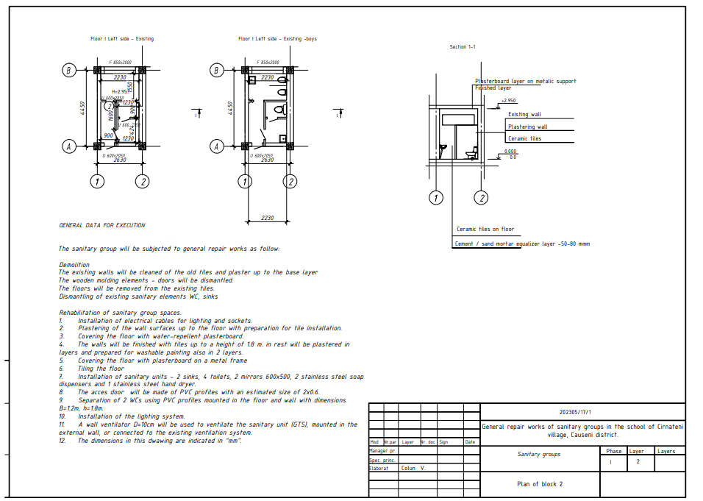
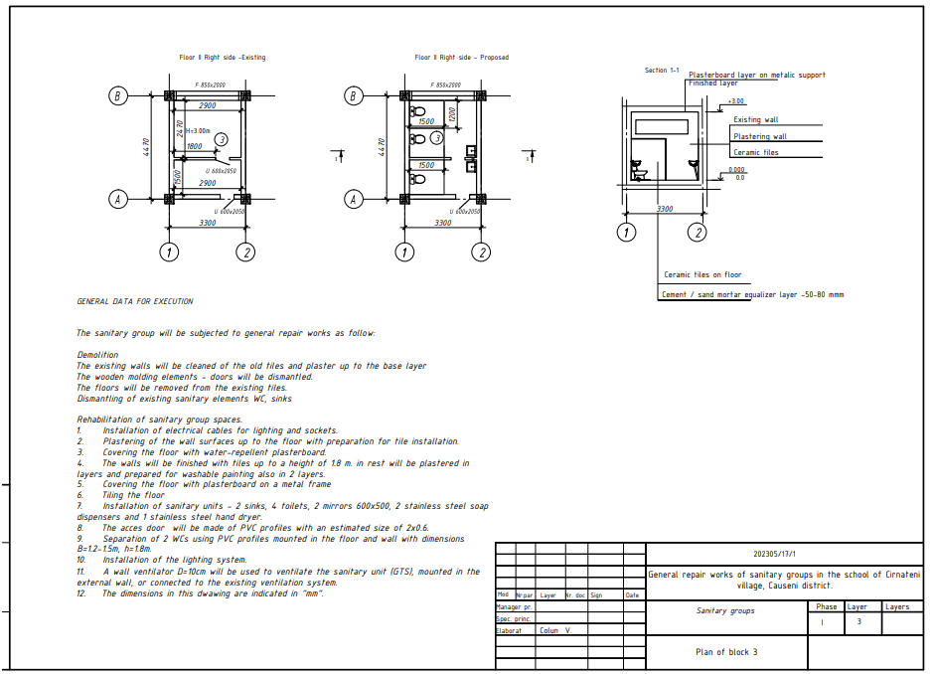

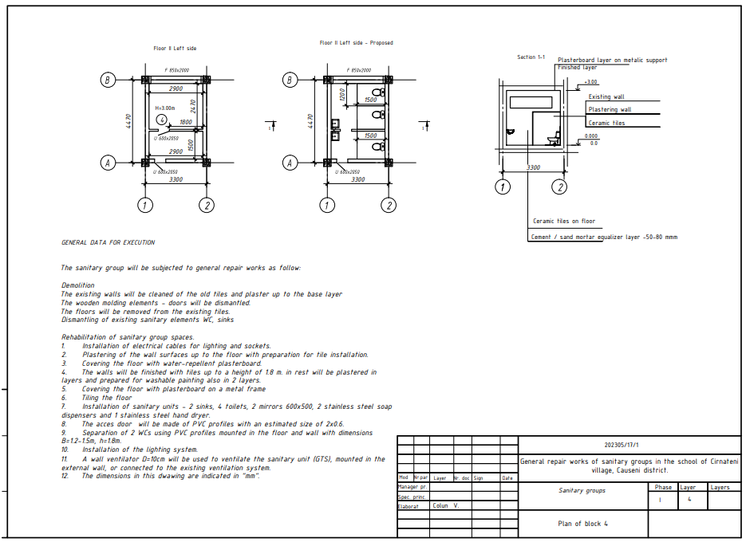

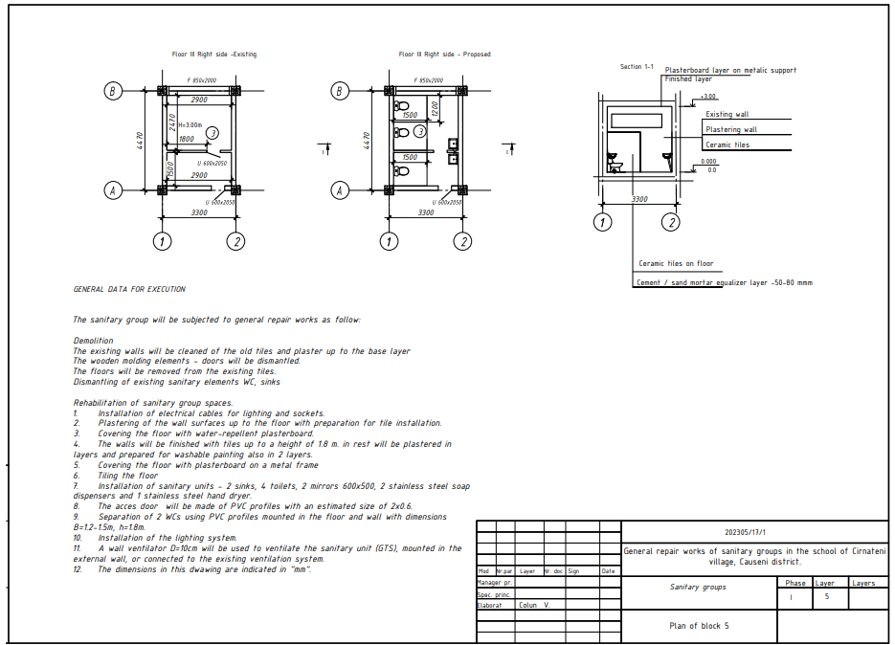
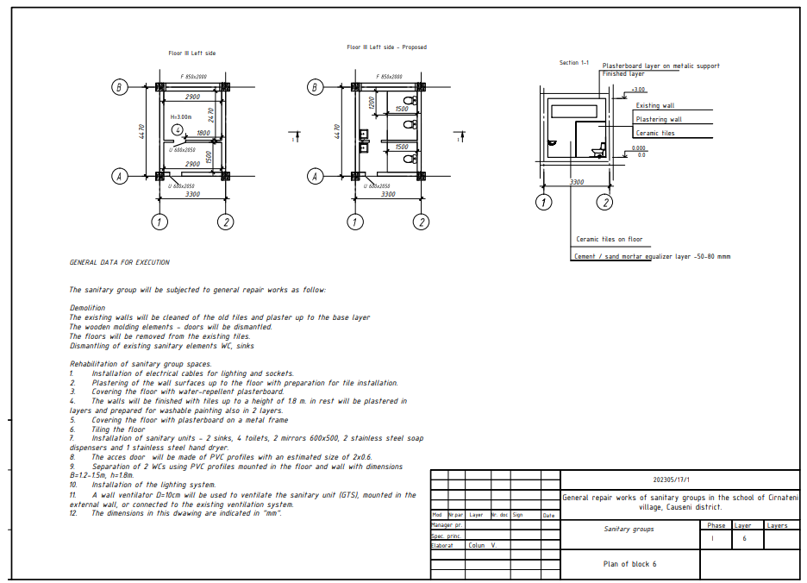

LOT 4
Ialoveni (IP Scoala Primara Ion Creanga)

№ | Simbol norm and resour. | Type of works | UM | Volume
1 | 2 | 3 | 4 | 5
 |  | 1. Dismantling
1 | RpSC05A | Dismantling sink, including accessories | Unit | 4,00
2 | RpSC07A | Dismantling a cast iron Turkish toilet bowl, fully equipped | Unit | 11,00
3 | RpSB01A | Dismantling of pipes and shaped connecting parts made of cast iron, for sewerage, with a diameter of 50 mm | m | 9,00
4 | RpSB01C | Dismantling of cast iron pipes and fittings, for sewerage, with a diameter of 100 mm | m | 12,00
5 | RpSA04A | Dismantling the heavy-type unplasticized polyvinyl chloride (PVC) pipe existing inside the building, at connections, columns, or distribution pipes, having a diameter of 12 mm - 50 mm | m | 42,00
6 | RpSC09A | Dismantling urinal, fully equipped | Unit | 2,00
7 | RpCM33A | Removal of tile, stoneware, ceramic veneers | m2 | 56,00
8 | RpCJ35A | Removal of cracked interior or exterior plasters on walls or ceilings | m2 | 38,00
9 | RpCK42C | Removal of cold floors made of concrete slabs, marble, stone, sandstone, ceramic tiles, etc. | m2 | 32,00
10 | RpCG29A | Dismantling of 6-8 cm thick brick or BCA masonry walls | m2 | 12,00
11 | RpCB18F | Dismantling of old concrete with mechanical means, plain concrete | m3 | 4,80
12 | RpCO56A | Dismantling wooden carpentry (doors, windows, shutters, boxes, blinds, masks, etc.) | m2 | 3,80
13 | RpSB05A | Dismantling a floor siphon, with a diameter of 50 mm | Unit | 2,00
14 | RpSC07A | Dismantling a cast iron Turkish toilet bowl, fully equipped | Unit | 11,00
15 | RpSE06A | Dismantling the connections of a boiler to the cold and hot water pipes, having a capacity of up to 1000 l | Unit | 1,00
16 | RpSD01A | Dismantling a single service faucet or with a connection, having a diameter of 3/8"-1/2" | Unit | 18,00
17 | RpEE24A | Dismantling electrical appliances for strong current: unipolar (switches, switches, sockets for removal or replacement, button for remote operation) | Unit | 3,00
18 | RpCM33A | Removal of tile, stoneware, ceramic veneers | m2 | 53,50
19 | RpEF23A | Dismantling of lighting fixtures of any type, including rods and bulbs | Unit | 3,00
 |  | 2. Concreting and plastering
20 | CD70A | Ordinary masonry of limestone blocks (Fortan) on the walls with manual preparation of the M-50 mortar, floor height up to 4m (gap in the wall) (thickness 200mm) | m3 | 0,36
21 | RpEJ08A | Execution of trenches with a depth of up to 5 cm in brick masonry walls of 5x50 cm2 | m | 24,00
22 | RpEJ09D | Sweeping trenches in walls up to 50 cm2 | m | 24,00
23 | CN53A | Priming the inner surfaces of Betonocontact walls | m2 | 94,00
24 | CF02B | Internal plasters of 2 cm thickness, rough, executed by hand, on walls or pillars, on flat surfaces with M 100-T brand cement-lime mortar for spirit, primer and the visible layer, on brickwork or blocks | m2 | 94,00
25 | CF17B | Various works - difference in thickness, +- 5 mm for the primer layer applied to the walls, executed with mortar  Increase=2.00 | m2 | 84,00
26 | CB01A | Formwork, made of softwood chips, for pouring the monolithic concrete between the prefabricated elements (floors, beams and diaphragms) including the supports | m2 | 2,00
27 | CA02B2 | Simple concrete poured in equalizations, slopes, trenches at heights up to 35 m inclusive, preparation with a concrete mixer on site and pouring with classic means concrete class C 10/8 (Bc 10/B 150) Small material (softwood cabinets)=1.01 | m3 | 3,80
28 | CG01A | Support layer for floors made of cement mortar M 100-T 3 cm thick with a finely chipped surface | m2 | 22,00
29 | CG01E3 | Support layer for floors made of 3 cm thick plaster (self-leveling screed). Add the plus or minus difference for every 0.5 cm of plaster support layer  Increase=2.00 | m2 | 22,00
30 | CK21D1 | Doors made of aluminum profiles, including the necessary fittings and accessories for doors mounted in masonry of any kind, for constructions with a height of over 35 m, in two leaves, with a frame area up to 7 square meters inclusive (.ALT-18) | m2 | 5,70
31 | CL20A | Ready-made ventilation grills | Unit | 2,00
32 | CI06A | Glazed, unglazed, matte or glossy flour plywood with boards of the same color and format with dimensions from 15 x 15 cm to 30 x 30 cm, executed on flat surfaces on walls and pillars, including the jambs and edges, with alternating joints, in rooms with an area larger than 10 sqm, fixed with cement-lime mortar M 100-T of approx. 2 cm thick | m2 | 88,40
33 | CI14A | Linear elements of ceramic tiles applied with adhesive (doors and windows)  Small material (cloth, water, etc.) = 1.05 | m | 24,00
34 | CG17D | Floors made of ceramic tiles including the support layer of adhesive mortar, executed on surfaces: larger than 16 m2 | m2 | 30,20
35 | CI14B | Linear elements of porcelain tiles applied with adhesive  Small material (cloth, water, etc.)=1.05 | m | 9,00
36 | CK22C | Aluminum profiles for constructions with heights up to 35 m from fixed panels and door leaves (ALT-18) | m2 | 31,20
37 | CK29F | Suspended ceilings from "Armstrong" prefabricated panels, including the grid system (Lilea mineral wool panel) | m2 | 30,20
 |  | 3. Electrical works
38 | RpEG01A | Installation of electrical switchboards on marble slabs, in industrial and social-cultural buildings, with an area of 0.15-0.30 square meters, mounted on consoles or on a metal frame  Small materials (vaseline, sponge, primer, water, etc.)=1.01 | Unit | 1,00
39 | RpEE15A | Installation of switches - monopolar switch 25 A - symbol 3129 N | Unit | 2,00
40 | RpEE15F | Installation of switches - illuminated switch scale 10 A -250 V, D.C. - symbol 0236 | Unit | 1,00
41 | RpEF02C | Installation of multiple lighting fixtures, for fluorescent lamps, including the support device, type CPB, CGC, with one or more tubes (Led 600x600)  Small materials (insulating tape, dowels, etc.)=1.02 | Unit | 4,00
42 | RpCU05F | Execution of accesses for pipes or tie-rods in stone or reinforced concrete walls of 16-25 cm thickness | Unit | 4,00
43 | RpEF01B | Installation of lighting fixtures, ceiling or wall, fully equipped  Small materials (insulating tape, dowels, etc.)=1.04 | Unit | 2,00
44 | RpEE01A | Installation of 10-25 A unipolar or bipolar switches, of normal construction, waterproof or sealed in aminoplast, bakelite, metal or porcelain casing, mounted buried or visible on wooden or plastic dowels, connected to copper or aluminum conductors  Installation of bipolar sockets, normal construction in bakelite or aminoplast, single, double, waterproof construction, sealed, metal sealed or similar, mounted buried under the plaster or apparently on wooden or plastic dowels | Unit | 3,00
45 | RpEE03A | Installation of bipolar sockets, normal construction in bakelite or aminoplast, single, double, waterproof construction, sealed, metal sealed or similar, mounted buried under the plaster or apparently on wooden or plastic dowels | Unit | 7,00
46 | RpED08A | Installation of copper electrical cables, with PVC insulation, with increased resistance to the propagation of flames, for voltages of 0.6/1 kV, symbol CYYF, installed apparently, having a section of 3x1.5 mmp  Small materials (clamps, shoes, wire, insulating tape) from mat.explicity = 1.05 m 28.00 | m | 28,00
47 | RpED08B | Installation of copper electrical cables, with PVC insulation, with increased resistance to the propagation of flames, for voltages of 0.6/1 kV, symbol CYYF, apparently installed, having a section of 3 x 2.5 mmp (thermo-insulating layer-cheromzit)  Small materials (clamps, shoes, wire, insulating tape) from mat.explicity = 1.05 | m | 34,00
48 | RpEA10C | Installation of protective elements made of plastic material, buried under the plaster, for masking conductors or electric cables, having the dimensions 17x17-17x60 mm | m | 4,00
49 | VC07A | Installation of axial window fans, type VF 315 - VF 900, weighing 3.6 - 8.2 kg with 0.25 - 0.55 kw motor  Small and assembly materials (screws, oxygen, carbide, etc.) = 1.01 | Unit | 2,00
 |  | 4. Sanitary works
50 | SB12A | Plastic pipe for sewerage, joined by end-to-end welding, with a diameter of 40-75 mm  Small material (steel wire, sanding paper, etc.) = 1.05 | m | 9,00
51 | SB12B | Plastic pipe for sewerage, joined by end-to-end welding, having a diameter of 110-125 mm  Small material (steel wire, sanding paper, etc.) = 1.05 | m | 12,00
52 | RpSE21A | Mounting the pressure regulator, with Dutch connections, having a diameter of 20-30 mm (existing)  Small material (hemp wood, small lead primer, etc.) = 1.01 | Unit | 1,00
53 | SB09C | Plastic connection piece for sewerage, joined with a rubber gasket, having a diameter of 50 mm | Unit | 16,00
54 | SB10C | Connecting piece (simple branching) made of plastic material for sewerage, joined with a rubber gasket, having a diameter of 50 mm (teu50) | Unit | 6,00
55 | SB09E | Plastic connection piece for sewerage, joined with rubber gasket, having a diameter of 110 mm (Cotd=110) | Unit | 14,00
56 | SB10E | Connecting piece (simple branching) made of plastic material for sewerage, joined with a rubber gasket, having a diameter of 110 mm (Teu110) | Unit | 11,00
57 | RpSB26A | Installation of the floor drain made of acid-resistant ceramic tiles, having a diameter of 50-100 mm  Small material (cement, sand, water, etc.) = 1.04 | Unit | 2,00
58 | SA16A | Plastic pipe joined by polyfusion welding, in columns, in residential and social cultural buildings, having a diameter of 20 mm | m | 68,00
59 | IC38A | The connection piece (fitting), with 2 joints, made of polypropylene joined by polyfusion with a pipe made of reinforced polypropylene, having an outer diameter of up to 20.0 mm, inclusive (d=20x1/2) | Unit | 24,00
60 | SC04A | Semi-porcelain sink, sanitary porcelain, etc. including for the disabled, having a drain pipe made of plastic material, mounted on brackets fixed on the walls made of brick or b.c.a.  Small material (codez, wooden dowels, plaster, etc.) = 1.02 | Unit | 4,00
61 | SD04A | Stand mixer tap with tilting arm for sink regardless of the closing method, including for the disabled, having a diameter of 1/2" | Unit | 4,00
62 | SC08A | Toilet bowl with feet, oriental, fully equipped, made of enameled cast iron, sanitary porcelain, etc., oval or rectangular type, recessed installation  Small material (wooden dowels, plaster, wood screws, codex, dichloroethane, etc.)=1.02 | Unit | 10,00
63 | SC09A | Sanitary porcelain urinal mounted on a brick or b.c.a. wall.  Small material (wooden dowels, plaster, wood screws, codex, dichloroethane, etc.)=1.02 | Unit | 2,00
64 | RpSE25A | Installation of the domestic hot water heater, working with hot water thermal agent 70-90 degrees C, having a capacity of up to 1000l (existing) | Unit | 1,00
65 | RpSC31A | Mounting the glass holder or soap dish made of enameled cast iron, sanitary porcelain, etc., mounted on a wall made of brick or b.c.a.  Small material (dowels, plaster, etc.) = 1.05 | Unit | 4,00
66 | RpSE27A | Installation of the mini(stainless steel) dryer ROCO InoxMDF 8058 1800v, mounted on a brick wall or b.c.a.  Small material (bracket, holtz screws=1.02 | Unit | 4,00
67 | RpSE27A1 | Installation of Solar 1kw electric convector. ,15 m.p., mounted on a concrete wall  Small material (bracket, holtz screws=1.02 | Unit | 2,00
68 |  | Installation of stainless steel soap dispensers | Unit | 4,00
69 |  | Semi-crystal sanitary mirror with polished edges, avid dimensions of 400 x 500 x 600 mm, mounted on a brick wall or b.c.a. | Unit | 4,00
 |  | 5. 4. Loading, transporting construction waste.
70 | TrI1AA01F2 | Loading materials from group A - heavy and small by transport up to 10 m - from the ramp or land, by car, category 2 | t | 15,00
71 | TsI50A1 | Transporting the earth with a 5 t dump truck at a distance of 1 km | t | 15,00

HMS21/2005 (legis.md)
Supply Intranet - Annex 2 Generic School Design Brief

