

**SITE-VISIT**

**ITB24/02798: EU4MD/ Development of Supervisory Control and Data Acquisition (SCADA) System for Ungheni Municipality**

**20 February 2024, 11:00**

**Ungheni Municipality**

**Background:**

The United Nations Development Programme (UNDP) is currently implementing the EU4Moldova: Focal Regions Programme that requires services of a company or consortium of companies with experience in the area of installation and implementation of the Supervisory Control and Data Acquisition system (SCADA) for Ungheni Municipality.

To fulfil this objective, the Programme has developed Technical Specifications for the acquisition, installation, and implementation of a new full-featured SCADA system that will allow instant monitoring and control of the selected system operating parameters at the "Apa-Canal" Ungheni.

On 07 February 2024 UNDP Moldova issued an Invitation to Bid for the Development of Supervisory Control and Data Acquisition (SCADA) System for Ungheni Municipality, in accordance with the Technical Specifications, developed by the Programme, and approved by the Beneficiary – Ungheni Mayoralty and “Apa-Canal” Ungheni.

The deadline for submission of bids is 06 March 2024, 16:30 Moldova time. Bids can only be submitted using the UNDP’s e-tendering platform Quantum. Bidders should follow the instructions for bidders published on tender’s website.

The EU4Moldova: Focal Regions Programme seeks the acquisition, installation, and implementation of a new full-featured SCADA system that will allow instant monitoring and control of the selected system operating parameters at the "Apa-Canal" Ungheni.

The SCADA system will have to provide crucial data for operational decision-making, including instant monitoring and control of the selected system operating parameters, as described in Technical Specifications.

Technical Specification have been prepared to provide to the Offerors details about plant and equipment to be properly designed, supplied, and installed, as well as the best practice and requirements about materials and installation methods to be used. Should part of the specifications conflict with other part of these specifications the Offeror shall obtain written instructions from the Programme before proceeding with S&I works affected by the discrepancies.

The SCADA system shall be extensive, with a capacity to add and monitor new sites, such as additional pumping stations and/or remote monitoring and control stations. This plant and equipment shall meet the indicated SCADA requirements, as well as provide sufficient capacity to accommodate additional pumping stations (control points) to handle future system demands, as provided in Technical Specifications.

The Offeror shall successfully design, manufacture, supply, install, program, integrate, test, commission, and conduct training on a fully operational extensive SCADA system, including software and hardware for measurement and data communications, monitoring and control, historical data recording, analysis and reporting system, covering all the main system components as per Technical Specifications document.

Some sites are already partially equipped with measurement equipment, which will be provided at the Offeror’s disposal by the Programme. Full Description of the Work and System Design Requirements associated with the SCADA system are provided in the Technical Specifications document.

The implementation of the training course will consider the constraints related to the availability of trainers and internal activities scheduled before the signing of the Contract. Provision of contemplated deliverables approved by UNDP shall be the sole criterion for completion of the Contractor's work and eligibility for payment/s.

All these types of works and activities will contribute, finally, to developing the community utility infrastructure and provision of local public services, necessary to foster local economic development, as well as to improve the living conditions of the population from Ungheni region, beneficiaries of the EU4Moldova: Focal Regions Programme.

A site visit was conducted on February 20, 2024, to provide potential bidders with an opportunity to inspect the implementation sites. The purpose of the visit was to document proposed technical solutions, assess site conditions, and clarify any questions regarding the procurement process.

The site visit was conducted as follows:

1. **Presentation of the requirements to the tender (technical aspects):**

UNDP representatives presented general aspects of the tender, pointing out the fact that the Offeror shall successfully design, manufacture, supply, install, program, integrate, test, commission and conduct training on a fully operational extensive SCADA system, including software and hardware for measurement and data communications, monitoring and control, historical data recording, analysis and reporting system. The provided solution shall cover the following main system components:

1. Central Dispatch Control Office (“DCO”), including:

* SCADA Server with redundancy.
* One (1) Primary Operator Workstation.
* One (1) Engineer Workstation.
* Network hardware.
* SCADA Software for Server and Workstations.

1. Local Data Acquisition and Control Equipment (“DACE”), including specified measurement equipment, PLC with Ethernet TCP/IP or 4G data network infrastructure, for:

* Two (2) water pumping stations (PS),
* One (1) water treatment plant (WTP),
* Nine (9) booster pumping stations (BPS)
* Nine (9) wastewater pumping stations (WWPS).

Each site shall be connected to the central DCO via a new data interconnection using secure data transmission over a wide area network (WAN)/internet or mobile operator network as described in the technical specifications. The WAN/Internet/mobile connection will be secured by the Beneficiary.

1. **Sites visit:**

The visit was organized to the following sites: Central Dispatch Control Office, Level 1 and 2 Water Pumping Stations, Water Treatment Plant, Booster and Wastewater Pumping Stations.

Some sites are already partially equipped with measuring equipment as described in the technical specifications. The list of installed equipment will be made available to bidders by the Beneficiary upon request.

During the site visit, some concerns were raised regarding the refurbishment of spaces for the Central Dispatch Control Office and the provision of furniture for SCADA system operators. The Apa-Canal Ungheni – final beneficiary of the investment – have committed to addressing these requirements based on technical specifications provided by the selected bidder.

Apa-Canal Ungheni also guaranteed that at all sites will be installed secured optical fiber for data transmission by the authorized Internet Service Provider.

1. **Questions and Answers:**

Representatives of the companies participating in the site visit were informed of the need to submit all questions noted via the Quantum platform. Official answers will also be sent to the representatives of the companies participating in the visit via the Quantum platform.

On 21 February 2024, UNDP sent a notification to the participants of the site visit via the Quantum platform requesting the submission of questions by Friday, 23 February 2024, using the Quantum messaging functionality.

By the agreed date and time, fifteen questions had been received, to which UNDP comes with the following answers and clarifications:

**Question 1.** In Invitation to Bid; Section 7: Bidding Forms in Form F: Eligibility and Qualification Form, there is the possibility to tick if the Statements of satisfactory Performance from the Top 3 Clients are attached, as well if the copies of the audited financial statements are attached.

We kindly ask you to specify if they must be attached at the time of submission or if they will be required after submission.

**Answer 1.** As per SECTION 3: DATA SHEET, 27. Documents to be submitted, the mentioned documents must be submitted along with the offer, as those have to demonstrate that the company meets the Eligibility Criteria.

**Question 2.** In Invitation to Bid; Section 3: Data sheet, point „*27. Documents to be submitted*” is found specified: *„Statement confirming the issuance of the Certificate(s) of Origin for the proposed equipment”*.

We kindly ask you to specify if you are referring to the CE Certificate and if it is required to be included in the bid or after contract signing, at the time of equipment approval.

**Answer 2.**  The participant will include in the bid the *„Statement confirming the issuance of the Certificate(s) of Origin for the proposed equipment”* and at the time of equipment approval – the Certificate itself.

**Question 3.** In Invitation to Bid; Section 3: Data sheet, point „*27. Documents to be submitted”* is found specified: *„Name and address of the authorized Service Center in the Republic of Moldova for warranty/ guarantee repair, maintenance services, including contract/ agreement”*.

We kindly ask you to remove this requirement, as the operator, we consider it is Contractor’s duty to provide repairs, maintenance and to arrive at the shortest notice from the time of intervention request throughout the contractual warranty period.

**Answer 3.** UNDP amended the Invitation to Bid; Section 3: Data sheet, point 27 and excluded the requirement *”Name and address of the authorized Service Center in the Republic of Moldova for warranty/guarantee repair, maintenance services, including contract/agreement”* in the **Documents to be submitted Section** and **Evaluation Criteria Section.**

**Question 4.** The tender documentation does not specify a minimum number for personnel or required roles. Please provide information regarding this aspect.

**Answer 4.** The bidder shall present the team envisaged to implement the assignment (CVs and other certifications will be provided), while the composition of the team remains at the discretion of the bidder.

**Question 5.** Regarding the control room and server room, we kindly ask you to:

* Confirm that the fitting out of the two rooms is the responsibility of the Beneficiary
* Confirm that the provision of air conditioning, furniture, etc. is the responsibility of the Beneficiary
* Provide the dimensions of each room

**Answer 5.** The Beneficiary (”Apa-Canal Ungheni”) confirms that it will ensure, at the implementation stage of the project:

* Fitting out / renovation of the two rooms at the dispatching office provided for the server room and the control room (operator).
* Providing these rooms with furniture and a suitable microclimate (air conditioner).
* A drawing of the actual dimensions of each room is provided below:

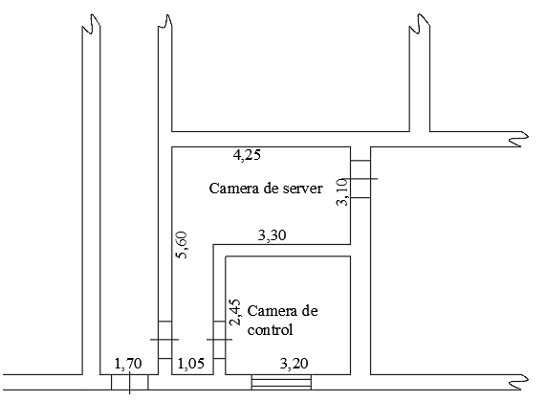

**Question 6.** We kindly ask you to confirm that the Beneficiary will provide the fiber optic ring in order to provide communication between all stations and the Central Dispatch.

**Answer 6.** The Beneficiary confirms that will provide internet connection (fiber optic) to all locations indicated in the technical specifications.

**Question 7.** We kindly ask you to confirm that the Contractor is only responsible for the local area network (LAN) of the Central Dispatch Centre.

**Answer 7.**The Beneficiary will provide all locations with internet access, so an internet connection point (a router) will be available at each location. It will be the obligation of the Contractor to establish LANs (where necessary) in all locations specified in the technical specifications, not only in the Dispatcher, so that all DACE panels are connected to the internet and as a result can be accessed by the SCADA Server.

**Question 8.** We kindly ask you to confirm that all stations must be provided with the possibility to control the pumps, but if the existing infrastructure does not allow this, only monitoring will be performed.

**Answer 8.** All DACE panels must be designed to allow remote control of local equipment. For example: if there are 4 pumps at a particular location, then it is necessary to provide 4 relays in the panel with the perspective to provide the start/stop function of these pumps. At the moment not all sites have the technical possibilities to realize remote control, in this case only monitoring will be performed.

**Question 9.** In order to ensure uniform offers by all bidders for the dimensioning of cable routes within PS-1, PS-2 and WTP, we kindly ask you to provide approximate dimensions.

**Answer 9.** The drawings with dimensions of PS-1, PS-2 and WTP are provided below:

1. **Water treatment plant and PS-2**

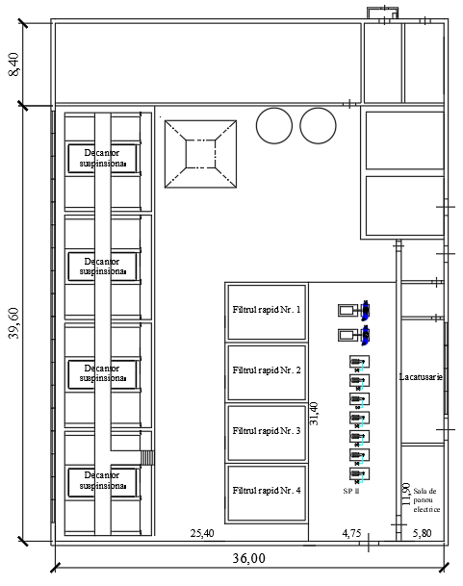

1. **PS-1**

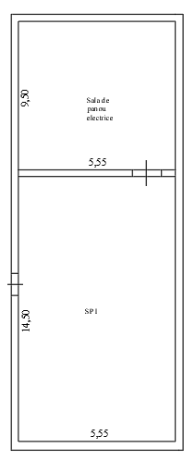

**Question 10.** If the stations are equipped with frequency converters, we kindly ask you to confirm that frequency converters will not be taken over in the system.

**Answer 10.** It is confirmed that the frequency converter parameters do not need to be taken over into the SCADA system.

**Question 11.** In Invitation to Bid; Section 3: Data sheet, point „*5. Language*” is found specified: *„All bids, information, documents and correspondence exchanged between UNDP and the bidders in relation to this bid process shall be in English and Romanian (acceptable).”*

Please specify the language requirements for the documents at the time of bid submission. Some documents as: Financial statements and auditor’s reports have a large number of pages and it is more challenging for us to translate them into English, so we kindly request to submit them in Romanian language.

**Answer 11.** Financial statements, auditor’s reports and other documents with large number of pages will be accepted in Romanian language.

**Question 12.** Please specify at which point is the LAN network and at which should we provide GSM?

**Answer 12.** It is planned that all locations included in the technical specifications will be provided with fibre optic internet access.

**Question 13.** Please specify what type of level transmitter is required for drinking water storage tanks from WTP? Hydrostatic, radar or ultrasonic?

**Answer 13.** According to the technical specifications, chapter 4.14, page 48, hydrostatic transmitters must be provided, but the contractor may also opt for the radar version if deemed appropriate. The ultrasonic type is excluded.

**Question 14.** Please confirm that the new SCADA system will be only for monitoring and not for control.

**Answer 14**. At the moment the control panels at the pump stations do not have remote control functionality. However, the new SCADA system needs to be designed and planned in such a way that it can provide remote control of the equipment in the future.

**Questions 15.** Please specify period of performance for the Contract, in months or days.

**Answer 15. As per Section 5: Schedule of Requirements - Maximum delivery, installation and commissioning of the fully functional SCADA system should not exceed 120 days after the Contract signature, up to latest beginning of September 2024.**