ANNEX B: TERMS OF REFERENCE

for
Procurement of Engineering Services for Rehabilitation of WASH facilities in 8 schools in Moldova (Package 7)

- BACKGROUND
    - UNICEF Moldova signed a work plan with the Ministry of Education and Research recently, and one of the key agenda of the work plan is to improve water, sanitation, and hygiene (WASH) services in schools. Therefore, UNICEF Moldova supports the Moldovan authorities to provide WASH services in schools and enhance Early Intervention systems and services for Moldovan and refugee children from Ukraine.
    - To that aim, UNICEF Moldova will conduct the assessment and rehabilitate/construct climate-resilient, energy-efficient, and environment-friendly WASH infrastructure in educational institutions, as detailed in the Scope of the Work below.
    - This project is expected to benefit more than 30 000 children by providing access to safe water and sanitation services annually, which is a fundamental right that safeguards health and human dignity.
    - The objective of these Terms of Reference is to guide a bidding exercise to identify suitable engineering firm for the procurement of engineering services required for this construction project.

- DEFINITION
  - Renovation of a building refers to the demolition & reconstruction work within the existing building, mentioned below as generic items. They will vary based on the specific needs of each building.
  - Rehabilitation of WASH facilities (Water, Sanitation, and Hygiene) refers to the process of restoring or improving existing water, sanitation, and hygiene infrastructure to ensure their functionality, safety, and effectiveness.
  - Design documentation refers to the set of technical documents that includes the detailed design drawing, (architectural, structural, mechanical, electrical, and plumbing drawings and other compartments), instructions and specifications necessary to perform the construction project.
  - Cost estimates and BoQ are documents used to appreciate the costs of materials, labor, and other resources required for a construction project. The cost estimates documentation includes detailed breakdowns of costs for each compartment of the project, while the BoQ provides a list with all types of works, quantities, and unit prices needed for the project.
  - Construction of new buildings refers to the construction of an independent built structure.
  - Construction of a new annex to the existing building refers to the construction of an additional structure that is physically connected to the current building to expand the usable space of the existing building while maintaining structural integrity, aesthetic coherence, and functional integration.
  - External Service Design refers to the process of planning and creating the infrastructure and networks outside a building to support its functionality. This includes the design of external systems (water supply pipelines, sewage systems, stormwater drainage, electrical power supply, and communication networks) to ensures that the building is connected to municipal or regional utility services and complies with all relevant codes and standards.
  - Internal Service Design refers to the process of planning and creating the infrastructure and networks inside a building to support its functionality and meet the needs of its users. This includes the design of internal systems such as plumbing, electrical wiring, HVAC, lighting, and communication systems. Internal service design ensures that the building’s internal services are efficiently and safely integrated, adhering to all relevant codes and standards.

- SCOPE OF SERVICES
  - The scope of engineering services is divided in 2 packages: Package 1 includes site assessment, design and technical documents, preparation of cost estimates and BoQ sets, technical support to procurement and author supervision services; and Package 2 includes quality assurance and site supervision. Each package is described in detail in Section 4 Expected Deliverables.
  - The Package 1 is including Rehabilitation of the existing WASH facilities within the building and adapting them to meet the needs of people with disabilities as well as construction of new facilities in a dedicated space within the building (by specific case). External works including installation of the WWTP with all necessary components and connections. Investigate and develop sustainable water supply solutions, ensuring a reliable and safe water source for the school (includes site assessment, design and technical documents, technical support to procurement, quality assurance and supervision) for the following locations:

6 | CANTEMIR | S. CIRPESTI |  | Instituţia Publică Gimnaziul "Ştefan cel Mare "
124 | CANTEMIR | S. CHIOSELIA |  | Instituţia Publică Gimnaziul "Nicolae Botgros"
88 | LEOVA | S. TOMAI |  | Liceul Teoretic ,,Mihai Viteazul”, Tomai
14 | DROCHIA | S. POPESTII DE SUS |  | Instituţia Publică Liceul Teoretic "Ion Creangă", s. Popeștii de Sus
27 | SOROCA | S. CERLINA |  | Instituţia Publică Gimnaziul Cerlina
83 | FALESTI | S. OBREJA VECHE |  | Gimnaziul "Sergiu Moraru", Obreja Veche
29 | UNGHENI |  | S. FRASINESTI | INSTITUȚIA PUBLICĂ GIMNAZIUL FRĂSINEŞTI
79 | HINCESTI | S. CRASNOARMEISCOE |  | IP Liceul Teoretic "Dimitrie Cantemir"
  - The contract will be signed with selected engineering firm for Package 1. The contract for Package 2 will be activated upon necessity and satisfactory completion of services under Package 1.
  - Potential Bidders shall visit the sites prior submitting their offers to get familiar with site conditions that may affect their Proposals. Potential Bidders are expected to make their own arrangements to visit the site and on their own expenses. UNICEF shall accept no excuse or claim whatever from the selected engineering firm for not knowing or being able to properly evaluate the site condition and requirements for the services to be carried out. Questions should be submitted in writing to UNICEF in accordance with instruction provided under the RFP.
  - All design drawings and technical documents developed for construction and/or renovation works implemented directly or indirectly by UNICEF shall be in line with the Organization’s commitments towards Accessible Buildings and achieving Climate Neutrality by 2020, as per PROCEDURE/DFAM/2020/001 on Eco-efficiency and Inclusive Access in UNICEF Premises and Operations, CF/EXD/2017-004 on Accessibility in UNICEF’s Programme-Relegated Construction, and Decision Memo: UNICEF Climate Neutral Strategy, 26 May 2015.
  - Policy documents mentioned at paragraph 3.6. and UNICEF Accessibility Technical Cards and Procedure on Eco-efficiency and Inclusive Access will be applied where possible, depending on the specific space availability and actual technical conditions in each location, and recommendations issued by National Agency of Public Health approved by Ministry of Education as guidance documents for renovation and building of washrooms in educational institutions in Moldova.

- EXPECTED DELIVERABLES
  - The table below describes in detail each required engineering service, including tasks and expected deliverables.
  - Deliverables shall be submitted to UNICEF in electronic format (drawings in AutoCAD and PDF) and hard copies printed in an appropriate scale.
Table 1: Services, Tasks and Deliverables
# | Service Descriptions | Tasks | Deliverables
Package 1

1- | Site Assessment  Evaluation of site characteristics and preparation of detailed analysis with recommendations for design and implementation. | 1.1 Assessment of existing buildings  Verify structural integrity and functionality of existing construction, finish quality, accessibility level, accuracy of as-built drawings, and if not available, prepare architectural drawings of existing buildings. | Detailed report approved by UNICEF with site layout, collected data, as-built drawings, building(s) and site analysis and recommendations.
1- |  | 1.2 Assessment of sites for evaluation of existing networks and determine suitability for construction of new wastewater treatment plant and/or additional outdoor networks required  Conduct site surveys (topographical, geotechnical and engineering); verify land legal status and construction laws.
1- |  | 1.3 Assessment of sites for evaluation of current status of water supply system and determine sustainable water supply solutions and sources for the school.  Conduct site surveys of existing source of water (test for water quality, quantity, measure the yield and recharge rate of the source to determine its capacity to meet current and future water demand); verify land legal status and construction laws
1- |  | Soil investigation  Check the site topography for surface and subsurface exploration. Subsurface exploration involves soil sampling and laboratory tests of samples retrieved. | Detailed report approved by UNICEF on soil investigation.
2- | Design and Technical Documents  Development of construction technical documents, and obtaining necessary construction permits, if required. | 2.1 Conceptual design  Produce design sketches that comply with site conditions, criteria, performance standards, greening and accessibility requirements; formulate and evaluate design options; develop conceptual design for the “passed-screening” option. | Feasibility report approved by UNICEF includes design criteria, options' analysis and conceptual design drawings.
2- |  | 2.2 Architectural design  Develop architectural design in 2 stages: a) Preliminary design based on approved conceptual design, and b) Detailed design with finish materials’ specifications. | Full set of architectural drawings with specifications, approved by UNICEF.
2- |  | 2.3 Structural design  Develop structural design in 2 stages: a) Preliminary design based on approved architectural design, and b) Detailed design with technical specifications and design analysis. | Full set of structural drawings, specifications, calculations and design analysis, approved by UNICEF.
2- |  | 2.4 Building internal and external service design  Develop design of plumbing, water supply, sanitary, electrical services in 2 stages: a) Preliminary design based on approved architectural design, and b) Detailed design with technical specifications and design analysis. | Full set of building service drawings, specifications, calculations and design analysis, approved by UNICEF.
2- |  | 2.5 Bid technical documents  Prepare Bill of Quantities (BoQs) and confidential cost estimate; and compile all technical documents (design drawings, specifications and bill of quantities). | BoQs for repairs, rehabilitation and/or new construction approved by UNICEF.
2- |  |  | Confidential cost estimates.
2- |  | 2.6 Permitting and declaration  Compile technical and administrative documents required for requesting permit and declaration, and obtain necessary construction permits and declaration for each construction work from Authority. | Original copy of permit(s) officially authorized by Authority.
 |  | 2.7 Author supervision  Perform the author supervision during the construction phase. Ensure the compliance of the executed works with the provisions of the design documentation elaborated, verified and approved in the appropriate manner. | Documented visits, adjustments, and additions/supplements  of the Design documentation if  required
3- | Technical Support to Procurement  Assisting UNICEF in the solicitation process and the selection of qualified construction companies. | Support during the Bidding period  Attend bidders’ conference with Potential Bidders; Provide answers and clarifications to their technical queries and questions during the preparation of bid period. | Report includes answers to all technical queries and questions of Potential Bidders during the bidding process.
Package 2

4- | Quality Assurance and Site Supervision  Technical oversight of ongoing construction activities to ensure compliance with specifications and signed contract and provide advice to UNICEF on any potential risks related to timeline, budget and quality of works. | Quality assurance  Undertake quality assurance and quality control plans and related procedures; review and approve contractor’s construction schedule, detailed designs, shop and as-built drawings; inspect material sources and materials’ tests.  Site supervision  Assist in project’s start-up; inspect and monitor time, progress, cost, quality and quantity of works and other agreed targets; approve workmanship and materials; certify payments and assist UNICEF in the control of variation orders; document project records that provide the necessary evidentiary and analyses in case of claims and disputes; ensure that works are executed in accordance with local Laws and regulations, national and international health and safety standards, quality standards and signed contract; liaise and co-ordinate with local authorities, if required; issue the Certificates of Partial, Substantial and Final Completion of works; prepare monthly progress reports and final narrative report; approve as-built drawings and Preventative Maintenance Manual. In case greening certification is pursued, engage with the Inclusive & Sustainable Operations team for guidance. | Reports approved by UNICEF  based on site visits.

- TIMEFRAME AND PAYMENT SCHEDULE
  - The timely completion of these engineering services is of utmost importance for UNICEF.
  - The duration required for completing Package 1 except “Author Supervision” and “Technical support for procurement” should be no later than two (3) months from date of signing the contract.
  - The duration required for completing Package 2 (if activated) will be linked to the construction contract timeframe but should not exceed 3-4 months.
  - The Defects Liability Period is [6] months counted as from the date of issuance of the Certificate of Substantial Completion.
  - UNICEF will issue interim and final payments upon satisfactory completion of each Deliverable.
Table 2: Timeframe and payment schedule
# | Scope of deliverable | Payment distribution | Timeframe
Package 1
1 | After approval of UNICEF on completed deliverables of site assessment  (Evaluation of site characteristics and preparation of detailed analysis with  recommendations for design and implementation) | 20 % | two (2) weeks
2 | After approval of UNICEF on completed deliverables of design and technical  documents (Tasks 2.1 - 2.4 / Design criteria, options' analysis and conceptual  design drawings; Full set of architectural drawings with specification; Complete  set of structural drawings, specifications, calculations and design analysis; Full set  of building service drawings, specifications) | 40 % | two (2) months
3 | Final payment, after approval of the BoQs and permits (tasks 2.5 - 2.6) | 30 % | two (2) weeks
4 | After providing technical Support during the Bidding period and signing the contract for Works with the Contractor. | 5 % | NA
5 | After approval of UNICEF on completed deliverable of Author supervision (task 2.7) | 5 % | NA
Package 2
1 | After approval of UNICEF on report confirming the completion of mobilization and construction of site office with storage, and 2 water reservoirs with lid | 15% | NA
2 | After approval of UNICEF on report confirming the completion of dismantling/demolition works | 15% | NA
3 | After approval of UNICEF on report confirming the completion of renovation/rehabilitation works | 15% | NA
 | After approval of UNICEF on report confirming the completion and testing of all plumbing, water supply, sanitary, and electrical works | 15% | NA
4 | After approval of UNICEF on report confirming the completion of wash facilities | 15% | NA
6 | After approval of UNICEF on the report confirming the Substantial Completion and signing the Certificate of Substantial Completion | 15% | NA
7 | After approval of UNICEF on the report confirming the Final Completion and signing the Certificate of Final Completion | 10% | [6] months after Substantial Completion
- KEY PERSONNEL

As a minimum the Engineering company must have employed the following stuff necessary to perform the assignment
  - Package 1:
- Project Manager (full-time) with 10-year experience in the domain.
- Architect with 6 - year experience in the domain.
- Structural/Civil Engineer with 5 - year experience in the domain.
- Electromechanical Engineer with 5-year experience in the domain.
- Water and Sanitation Engineer with 2-year experience in the domain.
- Heating, ventilation and air conditioning Engineer with 5-year experience in the domain.
- Topographer
- Interior designer with 5-year experience in the domain.
- BoQ specialist with 5-year experience in the domain
  - Package 2 :
- Project Manager with 8-year experience in the domain.
- Certified Technical Supervision Specialists (Rom equivalent: Responsabil Tehnic atestat) with 10 years relevant experience corresponding to the specific domain.

- ELIGIBILITY AND QUALIFICATIONS
  - The Potential Bidders are eligible to submit complete proposals for the services of Package 1 and Package 2 included in Section 4, and their submission will be taken into consideration in the proposal’s evaluation process.
  - The selected engineering firm is expected to assign or deploy adequate qualified staff to undertake the specific engineering services requested.
  - The Potential Bidder shall provide all the information and documentation requested in this section with its Proposal. Failure to submit the information below will disqualify the Potential Bidder.
  - Documents to be submitted in the Technical Proposal:
- The Potential Bidder must be registered as an engineering firm in Moldova. Technical Proposals shall include copies of original documents defining the constitution or legal status of the company, place of registration, and principal place of business; written power of attorney of the signatory of the nominated person to commit the contract.
- Copy of curriculum vitae (Maximum two (2) pages) of key personnel requested in Section 6 involved in providing the relevant service. UNICEF may conduct reference checks on the key personnel during the evaluation process.
- Copies of the technical qualification certificates
- Reports on the financial standing of the Potential Bidder.
  - The Potential Bidder must provide sufficient information in their proposal to demonstrate compliance with the requirements defined by UNICEF. The forms listed below contains the eligibility and minimum qualifying criteria that UNICEF will use to evaluate proposal for the award of the contract.
- Information to be submitted in the Technical Proposal (ANNEX C):
- Form 1: Technical Proposal Submission
- Form 2: Technical Proposal Letter
- Form 3: Potential Bidder’s General Information
- Form 4: Potential Bidder’s Contact Details
- Form 5: List of Completed Similar Services Undertaken the Last 3 Years
- Form 6: List of Similar Services in Hand
- Form 7: Proposed Methodology for the Implementation
- Form 8: Proposed Planning (Gantt Chart) for the Implementation
- Form 9: List of Proposed Key Personnel
- Form 10: CV of the Proposed Team
- Form 11: List of Office Equipment, Engineering Instruments and Design Software
- Form 12: Potential Bidder’s Financial Information/ Adequacy of Working Capital
- Form 13: Summary of Service Values Undertaken the last 3 Years
- Form 14: List of Current Litigations

- Information to be submitted in the Price Proposal (ANNEX D):
- Form 15: Price Proposal Letter
- Form 16: Price Proposal Submission
  - Errors in the Proposals
- In the event of any discrepancy between the copies of the Proposals submitted as hard copies, the original shall govern. The original and each copy of the Technical and Price Proposals shall be prepared in indelible ink and shall be signed by the authorized Firm’s representative.
- The Proposal shall contain no interlineations or overwriting except as necessary to correct errors made by the Bidders themselves. Any such correction shall be initialled by the person or persons signing the Proposal.
  - The following criteria will be considered for selection of Potential Bidders for the award of the contract:
- The capacity of the engineering firm to manage multiple assignments at the same geographical locations of this project.
- The engineering firm has demonstrable capacity (staff, equipment, logistics, finance) in similar types of assignment.
- The Potential Bidder must have wide range of experience and technical expertise in the field of construction engineering consultancy (at least 5 years).
- The Potential Bidder must be well informed of the construction engineering context of Moldova and is very familiar with country national construction norms and building legislation.
- The working experience with international and UN Organizations will be preferable.

- EVALUATION PROCESS AND METHOD
  - Following closure of the RFP, the Proposals will be evaluated by the evaluation team in 3 steps following the Proposal Evaluation Process stated in the RFP document. The evaluation will be restricted to the contents of the Proposals and the reference checks.
  - The technical merits of each Technical Proposal will be evaluated using the rating system in Table 3 (below) on the basis of the Proposal Evaluation Approach stated in the RFP document.
Table 3: Technical Evaluation Criteria
CRITERIA | MAXIMUM POINTS
TECHNICAL EVALUATION | 70
- Firm’s Profile  - Five (5) years as an engineering firm providing similar services (Water and sanitation in educational institutions, architectural and civil engineering).  - Proven experience in the country and similar services undertaken in the last 3 years; | 10
- Firm’s Experience  - Completed services of similar nature completed in past three (3) years with reference, as per Form 5;  - Type of clients to whom the services were provided (Government, private sector, UN Organizations, others); | 20
- Proposed Methodology and Planning  - Proposed work plan (Gantt Chart) for implementing per Packages.  - Proposed methodology and recourses allocation per packages | 10
- Resources (key personnel and equipment)  - Key personnel proposed to provide the services, including CVs, years of experience in similar services (proof required), education degree certificate (as requested, under 6. Key personnel);  - List of essential support staff;  - List of office equipment, engineering instruments and design software owned by the firm.  - Size and structure of the firm and the capacity of the engineering firm to manage multiple assignments. | 25
- Financial Capacity  - Financial reports for the last 2 years (2022 and 2023) | 5

ANNEX C: TECHNICAL PROPOSAL FORMS
The following Forms and information there within are considered an integral part of this submission and must be provided for the Proposal to be considered. The information should be provided according to the sample format.

Form 1: Technical Proposal Submission

This PROPOSAL FORM must be completed, signed and returned to UNICEF. Proposal must be made in accordance with the instructions contained in this Request for Proposal.

INFORMATION
Any request for information concerning this invitation, must be forwarded in writing by email or by fax, to the person who prepared this document, with specific reference to the RFP number.

DECLARATION
The undersigned, having read the Terms of Reference, the UNICEF Contract for Engineering Services, and RFP# [LRPS-2024-…………….] set out in the attached document, hereby offers to supply the services specified in Terms of Reference at the price or prices quoted in the Schedule of Prices, in accordance with the specifications stated and subject to the Terms and Conditions set out or specified in the RFP# [LRPS-2024-……………………….]

Name of authorized representative: _______________________________________

Title: _______________________________________

Signature: _______________________________________

Date: _______________________________________

Supplier Name: _______________________________________

Postal Address: _______________________________________

Telephone No.: _______________________________________

Fax No.: _______________________________________

Email Address: _______________________________________

Validity of Offer (not less than 90 days): _______________________________________

Currency of Offer: _______________________________________

Form 2: Technical Proposal Letter

Date: ___________

To: UNICEF Moldova, 131, 31 August 1989, MD-2012, Chisinau, Moldova

Dear Madam/Sir,

We, the undersigned, offer to provide engineering services in [country name] in accordance with your Request for Proposal RFP# [LRPS-2024-…………….] dated [e.g., June 2024] and our Proposal dated [---------------]. We are hereby submitting our Proposal, which includes this Technical Proposal and a Price Proposal sealed under separate envelopes.

If negotiations are held during the period of validity of the Proposal, we undertake to negotiate based on the proposed staff. Our Proposal is binding upon us and subject to the modifications resulting from Contract negotiations.

We understand that you are not bound to accept any Proposal you receive.

Yours sincerely,

Authorized Signature:
Name and Title of Signatory:
Name of Construction Company
Address:

Form 3: Potential Bidder’s General Information

Potential Bidder General Information
Description | Information | Remarks
Description | (to be filled by the Potential Bidder)
Registration number
Grade
Specialty
Expiry Date
Legal Status |  | Provide certified copies of Registration
Written power of attorney of  the signatory to the Bid | Provide original or certified copy of the power of  attorney attested by a Notary
VAT Registration Nr.
UNGM Registration Nr.

Form 4: Potential Bidder’s Contact Details

Name and Title of Contact Person
Address of Contact Person
Telephone/Cell number of Contact Person
Email of Contact Person

Form 5: List of Completed Similar Services Undertaken the Last 3 Years

Please provide copies of signed Contracts and Certificates of final completion for each completed service.

Completed Services

Employer name & contact details |  | Description of Services | Start date | End date | Value

Form 6: List of Similar Services in Hand

Please provide copies of signed Contracts for each service in hand.

Completed Services

Employer name & contact details |  | Description of Services | Start date | Expected end date | Value

Form 7: Proposed Methodology

Please provide methodology proposed by the Potential Bidder, the approach suggested for implementing the required engineering services, the plan for quality assurance, etc.

Form 8: Proposed Planning

Please provide detailed planning (Gantt Chart) proposed by the Potential Bidder for implementing.

Form 9: List of Proposed Key Personnel

Qualifications and experience of key management and technical personnel proposed for the required services. Signed CVs (Max. two (2) pages) and education degree certificate of all proposed key staff must accompany the submission, and it should be noted that substitution of staff during Project implementation shall be subject to the approval of UNICEF. (Key Personnel of all sub-Contractors must also be listed along with the name of the sub-Contracting Companies). A detailed organization chart of the company, including the location and staffing of existing offices must also be attached to the offer.

Management Key Staff
- Key Professionals for Design Stage
Name | Position | Task
- Key Professionals for Site Supervision Stage
Name | Position | Task
- Support Staff
Name | Position | Task

Form 10: CV of the Proposed Team

CV for each category of the services bidding for.

Position Title and No. | [e.g., PROJECT MANAGER]
Name of Expert: | [Insert full name]
Date of Birth: | [day/month/year]
Country of Citizenship/Residence

Education: List in reverse order starting with highest degree obtained up to Graduate Degree, the university/ institution or other specialized education, giving the following details:

S. No. | Degree/Diploma/Certificate obtained | Name of University/ Institution | Duration (mm-yyyy)
S. No. | Degree/Diploma/Certificate obtained | Name of University/ Institution | From | To

Employment record relevant to the services: Starting with present position, list in reverse order. Please
provide dates, name of employing organization, titles of positions held, types of activities performed and
location of the service, and contact information of previous clients and employing organization(s) who
can be contacted for references. Past employment that is not relevant to the service does not need to be included.

Period | Employing organization and your title/position. | Contact information for references | Summary of activities performed relevant to the Assignment
[e.g., May 2005-present] | [e.g., Ministry of ……, staff/advisor/consultant to… | Tel………/e-mail……; Mr. xxxxx,  [deputy director]

Membership in Professional Associations:
1.
2.

List of papers published in your name in peer reviewed/national/international journals:
1.
2.

Proficiency in Language Skills (indicate only languages in which you can work i.e. read, write, speak):
Languages | Read |  | Write |  | Speak |  | Understand
Languages |  | Not |  | Not |  | Not |  | Not
Languages | Easily | Easily | Easily | Easily | Easily | Easily | Easily | Easily
English
Bengali
Others (specify)

Expert’s contact information: (e-mail …………………., phone……………)

Form 11: List of Office Equipment, Engineering Instruments and Design Software

Office Equipment, Engineering Instruments and Design Software
- Office Equipment
Description | Quantity | Brand, Model, Specifications
- Engineering Instruments
Description | Quantity | Brand, Model, Specifications | Owned/Rented
- Design Software
Name | Version | Utilization

Form 12: Potential Bidder’s Financial Information/ Adequacy of Working Capital

IMPORTANT: Please provide attached copies of Audited Financial Reports for the last three (2) years.

Adequacy of Working Capital
Source of credit line |  | Amount | Remarks
 |  |  | Provide documentary evidence
Total:

Form 13: Summary of Service Values Undertaken the Last 3 Years

Service Values for the Last 3 Years
Employer name & contact details |  | Description of Services | Duration | Value
Total:

Form 14: List of Current Litigations

Please provide information on any current litigation in which the Firm(s) is involved.

Other Party(ies) | Cause of Dispute | Amount Involved

ANNEX D: PRICE PROPOSAL FORMS

Form 15: Price Proposal Letter

Date: ___________

To: UNICEF Moldova, 131, 31 August 1989, MD-2012, Chisinau, Moldova

Dear Madam/Sir,

We, the undersigned, offer to provide engineering services in [country name], as specified in the Annex B, following your Request for Proposal RFP# [LRPS-2024-…………….] dated [e.g., June 2024] and our Technical Proposal in the Annex C.

Our attached Price Proposal is for the sum of (---------------------------------------------------------------------------------------------------------------------------amount in figures and words). This amount is inclusive of all taxes payable under the applicable law.

Our Price Proposal shall be binding on us subject to the modifications resulting from Contract negotiations, up to the expiration of the validity of the Proposal.

We understand that you are not bound to accept any Proposal you receive.

Yours sincerely,

Authorized Signature:
Name and Title of Signatory:
Name of Construction Company
Address:

Form 16: Price Proposal Submission
Please fill the summary price offer template below and include a breakdown of the costs per school and the Personnel services cost table
Tab 1, Price offer summary
Service description | Price, MDL
Package 1
1 Site Assessment
2 Design and Technical Documents
3 Technical Support to Procurement
Total Package 1
Package 2
4 Quality Assurance and Site Supervision
Total Package 2
Grand Total

Tab 2 Breakdown of the costs per school
No | School name | Service description
No | School name | Package 1 |  |  |  | Package 2
No | School name | Site Assessment | Design and Technical Documents | Technical Support to Procurement | Quality Assurance and Site Supervision
1 | School name
2 | School name
…..

Tab 3 Breakdown of the costs using the Personnel services.
As a minimum the Engineering company must have the following personnel necessary to perform the assignment
This breakdown will exclusivity be used for determining remuneration for additional services provided under this assignment.
Service Description | Unit | Unit Price  (Fully loaded)
- Project Manager | Per Day
- Architect | Per Day
- Structural/Civil Engineer | Per Day
- Electromechanical Engineer | Per Day
- Water and Sanitation Engineer | Per Day
- Heating, ventilation and air conditioning Engineer | Per Day
- Topographer | Per Day
- Interior designer | Per Day
- BoQ specialist | Per Day
  - Site Supervision during execution of works
- Project Manager (full-time) | Per Day
- Technical supervisor (Responsabil Tehnic atestat) | Per Day
- Site visit report (all costs included) | Per visit
- Monthly monitoring and reporting (all costs included) | Per month

UNICEF will assume that the bidders will have factored in its offer all causes that may have an influence on the prices. Therefore, the costs indicated above should include all costs and benefits related to labor, including but not limited to:
- Head office overhead charges and reporting;
- Travel expenses to remote sites;
- Time lost due to inclement weather;
- Bonuses and all other incentive payments;
- Contribution to training levy and all statuary contributions;
- Contributions for annual and public holidays;
- Fares and time allowances for traveling;
- Safety and welfare facilities;
- Workmen's compensation and third-party liability insurance’s, sick pay or insurance in respect thereof;
- Obligations for redundancy payments;
- Engineering tool and instrument allowance;
- Use, repair and up keeping of engineering tools and instruments;
- Protective clothing and safety personnel protection;

ANNEX E: TECHNICAL SPECIFICATIONS
GENERAL TASKS

UNICEF is seeking proposals from qualified engineering/design firms to provide services for the design of WASH (Water, Sanitation, and Hygiene) sanitary groups in schools. The objective is to improve sanitation facilities to ensure the well-being and hygiene of students and staff.

SCOPE OF WORK

Design Company will prepare the design and technical documentation for the following tasks:
- Rehabilitation of the existing WASH facilities within the building and adapting them to meet the need of people with disabilities, as well, by specific case, will be analyzed the possibility of creation of new sanitary groups in a dedicated space within the building.
- Construction of the external sewage system, including the main collector, wastewater treatment plant (WWTP) and all necessary connections and components.
- Conduct a comprehensive assessment of the existing water supply source of the school, investigate and develop alternative sustainable water supply solutions, ensuring a reliable and safe water source for the school.

The Design Company is encouraged to visit the proposed sites, in order to familiarize themselves with the current conditions and identify suitable solutions for improvement.

Design Company shall undertake the following tasks:

- Site Assessment and Preliminary Data Collection:
- Conduct a technical assessment of the existing school buildings, including an evaluation of structural integrity, functionality, finish quality, accessibility level, and other relevant investigations as appropriate.
- Conduct the site assessment to identify the location for the new constructions, including the installation of the WWTP and all necessary components, construction of all necessary external networks required for connection of school WASH facilities. Perform the topographic survey and geotechnical analysis.
- Conduct a comprehensive assessment of the existing water supply source of the school, performing tests for water quality, quantity, and reliability of the source as a sustainable source for the school's water needs. Measure the yield and recharge rate of the source to determine its capacity to meet current and future water demand.
- Obtain necessary technical conditions for utilities connections (including preparation of necessary supporting documents, connection schemes and routes, load, and utilities consumption requirements calculations) if required.

- Design and Compartments:
- Prepare the preliminary Design for internal works including WASH facilities in existing spaces of the school building, and for those intended to accommodate the additional facilities ensuring it meets all necessary requirements and standards.
- Prepare the preliminary Design for the external works including water and sewage system, WWTP and all necessary connections and components, also development of solutions for interventions and improvements to ensure a reliable and safe water source for the school, interconnection of school facilities to the alternative sources as identified during the assessment including the construction of all necessary external networks, or other in accordance with the urban certificate and appropriate norms and regulations.
- Prepare the final Design and technical documentation covering all compartments: Architecture, Constructive/Structural Solutions (ACS), Electric Lighting/Power Equipment (EL/FPE), Internal and External Water Supply and Sewage System (WSSW), Wastewater treatment plant (WWTP), Heating and Ventilation (HV), Organization of Construction Works (OCW), Cost Estimation and Bill of Quantities (CE/BoQ).
- Obtain necessary technical approvals and coordination of the design documentation from all relevant institutions, in accordance with the provisions of the local regulations.
- The final Design documentation will be verified by authorized experts and its conformity will be confirmed by issuing the appropriate verification report.

- Estimation and Cost Verification:
- Calculate the Bill of Quantities considering all requirements of the beneficiary (School Administration, UNICEF representatives) regarding materials, capacity, dimensions, etc.
- The CE/BoQ should be calculated considering the probability of unforeseen or hidden works that may be discovered after the demolition or dismantling works are carried out.
- In accordance with local regulations, the CE/BoQ is also subject to verification and issuance of verification report, as well as for Design documentation.

- Additional requirements:
- Provide deliverables in three copies on paper and in electronic format (DWG, PDF, WORD) to both UNICEF and the beneficiary. Ensure that all formats are easily accessible and compatible for review and distribution.
- Maintain open and timely communication with UNICEF, the school administration, and the contractor throughout the project lifecycle. Respond promptly to inquiries and provide regular updates on project progress, milestones, and any issues encountered.
- Ensure the quality and accuracy of all deliverables and consultancy services provided. Conduct thorough reviews and quality checks to uphold professional standards and meet the expectations of both UNICEF and the beneficiary.
- Other Specific Considerations:
- The number of sanitary groups per school should be based on the current number of students, as provided by the school administration.
- The improvement of school WASH facilities must include such components like plumbing and sanitary facilities, water supply system, sewerage system, electrical system, heating and ventilation system, flooring, walls, and ceilings, handwashing facilities, accessibility features, waste management, aesthetic, and functional improvements.
- In case the school does not have a hot water network, the design company should take into consideration installation of water heaters and local hot water network to ensure the access to hot water at the handwashing facilities.
- Ensure that all sanitary groups are equipped with mirrors, paper holders, soap dispensers and hand dryers.
- Ensure that any reconstruction or interventions required for the sanitary groups are included in the technical expertise and design documentation. Major interventions beyond the scope should be discussed with the UNICEF and school administration.
- Environmental factors should be considered, such as terrain, drainage, and proximity to existing infrastructure, in determining the optimal placement of sanitary facilities.
- All design aspects and equipment choices will be preliminary coordinated with the school administration and UNICEF representatives to ensure functionality and compliance with standards.
- All these requirements, including but not limited to those related to the functionality of the designed sanitary groups and the installation of equipment such as water heaters and electric dryers, will be coordinated closely with the school administration and UNICEF representatives. Their input and approval will be sought to ensure that the final design meets the needs and standards required for the project's success.

- Design standards and norms
- The design works are to be carried out in accordance with local legislation as well as with the norms and standards in force.
- Whenever reference is made in the design to specific standards and codes that materials, installations, and other goods to be provided must comply with, as well as the works to be performed or tested, the provision of the latest editions or current revisions of the regulations and practical codes in force shall apply, unless expressly stated otherwise in the contract.
- In order to ensure fairness and accessibility to all products on the market, the specifications outlined in the design documentation must be generic and applicable to various solutions in the WASH design. Specific product endorsements or recommendations are not acceptable. The design should focus on technical parameters that accommodate different suppliers and technologies within the field.
- The design requirements must ensure that the sanitary groups in all schools are accessible to persons with reduced mobility as per national standard requirements, UNICEF Technical Cards and Climate, Energy, Environment and Disaster Risk Reduction (CEED).

PARTICULAR DATA FOR SELECTED LOCATION

The data and assessments provided in this chapter are intended to familiarize the engineering firm with the site conditions and school requirements. While every effort has been made to ensure the accuracy and completeness of this information, engineering firms are advised not to rely solely on it when preparing their offers. It is the responsibility of the engineering firms to conduct their own independent assessments and verifications to ensure the accuracy of their proposals. The information provided herein is for reference purposes only and should be used as a guide to assist in understanding the general project scope and requirements.
It should be considered as well that the assessment was performed a few months ago, and there may be changes or updates to the site conditions since then. Therefore, companies are encouraged to conduct their own site assessments and verify all relevant information before submitting their offers.
Thus, the engineering firm’s offer should be based on their own independent analysis and assessment of the project requirements and site conditions.

R. Cantemir, s. Cîrpești, ID 6

The gymnasium "Stefan cel Mare" building was designed with 3 blocks, two of which have three levels (block B and C) and the central administrative block with 2 levels (block A). Block C is preserved, and the 3rd floor of block B is also preserved due to the small number of students. Rehabilitation works of sanitary groups were executed in 2022, construction of sanitary groups for girls, boys, staff and with locomotor needs have been done. Their use is currently impossible due to the lack of centralized water system. The institution has a well, but it does not meet the standards. In 2023, cost estimates were made for the construction of a water well and tower. The institution has water filters inside the kitchen and canteen sinks. The drinking water is placed for children of grades 5-9 in the common space-corridor, for children of grades 1-4 there is a bottle in each class, and teachers have access to drinking water from the staff meeting room. The wastewater from the canteen and sinks is discharged into the cesspit/tank renovated in 2022, that doesn’t comply with norms and standards. Children, teachers, and staff use latrines outside the institution, because those built inside do not have centralized sewage or their own wastewater filtration system. The newly built sanitary groups offer all the necessary conditions for use (lighting, ventilation, winter heat). There are 19 handwashing facilities, of which only 8 are functional, those in the access area to the canteen. Those in the newly built sanitary groups, currently cannot be used due to lack of centralized water and sewerage systems. Hot water is present only for handwash facilities at the canteen. Classrooms for children grades 1-4 have sinks and space arrangement for them but are not connected to water and sewerage system. Classrooms for children in grades 5-9 require arranging space for sinks and connecting to the water and sewer system. The study block construction plans, have space designed for the construction of sanitary groups at 1st floor and 2nd floor. It is also necessary to build sanitary groups for kitchen staff.

Table 3 Demographics of school r. Cantemir, s. Cîrpești
Boys | 90 (46 class 1-4)
Girls | 88 (47 class 1-4)
Pupils with disabilities | 1
Total pupils | 178
Teaching staff | 17
Other staff | 15
Total Staff | 32

Particular recommendations to take into consideration for selected location (but not limited to these):
- Develop the detailed design of the wastewater treatment plant (WWTP) and connection to building sewerage system to ensure efficient treatment of wastewater from the sanitary facilities. Including connection of wastewater and water pipes for constructed sanitary groups.
- Investigate suitable solutions for connecting the school to a centralized water system or constructing an artesian well and water tower on the gymnasium grounds as an alternative. Develop the detailed design for the selected solution. Including pipe connection to the building facilities as kitchen, handwash facilities and sanitary groups and preparation of all the documentation required.
- Develop the design for construction of shower cabins ensure the connection to the water and wastewater system in locker room spaces, for girls and boys. Also, the design should include the renovation of sanitary groups at 1st and 2nd floor.
- Develop the design for construction of sanitary groups for students with limited mobility.
- The design should address any structural and functional issues present in the existing sanitary facilities and handwash facilities including renewing flooring, walls, and ceilings, and ensuring that all elements meet current health, safety, and accessibility standards. Considerations should also include upgrading plumbing and sanitary facilities, water supply system, sewerage systems, renovating fixtures and fittings, improving heating and ventilation, electrical system, installation of water heaters, handwashing facilities, waste management, aesthetic, and functional improvements, ensuring accessibility for persons with disabilities, and adhering to relevant building codes and regulations.
- Additionally, prioritize the use of sustainable and durable materials to enhance the longevity and efficiency of the rehabilitated sanitary groups.
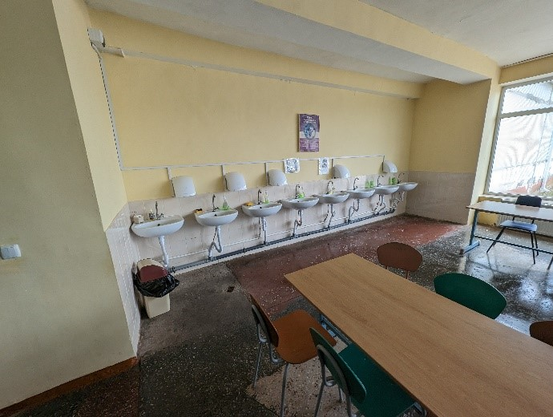  Cafeteria access | 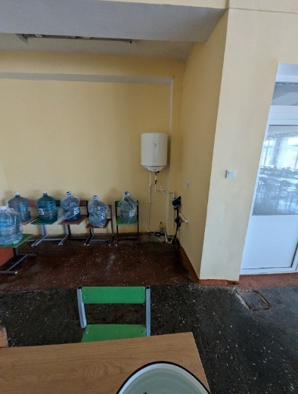  Cafeteria access water heater view
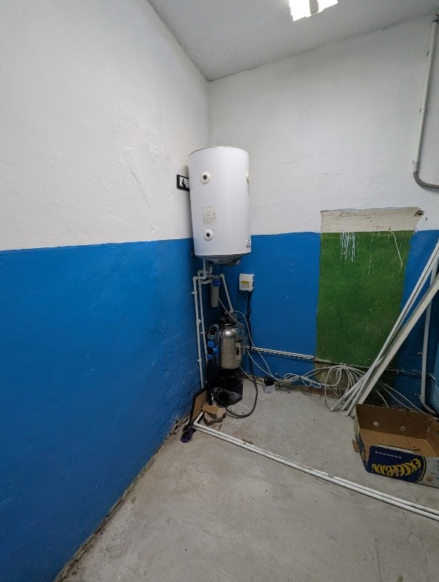  Cafeteria water heater | 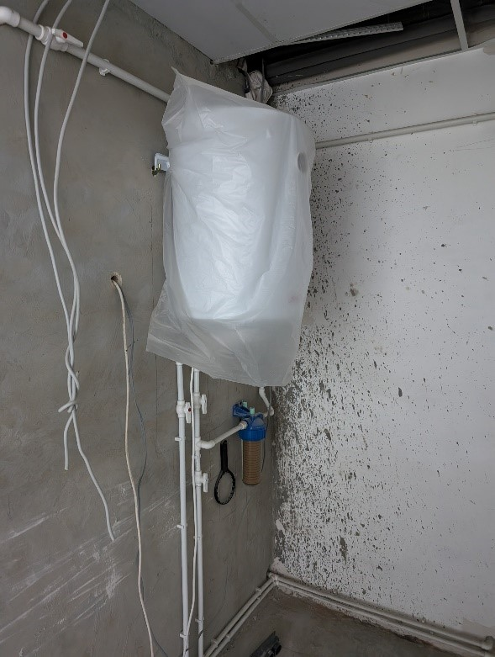  Water heater for SG installed 2022
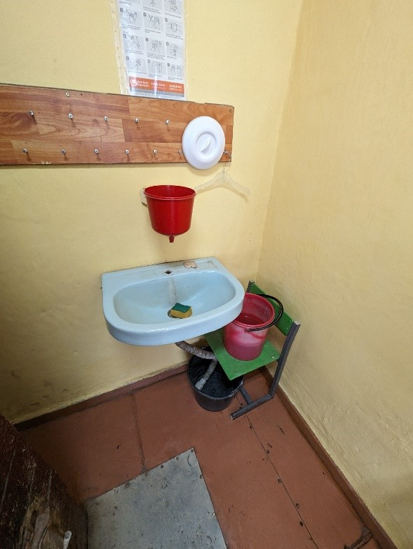  I Calssroom washbasins | 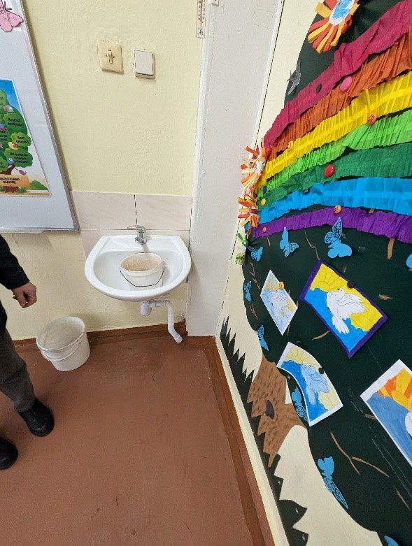  II Clasaroom washbasins
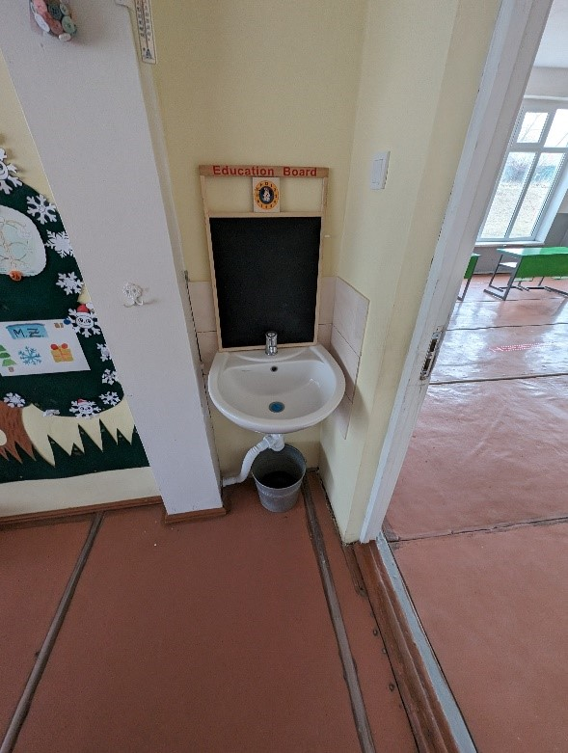  III Class washbasins | 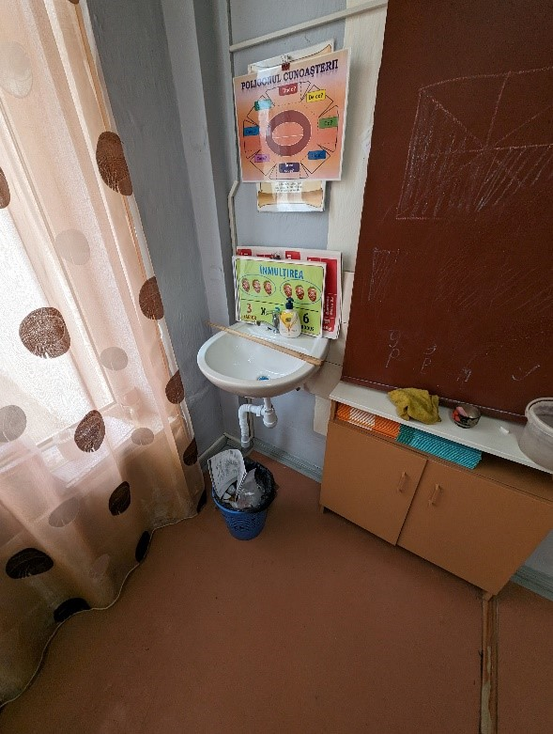  I Class washbasins
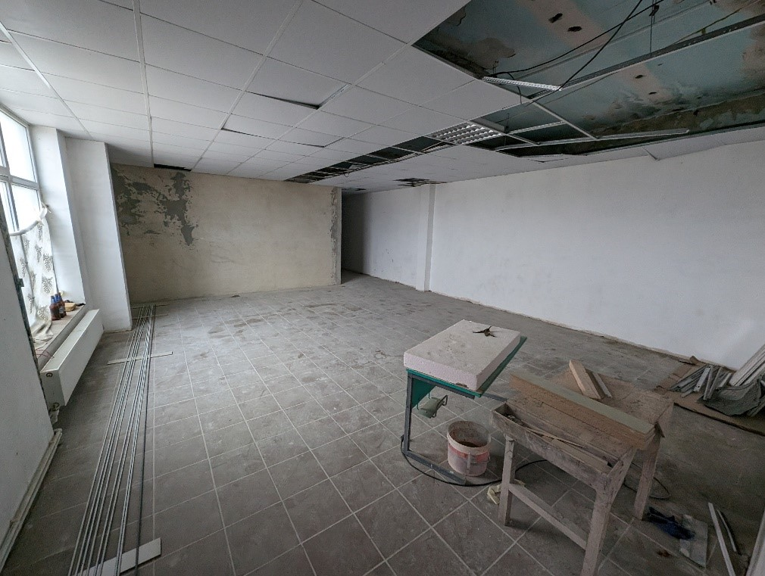
Changing the purpose of the sports hall to showers for girls and boys, constructing the water supply and sewage networks
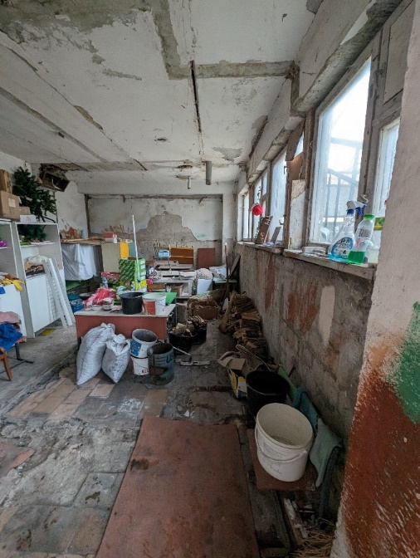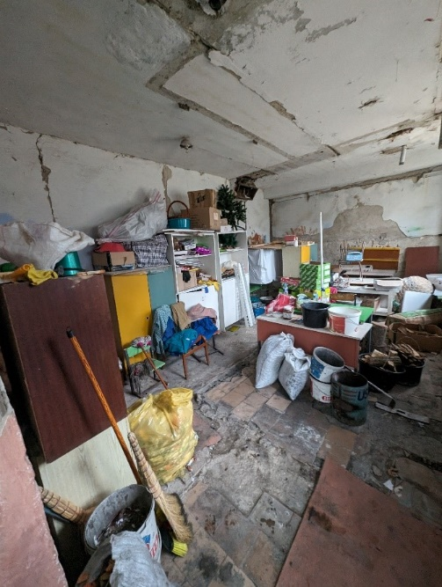
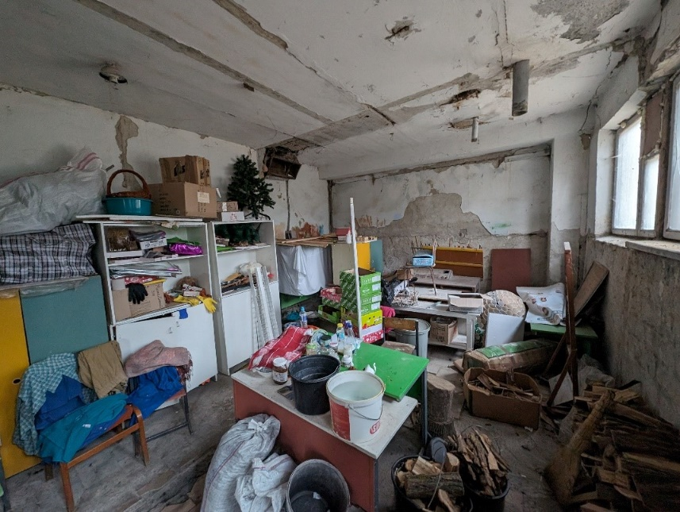
Block B, 1st floor – SG renovation for 1-4 class students, girls and boys separately
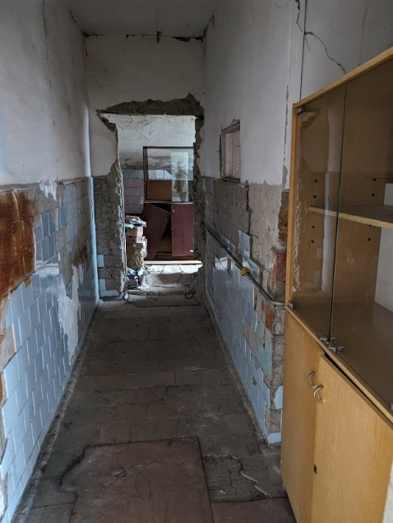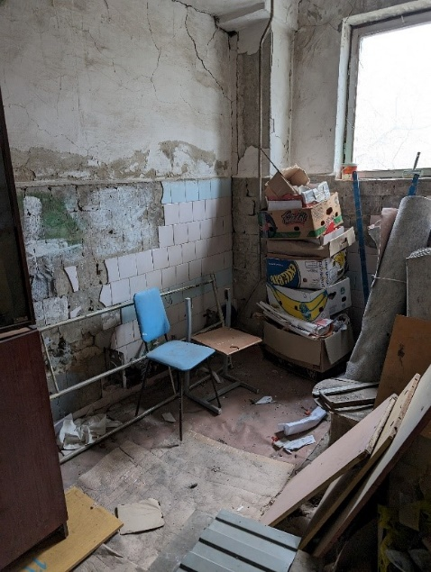
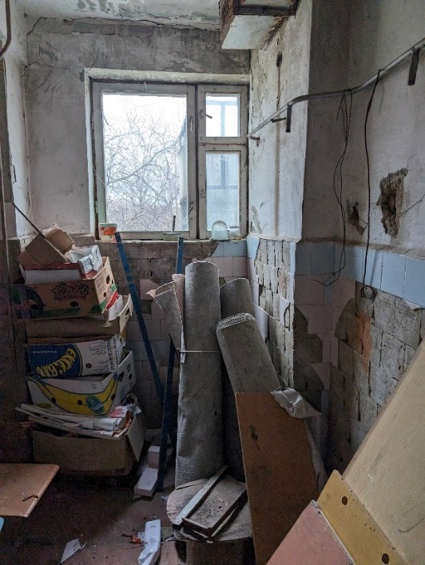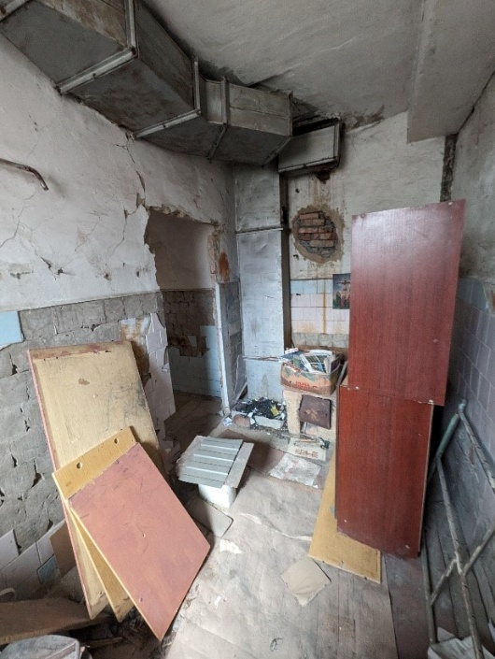
Block B, 2nd floor – SG renovation for girls 5-9 class
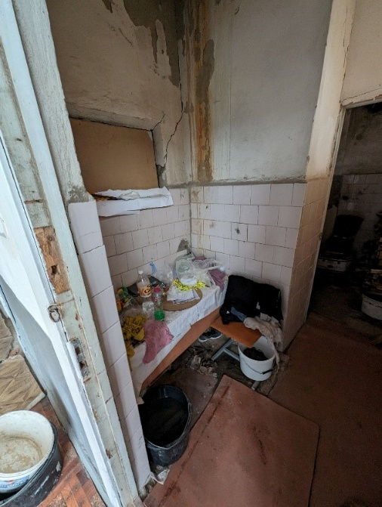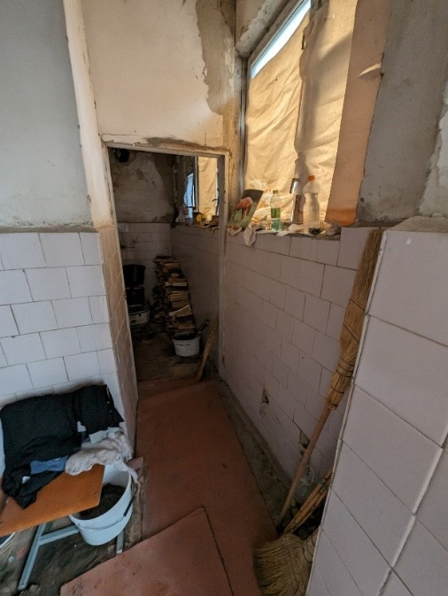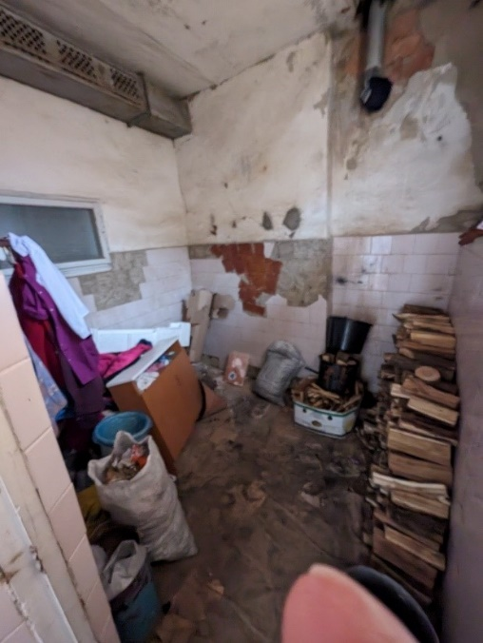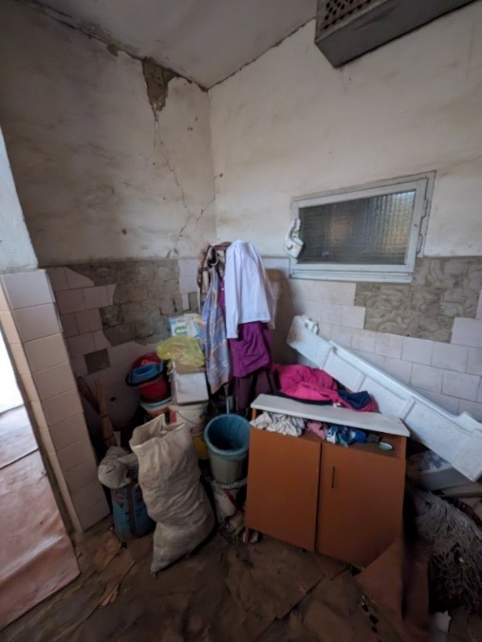
Block B, 2nd floor – SG renovation for boys 5-9 class

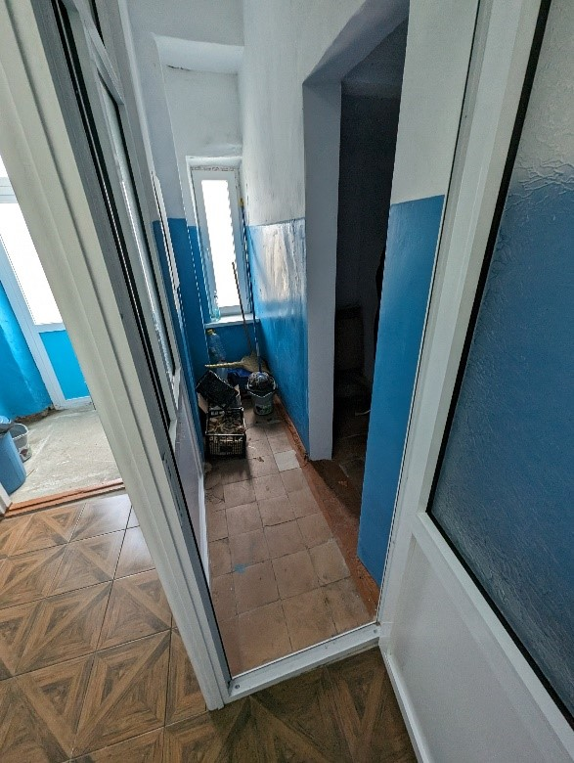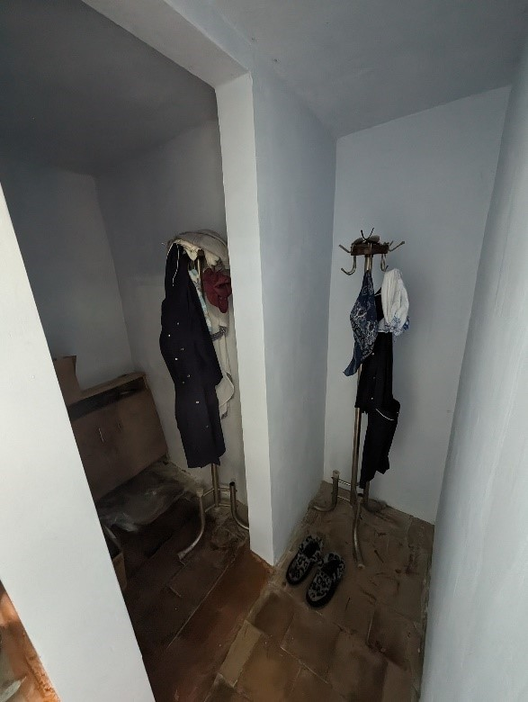
Cafeteria entrance – construction of SG and showers for staff
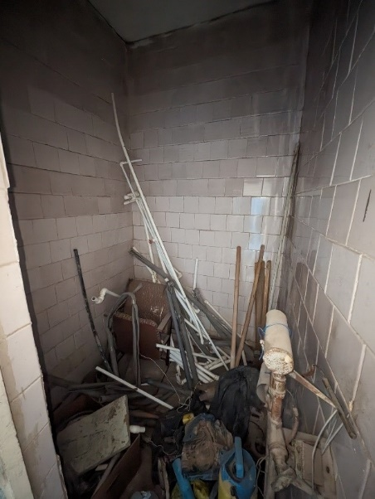
boilerroom – construction of SG for staff
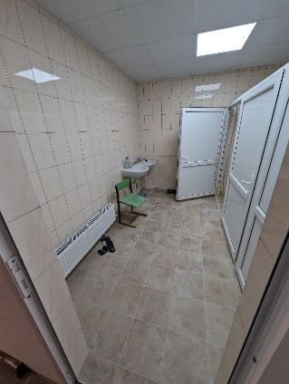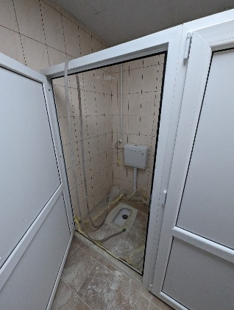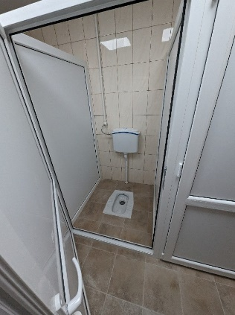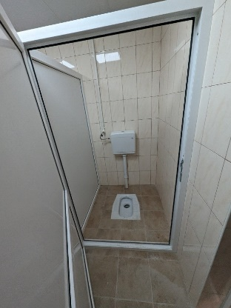
SG boys constructed in 2022 – installation of paper holders and soap dispensers, connection to water and sewage systems
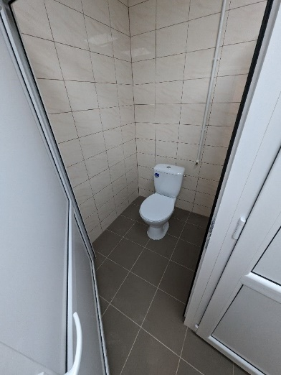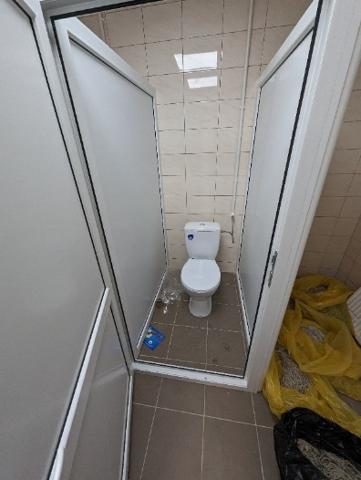
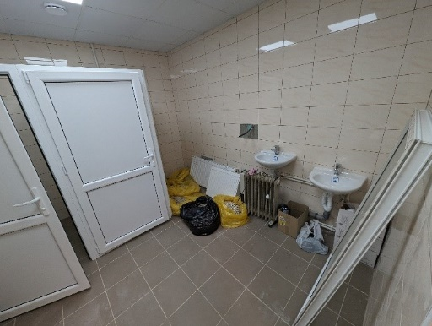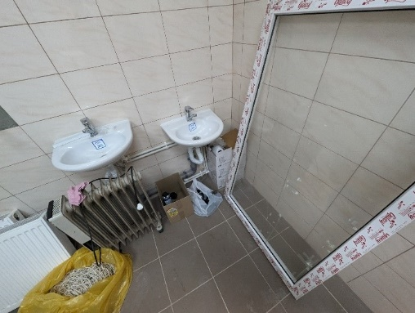
SG constructed in 2022 for persons with reduced mobility reequipment with all appropriate element as guide and support bars
SG constructed in 2022 – installation of paper holders and soap dispensers, connection to water and sewage systems
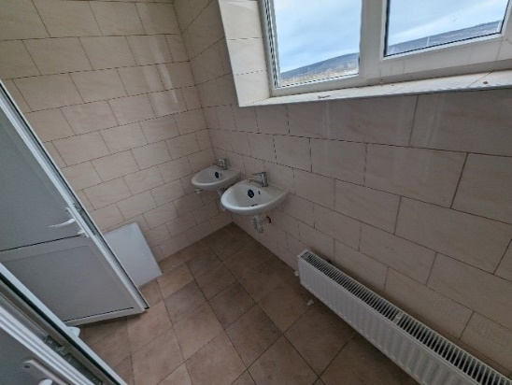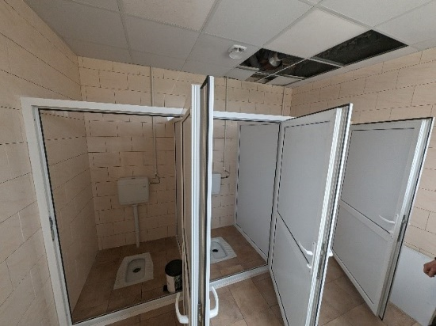
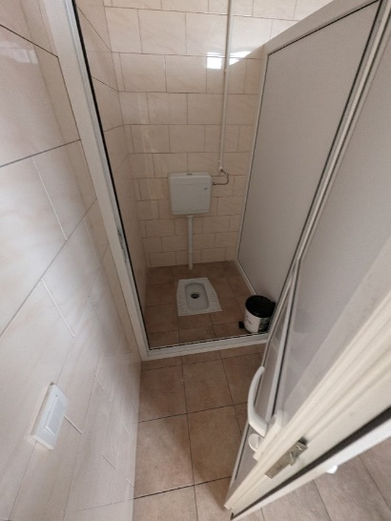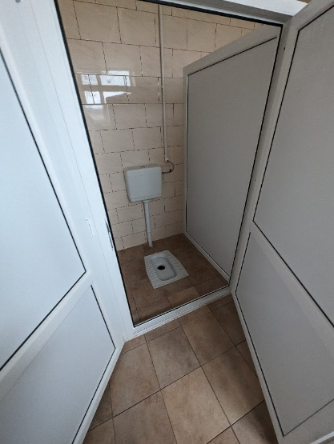
SG girls constructed in 2022 – installation of paper holders and soap dispensers, connection to water and sewage systems
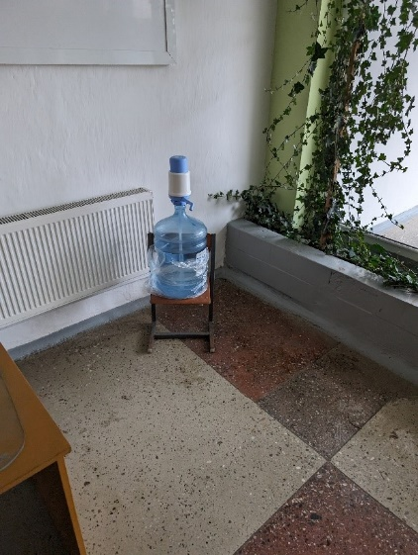  Hallway source of potable water | 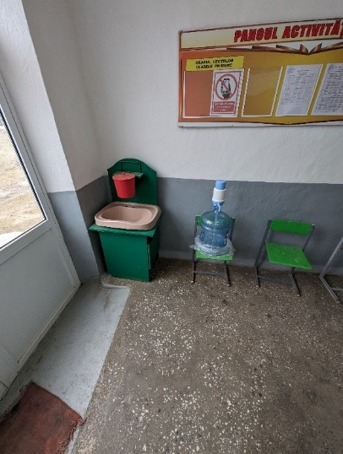  Hallway source of potable water and improvised washbasin

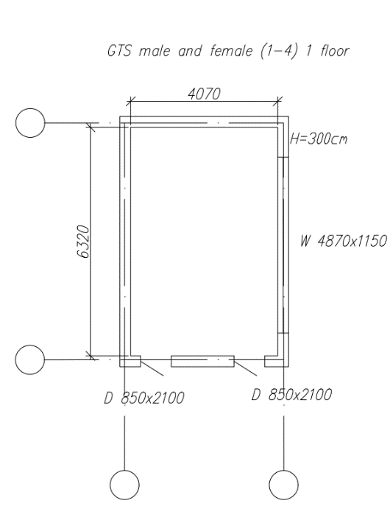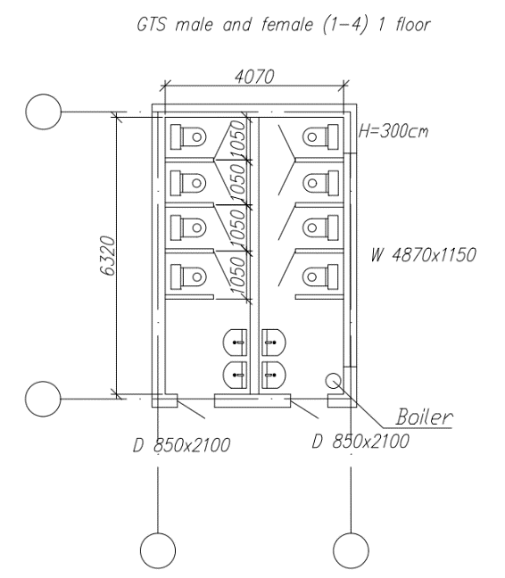
Photo 13 Photo 14

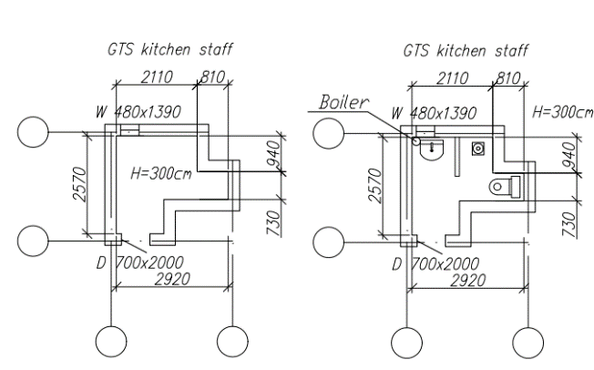
Photo 15 Photo 16
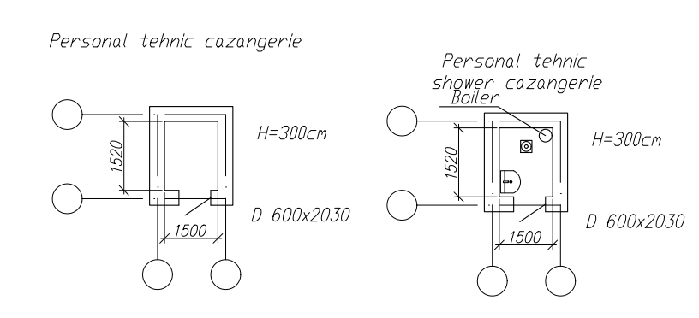
Photo 17 Photo 18
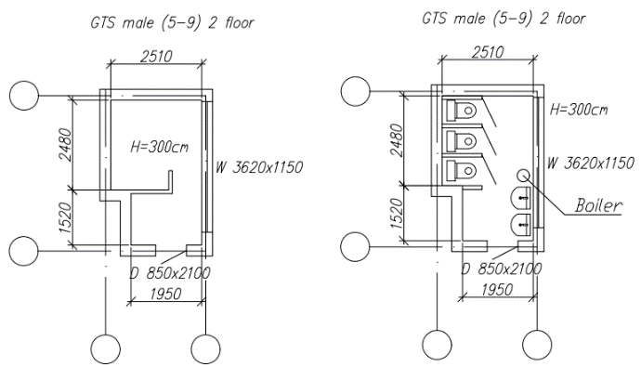
Photo 19 Photo 20
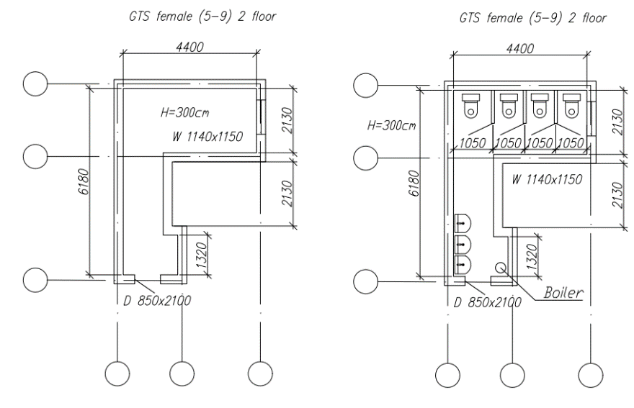
Photo 21 Photo 22

R. Leova, s. Tomai, ID 88
The school building consists of a 3-storey block. In 2013, sanitary groups were built inside the building, however, these facilities remained largely unused due to the absence of a reliable water supply. The school is connected to a local water supply system, sourced from a well located on the school premises. However, the water quality is poor, and the well's capacity is insufficient to meet the school's needs. The water is not drinkable and for consumption the school management buys the water in bottles. In total there are 18 toilet cabins inside, but they cannot be used, students must use the outside toilet, which do not have the necessary hygiene conditions. Also, in 2013 a wastewater treatment plant was built on the school's territory. At the moment the WWTP is defective, the pumps being out of operation.
Table 9 Demographics of school r. Leova, s. Tomai
Boys | 121
Girls | 100
Pupils with disabilities | 0
Total pupils | 221
Teaching staff | 22
Other staff | 13
Total Staff | 35

Particular recommendations to take into consideration for selected location (but not limited to these):
- Develop the detailed design of the wastewater treatment plant (WWTP) and connection to building sewerage system to ensure efficient treatment of wastewater from the sanitary facilities. Including connection of wastewater and water pipes for constructed sanitary groups.
- Investigate suitable solutions for connecting the school to a centralized water system or constructing an artesian well and water tower on the gymnasium grounds as an alternative. Develop the detailed design for the selected solution. The design should encompass the renovation of the pipeline and its connection to the school's water facilities.
- Develop the design for renovation of existing sanitary groups.
- Develop the design for construction of sanitary groups for students with limited mobility.
- The design should address any structural and functional issues present in the existing sanitary facilities and handwash facilities including renewing flooring, walls, and ceilings, and ensuring that all elements meet current health, safety, and accessibility standards. Considerations should also include upgrading plumbing and sanitary facilities, water supply system, sewerage systems, renovating fixtures and fittings, improving heating and ventilation, electrical system, installation of water heaters, handwashing facilities, waste management, aesthetic, and functional improvements, ensuring accessibility for persons with disabilities, and adhering to relevant building codes and regulations.
- Additionally, prioritize the use of sustainable and durable materials to enhance the longevity and efficiency of the rehabilitated sanitary groups.

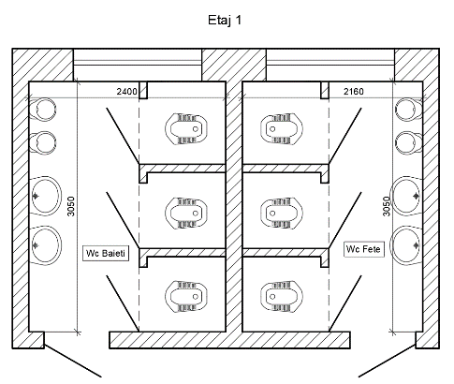  Photo 34 1st floor WASH facilities | 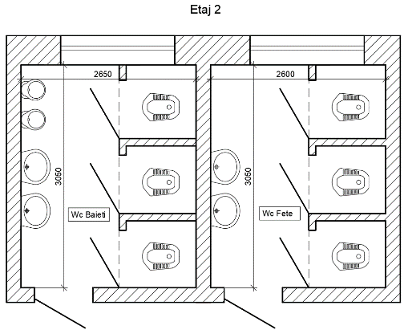  Photo 35 2nd floor WASH facilities, with ceiling damaged
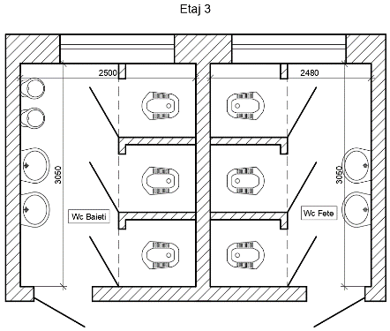
Photo 36 3rd floor WASH facilities

SG 1st floor boys
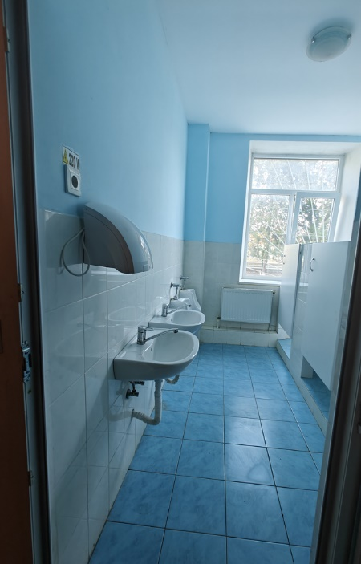 | 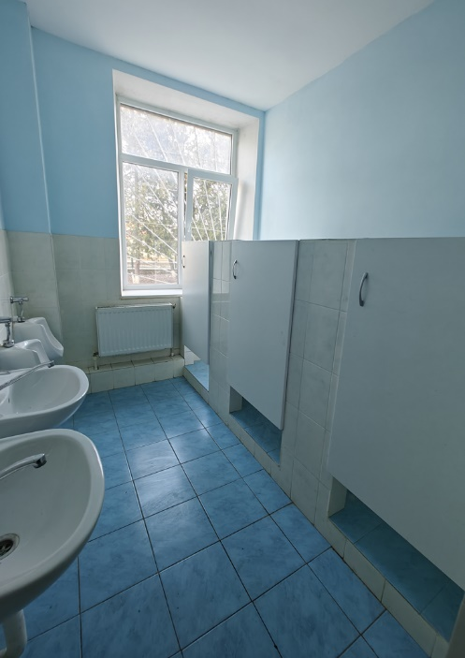
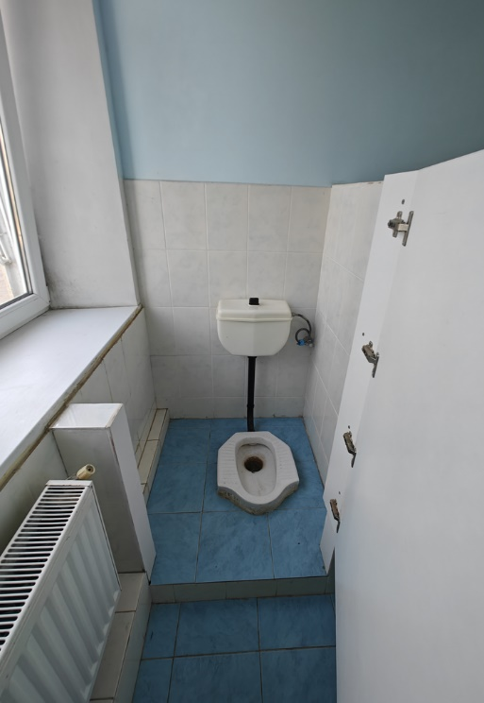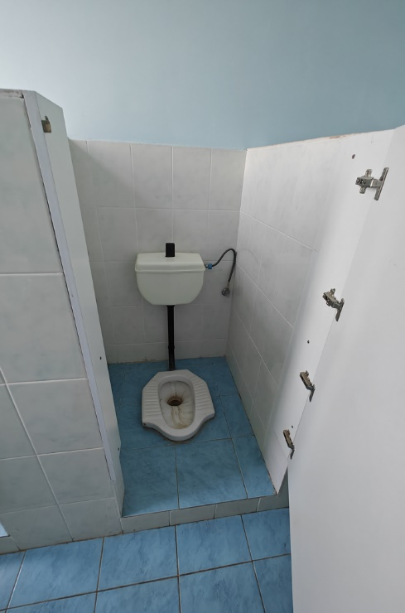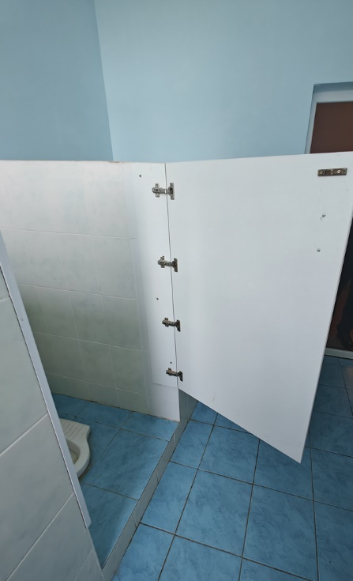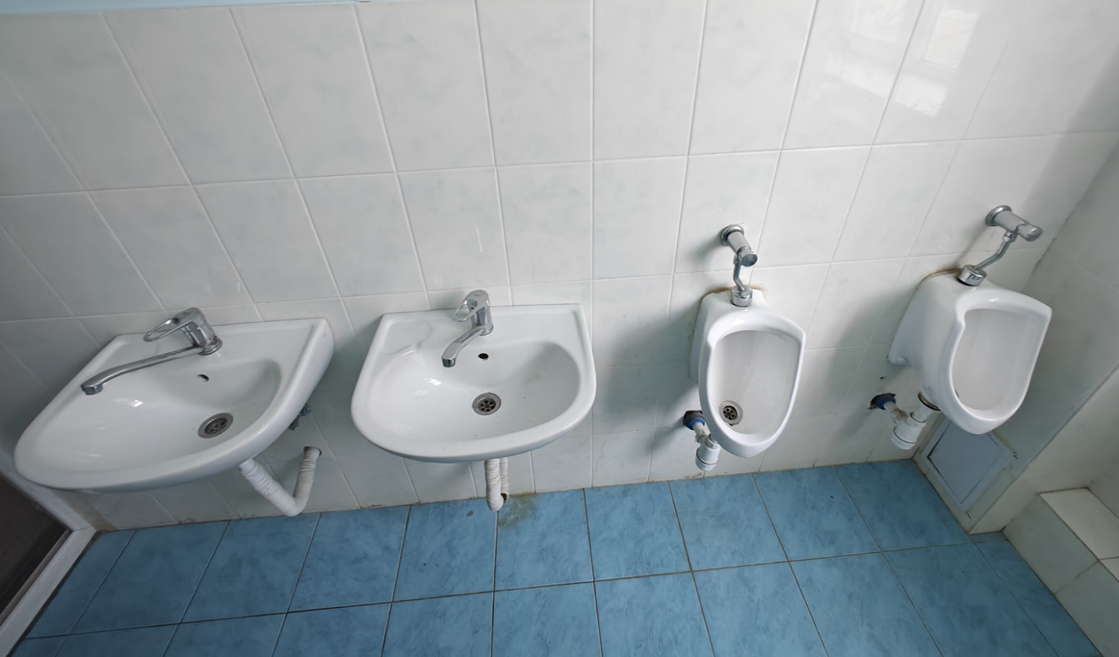
SG 1st floor girls
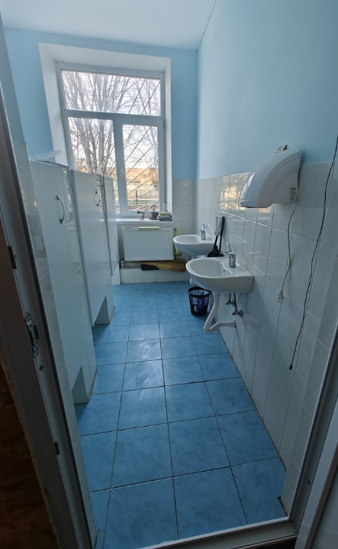 | 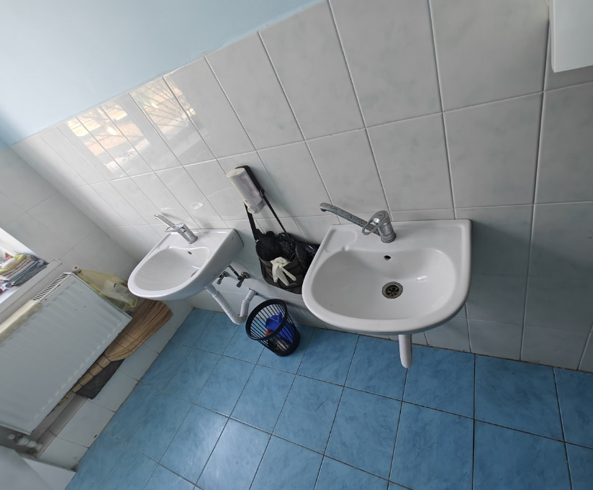
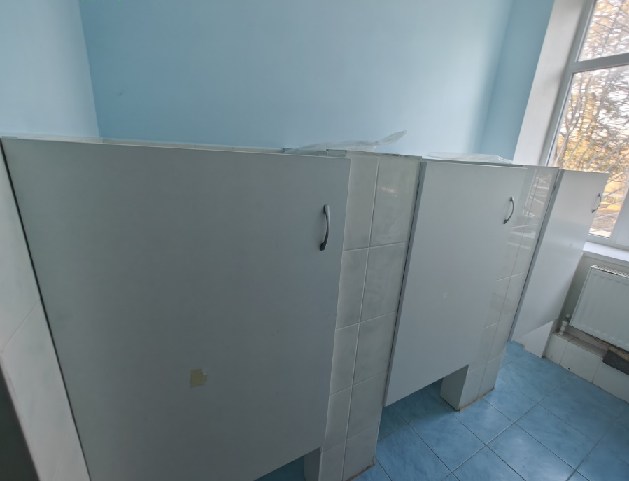
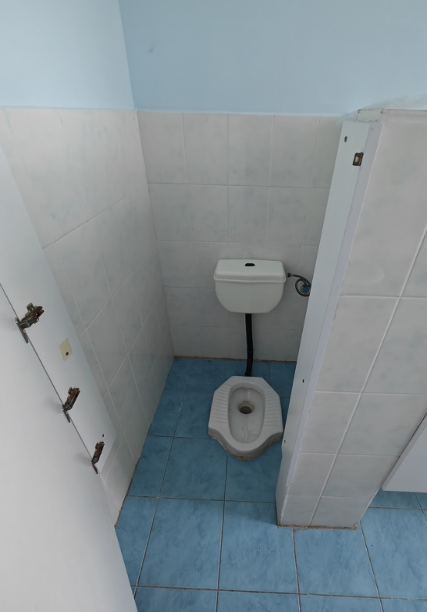 | 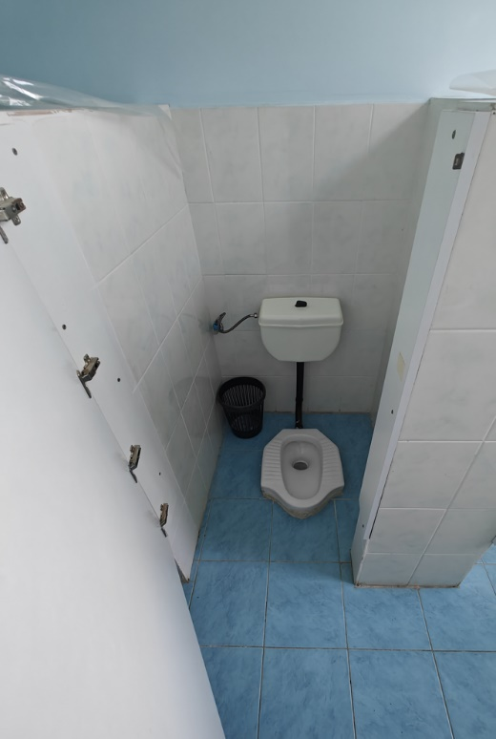
SG 2nd floor girls
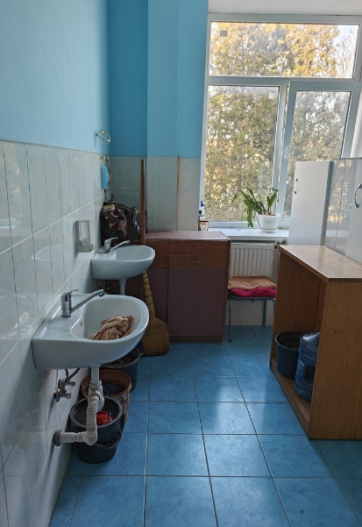 | 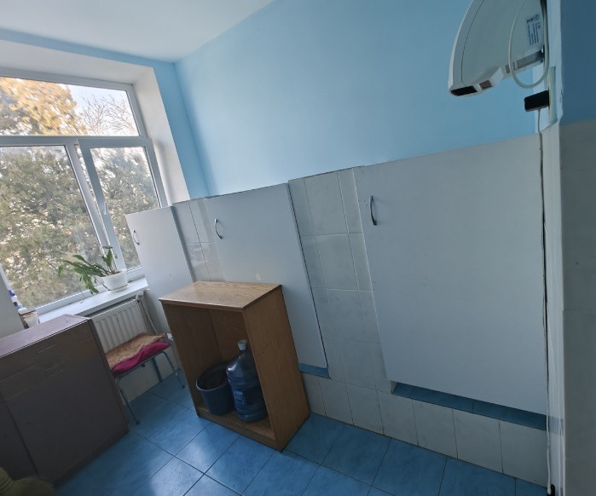
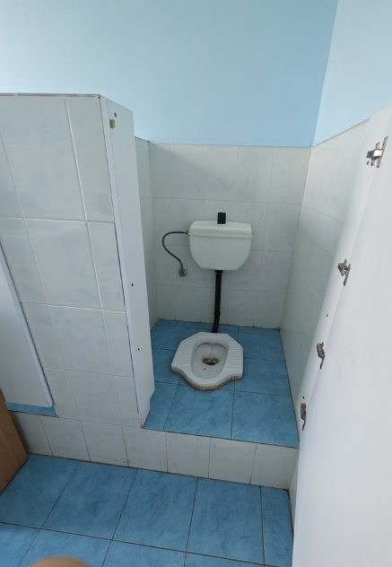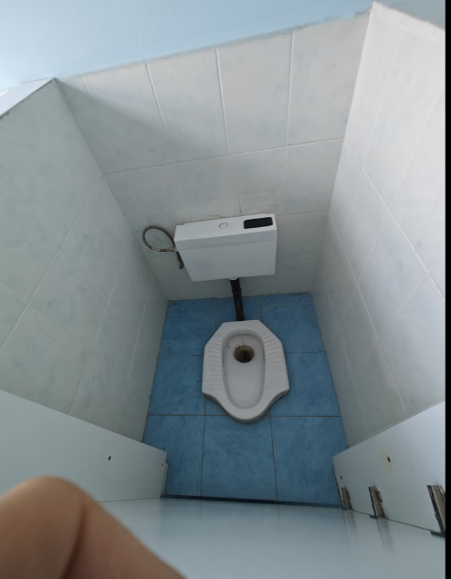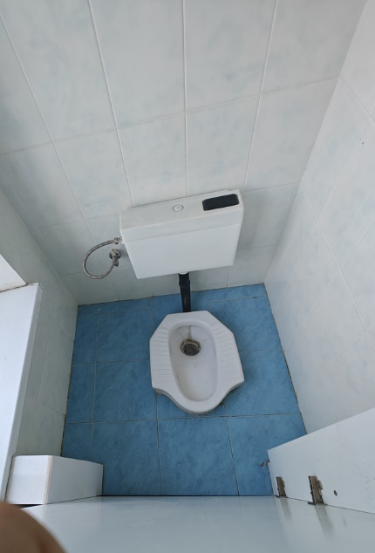
SG 2nd floor boys
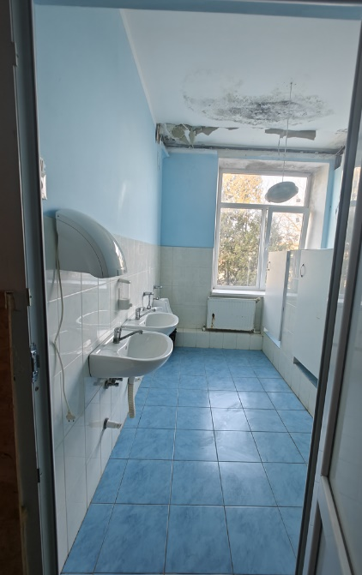 | 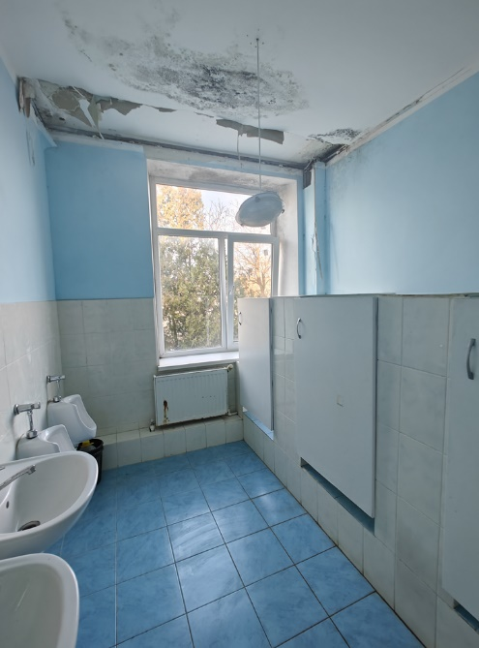
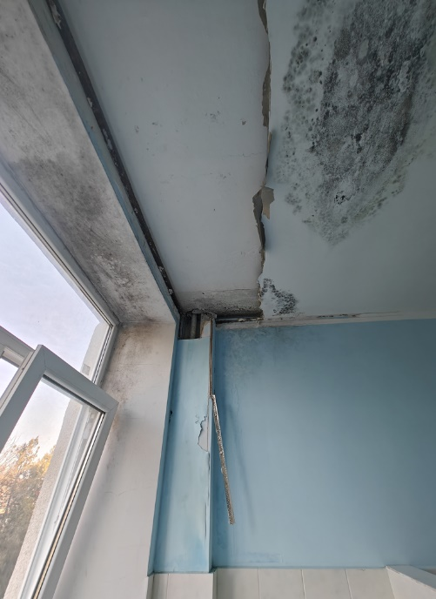 | 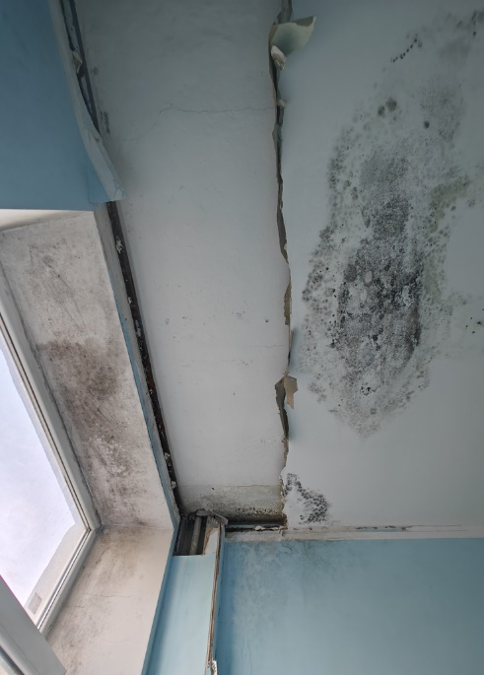
Defected WWTP
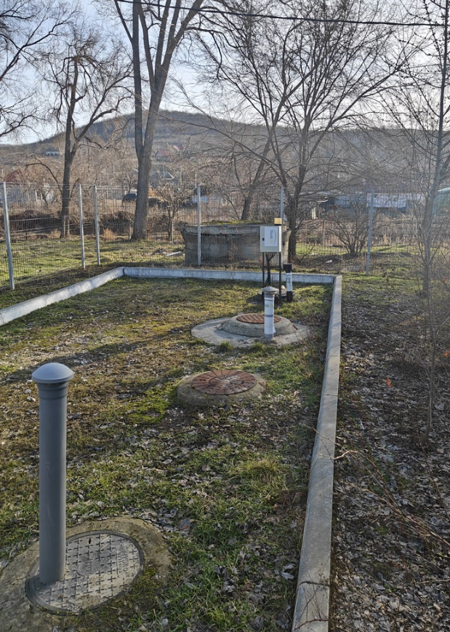

R. Cantemir, s. Chioselia, ID 124

The "Nicolae Botgros" Gymnasium building was designed with a single-level study block. Rehabilitation works on the sanitary groups were carried out in 2019, funded by the government. The sanitary groups lack a ventilation system, hot water, soap dispensers, and paper support. It is necessary to install PVC/Aluminum partition walls for cubicles, as the current ones are improvised from glued wood and lack privacy. Sanitary groups for people with disabilities need to be constructed. There is no hot water available at the sinks located in the sanitary groups and near cafeteria. Drinking water is not accessible at the water distribution points. The institution does not have water filters. Technical water needs are supplied from a spring water collector. Children bring water bottles from home for drinking. Water from a shallow well (do not meet sanitation standards) is used only for technical purposes. The locality does not have centralized sewage. Wastewater from the sanitary groups and cafeteria is discharged into a cesspool built in 1995, which has not been emptied to date. There are 8 handwashing facilities access points available (2 sinks for boys sanitary groups, 2 for girls sanitary groups, 1 for staff sanitary groups, and 3 located near the cafeteria). The total number of toilet cubicles is 5 (2 for girls, 2 for boys, and 1 for auxiliary staff and teachers). WASH facilities are not accessible to children with reduced mobility due to the lack of access ramps and guiding bars. Handwashing facilities are also not accessible to younger children due to sink height.

Table 26 Demographics of school, r. Cantemir, s. Chioselia
Boys | 79
Girls | 83
Pupils with disabilities | 10
Total pupils | 162
Teaching staff | 14
Other staff | 11
Total Staff | 25

Particular recommendations to take into consideration for selected location (but not limited to these):
- Develop the detailed design of the wastewater treatment plant (WWTP) and connection to building sewerage system to ensure efficient treatment of wastewater from the sanitary facilities. Including connection of wastewater and water pipes for constructed sanitary groups.
- Investigate suitable solutions for connecting the school to a centralized water system or constructing an artesian well and water tower on the gymnasium grounds as an alternative. Develop the detailed design for the selected solution.
- Develop the design for construction of sanitary groups for students with limited mobility including installations necessary systems and connections.
- Develop the design for renovation of existing sanitary groups for girls, boys and staff, including installation additional urinals with separation walls for boys, soap dispensers and paper holders, water heaters, mirrors. In addition, installation of 2 washbasins, soap dispensers and paper holders, water heaters for handwash facilities near cafeteria.
- Investigate the need and possible solutions for water filters installation for drinking water.
- The design should address any structural and functional issues present in the existing sanitary facilities and handwash facilities including renewing flooring, walls, and ceilings, and ensuring that all elements meet current health, safety, and accessibility standards. Considerations should also include upgrading plumbing and sanitary facilities, water supply system, sewerage systems, renovating fixtures and fittings, improving heating and ventilation, electrical system, installation of water heaters, handwashing facilities, waste management, aesthetic, and functional improvements, ensuring accessibility for persons with disabilities, and adhering to relevant building codes and regulations.
- Additionally, prioritize the use of sustainable and durable materials to enhance the longevity and efficiency of the rehabilitated sanitary groups.

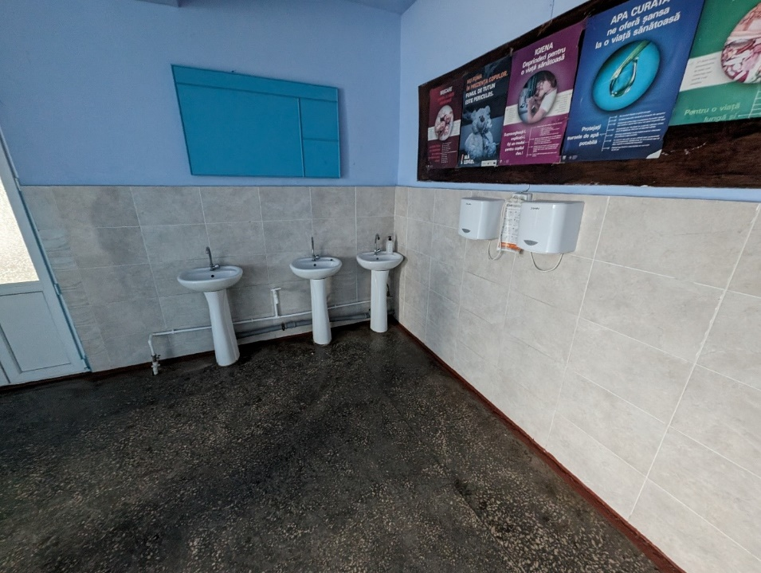
Canteen access – additional installation of 2 washbasins, camouflaging pipes, soap dispensers and paper holder, installation of water heaters
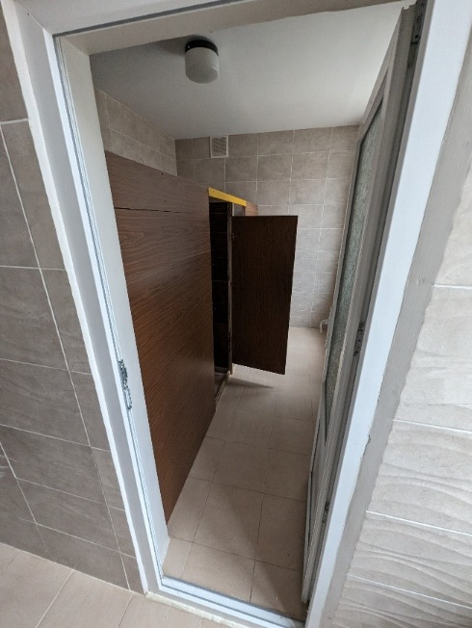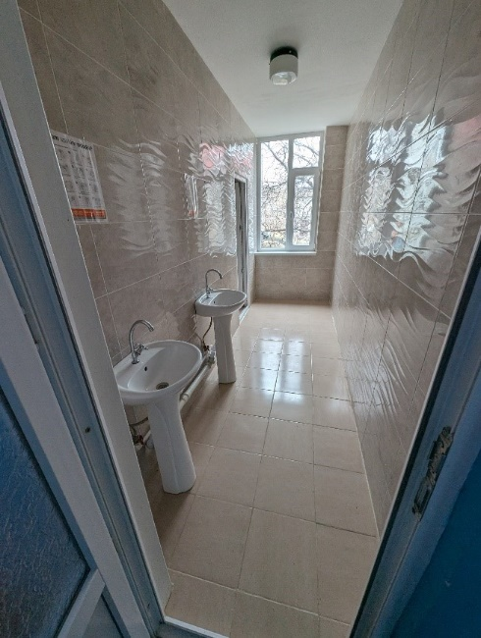

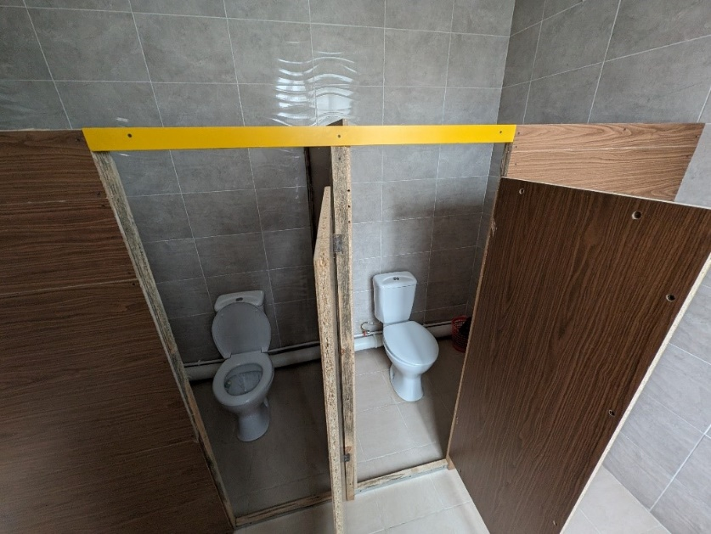
SG boys - installation of ventilation system, soap dispensers and paper holders, mirrors, installation of separation walls for cabins (currently are improvised glued wood), installation hand dryer, water heaters, additional 2 urinals and separation walls
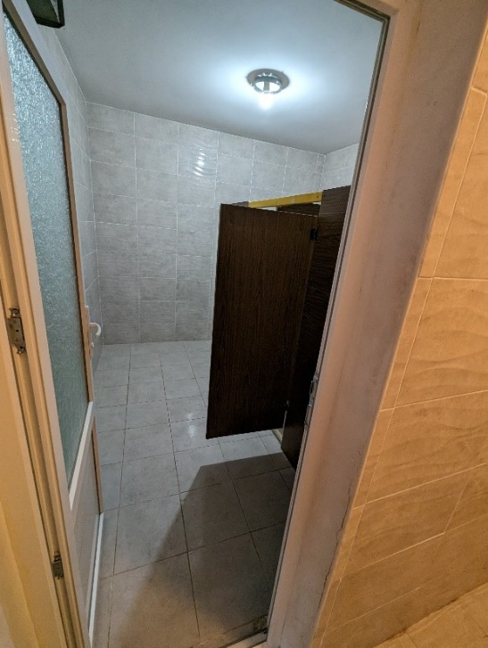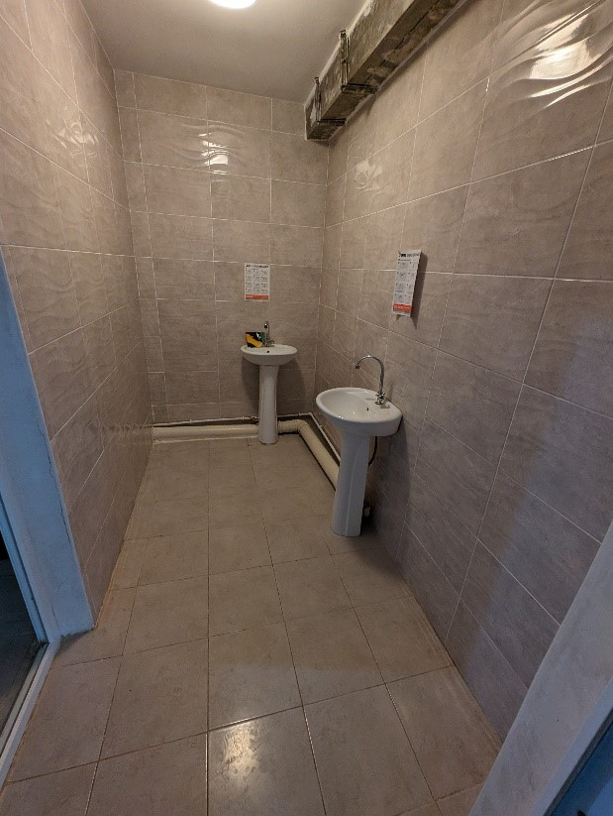
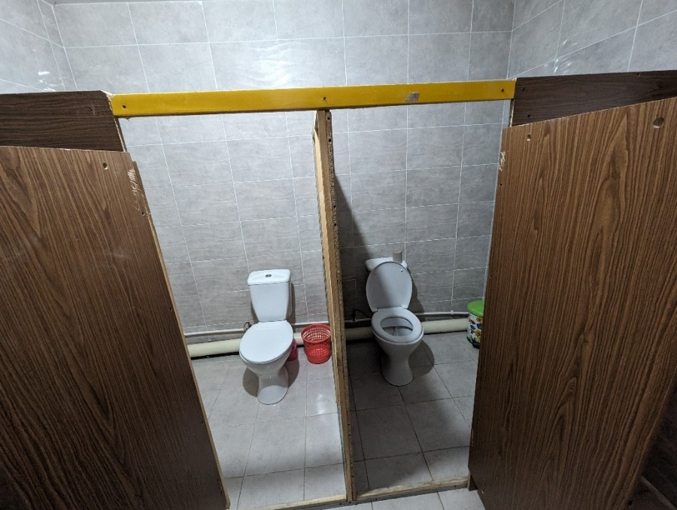
SG girls – installation of ventilation system, replacement of tap at the washbasins, modification of a cabin for menstrual hygiene for woman, installation of water heaters, paper holders and soap dispensers, mirrors, installation of separation walls for cabins (currently improvised from glued wood), installation of hand dryer
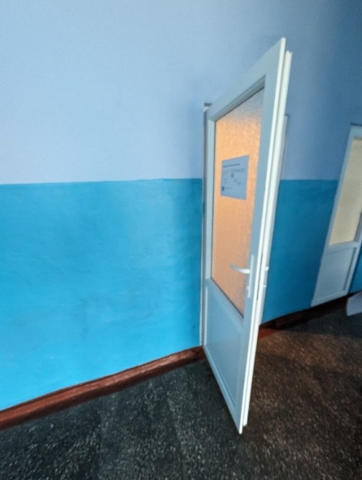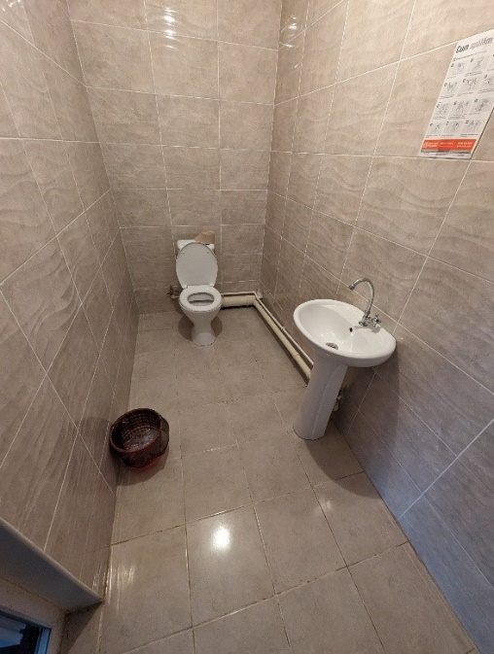
SG personal - installation of ventilation system, soap dispensers and paper holder, mirrors and hand dryers
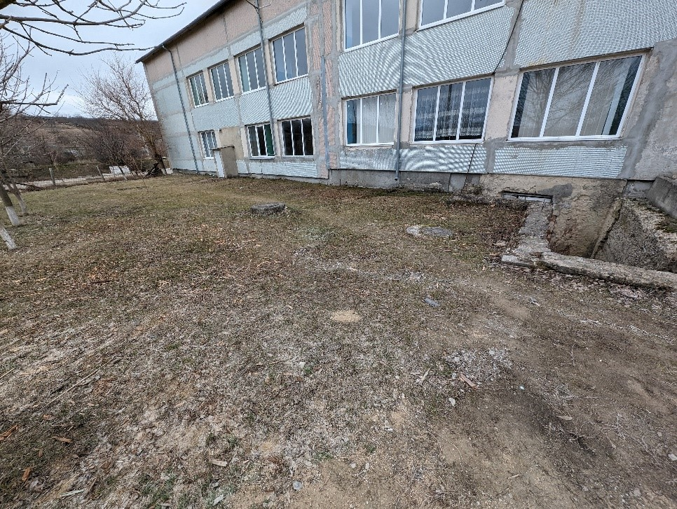
The cesspool-locality does not have a centralized drinking water system, at the moment the institution is supplied from the spring, it is proposed to design and build an artesian well and water tower
R. Drochia, s. Popeștii de Sus, ID 14

Public High School "Ion Creangă" is designed in 2 levels. The institution uses external sanitary groups. Two internal sanitary groups were repaired in 2014 but have never been used. The public institution is divided into three levels: primary level, lower secondary level, and upper secondary level. The staff and students from the primary, lower secondary, and upper secondary levels use the shared external sanitary groups. The age of students ranges from 7 to 18 years old. The school operates on a single shift. Water at the distribution points is potable. The locality does not have a centralized sewage network. Wastewater and excreta are evacuated into the cesspool. The institution is connected to a well, located on the school premises, and water is delivered to the building. There is a total of 11 distribution points for drinking water, out of which 5 are functional.

Table 1 Demographics of school, r. Drochia, s. Popeștii de Sus
Boys | 74
Girls | 75
Pupils with disabilities | 0
Total pupils | 149
Teaching staff | 20
Other staff | 12
Total Staff | 32

Particular recommendations to take into consideration for selected location (but not limited to these):
- Develop the detailed design of the wastewater treatment plant (WWTP) and connection to building sewerage system to ensure efficient treatment of wastewater from the sanitary facilities. Including connection of wastewater and water pipes for constructed sanitary groups.
- Investigate suitable solutions for connecting the school to a centralized water system or constructing an artesian well and water tower on the gymnasium grounds as an alternative. Develop the detailed design for the selected solution. Including pipe connection to the building facilities as kitchen, handwash facilities and sanitary groups and preparation of all the documentation required. Currently 2nd floor sanitary groups have no water and are not operating.
- Prepare the design for construction of sanitary groups for students with limited mobility and for staff including installation needed and pipe system connection. Design and general renovation of existing sanitary groups at 1st and 2nd floors.
- The design should address any structural and functional issues present in the existing sanitary facilities and handwash facilities including renewing flooring, walls, and ceilings, and ensuring that all elements meet current health, safety, and accessibility standards. Considerations should also include upgrading plumbing and sanitary facilities, water supply system, sewerage systems, renovating fixtures and fittings, improving heating and ventilation, electrical system, installation of water heaters, handwashing facilities, waste management, aesthetic, and functional improvements, ensuring accessibility for persons with disabilities, and adhering to relevant building codes and regulations.
- Additionally, prioritize the use of sustainable and durable materials to enhance the longevity and efficiency of the rehabilitated sanitary groups.

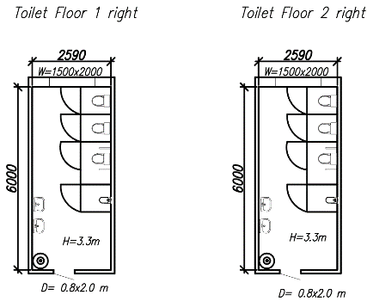  Photo 1.1 1st and 2nd floor right wing sanitary blocks | 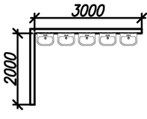  Photo 1.2 Handwash installation
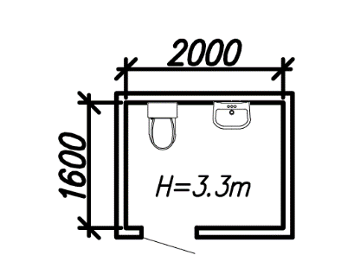
Photo 1.3 Kitchen staff proposed

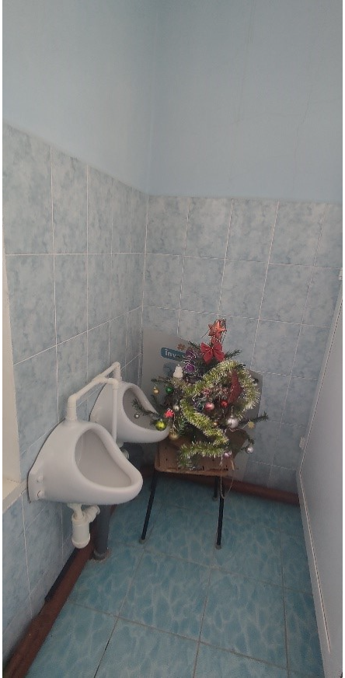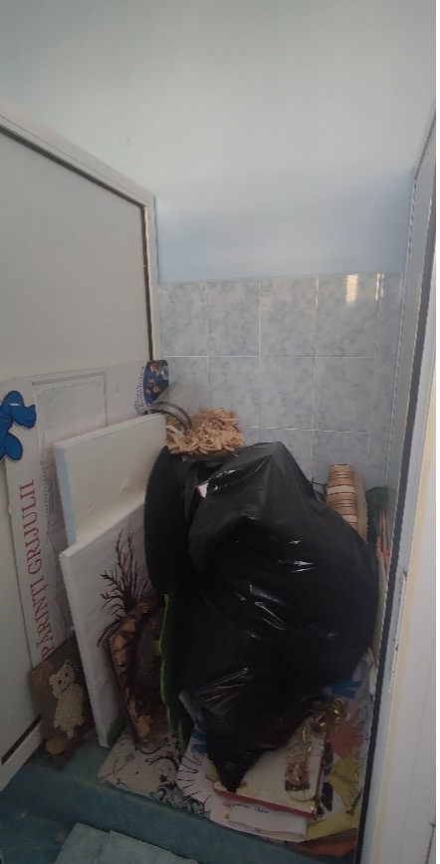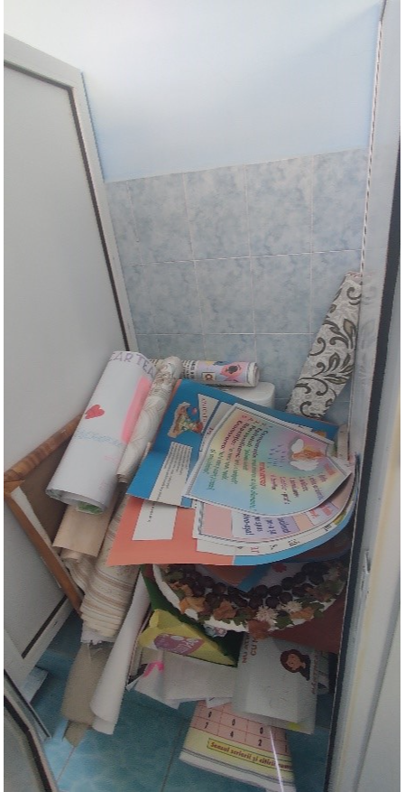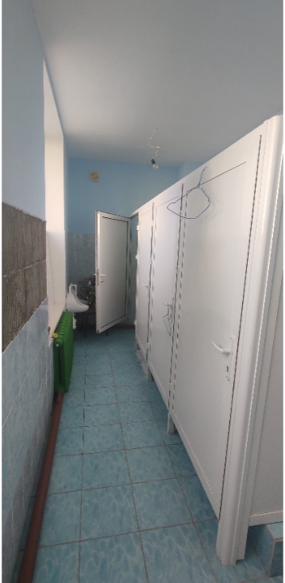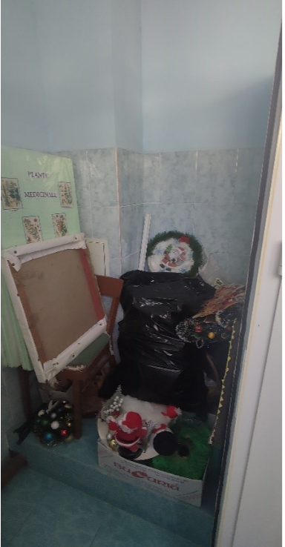
SG 1st floor boys left side
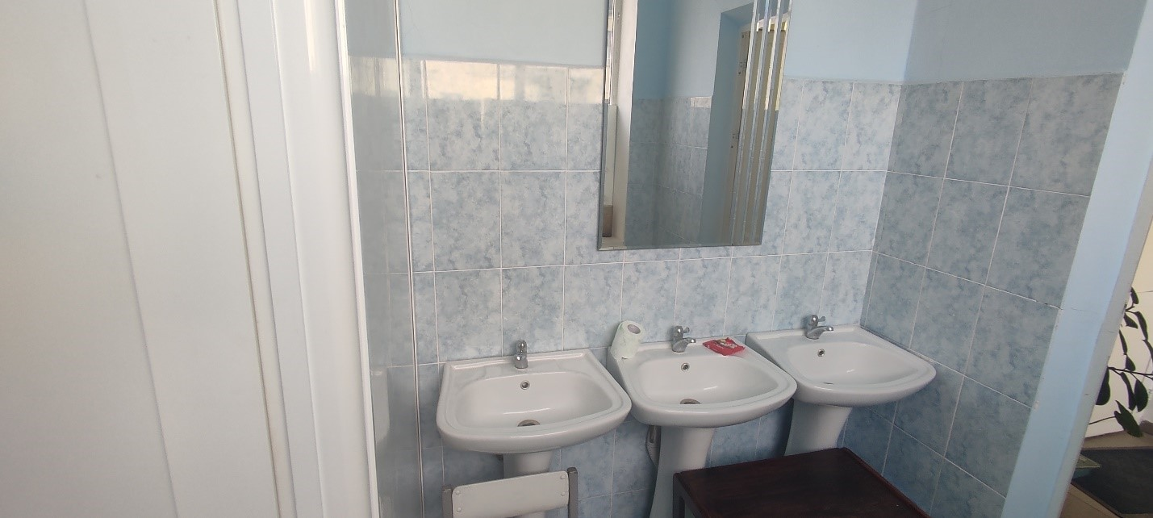
SG 1st floor boys left side
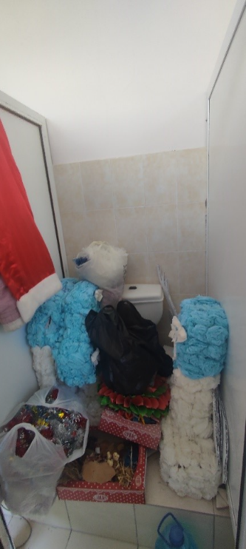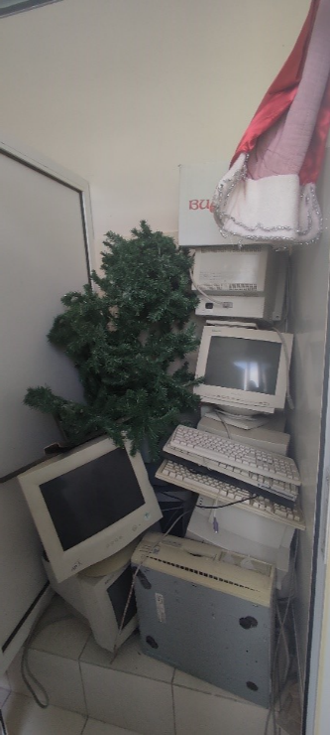
SG 2nd floor girls left side
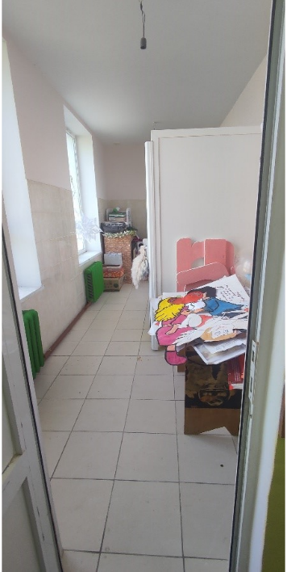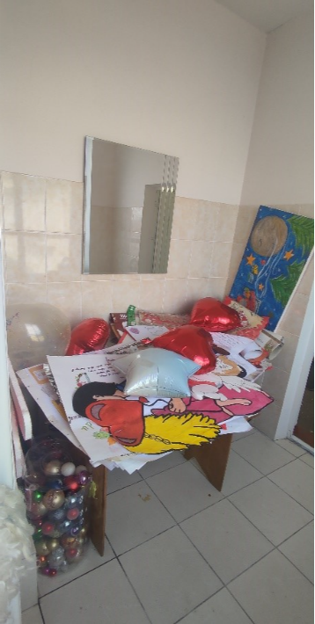
SG 2nd floor girls left side
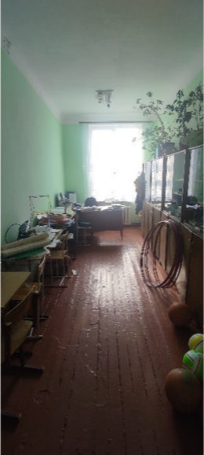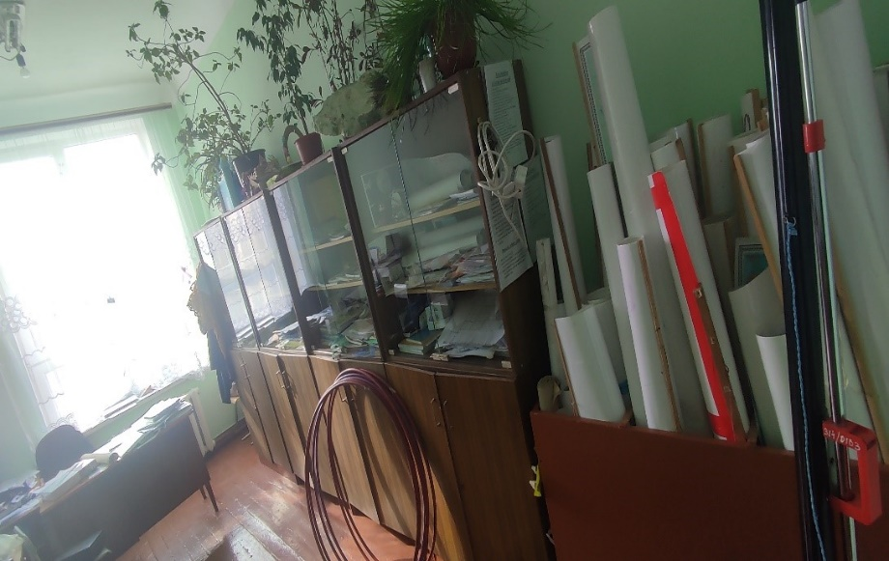
SG 1st floor right side
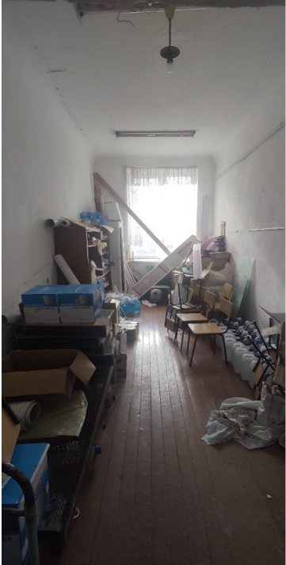
SG 2nd floor right side
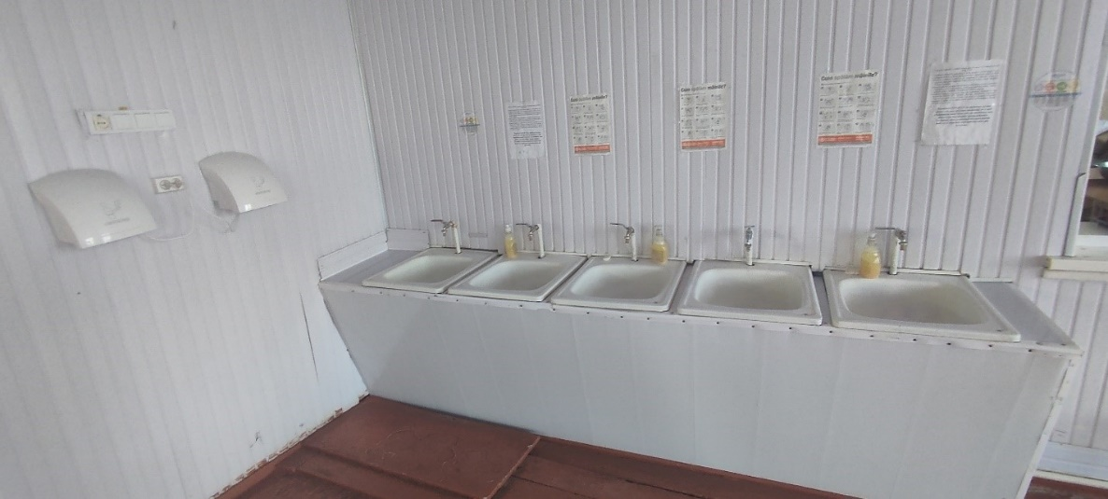
Cafeteria access – washbasins
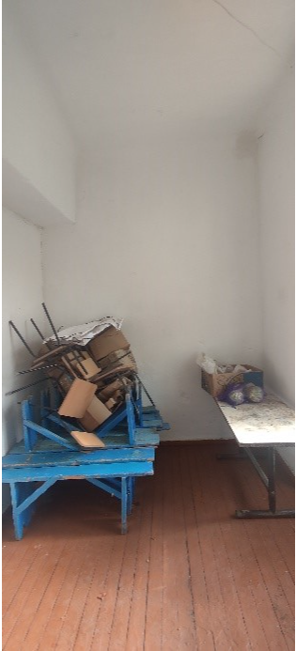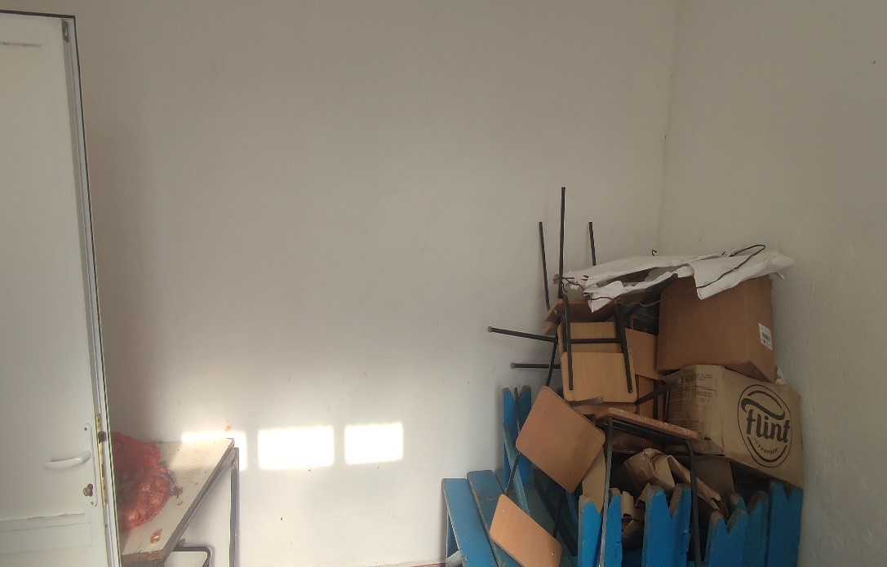
Proposed space for SG for staff, canteen area
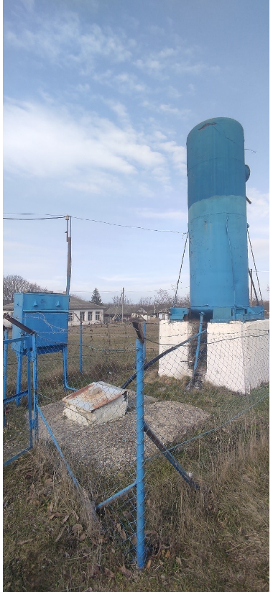
Existing water source situated on school premises

R. Soroca, s. Cerlina ID 27

The school building was constructed in 1959 and initially served as a cultural center. In 2003, the building was repurposed and reorganized into a school. The school operates on a single shift, with a total of 112 students, including 55 girls and 57 boys. There are no indoor sanitary groups in the school, only washbasins in the hallway and near the cafeteria. The water is supplied from the institution's pumping system from a well located on the institution premises, but the water is not for drinking. Therefore, water used for cooking is brought in bottles from a well in the locality. There is no sewage system. Students use outdoor toilets because there are no indoor sanitary groups. Hot water is not connected to the washbasins in the corridors.

Table 38 Demographics of school, r. Soroca, s. Cerlina
Boys | 57
Girls | 55
Pupils with disabilities | 0
Total pupils | 112
Teaching staff | 12
Other staff | 10
Total Staff | 22

Particular recommendations to take into consideration for selected location (but not limited to these):
- Develop the detailed design of the wastewater treatment plant (WWTP) and connection to building sewerage system to ensure efficient treatment of wastewater from the sanitary facilities. Including connection of wastewater and water pipes for constructed sanitary groups.
- Investigate suitable solutions for connecting the school to a centralized water system or constructing an artesian well and water tower on the gymnasium grounds as an alternative. Develop the detailed design for the selected solution. Including pipe connection to the building facilities as kitchen, handwash facilities and sanitary groups.
- Develop the design for construction of sanitary groups in the proposed existing spaces for girls, boys and staff, including all internal service systems.
- The design as well should include the renovation of washbasins from hallway and near cafeteria, installation of water heaters for the handwash facilities.
- The design should address any structural and functional issues present in the existing sanitary facilities and handwash facilities including renewing flooring, walls, and ceilings, and ensuring that all elements meet current health, safety, and accessibility standards. Considerations should also include upgrading plumbing and sanitary facilities, water supply system, sewerage systems, renovating fixtures and fittings, improving heating and ventilation, electrical system, installation of water heaters, handwashing facilities, waste management, aesthetic, and functional improvements, ensuring accessibility for persons with disabilities, and adhering to relevant building codes and regulations.
- Additionally, prioritize the use of sustainable and durable materials to enhance the longevity and efficiency of the rehabilitated sanitary groups.

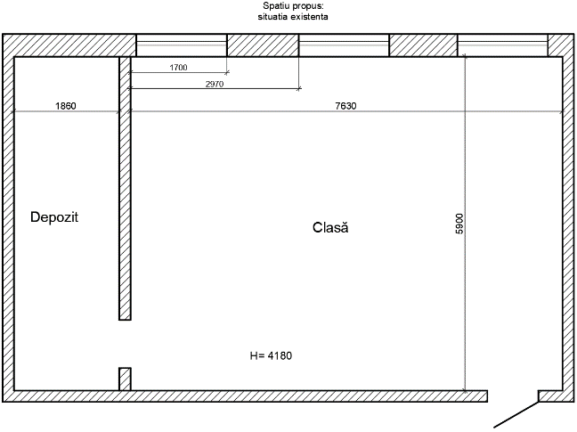  Photo 38.1 | 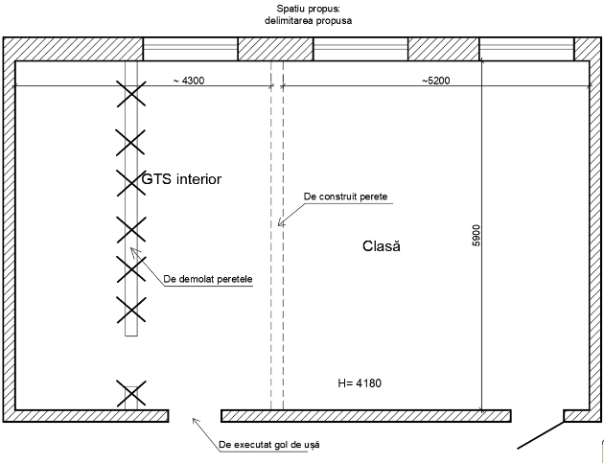  Photo 38.2
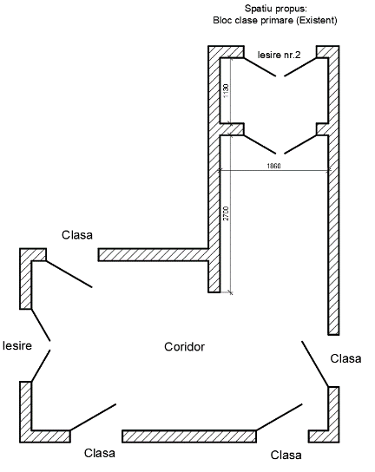  Photo 38.3 | 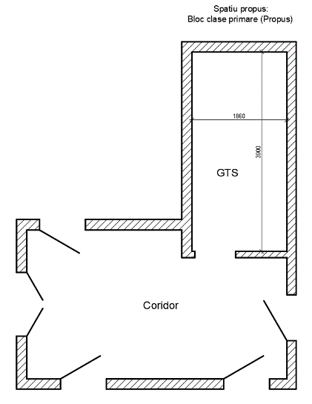  Photo 38.4

Hallway washbasins
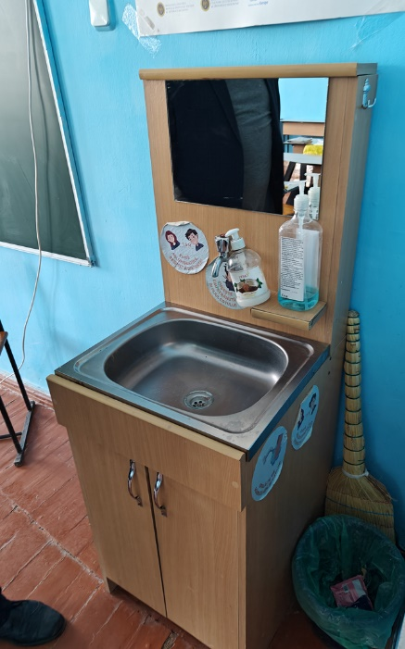 | 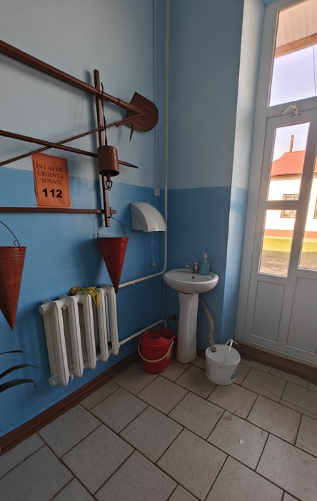
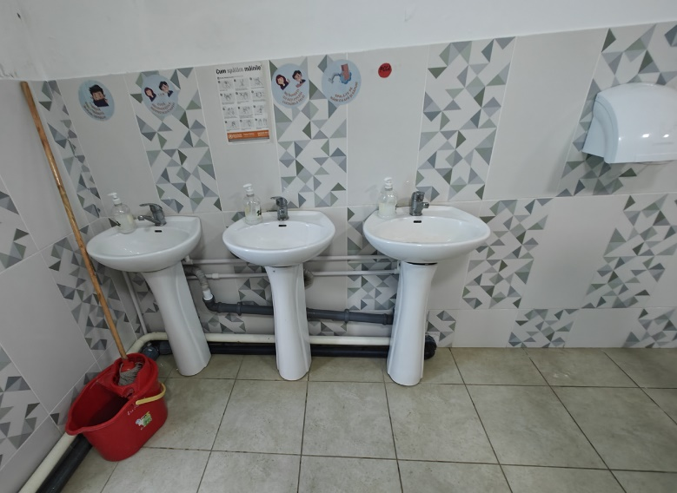
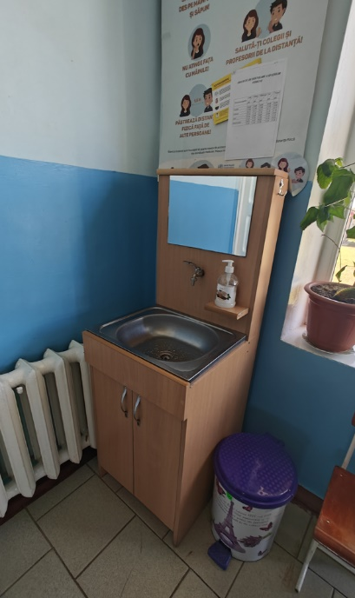 | 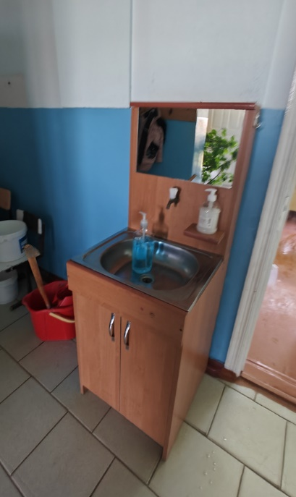
Space proposed for sanitary groups, Block 1
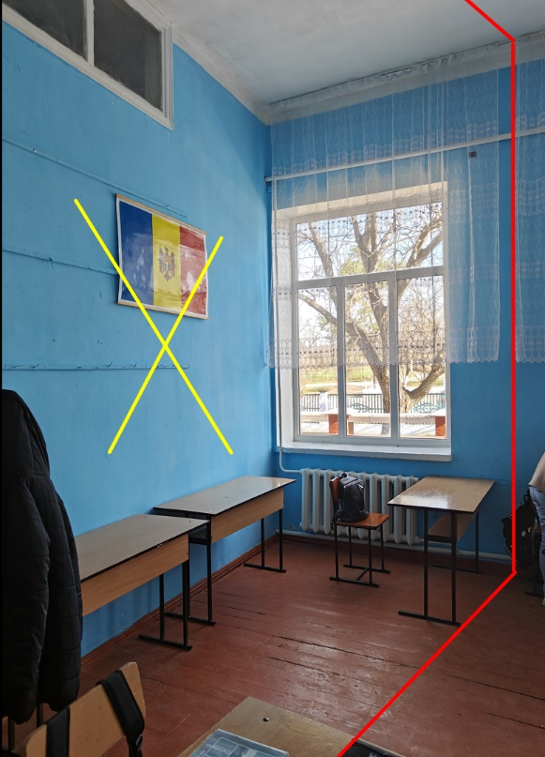 | 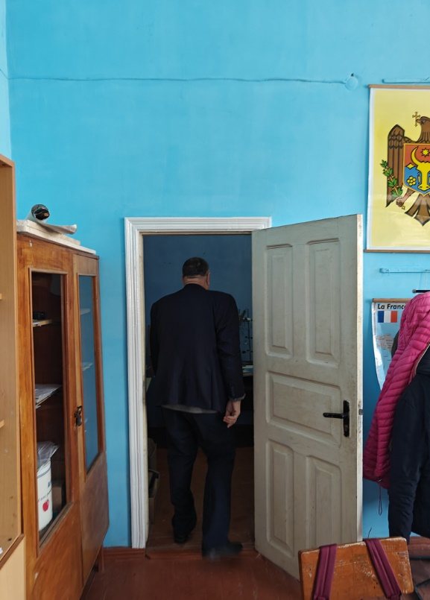
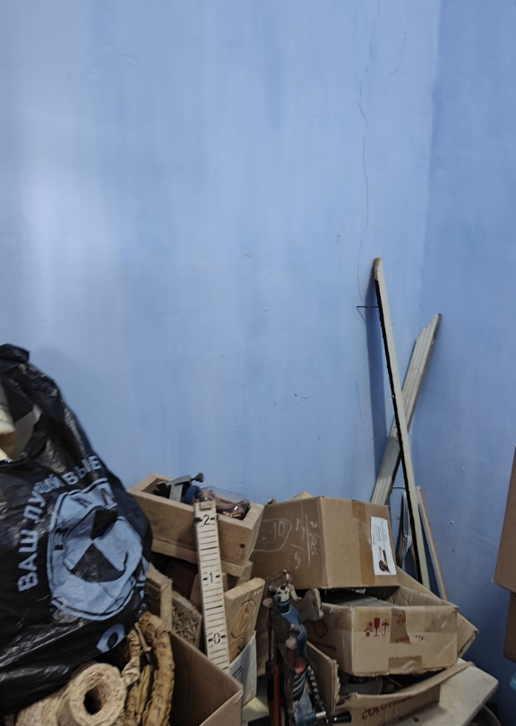 | 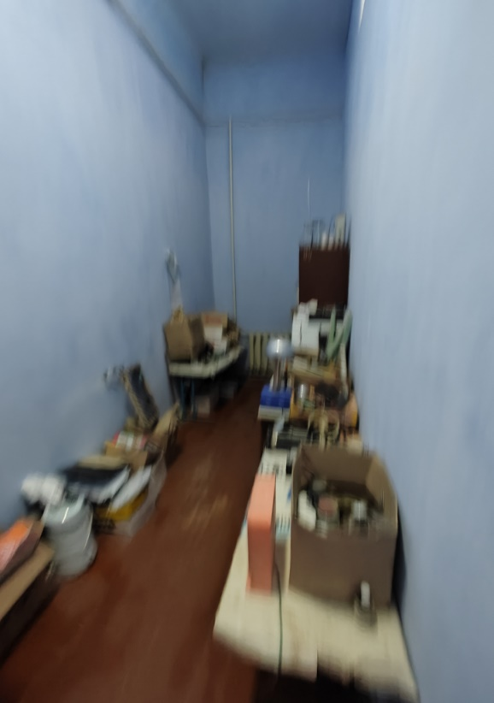
Space proposed for sanitary groups, Block 2
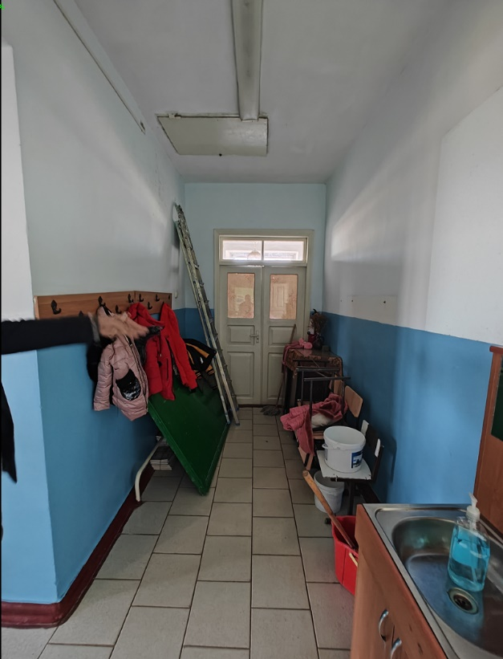

R. Fălești, s. Obreja Veche, ID 83
The school building comprises three levels, with a sports hall and cafeteria on a single level constructed in 1974. Rehabilitation works have been conducted in 2014 within the gymnasium, focusing on level 1 sanitary groups. The sanitary groups for girls consist of two cubicles for girls and 1 cubicle for persons with limited mobility. The sanitary groups for boys consist of three cubicles, 3 urinals, and 1 cubicle for staff. These facilities lack hot water access, paper holders, and soap dispensers. Hot water is also available at the sinks (4 pcs in total) in the canteen area. Drinking water is accessible at sinks located near the cafeteria. The locality is not connected to centralized drinking water distribution system. Water source for the institution is from the shallow well on the school premises that was assessed in September 2023 and the results indicates that it meets the minimum sanitation requirements. Water from the well is used for drinking and technical purposes. Installation of water filters is necessary. At the time of the visit, the locality does not have a centralized sewage system, although construction works are in progress. Wastewater is collected into a cesspit built in 2014, emptied twice per year. There are 9 water access points (2 sinks for boys’ sanitary group, 2 sinks for girls sanitary group, 1 sink for staff sanitary group, and 4 sinks located near the cafeteria). The total number of toilet cubicles are 7 (2 for girls + 1 for persons with limited mobility, 3 for boys + 3 urinals, 1 for staff). Handwashing facilities are not accessible to children with reduced mobility due to the absence of access ramps and guiding bars. Additionally, handwashing facilities are not easily accessible to younger children due to inappropriate height of sinks. There are no sanitary groups designated for boys with limited mobility. There are no sanitary groups for kitchen staff. There is no grease separation system for sinks in the cafeteria. The sports hall has spaces for shower cabins but are in bad condition.
Table 6 Demographics of school r. Fălești, s. Obreja Veche
Boys | 118
Girls | 102
Pupils with disabilities | 8; 3 deaf, 1 mental, 5 CES
Total pupils | 220
Teaching staff | 15
Other staff | 21
Total Staff | 36
Particular recommendations to take into consideration for selected location (but not limited to these):
- Develop the detailed design of the wastewater treatment plant (WWTP) and connection to building sewerage system to ensure efficient treatment of wastewater from the sanitary facilities. Including connection of wastewater and water pipes for constructed sanitary groups.
- Investigate suitable solutions for connecting the school to a centralized water system or constructing an artesian well and water tower on the gymnasium grounds as an alternative. Develop the detailed design for the selected solution. Including pipe connection to the building facilities as kitchen, handwash facilities and sanitary groups and preparation of all the documentation required.
- Develop the design for renovation/construction of sanitary groups on the second floor for girls, boys, staff, adhering to design standards.
- Develop the design for renovation/construction of sanitary groups for persons with limited mobility adhering to design standards.
- The design must include the construction of shower cabins as well for girls and boys within sports hall from existing spaces. Also renovate/construct sanitary groups from the existing spaces for kitchen staff.
- For sanitary groups used by elementary school students (boys and girls), installation of water heaters, privacy walls for urinals, faucets, pipe camouflage.
- For staff sanitary groups, installation of soap dispensers and paper holders, installation of water heaters and faucets.
- For handwash facilities located near dining room: Water heater reparation/replacement, pipe camouflage, mirror installation, soap dispensers and paper holders’ installation, installation of 2 sinks for smaller children at an appropriate height.
- Investigate the need and possible solutions for water filters installation for drinking water.
- The design should address any structural and functional issues present in the existing sanitary facilities and handwash facilities including renewing flooring, walls, and ceilings, and ensuring that all elements meet current health, safety, and accessibility standards. Considerations should also include upgrading plumbing and sanitary facilities, water supply system, sewerage systems, renovating fixtures and fittings, improving heating and ventilation, electrical system, installation of water heaters, handwashing facilities, waste management, aesthetic, and functional improvements, ensuring accessibility for persons with disabilities, and adhering to relevant building codes and regulations.
- Additionally, prioritize the use of sustainable and durable materials to enhance the longevity and efficiency of the rehabilitated sanitary groups.

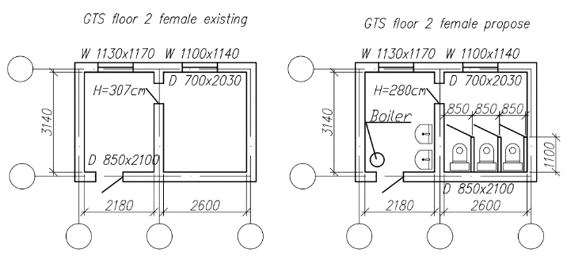  Photo 6.1 2nd floor, WASH facilities girls | 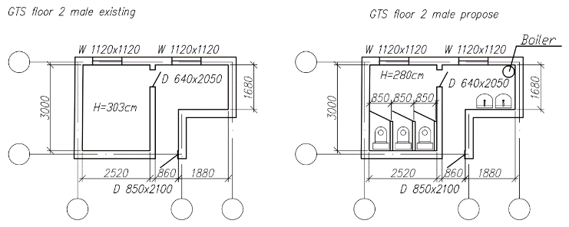  Photo 6.2 2nd floor, WASH facilities boys
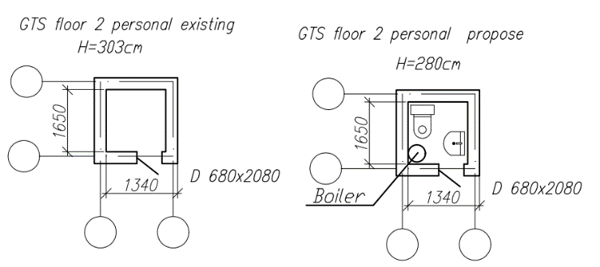  Photo 6.3 2nd floor, sanitary block staff | 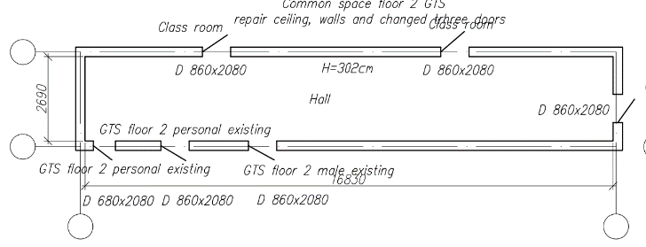  Photo 6.4 2nd floor, commune space
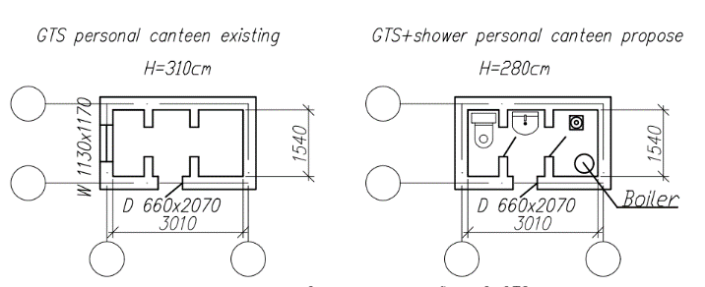  Figure 6.5 Sanitary block, kitchen staff | 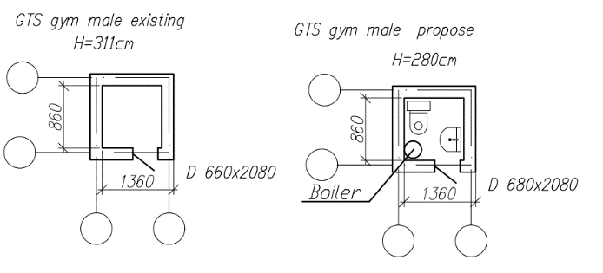  Figure 6.6 Sanitary block, sports hall boys
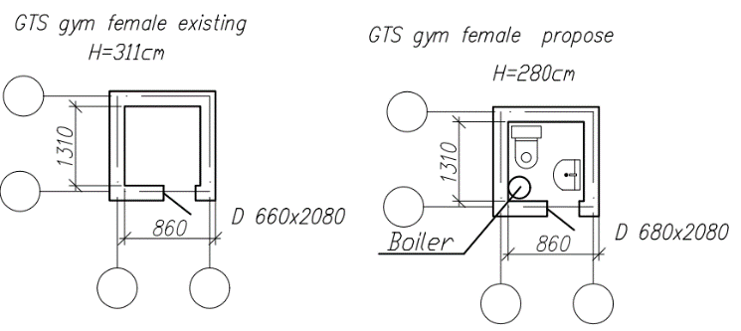  Photo 6.7 Sanitary block, sports hall girls | 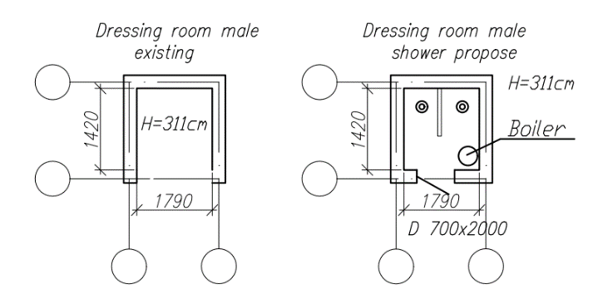  Photo 6.8 Shower cabin, sports hall boys
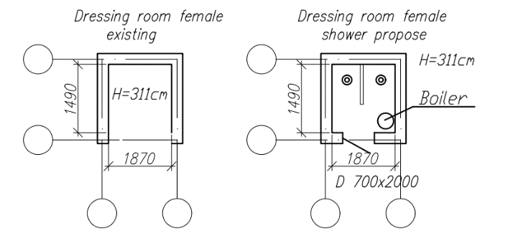
Photo 6.9 Shower, sports hall girls

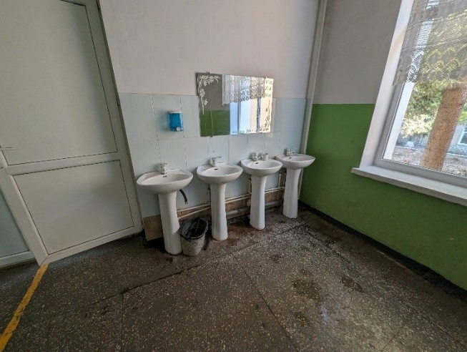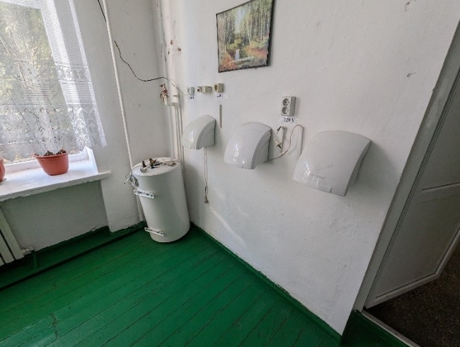
Cafeteria access – water heater replacement, mirrors installation, paper holders and soap dispensers , 2 additional washbasins for small children
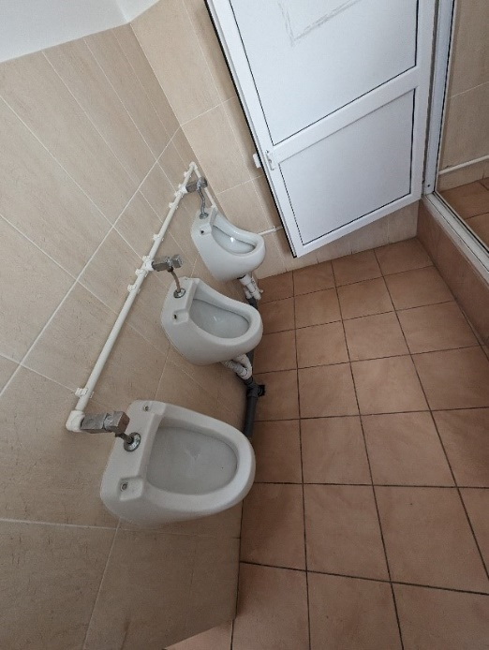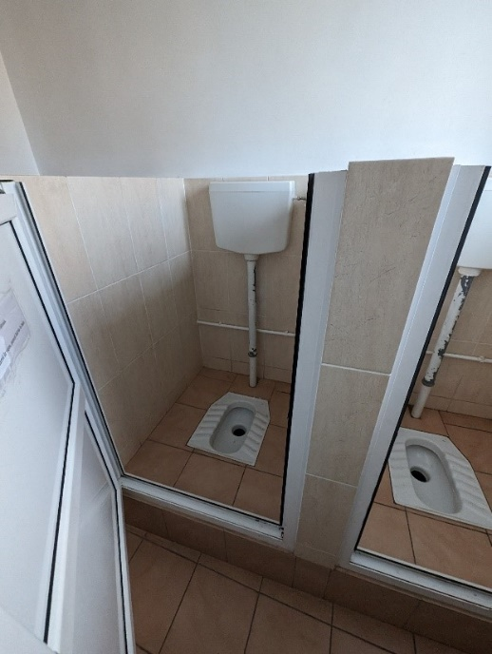
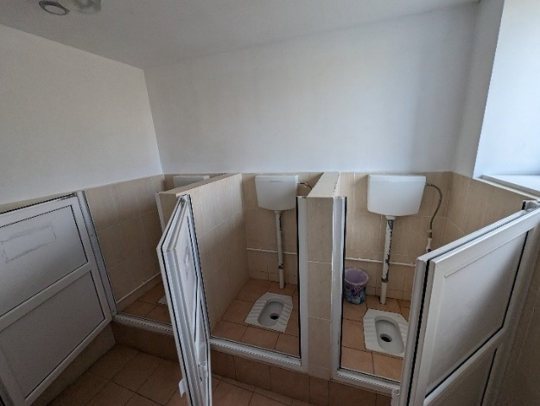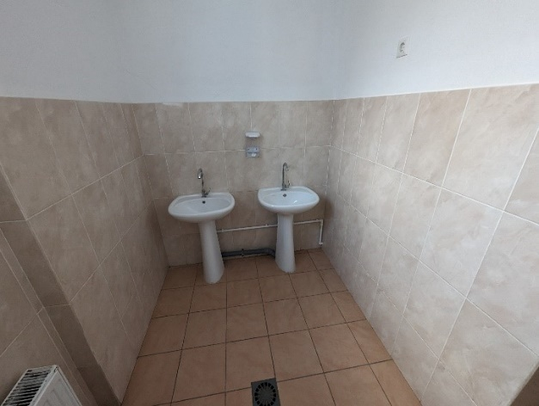
SG boys class 1-4 – paper holders and soap dispensers, tap replacement, water heaters installation, mirrors, separation walls
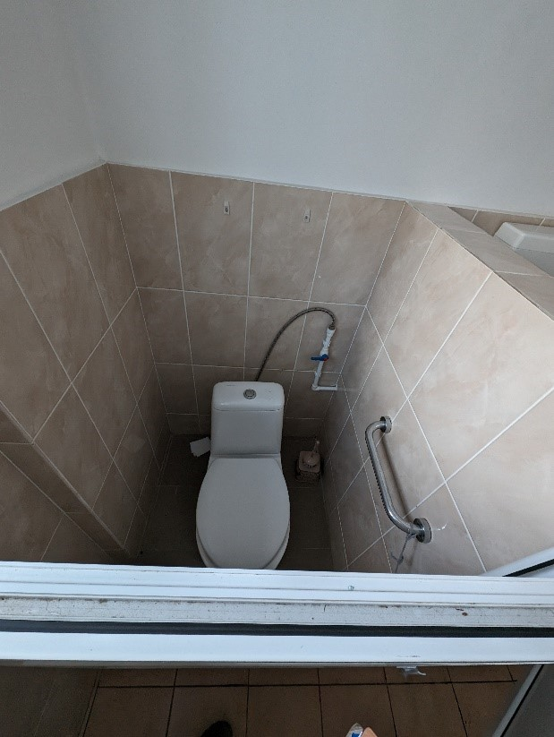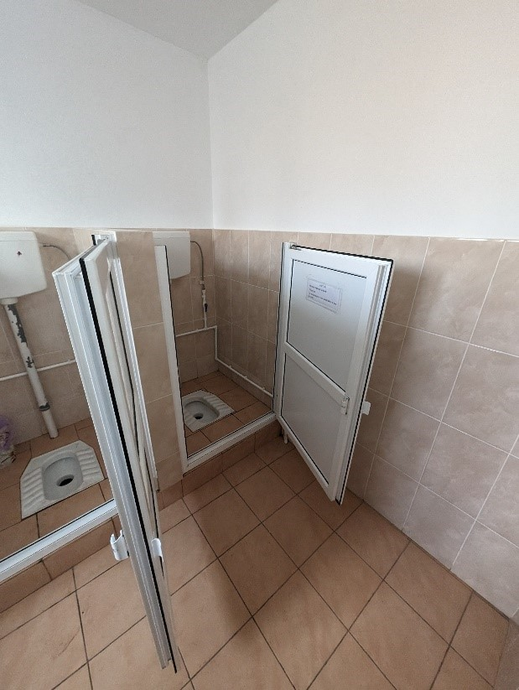
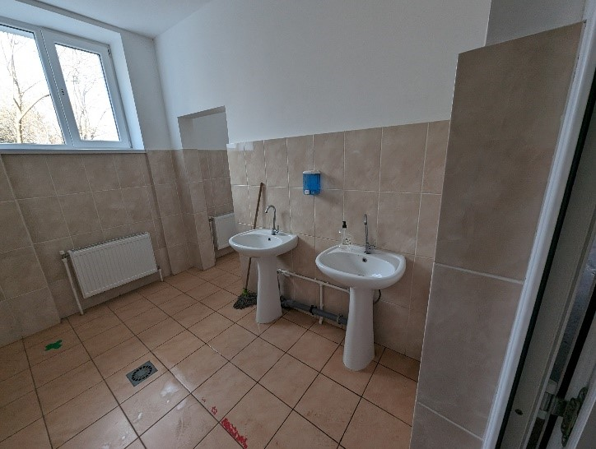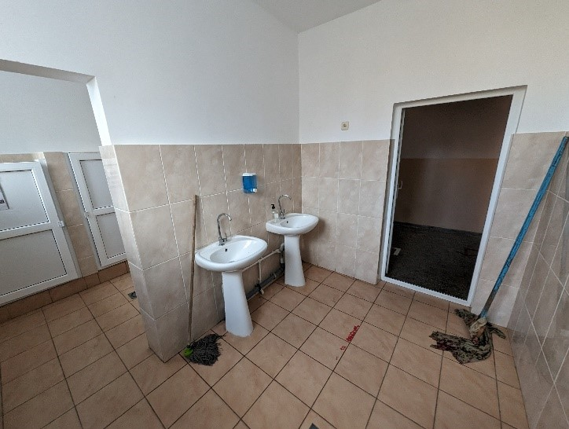
SG girls class 1-4 – paper holders and soap dispensers, tap replacement, water heaters installation, mirrors

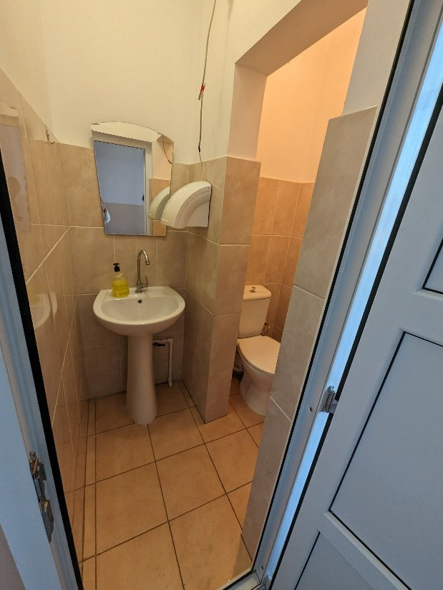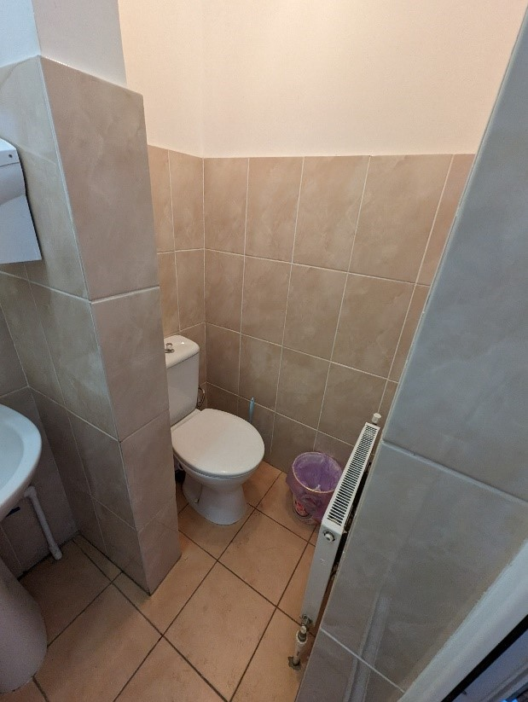
SG staff - paper holders and soap dispensers, tap replacement, water heaters installation, mirrors
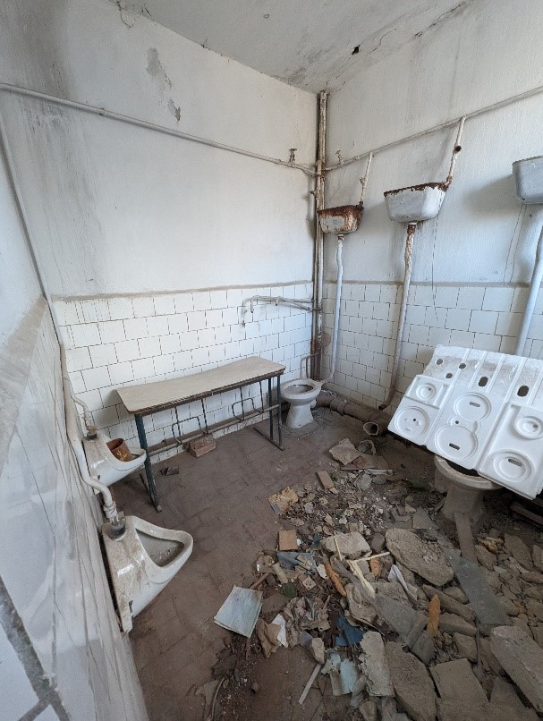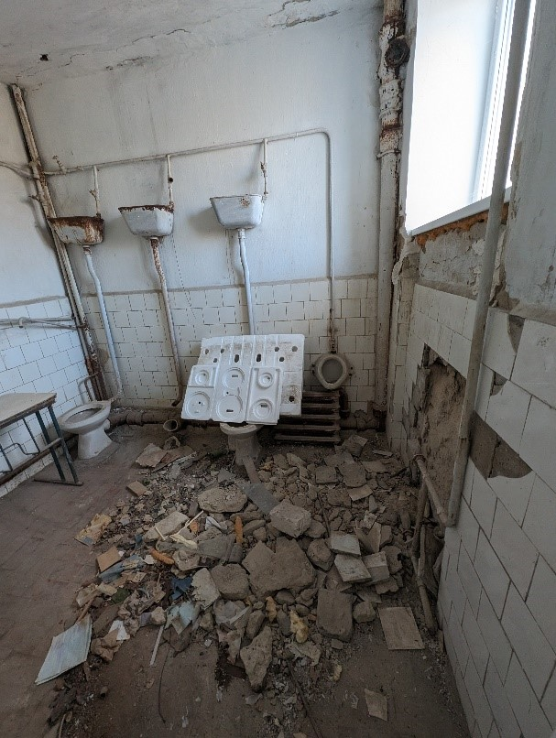
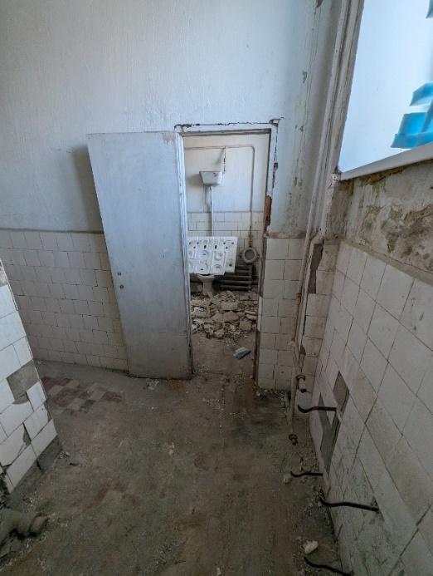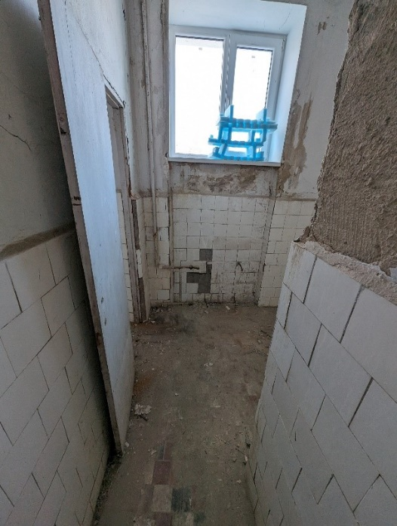
2nd floor – rehabilitation of sanitary groups for boys, with all internal facilities and service systems
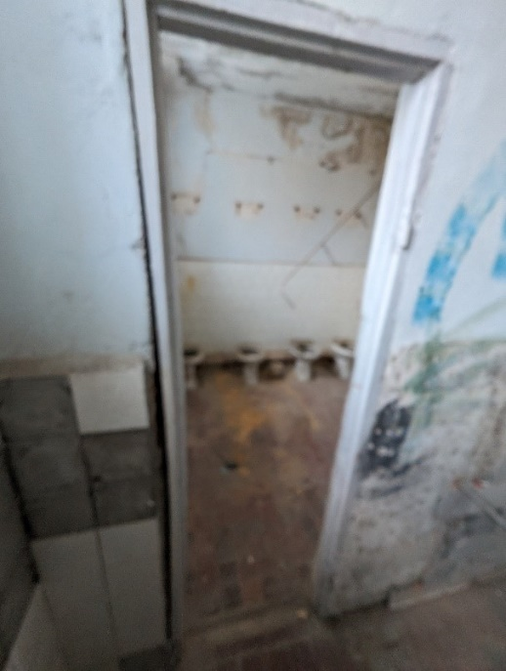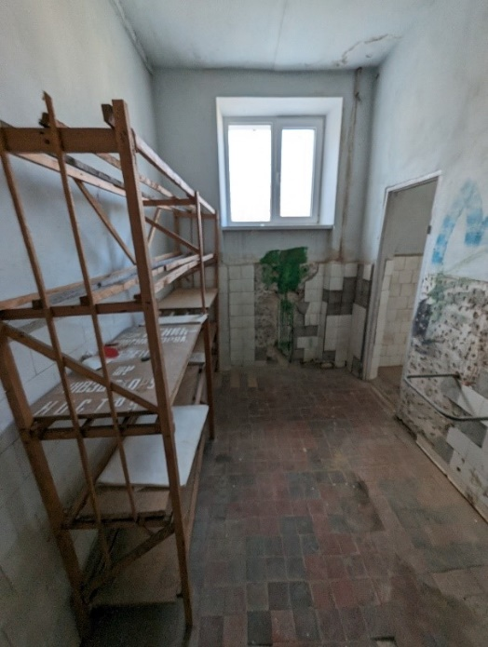
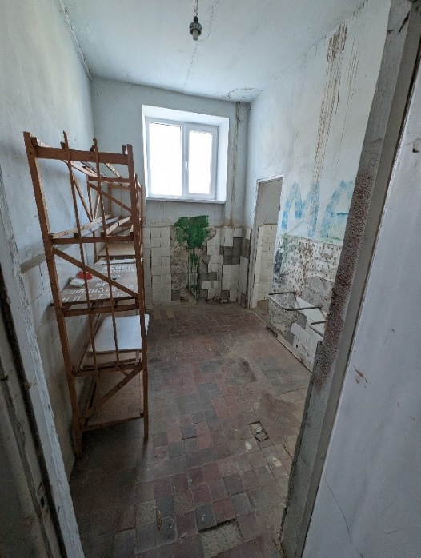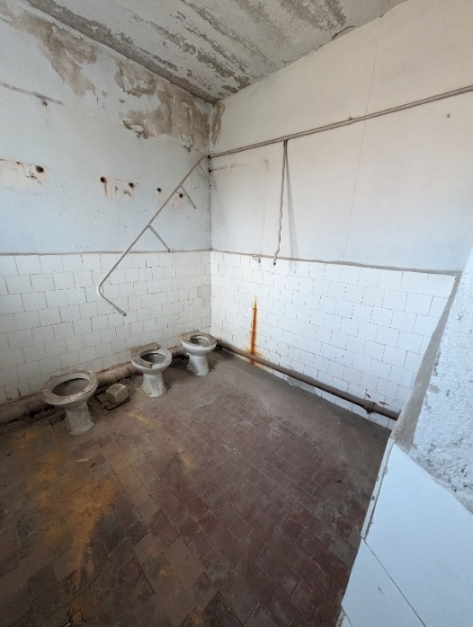
2nd floor – rehabilitation of sanitary groups for girls, with all internal facilities and service systems
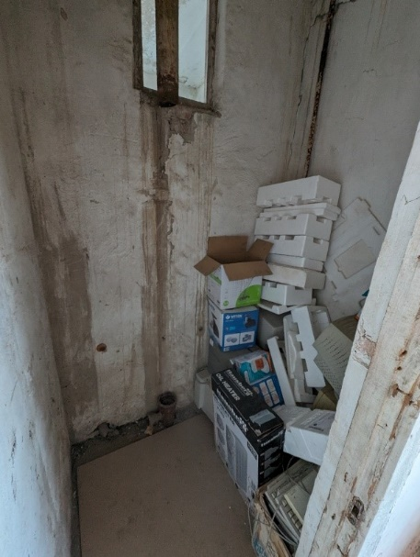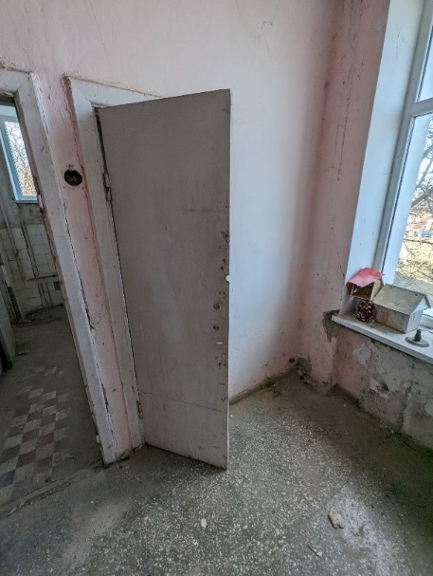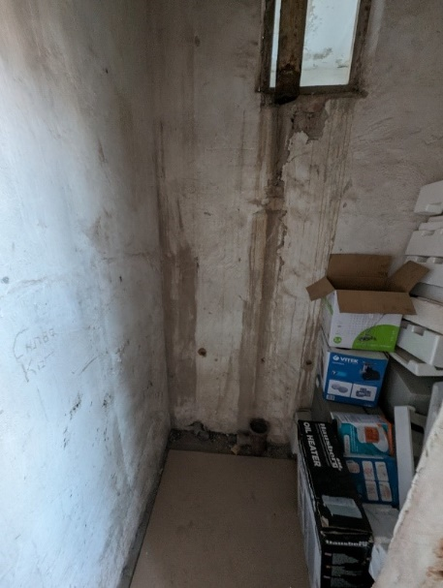
2nd floor – rehabilitation of sanitary groups for staff, with all internal facilities and service systems
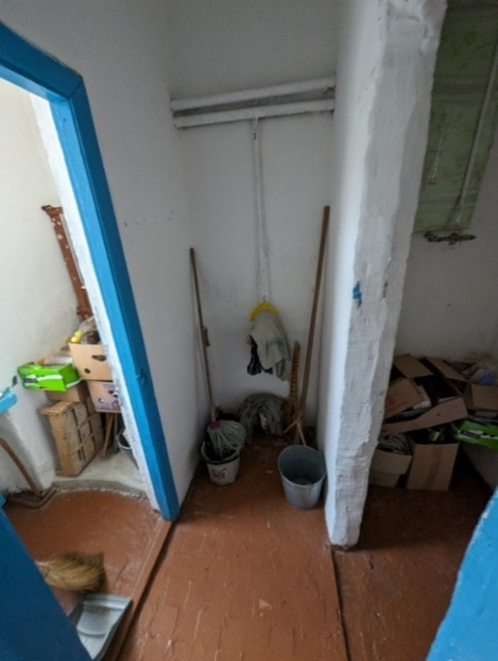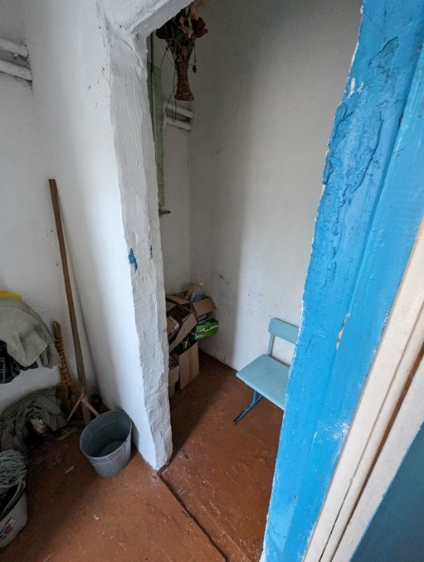

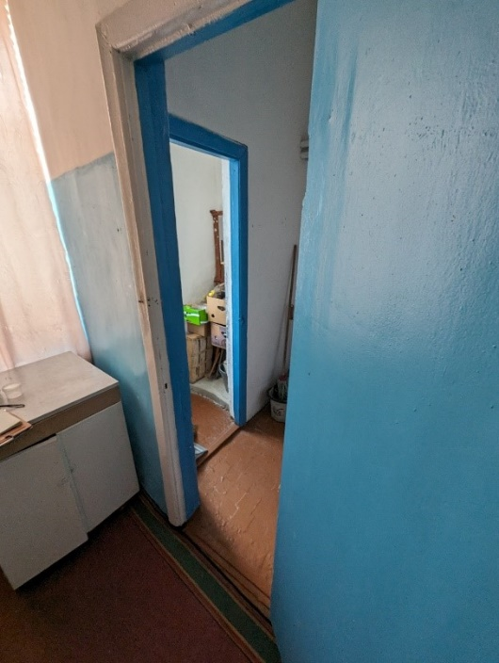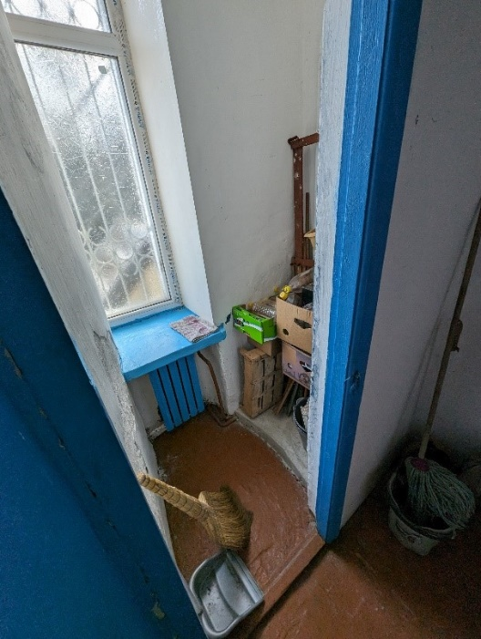
SG for kitchen staff – construction of sanitary groups for staff, with all internal facilities and service systems
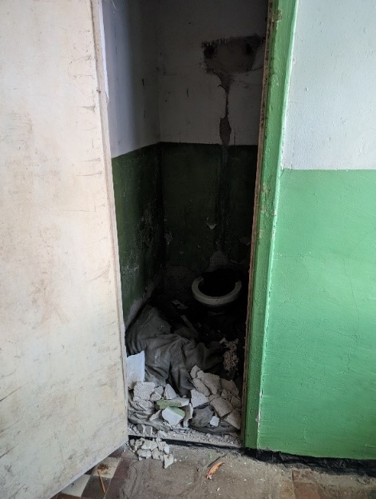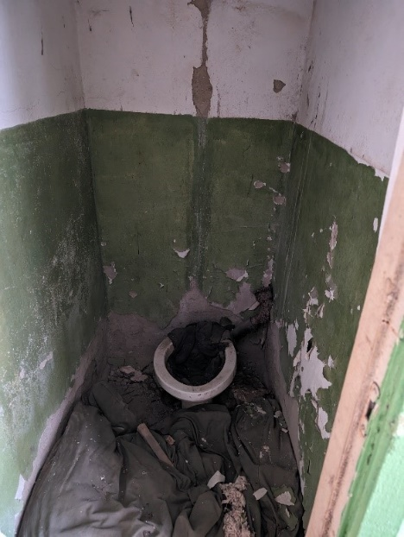
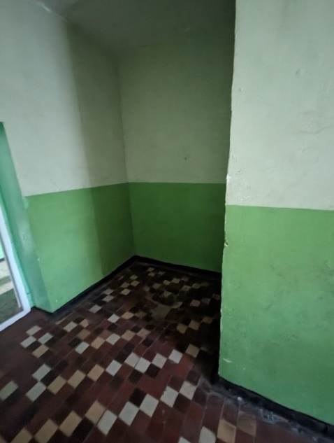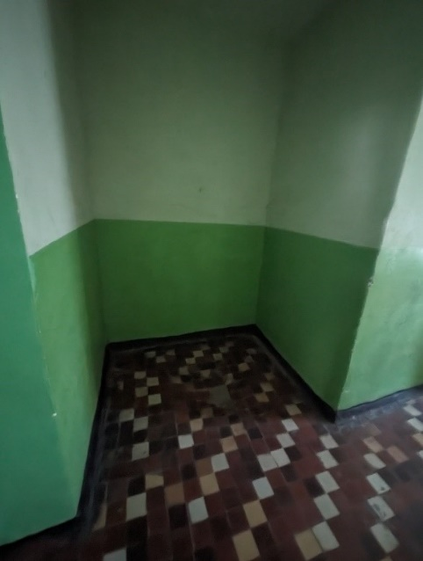
Sports hall – construction of showers and SG for boys
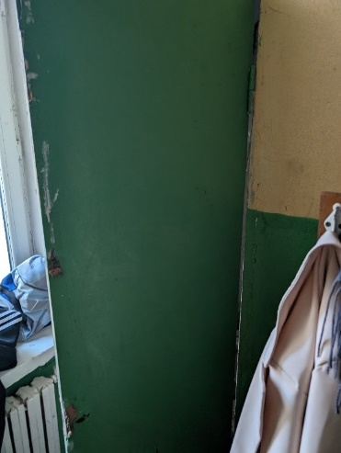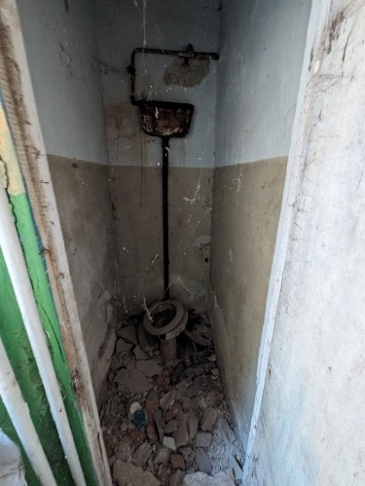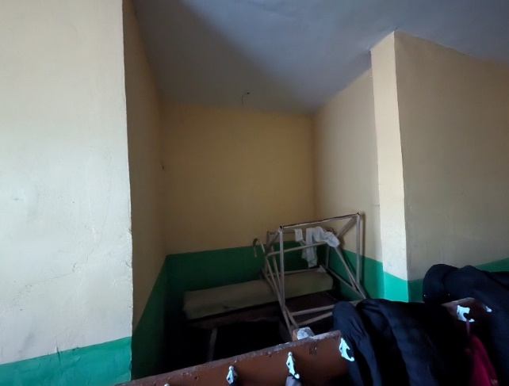
Sports hall – construction of showers and SG for boys

R. Hîncești, s.Crasnoarmeiscoe, ID 79

The Public Institution, Dimitrie Cantemir Theoretical High School, is designed in 2 levels. The institution was built in 1976 and. The sanitary groups were rehabilitated in 2010. Drinking water is supplied from a shallow well on the school's premises using a pump. In 2023, the water level in the well significantly decreased, resulting in weak water pressure in the institution and it is partial distributed to the water access points. The institution has 12 water distribution points, of which only 9 are functional, located in the canteen, toilets, and medical office. The institution has an inside sewerage system, but due to the lack of a centralized sewerage network, sewage is discharged into a cesspit. The institution has 14 cabins, of which only 4 are functional (due to continuous lack of drinking water and weak pressure). There are 12 handwashing facilities, of which only 9 are functional. The canteen sinks (6 sinks) are equipped with hot water, and there are plans for installing 2 additional sink areas. The locality lacks a centralized sewerage system. The urinals in the boys' sanitary group are not connected to the water pipeline. The high school does not have a sanitary group for pupils with limited mobility.

Table 19 Demographics of school r.Hîncești, s.Crasnoarmeiscoe
Boys | 117
Girls | 118
Pupils with disabilities | 0
Total pupils | 235
Teaching staff | 24+3 administrative
Other staff | 18
Total Staff | 45

Particular recommendations to take into consideration for selected location (but not limited to these):
- Develop the detailed design of the wastewater treatment plant (WWTP) and connection to building sewerage system to ensure efficient treatment of wastewater from the sanitary facilities. Including connection of wastewater and water pipes for constructed sanitary groups.
- Develop the design for rehabilitation of the existing exterior water source (shallow well).
- Develop design for the reparation of sanitary group, alongside with non-functional showers in the sports hall.
- The design should address any structural and functional issues present in the existing sanitary facilities and handwash facilities including renewing flooring, walls, and ceilings, and ensuring that all elements meet current health, safety, and accessibility standards. Considerations should also include upgrading plumbing and sanitary facilities, water supply system, sewerage systems, renovating fixtures and fittings, improving heating and ventilation, electrical system, installation of water heaters, handwashing facilities, waste management, aesthetic, and functional improvements, ensuring accessibility for persons with disabilities, and adhering to relevant building codes and regulations.
- Additionally, prioritize the use of sustainable and durable materials to enhance the longevity and efficiency of the rehabilitated sanitary groups.

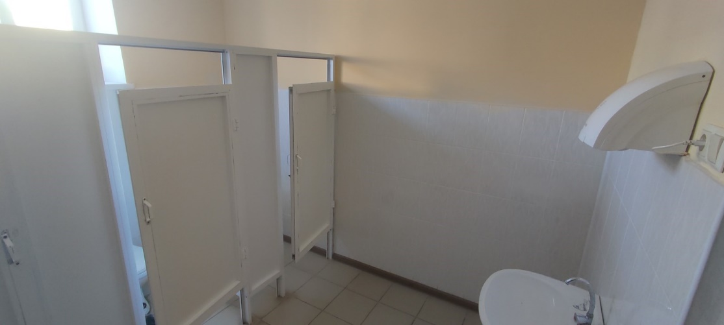

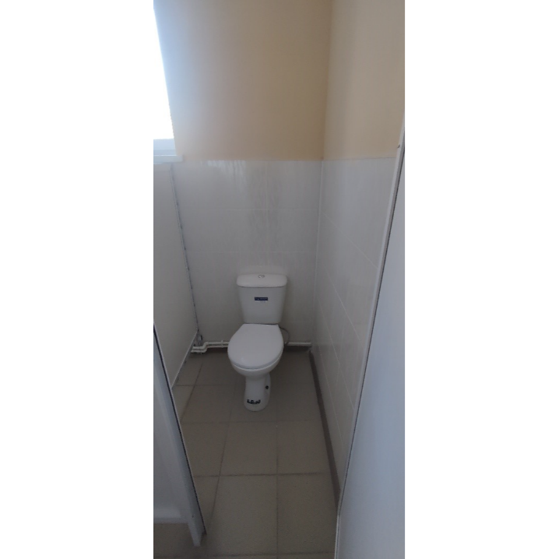 | 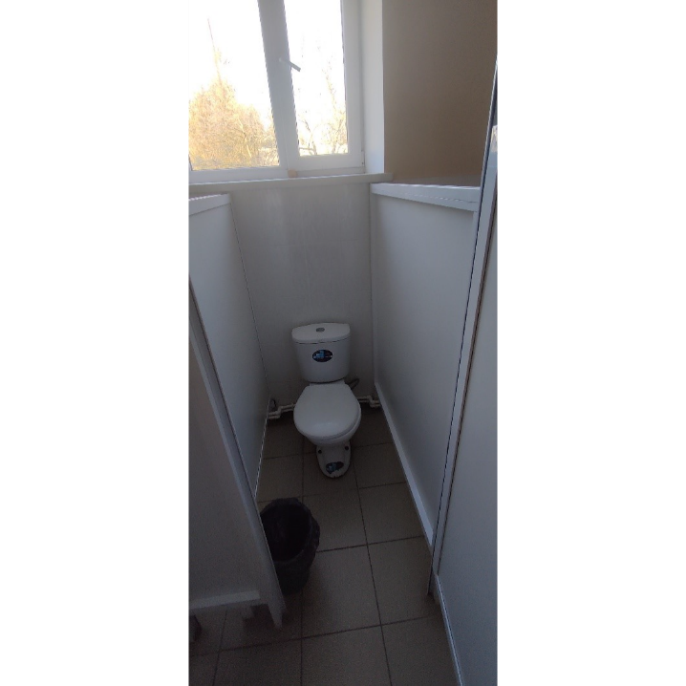
Level 1 GTS girls
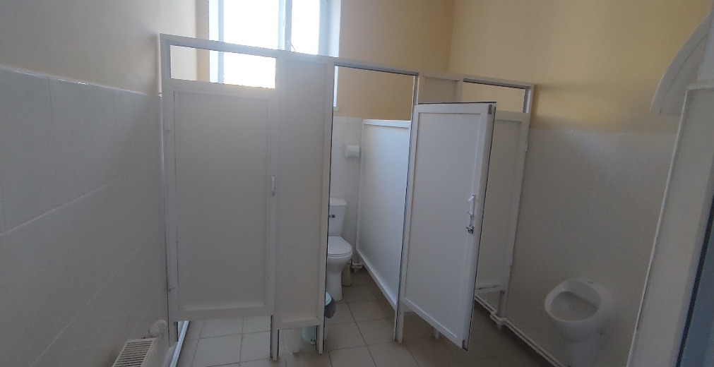

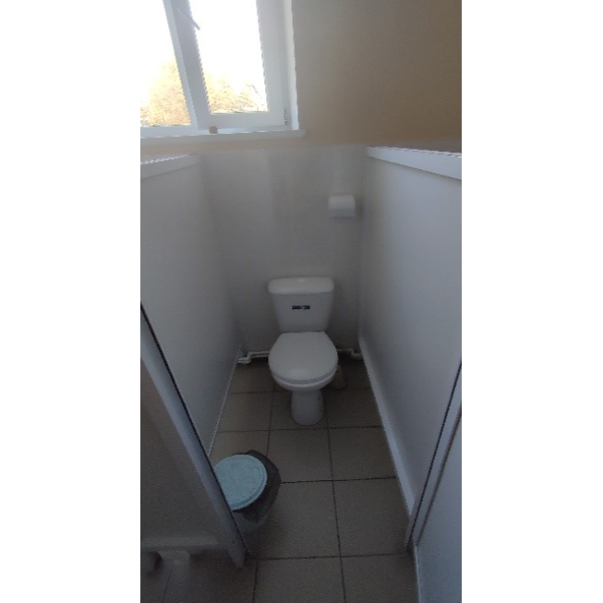 | 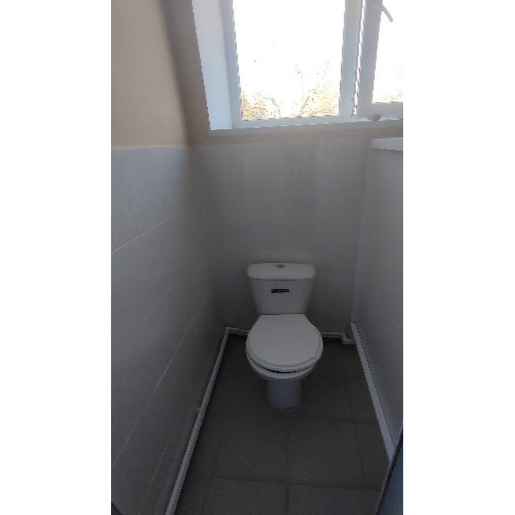
Level 1 GTS boys
,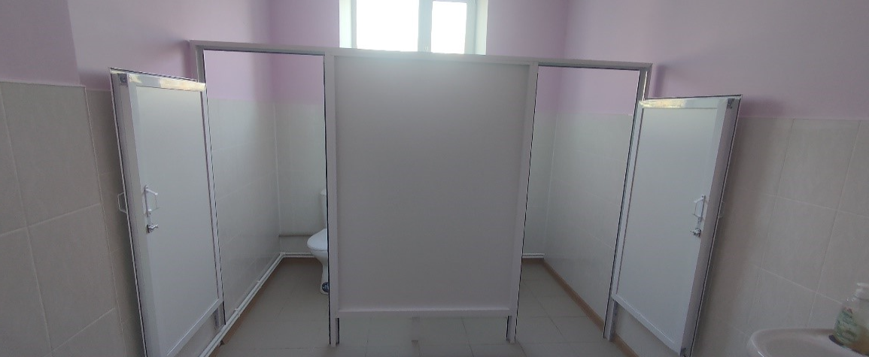
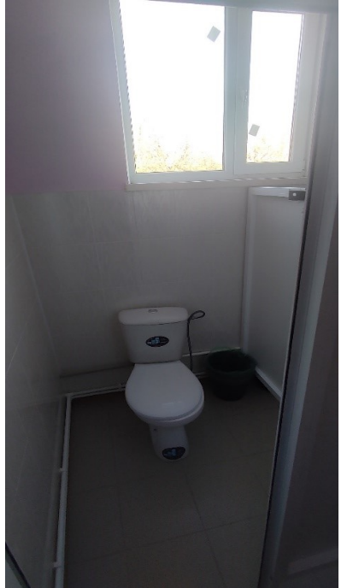 | 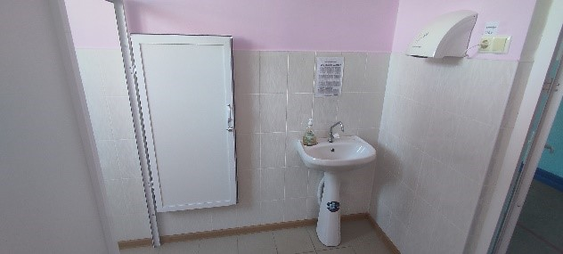  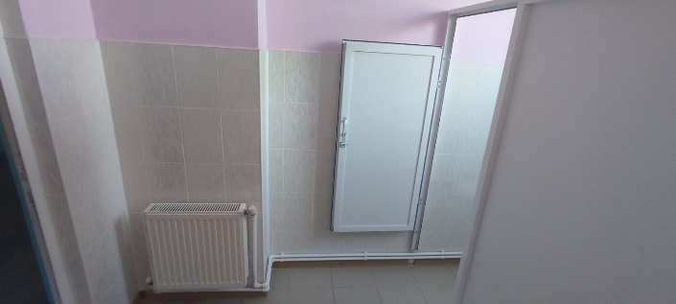
Level 2 GTS staff
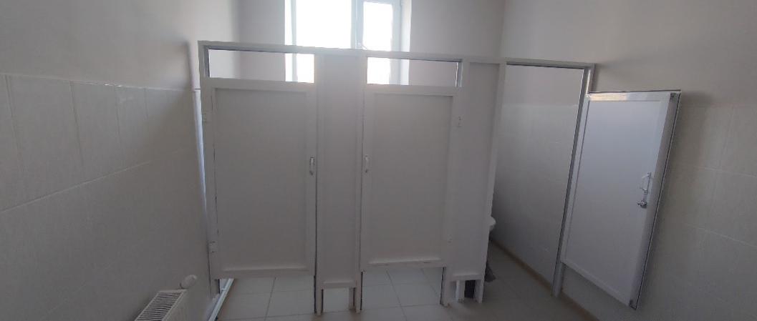

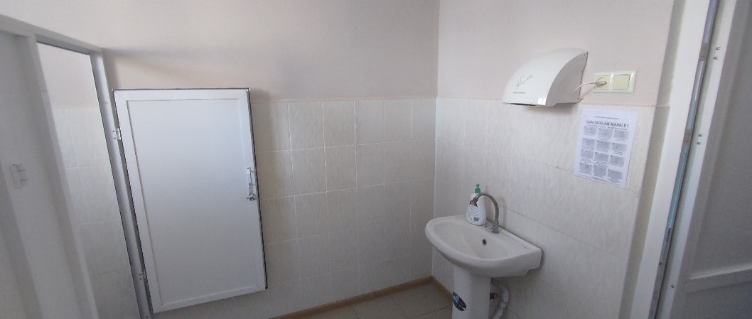

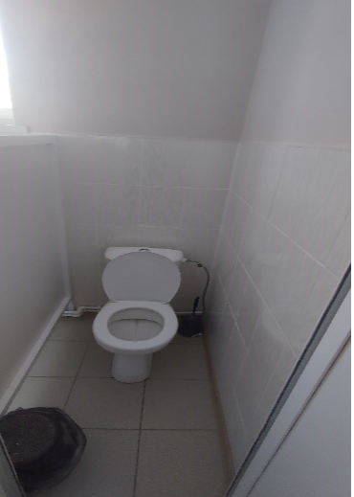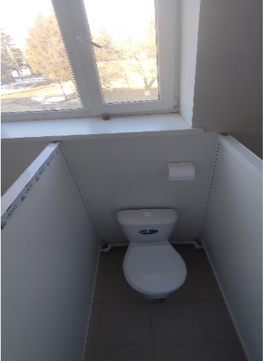
Level 2 GTS girls
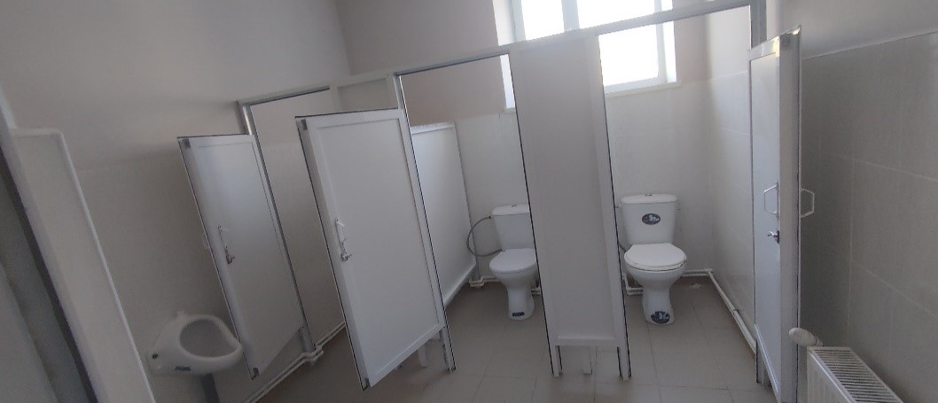

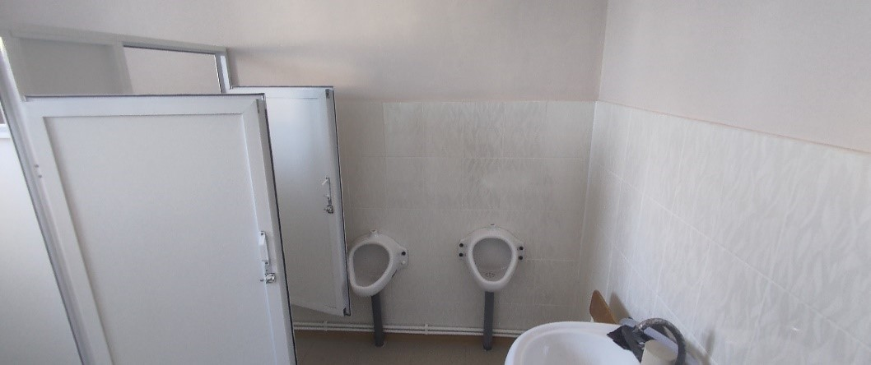

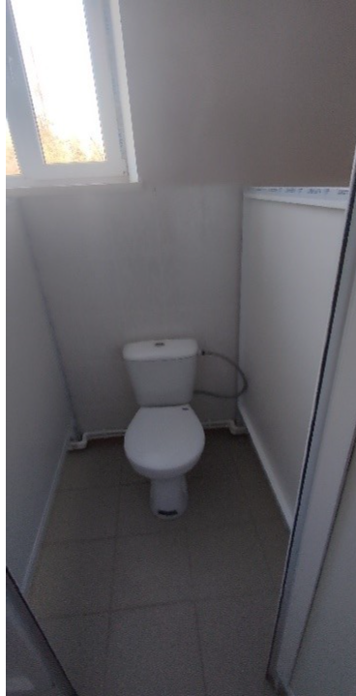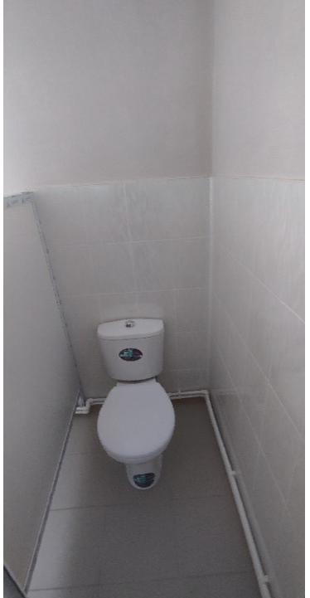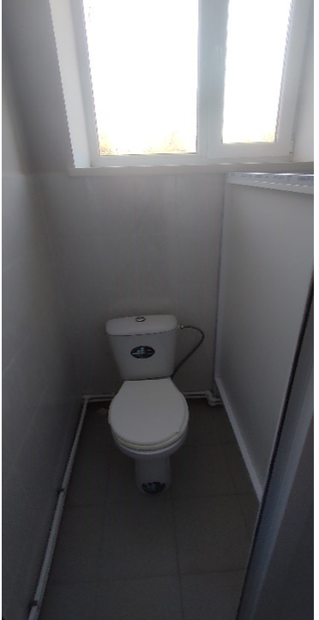
Level 2 GTS boys
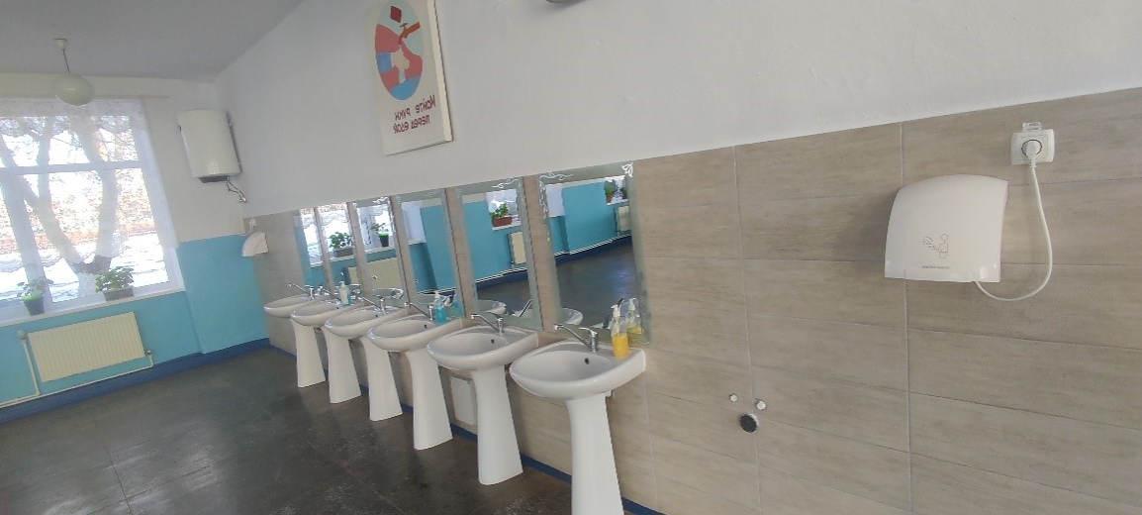
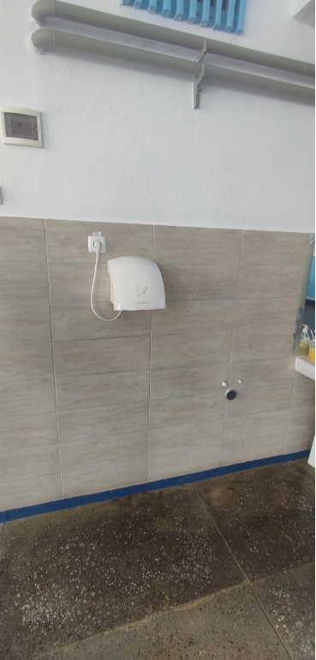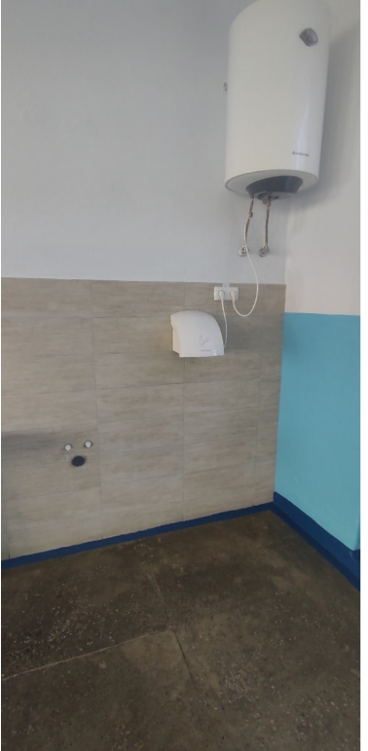
Handwashing facilities - canteen access
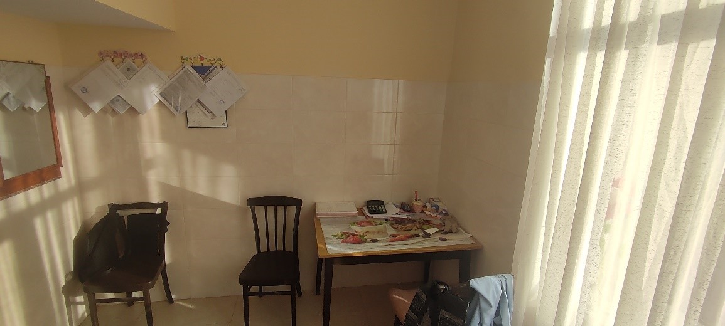

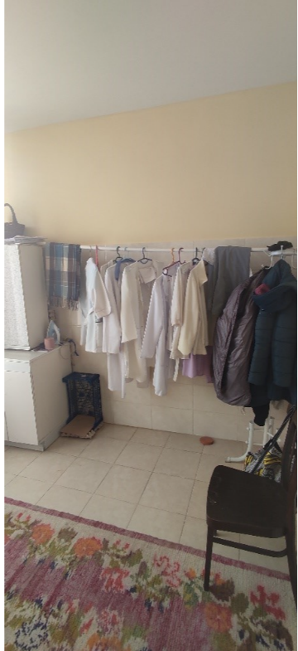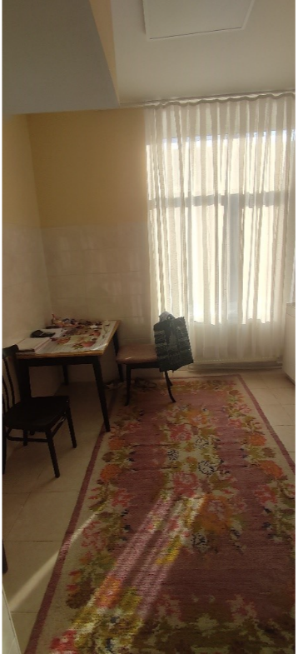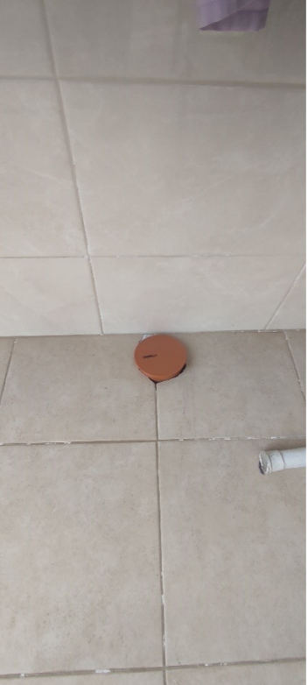
GTS technical staff in the kitchen

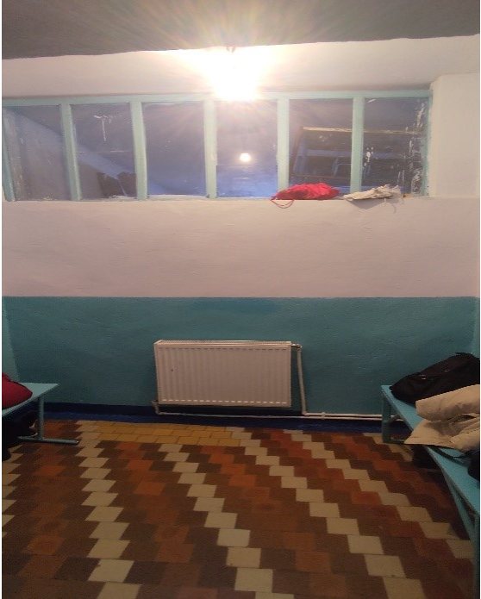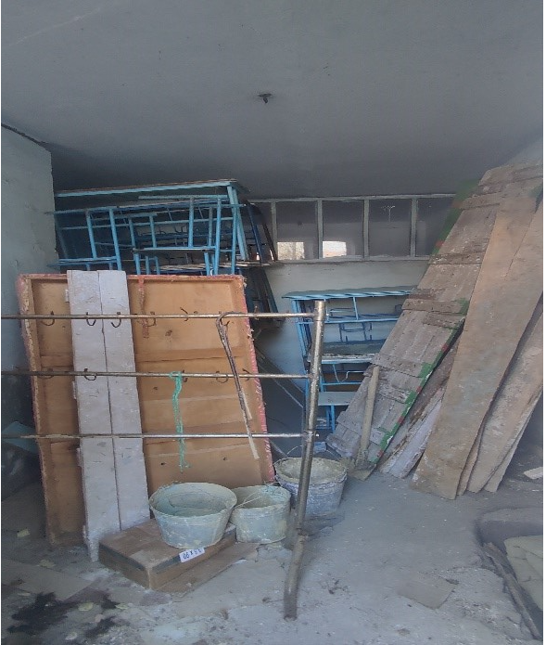
GTS girls locker room

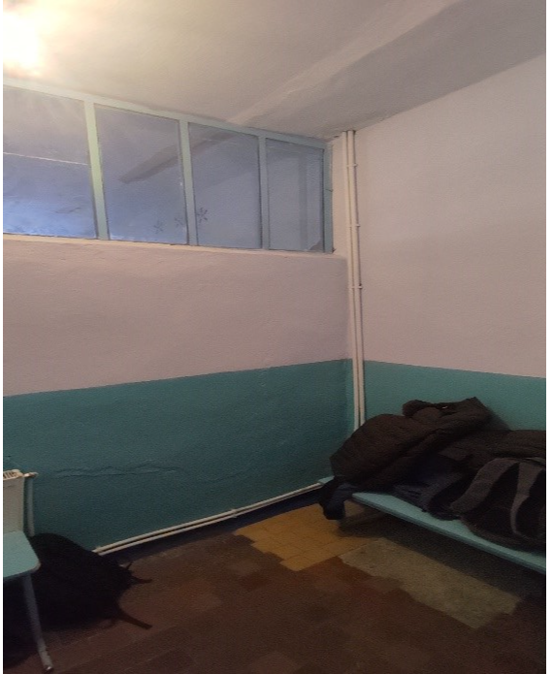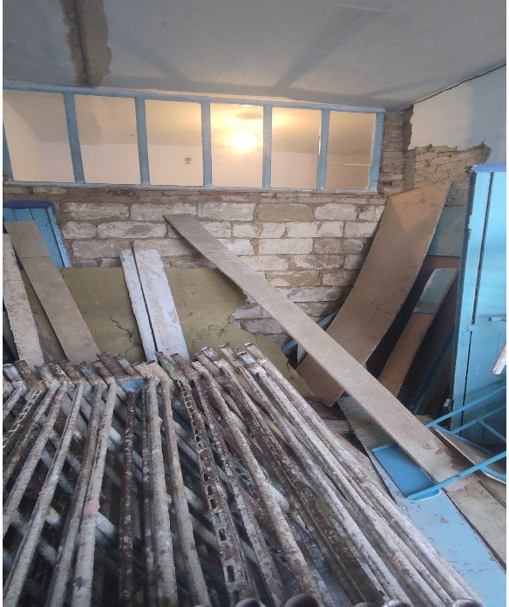
GTS girls locker room

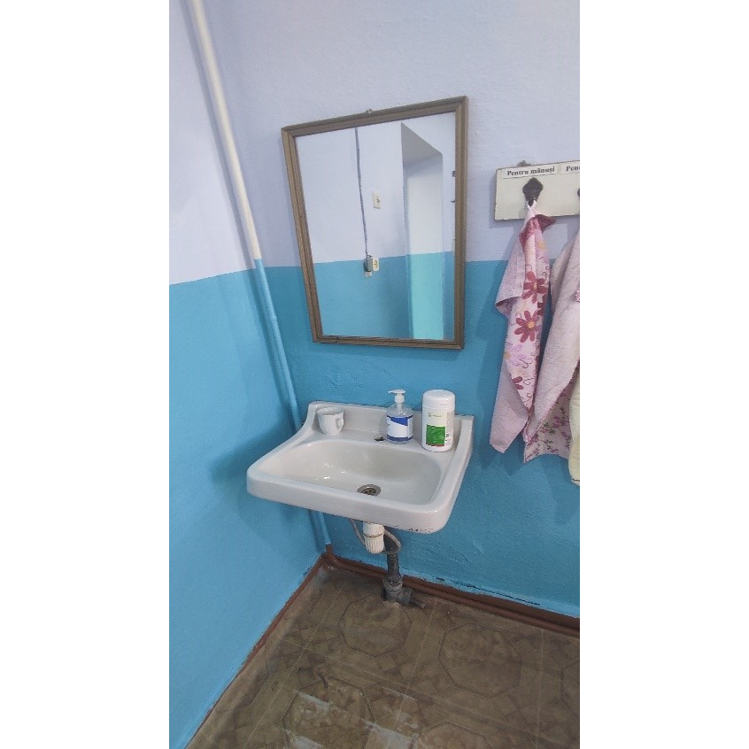
Handwashing facilities medical office
R. Ungheni, s. Frăsinești, ID 29

The institution consists of two blocks with one level each. Rehabilitation works of the toilets were carried out in 2018 (sanitary groups for boys has 2 cabins and a washbasin, sanitary groups for girls has 2 cabins and a washbasin, sanitary groups for teachers and technical staff has a cabin and a washbasin), but these facilities cannot be used due to the lack of centralized water. Children, teachers, and technical staff go to the latrines in the schoolyard toilet building.
Centralized water is not available continuously, the supply takes place from artesian wells near the institution. Identification of other groundwater sources were carried but failed to locate a new source. Water supply is carried out without a contract and is interrupted countless times. The water pressure at the time of the visit is very low.
There are 3 drinking water distribution points, located within the common space-corridor in the study block for classes. The hand washing points are in sanitary groups (3 sinks that cannot be used due to lack of centralized drinking water) and inside the canteen (5 sinks) that have only cold water.
The locality does not have centralized sewerage system, the wastewater from the canteen is discharged into the cesspit/tank built in 1990 and is not emptied.

Table 3 Demographics of school, r. Ungheni, s. Frăsinești
Boys | 44 (21 class 1-4)
Girls | 60 (26 boys’ grade 1-4)
Pupils with disabilities | 5
Total pupils | 104
Teaching staff | 15
Other staff | 8
Total Staff | 23

Particular recommendations to take into consideration for selected location (but not limited to these):
- Develop the detailed design of the wastewater treatment plant (WWTP) and connection to building sewerage system to ensure efficient treatment of wastewater from the sanitary facilities. Including connection of wastewater and water pipes for constructed sanitary groups.
- Develop the detailed design for improvement of the water supply situation, renovate and clean the well to bring a higher level of water in the existing well, (installation of water tanks) or identify and design of artesian well including the connection of pipeline, on the territory of the institution for a sustainable water source.
- Prepare the design for renovation of handwash facilities at the dining room. Increase the number of cabins for students, boys and girls.
- The design should address any structural and functional issues present in the existing sanitary facilities and handwash facilities including renewing flooring, walls, and ceilings, and ensuring that all elements meet current health, safety, and accessibility standards. Considerations should also include upgrading plumbing and sanitary facilities, water supply system, sewerage systems, renovating fixtures and fittings, improving heating and ventilation, electrical system, installation of water heaters, handwashing facilities, waste management, aesthetic, and functional improvements, ensuring accessibility for persons with disabilities, and adhering to relevant building codes and regulations.
- Additionally, prioritize the use of sustainable and durable materials to enhance the longevity and efficiency of the rehabilitated sanitary groups.

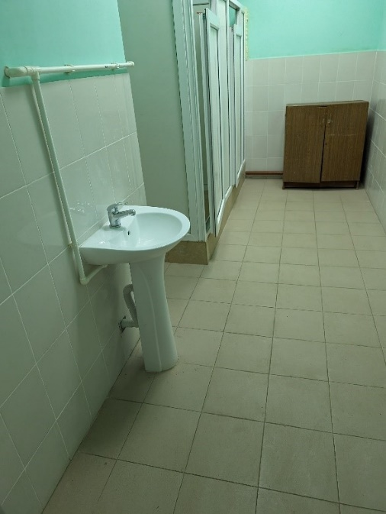  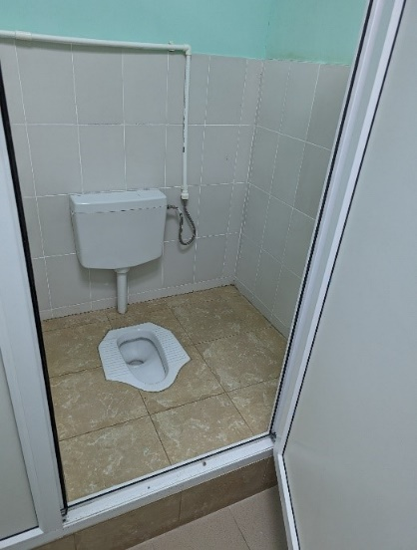  GTS guys-required Ventilation system and hand dryer, lack of centralized water | 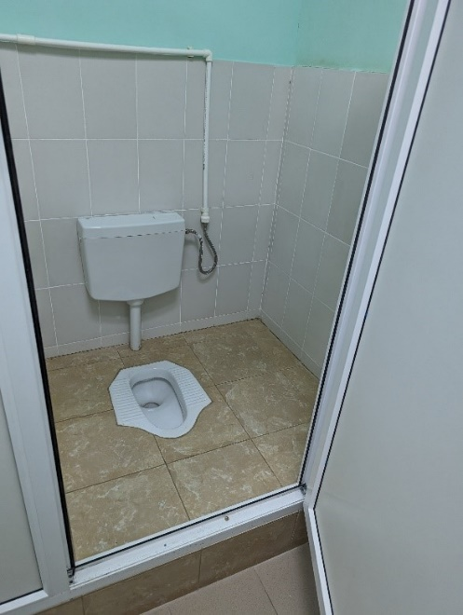  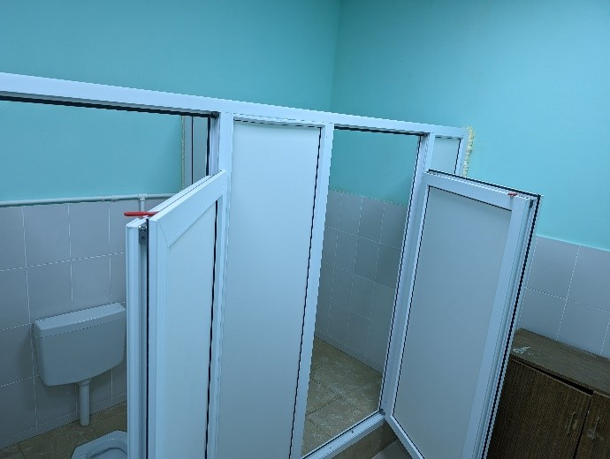  GTS guys-required Ventilation system and hand dryer, lack of centralized water
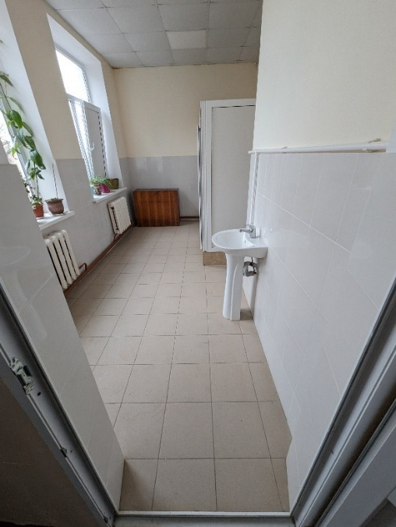  GTS girls – cowardly dryer Ventilation system, lack of continuous water | 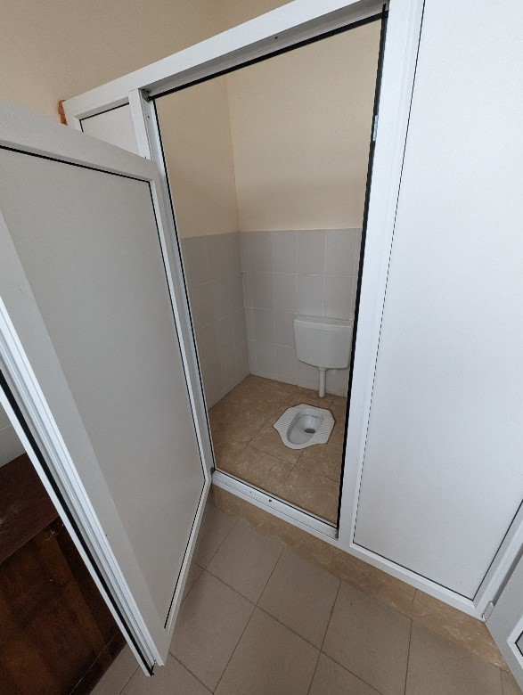  GTS girls – cowardly dryer Ventilation system, lack of continuous water
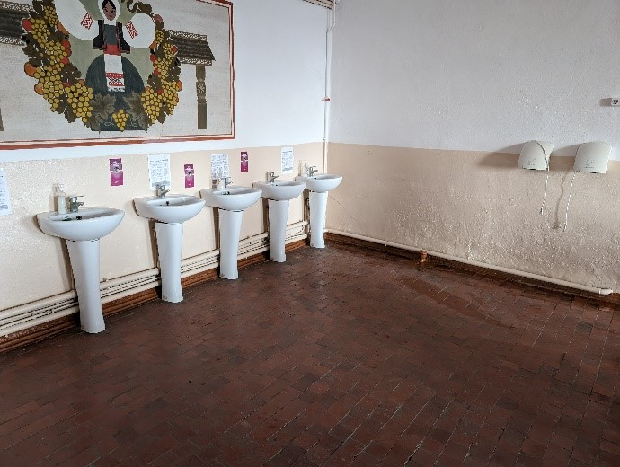  Access to the centralized water canteen pressure is poor, it is necessary to repair the access area and change washbasins | 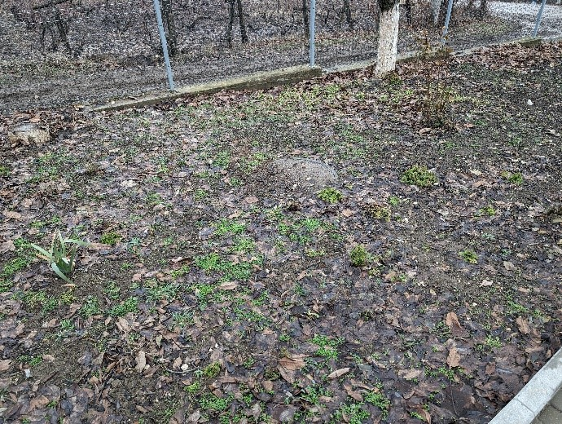  Cesspool, necessary to build the local wastewater treatment plant
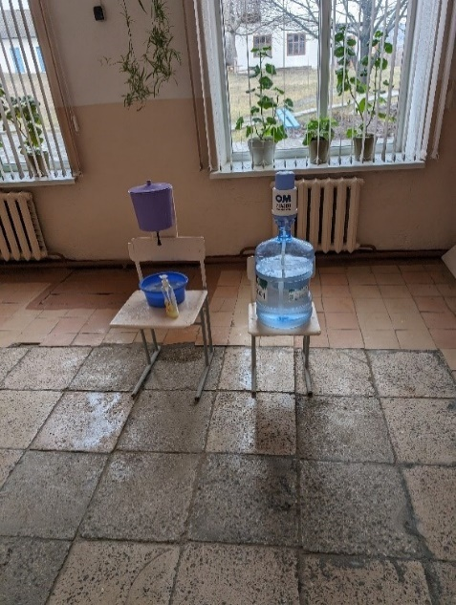  Point for drinking water (classes 5-9) and improvised system for washing hands | 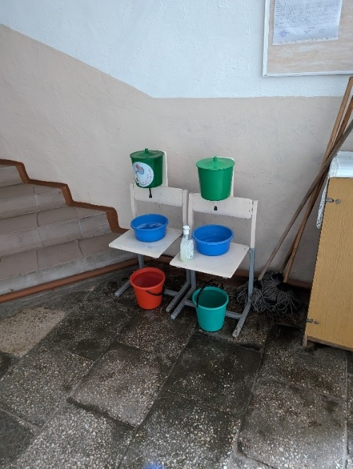  Improvised handwashing system (class 1-4)
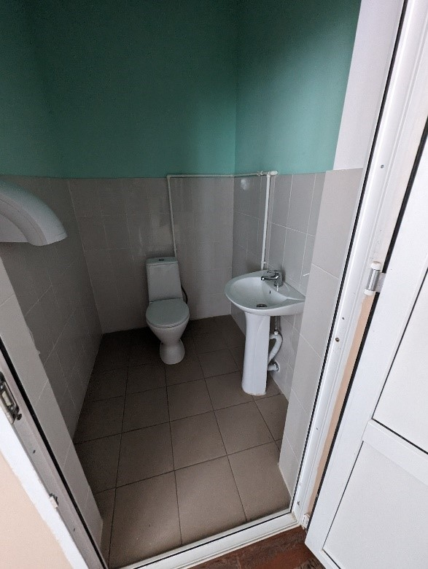  GTS staff-missing water, ventilation and lighting needs to be repaired | 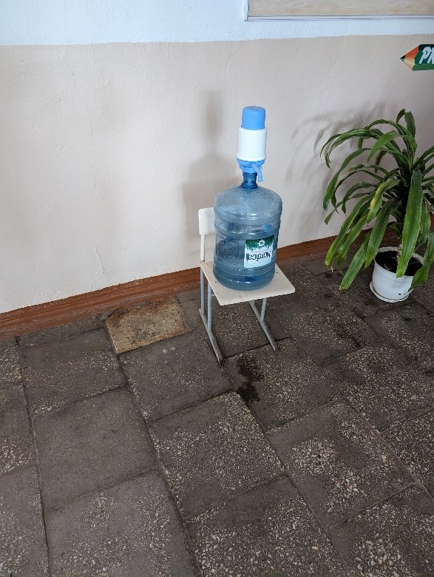  Source for drinking water, grades 1-4

The purpose of assessing existing buildings is either to maintain their original use, or to change their use.
In line with UNICEF’s Accessibility Technical Cards and Procedure on Eco-efficiency and Inclusive Access
In the case of UNICEF office construction/renovation/rehabilitation, engage with the Inclusive & Sustainable operations team to ensure compliance with the Procedure on Eco-Efficiency and Inclusive Access in UNICEF Facilities and Operations, including the cases where a green building certification is pursued.
Full architectural set includes master plan, layout, plans, sections, elevations, 3D images, details and finishes.
Full structural set includes foundation details, structural design and details of columns, beams, slabs, stairs, etc.
Such as owner’s permit, construction permit, environmental permit, permits from utility companies, including necessary design/drawings and documentation for service declaration to the government.
Duration depends on the tendering process.
After issuance of the Certificate of Substantial Completion.
Will be linked to the timeframe agreed in the construction contract.

