Annex 4.1: Technical Responsivess Table for LOT 1
LOT 1 Development of Designs and Installation of a Photovoltaic System with storage of 140 kW capacity for Strășeni District Hospital

# | Requirement/ parameter | Description | Indicate compliance  (YES / NO) | Highlight deviations and provide comments
Installation
 | Meteorological design conditions | Wind pressure – 30 kgf/m²  Snow load – 50 kgf/m²  Minimum temperature – -25°C  Maximum temperature – +60°C.
 | Execution electrical schematic | According to Annex 3.1.
 | General warranty period | ≥ 5 (five years) of general warranty for the entire PV system. The warranty should include the due maintenance to ensure the reliable and efficient operation of the PV system and elimination of defects/malfunctions that occur during the warranty period
 | Equipment condition | New, manufactured after the year 2023
 | Total power of the panels (DC) | ≥ 140 kWp
 | Total energy of the batteries | ≥ 164 kWh
 | Rated power of the inverter (AC) | 4x25=100 kW
 | Panel placement method | Metal roofing tile, Positioning  east – west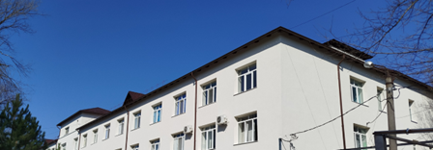
 | Inverter connection voltage (AC) | 400 V
 | Neutral grounding system | TN-S
 | Equipment for technical monitoring, connected to the inverter, with readings displayed in the application | To be implemented/equipped as required
 | Each panel must be equipped with an optimizer compatible with the inverter (specified in the technical datasheet) | To be implemented/equipped as required
 | Automatic system for monitoring the operation of the installation (online) of energy consumption and production data, with the ability to schedule the charging/discharging periods of the batteries, error and alarm indication, accessible to at least 3 users | Yes, free of charge, from the inverter manufacturer, on a web platform with free internet access
Equipement
 | The commercial energy metering cabinet equipped with a bidirectional meter. | Within the limits of Grid connection permit (Annex 2.1)
 | Solar panels:  Unit power  Lifespan  "Active" part  Module efficiency  Output power tolerance  Voltage, current, etc.  Dimensions  Electrical safety class  Connecting elements  IP protection rating  Weight | ≥ 500;  ≥ 25 years;  Monocrystalline;  ≥ 21%  Variation 0 - 3%  The strings formed must be compatible with the inverter under nominal operating conditions;  Within the availability limits of the existing roof space;  II  MC4  ≥ 67  Unlimited (provided that the existing supporting structures can bear the load, which will be reflected in the project’s structural part)
 | Inverter:  Minimum DC input power;  Minimum AC output power;  Minimum DC input for battery (5-42 kWh);  Number of DC inputs for battery;  Number of DC inputs for strings;  Number of MPPTs;  Rated voltage;  Rated frequency;  Neutral treatment regime;  DC/AC overvoltage protection;  Reverse polarity protection;  Insulation monitoring;  Internet connection;  Cloud services;  “On-grid” network connection;  Cooling;  Outdoor mounting;  Network connection standard;  Warranty period; | ≥ 37,5 kWp;  25;  Yes;  2;  4;  2;  400V;  50 Hz;  TN-S;  Yes, TII;  Yes;  Yes;  WLAN or 4G;  Yes;  Yes;  Natural;  Yes;  (SM) EN 50549  ≥ 10 (ten) years
 | Batteries  Technology;  Set capacity;  Maximum charge/discharge power;  Number of modules in the set;  Communication system;  Operating temperature; | LiFePO4;  ≥ 20,7 kWh;  10,5 kW;  3;  RS485/FE/CAN  -20℃to +55℃
 | Panel mounting system | Standardized for roof type “according to pt. 20,”  e.g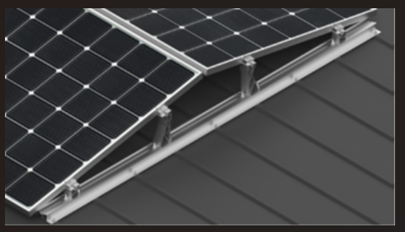
 | DC cables | Standardized for photovoltaic systems, colors according to Electrical Installation Regulations pt. 1.1.30,  S ≥ 6 mm².
 | Switching devices, protection devices, and surge protectors (AC/DC) | Standardized for photovoltaic systems, voltages, currents, and types according to the results of string modeling and the recommendations of panel and inverter manufacturers.
 | Distribution cabinets:  Material;  Method of installation;  Number of spare modules (poles);  IP protection rating;  IK protection rating. | ABS (plastic);  Outdoor;  ≥ 30% but not less than 4 modules;  ≥ 54;  ≥10.
 | It will be necessary to implement a control and command system for the photovoltaic plant and the storage system to ensure the exclusion of surplus energy delivery to the grid. | The works will be carried out using the contractor’s workforce
 | Assembly and installation of specialized equipment room for inverters and accumulators  Construction attached to the building, from sandwich panels (≥ 10 cm of mineral wool), according to fire safety requirements | The services will be carried out using the contractor’s own workforce. It is designed to be assembled on the exterior of the hospital building, attached to the wall at ground level, made of sandwich panels with a thickness of 10–15 cm. The exact dimensions will be determined during the design phase; indicative values: area approximately 10 m², height 2.2–2.5 m
 | Certificate of origin | For the main machinery, equipment, and materials used in the project — panels, inverter, electronic meter, cables, switches, etc

