Annex 4.2: Technical Responsivess Table for LOT 2
LOT 2 Development of Designs and Installation of a Photovoltaic System with storage of 180 kW capacity for Anenii Noi District Hospital

# | Requirement/ parameter | Description | Indicate compliance  (YES / NO) | Highlight deviations and provide comments
Installation
 | Meteorological design conditions | Wind pressure – 30 kgf/m²  Snow load – 50 kgf/m²  Minimum temperature – -25°C  Maximum temperature – +60°C.
 | Execution electrical schematic | According to Annex 3.2
 | General warranty period | ≥ 5 (five years) of general warranty for the entire PV system. The warranty should include the due maintenance to ensure the reliable and efficient operation of the PV system and elimination of defects/malfunctions that occur during the warranty period
 | Equipment condition | New, manufactured after the year 2023
 | Total power of the panels (DC) | ≥ 105 kWp (Main building section- first installation)  ≥ 75 kWp (Secondary building section- second installation)
 | Total energy of the batteries | ≥ 62 kWh
 | Rated power of the inverter (AC) | 3x25=75 kW (Main building section- first installation)  2x25=50 kW (Secondary building section- second installation)
 | Panel placement method | Corrugated metal sheet, Positioning  east – west  Roof- (Main building section- first installation)  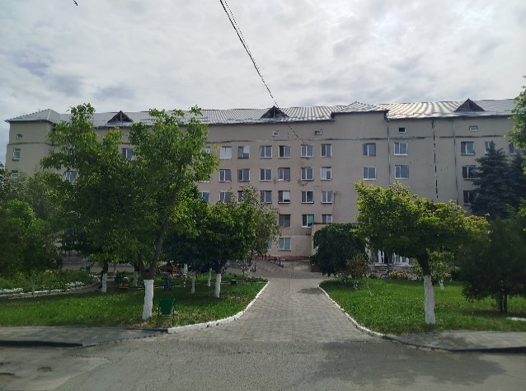  Roof- (Secondary building section- second installation)  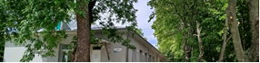
 | Inverter connection voltage (AC) | 400 V
 | Neutral grounding system | TN-S
 | Equipment for technical monitoring, connected to the inverter, with readings displayed in the application (the distance of 70 meters between buildings) | To be implemented/equipped as required
 | Each panel must be equipped with an optimizer compatible with the inverter (specified in the technical datasheet) | To be implemented/equipped as required
 | Automatic system for monitoring the operation of the installation (online) of energy consumption and production data, with the ability to schedule the charging/discharging periods of the batteries, error and alarm indication, accessible to at least 3 users | Yes, free of charge, from the inverter manufacturer, on a web platform with free internet access
Equipement
 | The commercial energy metering cabinet equipped with a bidirectional meter. | Within the limits of the Grid Connection Permits (Annex 2.2.1, 2.2.2, 2.2.3)
 | Reconstruction of the connections in the transformer substation by installing 2 motor-operated automatic circuit breakers, and 1 prefabricated controller for programming the operation of the Automatic Transfer Switch (ATS), in order to increase reliability and ensure Reliability Category I for the power supply.  (For Installation 1 – the main building) | Snom = 250 kVA;  Unom = 400 V;  Electronic circuit breaker, adjustable with LSI protections;  Motorized operation;  Capability to adjust voltage settings within the range of 0.5 – 1.5 Un;  Capability to adjust time settings within the range of 0 – 60 seconds, step of 1 second;  Operating mode with and without priority, restoration of the normal scheme after re-energizing the backup connection.
 | Solar panels:  Unit power  Lifespan  "Active" part  Module efficiency  Output power tolerance  Voltage, current, etc.  Dimensions  Electrical safety class  Connecting elements  IP protection rating  Weight | ≥ 500;  ≥ 25 years;  Monocrystalline;  ≥ 21%  Variation 0 - 3%  The strings formed must be compatible with the inverter under nominal operating conditions;  Within the availability limits of the existing roof space;  II  MC4  ≥ 67  Unlimited (provided that the existing supporting structures can bear the load, which will be reflected in the project’s structural part)
 | Inverter:  Minimum DC input power;  Minimum AC output power;  Minimum DC input for battery (5-42 kWh);  Number of DC inputs for battery;  Number of DC inputs for strings;  Number of MPPTs;  Rated voltage;  Rated frequency;  Neutral treatment regime;  DC/AC overvoltage protection;  Reverse polarity protection;  Insulation monitoring;  Internet connection;  Cloud services;  “On-grid” network connection;  Cooling;  Outdoor mounting;  Network connection standard;  Warranty period; | ≥ 37,5 kWp;  25;  Yes;  2;  4;  2;  400V;  50 Hz;  TN-S;  Yes, TII;  Yes;  Yes;  WLAN sau 4G;  Yes;  Yes;  Natural;  Yes;  (SM) EN 50549  ≥ 10 (ten) years
 | Accumulators (Batteries)  Technology:  Set capacity  Maximum charge/discharge power  Number of modules in the set  Communication system  Operating temperature | LiFePO4;  ≥ 20,7 kWh;  10,5 kW;  3;  RS485/FE/CAN  -20℃to +55℃
 | Panel mounting system | Standardized for roof type “according to pt. 20,”  e.g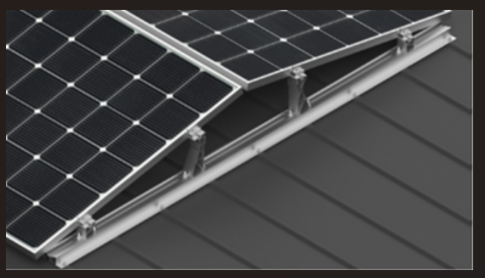
 | DC cables | Standardized for photovoltaic systems, colors according to Electrical Installation Regulations pt. 1.1.30,  S ≥ 6 mm².
 | Switching devices, protection devices, and surge protectors (AC/DC) | Standardized for photovoltaic systems, voltages, currents, and types according to the results of string modeling and the recommendations of panel and inverter manufacturers.
 | Distribution cabinets:  Material;  Method of installation;  Number of spare modules (poles);  IP protection rating;  IK protection rating. | ABS (plastic);  Outdoor;  ≥ 30% but not less than 4 modules;  ≥ 54;  ≥10.
 | It will be necessary to implement a control and command system for the photovoltaic plant and the storage system to ensure the exclusion of surplus energy delivery to the grid. | The works will be carried out using the contractor’s workforce
 | Construction of specialized equipment room for inverters and accumulators  Construction attached to the building, on the ground, from sandwich panels (≥ 10 cm of mineral wool), according to fire safety requirements | The works will be carried out using the contractor’s own workforce. It is designed to be built on the exterior of the hospital building, attached to the wall at ground level, made of sandwich panels with a thickness of 10–15 cm. The exact dimensions will be determined during the design phase; indicative values: area approximately 10 m², height 2.2–2.5 m
 | Certificate of origin | For the main machinery, equipment, and materials used in the project — panels, inverter, electronic meter, cables, switches, etc

