SECTION 1. LETTER OF INVITATION

Dear Sir/Madam,

The United Nations Entity for Gender Equality and the Empowerment of Women, hereinafter referred to as UN Women hereby invites prospective vendors to submit a quotation(s) in accordance with the Request for Quotation (RFQ) documents, including General Conditions of Contract (GCC) and the Terms of Reference as set out in this RFQ.

To enable you to submit a proposal, please read the following documents carefully.
- Section 1. This Letter of Invitation
- Section 2. Instructions to Vendors (including referenced General Conditions of Contract and Model Forms of Contract, available publicly on the UN Women website at: https://www.unwomen.org/en/about-us/procurement/contract-templates-and-general-conditions-of-contract
- Section 3. Information Sheet
- Section 4. Schedule of Requirements

Your submission should include the following:
- Form A: Quotation Submission Form
- Form B: Technical and Financial Offer
- Form C: Voluntary Agreement to Promote Gender Equality and Women’s Empowerment (optional - completed online)

If you are interested in submitting a quotation in response to this RFQ, please prepare your quotation in accordance with the requirements and procedure as set out in this RFQ and submit it by the deadline set out in the notice.

Should you require further clarifications, kindly communicate with the procuring office through the “Messages” function in Quantum.

We look forward to receiving your proposal,
UN Women Procurement Section

SECTION 2. INSTRUCTIONS TO VENDORS
GENERAL PROVISIONS
1. Scope | Vendors are invited to submit a quotation for the services/goods specified in the Terms of Reference (TOR)/Schedule of Requirements (SOR), in accordance with this Request for Quotation (RFQ).  Vendors shall adhere to all the requirements of this RFQ, including any amendment made in writing. This RFQ is conducted in accordance with Policies and Procedures of UN Women.
2. Interpretation of the RFQ | Any quotation submitted will be regarded as an offer by the vendor and does not constitute or imply the acceptance of the quotation by UN Women. UN Women is under no obligation to award a contract to any vendor as a result of this RFQ. Nothing in or in connection with this RFQ shall give rise to any liability on the part of UN Women unless and until the contract is signed by UN Women and the successful vendor. UN Women is not bound to accept the lowest evaluated quotation or any other quotation that UN Women may receive.
3. Deadline for the Submission of Quotation | Complete quotations must be received by UN Women in the manner, and no later than the date and time, specified in this document and the RFQ.  If any doubt exists as to the time zone in which the quotation should be submitted, refer to http://www.timeanddate.com/worldclock/.  It shall be the sole responsibility of the vendor to ensure that their quotation is submitted by specified submission method and received by UN Women by before the closing date and time.  Any quotations received after the stipulated deadline will be rejected.  UN Women may, at its discretion, extend this deadline for the submission of proposals by amending the solicitation documents in accordance with the Article 12 - “Amendment of solicitation documents”. In this case, all rights and obligations of UN Women and vendors subject to the previous deadline will thereafter be subject to the new deadline as extended.
4. Method of Submission | The vendor shall submit a complete quotation electronically through the Quantum system.  Electronic files that form part of the Quotation must be documents and forms in accordance with the format and requirements indicated in the RFQ (use the templates provided where applicable).  Quotations with no fixed price will be disqualified and will not be considered for evaluation.  The Quotation must be submitted electronically through the Quantum system (as indicated in the RFQ Documents). Electronic files that form part of the Quotation must be in accordance with the format and requirements indicated in the RFQ Documents;  Vendors must be aware that the mere act of submission of a quotation, in and of itself, implies that the vendor fully accepts the UN Women General Conditions of Contracts.
5. Withdrawal, Substitution, and Modification of Quotation | A vendor may withdraw, substitute or modify its quotation after it has been submitted at any time prior to the deadline for submission. In case of withdrawal, the vendor shall send a written notice to UN Women through the “Messages” functionality on the Quantum system. In case of substitution or modification of the quotation, if any, the vendor shall resubmit their quotation in the Quantum system. The substituted or modified quotation shall supersede the initial quotation.
6. Cost of preparation of quotation | UN Women shall not be responsible for any costs associated with a Supplier’s preparation and submission of a quotation, regardless of the outcome or the manner  of conducting the selection process.
7. Supplier Code of Conduct | All vendors must read the United Nations Supplier Code of Conduct and acknowledge that it provides the minimum standards expected of suppliers to the UN. The Code of Conduct, which includes principles on labour, human rights, environment and ethical conduct may be may be found at: https://www.un.org/Depts/ptd/about-us/un- supplier-code-conduct  Vendors who take part in this solicitation exercise, and willing to do business with UN Women must take all appropriate measures to ensure that neither themselves nor their parent, subsidiary, affiliate entities or their subcontractors are engaged in any gender-based or other discriminatory employment practices, including those relating to recruitment, promotion, training, remuneration, and benefits.  UN Women also expects all its suppliers to adhere to the principles of the United Nations Global Compact (https://www.unglobalcompact.org/) and requests that all Vendors observe the highest standard of ethics during the entire solicitation process, as well as the duration of any contract that may be awarded as a result of this RFQ exercise.  UN Women implements a policy of zero tolerance on proscribed practices, including fraud¹, corruption², collusion³, unethical practices⁴, and obstruction.⁵ UN Women requires all vendors to observe the highest standard of ethics at all stages, including pre- bidding/solicitation, during the procurement process, post-contract award, and contract implementation.  UN Women is committed to prevent, identify, and address all acts of fraud and corrupt practices against UN Women as well as third parties involved in UN Women activities. In pursuance of this policy, UN Women shall reject a proposal if it determines that the selected vendor has engaged in any corrupt or fraudulent practices in competing for the contract in question.  Further, UN Women shall declare a vendor ineligible, either indefinitely or for a stated period, to be awarded a contract if at any time it determines that the vendor has engaged in any corrupt or fraudulent practices in competing for, or in executing a UN Women contract.
8. Conflict of Interest | UN Women encourages every prospective Supplier to avoid and prevent conflicts of interest, by disclosing to UN Women if you, or any of your affiliates or personnel, were involved in the preparation of the requirements, design, specifications, cost estimates,  and other information used in this RFQ.
9. General Conditions of Contract | Any Purchase Order or Contract that will be issued as a result of this RFQ shall be subject to the UN Women General Conditions of Contract, which are available publicly on the UN Women website.
10. Eligible Vendors | Vendors may be a legally constituted commercial entity with legal capacity as a firm(s) with a valid registration, to enter into a binding commercial contract with UN Women.  Vendors shall not be eligible to submit a quotation if at the time of quotation submission:  - is suspended by or has any pending disputes or litigations with UN Women or other Organizations, Funds or Programs of the UN System;  - is subject to European Commission (EC) Financial Sanctions (the “EC Sanction List” - applicable only to projects/programmes funded by EC);  - has engaged in any money-laundering activities, which include, but are not limited to: any transaction involving the transfer, disbursement, transportation, transmission, or exchange of funds (including wire transfers and currency exchanges) by any means. is included in the Ineligibility List, hosted by UNGM, that aggregates information disclosed by Agencies, Funds or Programs of the UN System;  - is included in the Consolidated United Nations Security Council Sanctions List, including the UN Security Council Resolution 1267/1989 list;  - is included in the World Bank Corporate Procurement Listing of Non-Responsible Vendors and World Bank Listing of Ineligible Firms and Individuals.  As part of the RFQ exercise, by submitting a Quotation(s), vendor(s) declares (both for parent and/or subsidiary entities, as applicable) that it:  - is not a company, or associated with a company or individual, under procurement prohibition lists as stated above.  - is not under formal investigation, nor has been sanctioned within the preceding three (3) years by any national authority of a United Nations Member State for engaging or having engaged in proscribed practices, including but not limited to corruption, fraud, coercion, collusion, obstruction, or any other unethical practice.  - has not declared bankruptcy, is not involved in bankruptcy or receivership proceedings, and there is no judgment  - or pending legal action against them that could impair their operations in the foreseeable future.  - undertakes not to engage in proscribed practices (including but not limited to: corruption, fraud, coercion, collusion, obstruction, or any other unethical practice), with UN Women or any other party, and to conduct business in a manner that averts any financial, operational, reputational or other undue risks to UN Women;  It is the vendor’s responsibility to ensure that its employees, joint venture partners, sub- contractors, service providers, suppliers and/or their employees meet the eligibility requirements as established by UN Women.
11. Conflict of Interest | All vendors found to have a conflict of interest shall be disqualified. Vendors may be considered to have a conflict of interest if:  - they are or have been associated in the past, with a firm or any of its affiliates that have been engaged by UN Women to provide consulting services for the preparation of the design, specifications, TOR, cost analysis/estimation and other documents to be used for the procurement of the goods/ services/ civil works required in the present procurement process.  - has a close business or family relationship with a UN Women personnel who:  - are directly or indirectly involved in any stage of the RFQ-process of such contract; or (ii) would be involved in the implementation or supervision of such contract;  - has an interest in other vendors (who is submitting a proposal/s in response to this RFQ) including when they have common ownership and/or management. Vendors shall not submit more than one quotation, except for alternative offers, if permitted. This will result in the disqualification of all quotations in which the vendor is involved.  Vendors must disclose any actual or potential conflict of interest and they shall be deemed ineligible for this procurement process unless such conflict of interest is resolved in a manner acceptable to UN Women. Failure to disclose any actual or potential conflict of interest may lead to the vendor being sanctioned or debarred by UN Women, and the proposal security (if applicable) shall be surrendered to UN Women.
12. Clarification of Solicitation Documents | Vendors may request clarifications on any of the RFQ documents no later than the date indicated in the RFQ. Any request for clarification and all other correspondence in relation to this RFQ must be sent in writing through the “Messages” functionality in the Quantum system.  UN Women will publish the responses (including an explanation of the query but without identifying the source of inquiry) to all prospective vendors through the Quantum system. Responses will be made to clarification questions received by the deadline for questions indicated in the RFQ. Responses to clarification requests shall be binding for all vendors.
13. Amendment of Solicitation Documents | At any time prior to the deadline for submission of Quotations, UN Women may, for any reason, amend the solicitation documents. Prospective vendors will be notified through the Quantum system (as applicable) of all amendments to the solicitation documents. In order to afford prospective vendors reasonable time, UN Women may, at its discretion, extend the deadline for the submission of quotations.
14. Cost of Quotation | The vendor shall bear all costs related to the preparation and/or submission of the quotation regardless of whether its quotation is selected or not. Vendors acknowledge that their participation in any stage of the solicitation process for this RFQ is at their own risk and cost and shall not in any way include these as a direct cost of the assignment.  UN Women shall not be responsible or liable for those costs, regardless of the conduct or outcome of the procurement process.
15. Language | The quotation, as well as any and all related documents and correspondence exchanged by the vendor and UN Women, shall be written in the English language, or as otherwise indicated in the RFQ. Any document furnished by the vendor in another language than what is indicated in the RFQ must be submitted together with an English translation of relevant excerpts. In such a case, for purposes of interpretation of the quotation, the English translation shall govern.
16. Currency of  Quotation | Prices in the Quotation shall be quoted in the currency indicated in the RFQ, or any freely convertible currency. Where proposals are quoted in different currencies, for the purposes of comparison of all quotations:  - UN Women will convert the currency quoted into United Stated Dollars (USD), in accordance with the UN Operational Rate of Exchange in force at the time of the quotation submission deadline date and time.  - In the event that UN Women selects a quotation for an award that is quoted in a currency different from the preferred currency, UN Women shall reserve the right to award the contract in the currency of UN Women’s preference, using the conversion method specified above.
17. Duties and taxes | Article II, Section 7, of the Convention on the Privileges and Immunities provides, inter alia, that the United Nations, including UN Women as a subsidiary organ, is exempt from all direct taxes, except charges for public utility services, and is exempt from customs restrictions, duties, and charges of a similar nature in respect of articles imported or exported for its official use. All quotations shall be submitted net of any direct taxes and any other taxes and duties, unless otherwise specified in the RFQ.
18. Documents to be submitted | The quote shall comprise of the following documents and related forms which details are provided in the RFQ:  - Documents establishing the eligibility and qualifications of the bidder;  - Statement of Confirmation  - Technical and Financial Offer in accordance with the Schedule of Requirements  - Voluntary Agreement for Promoting Gender Equality and Women’s Empowerment  (optional);  Any attachments and/or appendices to the RFQ;
19. Quotation validity period | All Quotations shall remain valid and open for acceptance for a period instructed in the RFQ Documents after the Deadline for Submission. A Quotation valid for a shorter period may be rejected.  During the Quotation validity period, the Vendor shall maintain its original Quotation without any change, including the availability of the key personnel, the proposed rates and the total price.  In exceptional circumstances prior to the expiration of the Quotation validity period, UN Women may solicit the Vendor’s consent to an extension of the period of validity. The request and the responses thereto shall be made in writing and shall be considered integral to the Quotation. If the Vendor agrees to extend the period of validity, such extension shall be made without any change in the original Quotation. The Vendor has the right to refuse to extend the validity of its Quotation, and in which case, such Quotation will not be further evaluated.
20. Price variation | No price variation due to escalation, inflation, fluctuation in exchange rates, or any other market factors shall be accepted at any time during the validity of the quotation after  the quotation has been received.
21. Alternative Quotes | Unless otherwise specified in the RFQ, alternative quotes shall not be considered. If permitted, an alternative quote may be submitted only if a conforming quote to the RFQ requirements is submitted. Where the conditions for its acceptance are met, or justifications are clearly established, UN Women reserves the right to award a contract based on an alternative quote. If multiple/alternative quotes are being submitted, they  must be clearly marked as “Main Quote” and “Alternative Quote”
22. Errors or Omissions | Vendors shall immediately notify UN Women in writing of any ambiguities, errors, omissions, discrepancies, inconsistencies, or other faults in any part of the RFQ, with full details of those ambiguities, errors, omissions, discrepancies, inconsistencies or other faults.  Vendors shall not benefit from such ambiguities, errors, omissions, discrepancies, inconsistencies, or other faults.
23. Payment Terms | UN Women shall affect payment to the vendor within 30 days after satisfactory receipt of the goods/services and upon submission of payment documentation and acceptance of the documentation by UN Women, unless otherwise stated in the RFQ. Payment will be affected by bank transfer in the currency of contract.  Except when the interests of UN Women so require, it is UN Women’s standard practice not to make any advance payment(s) (i.e., payments without having received any outputs). Advance payments may not be made unless in exceptional circumstances and with appropriate authorization. Any request for advance payment must be justified and documented in the Quotation. The justification must explain the need for the advance payment, itemize the amount requested, and provide a time-schedule for utilization of  the requested advance payment amount.
24. Confidentiality | Information relating to the examination, evaluation and comparison of Quotations, and the recommendation of contract award, shall be treated with appropriate confidentiality.
25. Evaluation method | To evaluate a Quotation, UN Women shall only use all the methodologies and evaluation criteria defined in the RFQ Documents. No other methodology or evaluation criteria shall be permitted. UN Women shall examine the quotations to determine whether they are: submitted before the deadline, complete with respect to minimum documentary requirements, whether the documents have been properly signed, and whether the quotations are generally in order, among other indicators that may be used at this stage. UN Women may reject any Quotation during the preliminary examination which does not comply with the requirements set out in the RFQ, without further consultation with the Vendor.
26. Due diligence and audit | UN Women may carry out audits of the Vendor’s accounting records and financial statements and conduct background checks/due diligence on the Vendor recommended for award, to confirm the Vendor meets the criteria set forth in the RFQ or as appropriate to the nature of the procurement process. UN Women may reject a Vendor on the basis of such findings. Vendor shall permit UN Women representatives to access their facilities at any reasonable time to inspect the Vendor’s premises.
27. Clarification of Quotations without materials deviation | To assist in the examination, evaluation and comparison of quotations, UN Women may, at its discretion, ask the vendor for clarification of its quotation (without material deviation, reservation, or omission). The request for clarification and the response shall be in writing and no change in price or substance of the quotation shall be sought, offered or permitted.
28. Award criteria | In the event a contract award, UN Women shall award the Contract to a vendor who has been determined as eligible and qualified and whose quotation has been determined to be the lowest priced, substantially compliant offer to the RFQ, which offers best value for money. Due consideration will be given to UN Women’s Procurement Principles. UN Women reserves the right to conduct negotiations with the vendor recommended for award on the content of their quotation.  Where indicated in the RFQ, the contract may be awarded for one or more lots/items  at the discretion of UN Women.
29. Right not to accept any quotation | UN Women reserves the right to accept or reject any quotation, and to annul the tendering process and reject all quotation at any time prior to contract award, without thereby incurring any liability to the affected vendor or vendors or any obligation to inform the affected vendor or vendors on the grounds for UN Women’s action. UN Women shall not be obliged to award the contract to the lowest priced offer.
30. Right to vary requirement at time of award | At the time of award of Contract or Purchase Order, UN Women reserves the right to vary (increase or decrease) the quantity of services and/or goods, by up to a maximum of twenty five percent (25%) of the total offer, without any change in the unit price or other terms and conditions. If there is any restriction associated with quantity, the  Vendor must clearly state such restrictions and any price variation in their Quotation.
31. Liquidated Damages | If specified in the RFQ, UN Women shall apply Liquidated Damages for the damages and/or risks caused to UN Women resulting from the Contractor’s delays or breach of its obligations as per the Contract. The payment or deduction of such liquidated damages shall not relieve the Contractor from any of its other obligations or liabilities  pursuant to any current contract or purchase order.
32. Quotation Protest | UN Women’s vendor protest procedure provides an opportunity for appeal to vendors who believe that they have been unjustly treated in connection with this RFQ. The vendor protest procedure is available online and accessible from this link http://www.unwomen.org/en/about-us/procurement/vendor-protest-procedure and provides further details regarding UN Women’s vendor protest procedures.  Vendors, their subsidiaries, agents, intermediaries, and principals must cooperate with the Internal Audit Service (IAS) of UN Women’s Independent Evaluation and Audit Services as well as with other investigations authorized by the Executive Director and with the UN Women Ethics Office as and when required. Such cooperation shall include, but not be limited to the following: access to all employees, representatives, agents, and assignees of the Vendor; as well as the production of all documents requested, including financial records. Failure to fully cooperate with investigations will be considered sufficient grounds to allow UN Women to repudiate and terminate the contract and to debar and remove the vendor from UN Women’s list of registered suppliers.
33. Type of Contract to be awarded | Submission of a quotation shall be deemed as an acknowledgement by the vendor that all obligations stipulated by the RFQ will be met and, unless specified otherwise, the vendor has read, understood and agreed to all the instructions and requirements of the RFQ, the types of contract to be signed and the applicable General Conditions of Contract, which are available publicly on the UN Women website.
34. Signature of Contract | After the award is concluded and the decision is made, UN Women will furnish the winning vendor with a filled copy of the contract. Within ten (10) calendar days of receipt of the contract from UN Women, the successful vendor shall sign, date and return the signed contract to UN Women. Failure to do so may constitute sufficient grounds for the annulment of contract, rejection of offer and on which event UN Women may award the contract to the second ranked vendor or call for new quotations. UN Women reserves the right to suspend/debar the vendor from doing business with UN Women or/and other UN Organizations if Vendor refuses to sign the contract.
35. Policies and  procedures | This RFQ is conducted in accordance with Policies and Procedures of UN Women.
36. Gender-Responsive and Sustainable Procurement | In support of UN Women’s mandates, quotations from eligible women-owned businesses (a legal entity that is more than 51% owned, managed and controlled by one or more women) are encouraged.  In the case two (2) or more fully responsive quotations with the same price are received, UN Women will award the contract to the women-owned business. If more than one company is women-owned, UN Women will request the Best and Final Offer (BAFO) from all women-owned entities. In case none of the vendors submitting the lowest- priced fully responsive quotation are women-owned, UN Women will request the BAFO from those who submitted the lowest-priced fully responsive quotation.  UN Women expects all vendors in the areas of, including but not limited to, transportation, facilities and meeting venues, to include disability considerations for  the services to be accessible for all, where applicable.
37. Debriefing | Normally, UN Women does not offer a detailed debrief to involved unsuccessful vendors on any tender exercise. In the event that a vendor is unsuccessful, and in case of high-value or highly complex contracts, the vendor may request a debriefing from UN Women and UN Women may, in its own discretion, offer a debriefing in writing. The purpose of the debriefing is to discuss the strengths and weaknesses of the vendor’s submission, in order to assist the vendor in improving its future proposals for UN Women procurement opportunities. The scope of such debriefing is upon UN Women to decide. The content of other proposals and how they compare to the vendor’s submission shall not be discussed.

SECTION 3. INFORMATION SHEET

Title of requirement | Promotional materials and printing services for UN Women in Moldova
Deadline for Submitting Clarification Questions | 3 days before deadline for responses.
Quotation Validity Period | 90 business days
Value Added Tax on Proceed Quotation | Must be exclusive of VAT and other applicable indirect taxes
Liquidated Damages | Will be imposed as follows:  Percentage of contract price per week of delay: 0,1% up to a maximum of 10% of the Contract value, after which UN Women may terminate the contract.
Partial Proposals (Require Full Quantity) | Submitting proposals for parts or sub-parts of the ToR is not allowed.  If allowed, describe below how, and ensure that requirements properly describe the sub-parts: Click or tap here to enter text.
Alternative Proposals (Allow Multiple Responses) | Shall not be considered.
Site Inspection | A site inspection will not be held.  Date and Time: Click or tap to enter a date.  Location: Click or tap here to enter text.
Contract award to one or more vendor | UN Women will award a contract to:  One Proposer Only.
Method of Evaluation | Lowest-priced technically compliant.
Type of contract award (or Outcome of the process) | Contract Order
Documents to be presented by the supplier | ☒ Copy of Company’s Registration Certificate;  ☒ Statement or certificate of Quality for the offered products
Evaluation Criteria | ☒ Technical responsiveness/Full compliance to requirements;  ☒ At least 2 years of stated experience in provision of printing services  ☒ Have at least 1 similar successful project.  ☒ Availability to present samples upon request  ☒ Maximum delivery period as per required terms of 20 calendar days after Contract signature.
Other information related to the RFQ | Design, logos, text and other needed materials will be provided by the UN Women for each product.

SECTION 4: SCHEDULE OF REQUIREMENTS

Rationale:

One of the strategic objectives of UN Women is the economic empowerment of women. This objective aligns with the extended mandate of the National Commission for Financial Protection (CNPF) and its commitment to consumer protection and financial inclusion by increasing women's access to financial resources, such as loans and microfinancing, as well as alternative financial services.

The partnership between UN Women and CNPF aims to create synergies improving financial autonomy and protection for women and ensuring that gender perspectives are fully integrated into the mandate of CNPF. By incorporating gender considerations into financial policies, regulations, and consumer protection measures, we can effectively address the unique financial needs and challenges faced by women, thereby promoting better economic empowerment and inclusion.

In order to increase awareness and education among women, emphasizing the importance of advancing gender equality in this field. Various communication materials will be used to inform and educate the general public.

Scope of Work:
Under the overall guidance of UN Women Communication’s Officers, the selected company will be responsible to produce visibility materials required during the implementation of UN Women Women Economic Empowerment programme in Moldova with CNPF, Pay Gap program and brochures for other areas.
Technical Specifications for Goods:
Item No | Minimum technical requirements | Unit | Quantity | Deadline
1 | Branded A5 notebooks with hard front  Nature: A5 Notebook with full print on back with lined pages, and 7 personalized pages  Binding: Vertical spiral  Paper: Semi-glossy finish, at least 100 gsm lined pages with printed logo  Print: 4+0, with 7 personalised inside pages with information and the other pages - lined pages with logo, design provided by UN Women  Design: logos and text  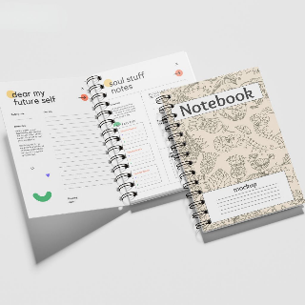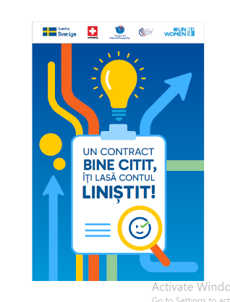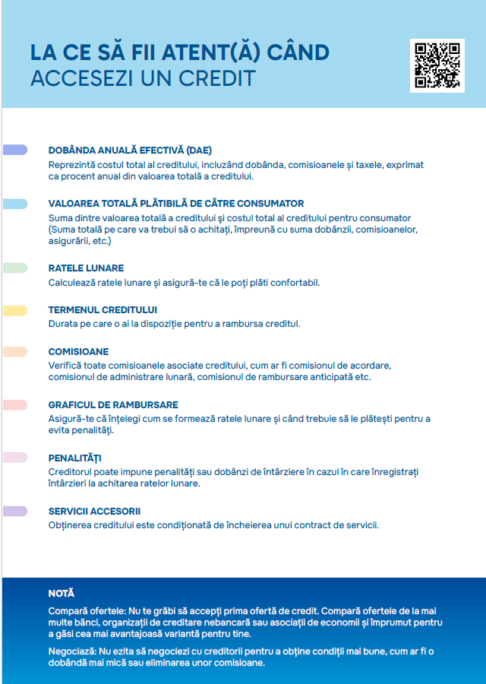 | pc | 300 | Within 20 days of contract signature
2 | Plastic Pen  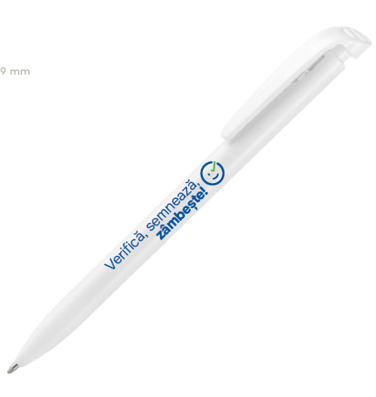  Nature: White minimalistic plastic ballpoint pen  Size approx.: 145 mm x 9 mm  Color: white  Ink color: blue  Print: 4+4  Design: logos and/or text | pc | 300 | Within 20 days of contract signature
3 | Water bottle  Nature: Aluminium water bottle with matchning carabiner  Volume: 750 ml  Size: approx. ø70×250 mm  Color: white  Print: Full color print, 4+0  Print size: 60mm x 100mm  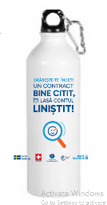  Design: logos and/or text on the front side | pc | 300 | Within 20 days of contract signature
4 | Fairtrade drawstring Backpack  Nature: Fairtrade cotton drawstring bag with distinctive Fairtrade label.  Size: 380×420 mm  Material: 100% fairtrade cotton, at least 180 gsm  Print: 4+0  Print size: 270mm x 330mm  Design: Logos and/or text on the front side  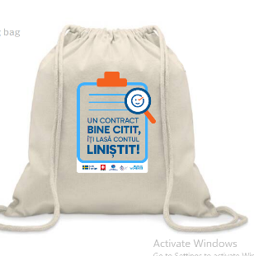 | pc | 300 | Within 20 days of contract signature
5 | - Backpack with laptop compartment Nature: Backpack in PU leather and RPET polyester.  - Main compartment with interior padded 15'' laptop pocket.  - Front pocket.  - Padded back and shoulder straps.  - Trolley strap to attach to hand luggage and side pockets.  - Material: PU leather and 600D PRET polyester  - Size: 30cm/43cm/11cm  - Colour: black  - Print: logo, 4+0  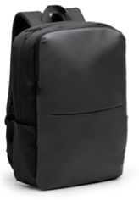  Design: Provided by UN Women | pcs | 40 | August 18
6 | Oversized T-shirt  - Unisex (XL, L, M, S)  - Cotton + Elastane  - 3 designs:  Feminism is my salary expectation.  #CloseTheGap  Equality means business.  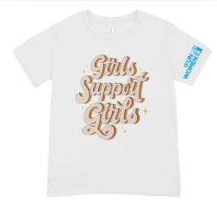  Design: provided by UN Women | pcs | 15 S  15 M  5 L  5 XL | August 18
7 | Umbrella  - Size: ⌀ 970 x 570 mm  - Material: Polyester  - Color: Black,  - Weight: 340 g  - Marking: DTF - 200 x 70 mm / Screen Printing - 200 x 70 mm  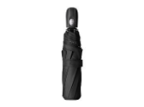  Design: provided by UN Women | pcs | 40 | August 18
8 | Power bank  - Recycled ABS power bank with 5000 mAh battery and built-in magnetic wireless charger (5W).  - With USB-C input and charger port. Including self-adhesive metal ring to use the magnetic function on any wirelessly chargeable device.  - Compatible with iPhone® 12 or newer. Including USB charger cable.    Design: provided by UN Women | pcs | 40 | August 18
9 | Symbolic envelope with "salary difference" + fake banknotes  - Include fake banknotes or a pay slip with a blank line: "Missing: 15,6% of her salary.”  - DL envelope 210mm x 99mm  - DL Pay Slip: 10.5 x 21 cm.    Design: provided by UN Women | pcs | 40 | August 18
10 | Sticker set - Volumetric puffy/bubble stickers  - Material: soft, slightly raised, with air-filled or cushioned effect, creating a puffy, 3D appearance.  - Approx Size of print: Design 1-7x5cm, design 2-3x7cm Print: 4C, high-resolution digital printing for detailed designs  - Shape: die-cutting, with smooth, rounded edges  - Adhesion: strong and long-lasting Background: transparent/white  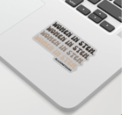  Design 1-4: provided by UN Women | pcs | 40 | August 18
11 | Custom enamel pin with magnetic attachment and paper backing card.  - Nature: Metal pin badge with enamel paint finish. Custom shape and design, with magnetic attachment.  - Pin material: metal with enamel paint  - Pin size: 30x30 mm.  - Pin print: Enamel paint, 4+0  - Card material: 300 gsm paper.  - Card size: approx. 50x75mm  - Card print: 4+0  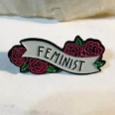  Design: provided by UN Women | pcs | 40 | August 18

Delivery Requirements
Delivery Requirements
Delivery date and time | Bidder shall deliver the goods within 20 calendar days after Contract signature.
Delivery Terms (INCOTERMS 2010) | DAP
Customs clearance  (must be linked to INCOTERM | ☐ Not applicable  Shall be done by:  ☐ Name of organisation  ☒ Supplier/bidder  ☐ Freight Forwarder
Exact Address(es) of Delivery Location(s) | UN Women Moldova premises  Maria Cebotari 18 Str., 3rd floor.  MD-2012, Chisinau, Republic of Moldova
Distribution of shipping documents (if using freight forwarder) | N/A
Packing Requirements | As per manufacturer standards
Training on Operations and Maintenance | No
Warranty Period | As per manufacturer requirements
After-sales service and local service support requirements | No
Preferred Mode of Transport | Land

FORM A: QUOTATION SUBMISSION FORM

Vendors are requested to complete this form, including the Company Profile and Bidder’s Declaration, sign it and return it as part of their quotation along with Form B: Technical and Financial Offer. The vendor shall fill in this form in accordance with the instructions indicated. No alterations to its format shall be permitted and no substitutions shall be accepted.

We, the undersigned, offer to supply the goods/services required in accordance with your Request for Quotation. We hereby submit our Quotation, which shall be valid and remain binding upon us for the period of time specified in the RFQ.

Vendor Declaration: on behalf of our firm, its affiliates, subsidiaries and employees, including any JV / Consortium / Association members or subcontractors or suppliers for any part of the contract:
- Requirements and Terms and Conditions: I/We have read and fully understand the RFQ, including the RFQ Information and Data, Schedule of Requirements, the General Conditions of Contract and any Special Conditions of Contract. I/we confirm that the Bidder agrees to be bound by them.
- I/We confirm that the Bidder has the necessary capacity, capability and necessary licenses to fully meet or exceed the Requirements and will be available to deliver throughout the relevant Contract period.
- Ethics: In submitting this Quote I/we warrant that the bidder: has not entered into any improper, illegal, collusive or anti-competitive arrangements with any Competitor; has not directly or indirectly approached any representative of the Buyer (other than the Point of Contact) to lobby or solicit information in relation to the RFQ; has not attempted to influence, or provide any form of personal inducement, reward or benefit to any representative of the Buyer.
- I/We confirm to undertake not to engage in proscribed practices, or any other unethical practice, with the UN or any other party, and to conduct business in a manner that averts any financial, operational, reputational or other undue risk to the UN and we have read the United Nations Supplier Code of Conduct: https://www.un.org/Depts/ptd/about-us/un-supplier-code-conduct and acknowledge that it provides the minimum standards expected of suppliers to the UN.
- Conflict of interest: I/We warrant that the bidder has no actual, potential or perceived Conflict of Interest in submitting this Quote, or entering into a Contract to deliver the Requirements. Where a Conflict of Interest arises during the RFQ process the bidder will report it immediately to the Procuring Organisation’s Point of Contact.
- Prohibitions, Sanctions: l/We hereby declare that our firm, its affiliates or subsidiaries or employees, including any JV/Consortium members or subcontractors or suppliers for any part of the contract is not under procurement prohibition by the United Nations, including but not limited to prohibitions derived from the Compendium of United Nations Security Council Sanctions Lists and have not been suspended, debarred, sanctioned or otherwise identified as ineligible by any UN Organization or the World Bank Group.
- Bankruptcy: l/We have not declared bankruptcy, are not involved in bankruptcy or receivership proceedings, and there is no judgment or pending legal action against them that could impair their operations in the foreseeable future.
- Offer Validity Period: I/We confirm that this Quote, including the price, remains open for acceptance for the Offer Validity.
- I/We understand and recognize that you are not bound to accept any Quotation you receive and we certify that the goods offered in our Quotation are new and unused.

Signature:
Name: Click or tap here to enter text.
Title: Click or tap here to enter text.
Date: Click or tap to enter a date.

FORM B: TECHNICAL AND FINANCIAL OFFER

Vendors are requested to complete this form and return it as part of their quotation. The Vendor shall fill in this form in accordance with the instructions indicated. No alterations to its format shall be permitted and no substitutions shall be accepted.
INCOTERMS: Click or tap here to enter text.
Item No | Description | UOM | Qty | Unit price MDL, VAT 0% | Total price
1. | Branded notebooks with hard front | pc | 300
2. | Plastic Pen | pc | 300
3. | Water bottles | pc | 300
4. | Branded Backpack with cord | pc | 300
5. | Backpack with laptop compartment | pc | 40
6. | Oversized T-shirt | pc | 40
7. | Umbrella | pc | 40
8. | Power bank | pc | 40
9. | Symbolic envelope with "salary difference" + fake banknotes | pc | 40
10. | Sticker set - Volumetric puffy/bubble stickers | pc | 40
11. | Custom enamel pin with magnetic attachment and paper backing card. | pc | 40
Total Price
Transportation Price
Other Charges (specify)
Total Final and All-inclusive Price MDL (VAT 0%)

I, the undersigned, certify that I am duly authorized to sign this quotation and bind the company below in event that the quotation is accepted.

Authorized Signature: | ______________________________
Date: | ______________________________
Name: | ______________________________
Functional Title of Authorised Signatory: | ______________________________
Email Address: | ______________________________

The decision on inclusion of VAT and any other taxes in financial proposals shall be based on the local legislation and SBAA agreement with the host country/-ies of the relevant Office ordering or performing the payment for the services. Depending on host countries, UN Women may be exempt from payment of direct and indirect taxes or may be required to pay the taxes and request reimbursement by submitting tax invoices.

