LRFQ-2019-9153393, Electric height adjustable office desks
Annex B

FORM FOR SUBMITTING SUPPLIER’S QUOTATION
This Form must be submitted only duly signed and stamped

The undersigned, having read the Terms and Conditions of LRFQ-2019-9153393, hereby offers to supply the goods specified in the schedule at the price or prices quoted, in accordance with any specifications stated and subject to the Terms and Conditions set out specified in the document.

Table 1. Goods description; requirements and offered specifications
 | Required specification | YES/NO | If NO, insert the proposed specification
1 | Adjustable height, 650-1100 mm
2 | Desktop size 1600 x 700 mm
3 | Cable management cut-out with cap, at least 200 x 100 mm
4 | Anti-collision sensor
5 | 25 mm melamine MFC desktop, 2 mm ABS edge, light wood color
6 | Two telescopic columns, at least one motor with at least 60 kg lifting capacity
7 | Under-the desk metallic cable tray
8 | Cloth-covered adjustable separator screen
9 | At least 3 years forwarded manufacturer warranty for the electric components and 3 years for the frame, desktop and legs
10 | Manufacturer EU furniture standards conformity (EN 527, ISO 2016:2007)
11 | Manufacturer electrical components certification
12 | Safety compliance certification
13 | Ecological and sustainability certification
14 | Demonstration sample available
15 | Installation services included
16 | Delivery date within 45 days from contract signature

Generic image of the desks required under this solicitation:

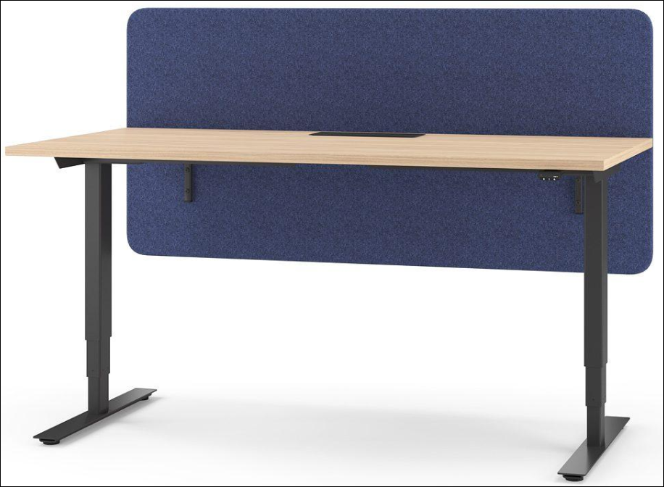

Table 2: Price Offer. Please provide the prices for the desks and the screens separately

Item No. | Description/Specification of equipment | Quantity | Unit Price, USD, VAT 0% | Sub-total Price, USD, VAT 0%
1 | Electric Height Adjustable Computer Desk | 30
2 | Cloth-covered adjustable separator screen | 30
3 | Other additional costs (if any)
 | Total price

All other information that we have not provided automatically implies our full compliance with the requirements, terms and conditions of the RFQ.

[Name and Signature of the Supplier’s Authorized Person]
[Designation]
[Date]

