Annex 2
FORM FOR SUBMITTING SUPPLIER’S QUOTATION
(This Form must be submitted only using the Supplier’s Official Letterhead/Stationery)

We, the undersigned, hereby accept in full the UNDP General Terms and Conditions, and hereby offer to supply the items listed below in conformity with the specification and requirements of UNDP as per RFQ Reference No. RfQ20/02162:

TABLE 1 : Offer to Supply Goods Compliant with Technical Specifications and Requirements
Goods | Nr. Of items | Price per item | Total price in MDL, VAT 0%
- Furniture (Chairs)  Type: Opera S Weight: 4,14 kg  Total height: 84 cm Chair case colour: black  Seat height: 47 cm Chair back colour: red  Seat wide: 49 cm Material: polypropylene/polycarbonate  Seat depth: 55 cm Delivery location: Holercani village  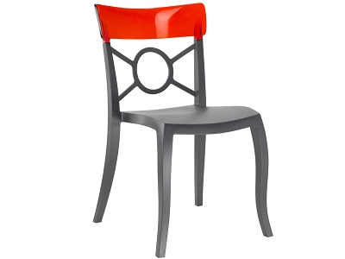  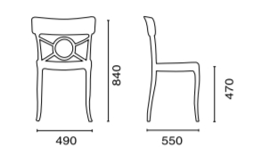 | 156
Total Final and All-Inclusive Price Quotation

TABLE 3 : Offer to Comply with Other Conditions and Related Requirements
Other Information pertaining to our Quotation are as follows: | Your Responses
 | Yes, we will comply | No, we cannot comply | If you cannot comply, pls. indicate counter proposal
Maximum Delivery period not to exceed 2 calendar months upon signature of PO contract by both parties
Validity of Quotation 90 calendar days
All Provisions of the UNDP General Terms and Conditions

All other information that we have not provided automatically implies our full compliance with the requirements, terms and conditions of the RFQ.

[Name and Signature of the Supplier’s Authorized Person]
[Designation]
[Date]

This serves as a guide to the Supplier in preparing the quotation and price schedule.
Official Letterhead/Stationery must indicate contact details – addresses, email, phone and fax numbers – for verification purposes

