CONCEPT and TECHNICAL REQUIREMENTS
reengineering of the electronic platform of the surveillance system for communicable diseases and public health events

CONTENT
1 Introduction 6
1.1 Goal of the document 6
1.2 Scope 6
1.3 Abbreviations 6
2 Analysis Methodology 8
2.1. Goals 8
2.2. Stages of the process 8
2.2.1. Analysis of the Beneficiary’s organization 9
2.2.2. Planning and management of requirements 9
2.2.3. Collection of requirements 9
2.2.4. Analysis and documentation of requirements 10
2.2.5. Communication and presentation of requirements 11
2.2.6. Assessment and validation of requirements 11
3 Background 13
3.1 Overall structure of EAS 13
3.2 Proposed architecture 13
4 EAS modules 15
4.1 “Notification of nominal cases and results of epidemiological investigation” 15
4.1.1 Notification 17
4.1.2 Notified primary diagnosis 19
4.1.3 Patient identification data 20
4.1.4 Registration of the case in the information system 23
4.1.5 Symptoms / signs of the disease 24
4.1.6 Final diagnosis 28
4.1.7 The results of the epidemiologic investigation 29
4.1.8 Case transfer 30
4.1.9 Case classification 31
4.1.10 Other 32
4.2 Graphics 33
4.2.1 Display of cases on the map of Moldova (GIS) 33
4.3 Reports module 34
4.3.1 F2 Report 35
4.3.2 “List of individual cases” report 35
4.3.3 “List of symptoms of individual cases” Report 37
4.3.4 “List of epidemiologic investigations of individual cases” Report 38
4.3.5 Alert Report 40
4.4 Alerts module 41
4.4.1 Alert generation rule 41
4.4.2 Viewing alerts 43
4.4.3 Conditions for generating alerts 44
4.5 Modul on data exchange and interoperability with other electronic system 46
– need further development 46
5. Roles 47
6. Coverage of functional requirements 51
UC 01: Notification 51
UC 02: Notified primary diagnosis 52
UC 03: Patient data 53
UC 04: Case registration 55
UC 05: Symptoms / signs 55
UC 06: Final diagnosis 57
UC 07: Investigation result 58
UC 08: Change status 59
UC 09: Case transfer 60
UC 10: Graphic representation 61
UC 11: Reports 61
UC 12: Alert 62
7. Non-functional requirements 64
1. General system requirements of AIS ISS 64
2. IT system performance requirements 65
3. SIA ISS security and protection requirements 65
4. Administration performance requirements 67
5. SIA ISS software, hardware and communication requirements 68
6. The information system documentation requirements 69
7. IT system maintenance requirements 70
8. The final product and delivered components 70
8. Annexes 72
Annex 1, 058 / e 72
Annex 2, F2 73
Annex 3 Epidemiological investigation conclusions 77
Nomenclatures 78
1. Health facilities 78
2. Affiliation 78
3. Clasification_I 79
4. CUATM 79
5. ICD-10 79
6. Level_D 79
7. Country 79
8. Social_S 80
9. Environment_R 80
10. Age 80
11. Insurance 80
12. Users 81
13. Rash_T 81
14. Palsy_T 81
15. Contractures_T 82
16. Cough_T 82
17. Tonsillitis_T 82
18. Evolution_T 82
19. Final_T 83
20. Case_T 83
21. Patient_T 83
22. FPT_A 83
23. FPT_P 84
24. Conditions_T 84
25. Detection _T 84
Interfaces 86
Login page 86
List of notifications 87
Notification 88
Primary diagnosis 89
Patient data 90
Registration of the case in the system 91
Symptoms / signs 92
Final diagnosis 93
Epidemiologic investigation result 94

Background
The IT solution is necessary to strengthen the surveillance system for communicable diseases and public health events that will be obtained as a result of the re-engineering process of the Automated Information System "The Advanced Surveillance System for Avian Influenza and Other Infectious Diseases / Epidemiological Alert System (at the initial stage) for management and evidence in the field of state surveillance of communicable diseases in the Republic of Moldova.
The electronic platform for the surveillance system for communicable diseases and public health events will be a technical solution that will allow the registration of the data set on registration / urgent notification of the case of infectious disease, intoxication, food poisoning and / or acute occupational infection according to Form report 058 / e “Urgent notification sheet on the detection of the case of infectious disease, acute food and / or occupational intoxication, adverse reaction after administration of immunobiological preparations” and generation of the result of the epidemiological investigation.
The system will allow monitoring the process of systematic and continuous public health data collection, analysis, interpretation and dissemination in the context of their distribution in time, space, population group and analysis of risk factors for contacting these diseases, including epidemiological studies, in order to implement public health measures on the territory of the Republic of Moldova
For maximum operability, the system will be integrated with other systems (SIA AMP, SIA AMS, CNAM, RSP, etc ..) through the government interoperability platform Mconnect, which will significantly reduce the time required to collect data needed to conduct epidemiological investigation.
An adequate level of protection of personal data will be ensured. The electronic system will establish a hierarchy, the level of access and the responsibilities of the main actors, regarding the processing of the data stored in the system. The full name of the electronic platform is "Automated Information System" Advanced System for Surveillance of Avian Influenza and Other Infectious Diseases "(SIA SPS).
The product of the re-engineering services of the electronic platform of the surveillance system for communicable diseases and public health events will be the property of the Beneficiary. The developer will provide a guarantee at least 12 months after signing the delivery note.
- Introduction
  - Goal of the document
The goal of this document is to define how the IT solution developed in the course of the Epidemic Alert System (hereinafter EAS) re-engineering will be implemented, which will be dedicated (at the initial stage) to the state surveillance of communicable diseases management and follow up in the Republic of Moldova.
The system requirements will be clearly structured and documented at the analysis stage, based on the available information and consideration of all provided documents.
This document presents the structure, the final architecture of the technical solution, the functional and non-functional requirements, the modules to be implemented, as well as the parameters that need to be implemented to meet the requirements.
  - Scope
The document is available during the analysis phase and is valid for the entire duration of its development.
The information included in this document (functional requirements, non-functional requirements) will be used in the final IT solution design and implementation.
Any changes to the content of this document shall be made in strict compliance with the Change Management procedure included in the Quality System.
  - Abbreviations
Abbreviation | Definition
ISS | Improved Avian Influenza and Other Infectious Disease Surveillance System
AIS | Automated Information System
AIS ISS | Automated Information System “Improved Avian Influenza and Other Infectious Disease Surveillance System“;
EAS | Epidemic Alert System
PHC | Public Health Center
NAPH | National Agency for Public Health
HF | Health facility
PRHF | Primary Record Healthcare Facility
HC | Healthcare
System | AIS ISS
DB | Database
AIS ISS DB | Improved Avian Influenza and Other Infectious Disease Surveillance System Database
GIS | Geographic Information System
CUATM | Classifier of administrative territories in Moldova
SIA AMP | Information sistem for primary health care
SIA AMS | Information sistem for hospital care
CNAM | National Health Insurnace Company
RSP | Population Registry
AOAM | Mandatory Health insurance

- Analysis Methodology
Analysis methodology regarding the stages and activities of the analysis process, as a component part of the proposed IT solution development cycle, is based on the best practices in the field, recommendations and instructions that can be found in the following specific guides and frameworks and which have an impact on the activities carried out by the business analyst:
- International Institute of Business Analysis (IIBA) - A Guide to the Business Analysis Body of Knowledge (BABOK Guide), version 2.0
- Unified Modeling Language (UML)
- Information Technology Infrastructure Library (ITIL)
The analysis methodology is flexible, designed primarily to meet the business needs of the Beneficiary, and can be adapted in this regard. The underlying framework supports a number of types of developments, whether the Beneficiary wants a new IT solution or an improvement of the existing one.
The tools and techniques provided in the analysis methodology support the development of the whole analysis process facilitating the management of the Beneficiary’s requirements to get what the specialized literature calls SMART requirements:
- S - Specific - are they clear about what? where? when? and how? what needs to be done
- M - Measurable - are measurable, quantifiable, measurable in terms of progress and level of implementation / accomplishment
- A - Achievable - the goal can be achieved with the available resources
- A - Relevant - relevant in the context of reengineering
- T - Time-boxed - limited in time
Each Beneficiary shall define their business needs in a different way. However, regardless of the culture and processes of an organization, the principle behind the business requirements is the same: sufficient investigation to discover the business need so that there is certainty that the stakeholders (key users from the part of the Beneficiary) agree with the identified need and direction before going into more detail.
  - Goals
The main goals pursued in the analysis process are:
- defining the IT solution as “what is” and “what should be”;
- defining in detail the IT solution requirements and translating the requirements obtained in this process into detailed specifications, both software and hardware, based on the platforms and technologies sought to be provided in the course of re-engineering.
  - Stages of the process
Elaboration on the business analysis process main goals requires imposing and successful completion of the following important stages:
- Analysis of the Beneficiary’s organization
- Planning and management of requirements
- Collection of requirements
- Analysis and documentation of requirements
- Communication and presentation of requirements
- Assessment and validation of requirements
    - Analysis of the Beneficiary’s organization
The analysis of the Beneficiary’s organization aims at identifying the problems/needs that the Beneficiary intends to solve by developing and implementing the IT solution, review of the existing infrastructure of the Beneficiary’s organization, as well as the requirements to be implemented.
At this stage, the main role is played by the business analyst, who shall carry out the following activities:
- Defines problems and needs and identifies the reasons thereof;
- Identifies the overall requirements to be met by the proposed IT solution;
- Identifies the parties involved, in terms of organizational entities within the Beneficiary’s organization involved in the use and administration of the solution to be provided and identifies the roles and responsibilities for each system implementation activity and administration process;
    - Planning and management of requirements
At this stage, the analysis phase shall be planned in detail. The planning shall be based on a previously agreed action plan.
The approach to be followed during the analysis phase shall establish:
- the number and type of meetings at the analysis stage, the proposed agendas and persons involved;
- the type and initial structure of the deliverables.
    - Collection of requirements
Collection of requirements is an important activity in the business analysis process. Clearly, correctly and completely defined requirements are the basis for an IT solution that fully meets the needs of the Beneficiary.
The Developer’s team will analyze all the elements (including, but not limited to processes, infrastructure, documents, regulations) in the Beneficiary’s organization that are necessary to fully define the requirements of the IT solution to be delivered.
The main techniques for collecting the requirements that will be used at this stage are:
- Analysis sessions, including structured or unstructured interviews, workshops or focus groups with key users of the IT solution. The business analyst is responsible for setting the discussion agendas for each analysis session. These will be communicated to the Beneficiary in advance, as well as to the key users who must participate in the discussions. Minutes of the meeting will be drafted for each meeting, and signed by all participants.
- Review of the documentation provided by the Beneficiary, or other public documents related to carrying out the re-engineering.
The level of structuring and organization of requirements at this stage will be minimal, with no emphasis on dependencies between the requirements or grouping by modules.
Development of requirements implies identification of the IT solution requirements and accomplishment and implementation of activities by both the Developer and the Beneficiary:
DEVELOPER’S OBLIGATIONS
- to receive, analyze and understand all the requirements expressed by the Beneficiary related to the IT solution to be delivered;
- to include in the Requirements Matrix all the requirements expressed by the Beneficiary and which are part of the re-engineering goal; all requirements expressed by the Beneficiary which are not covered by the goal may be detailed, clearly specifying this.
- to respond to any clarification request and to respond to the Beneficiary’s any request to change the specifications of the IT solution as soon as possible.

OBLIGATIONS OF THE BENEFICIARY
- Ensure the availability of key users throughout the analysis phase, in accordance with the agreed Action Plan;
- Provide the Developer with all necessary information to properly detail the requirements of the IT solution, including, but not limited to: contact details of the key users by communicated typology, workflows or processes impacted by solution implementation, details about existing hardware and/or software infrastructure;
- Respond as soon as possible to all Developer’s requests for clarification/modification of requirements in an affirmative/negative way, and provide the necessary justifications.
    - Analysis and documentation of requirements
The starting point of requirements analysis and documentation are the requirements defined in the Requirements Matrix allowing identification of those who need information (Who?), Where (Where?), When (When?) and in what form and content. (How?). The goal of this stage is to accomplish a sufficiently detailed description of the IT solution requirements to ensure development of a solution that fully meets the Beneficiary’s needs.
The business analyst must determine what types of models are needed to meet the goal of the solution and to be understood by all stakeholders, both the Beneficiary’s key users and development/implementation teams.
The analysis and documentation of the IT solution requirements shall be made using the object-oriented analysis technique, using the UML standard. Starting from Philippe Kruchten’s 4 + 1 model, the business analyst shall detail the following perspectives of the architectural model:
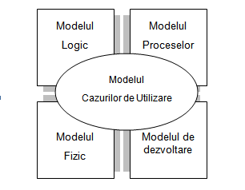
Figure1 . Model 4 + 1
The aim of this type of modeling is to describe the functionality of the system as seen from the outside by a number of actors and their connections with the use cases provided by the system.
The result of the requirements analysis and documentation activities at the analysis stage shall be materialized/presented in the form of a business analysis document.
    - Communication and presentation of requirements
Maintaining and involving all stakeholders throughout the process is an essential, extremely difficult activity and is largely the responsibility of the business analyst and the manager.
The communication and information of the team about the activities implementation stage, progress, identified risks shall start at the inception of the reengineering activity, continue throughout the process until completion and go on in the subsequent post-implementation phases.
Specific to the analysis process, as a first step in the communication and presentation of requirements, after completing the collection and analysis of requirements by the team involved in the analysis process, the results and design integration for each separate component will be verified. The analysis document will be validated in terms of feasibility of the proposed IT solution.
    - Assessment and validation of requirements
In the process of assessment and validation, the team shall review the document and provide comments in writing. These comments can be summarized in various forms: comments inserted in the document, notes or reports, minutes of meetings, as results of discussions.
The business analyst shall put together all comments and make necessary changes in the analysis document. Consideration shall be given to compliance with the goal and scope, as originally defined. Additional changes that are not covered by the goal or scope shall be documented.
The scope can be extended according to the change management procedure.
The analysis stage shall be considered completed once the analysis document is approved and signed.
- Background

Overall structure of EAS
EAS shall allow the recording of information about the process of systematic and continuous collection, analysis, interpretation and dissemination of health data on communicable diseases and public health events, in the context of their spread over time, space, population groups and analysis of risk factors related to contacting these diseases, including in the course of epidemiological research, in order to implement public health measures on the territory of the Republic of Moldova;
The system provides for an open architecture for integration with various external platforms using secure data transfer channels. The modular design ensures a high level of security.

Proposed architecture
The EAS, will be based on a modular architecture that implies the existence of components that have complex functionalities in the application.
The EAS will be based on a logical architecture that requires the existence of a database and an application server.
The system provides an open architecture for further integration with various external platforms using secure data transfer channels.
Users will access the system through the WEB interface, and access authorization will be ensured by user’s authentication by login/password.
Users will access the system via WEB interface, and access authorization will be ensured by user authentication via MPass.
The system will have:
- A single database for storing and managing data on nominal notifications of human origin;
- An alert triggering system;
- A reporting system allowing to create analytical, statistical and graphical reports;
- A visualization system of the epidemiological situation on the map of Moldova;
- Interaction system with other electronic systems such as Population Register, NHIC, etc .;
- Web application for the exchange of data with other electronic systems developed or under development throughout MConnect platform.

The main modules in the application are:
Notification of cases. The basic component which will be used to notify cases of infectious disease, intoxications, food and/or occupational toxic infections, register process related data, perform other functionalities necessary for the proper process development, generate the documents related to the notification process. The Form 058/e shall serve as basis for process. In this component, the notified cases will be managed, the results of the epidemiological investigation and other functionalities necessary for the proper process development, will be introduced.
Interactive map. This component will be responsible for the graphical presentation of information on the epidemiological situation depending on certain parameters.
Alerts. Through this component the system users will be notified about the events that need to be managed or simply need to be informed.
Reports. The module is designed to generate different reports.
Administration with its own functionalities to ensure full operation
- “User Administration”; - how to administer users;
- “Notifications/alerts” - a mode synchronized with functional modules used to send messages to the actors of a process regarding the changes in information related to processes, statutes, etc.
- “Security and audit” – a module to log actions in the system
- “Configuration” - a module to configure application settings, classifiers, etc.
Authenticated users will have access to modules according to permissions and related roles. The information system will ensure the authorized access to the system’s functionalities in accordance with the roles and permissions set by the persons with administration role.

- EAS modules

“Notification of nominal cases and results of epidemiological investigation”
This module allows for urgent registration/notification about the detection of an infectious disease, intoxication, food poisoning and/or acute occupational infection case. The initial entry Form 058/e “Urgent notification on detection of an infectious disease, acute food and/or occupational poisoning, adverse reaction to administration of immune-biological preparations” (Annex 1) and the result of the epidemiological investigation (Annex 3).
Given that one of the system’s benefits is to reduce the data collection time, the system’s interface will contain a minimum of active fields, while the output forms will correspond to the attached original.
The notification form contains the following sections:
- Notification - contains data about the health facility and the person notifying the case. In addition, this section also contains the epidemiological number of the notification.
- Notified primary diagnosis - contains information about the primary diagnosis, the date and time of its establishment, the date and time of disease onset. Also this section informs about the level of primary diagnosis which serves as a case confirmation indicator.
- Patient identification data - contains personal data about the patient such as: name, surname, PIDN, citizenship, occupation, primary healthcare facility, etc. ...
- Registration of the case in the information system – this section fills itself with the data about the institution and person who entered the case into the system.
- Symptoms/signs of the disease - this section contains categorized symptoms, data on whether the patient has been hospitalized, and if the infection is preventable by vaccination, features the vaccination schedules. In addition, this section also informs whether the notified case is a singular case or an outbreak case.
- Final diagnosis - contains data about the final diagnosis and who and when established this diagnosis. It describes the form of evolution and the end of the disease.
- Results of the epidemiological investigation – contains the outcome of the epidemiological investigation of the case for final classification.
The case registration is possible both by the person who detected the case and by some other person provided the institution and the person who identified this case is indicated.
Next, the fields that are used for each section will be described, and if necessary, in case of section with non-homogeneous flows implying different actions or different roles, diagrams will be presented.
The system will allow the entry of data from the completed form and vice versa, which means that after entering the necessary data into the system, it will be possible to generate and print the notification form with already filled in data.
Notifications will have the following statuses in the system:
- In process
- Pending
- Under investigation
- Classified
The following table provides the description of the statuses.

Registration status | Description
In process | These are notifications that have not been “Finished” by the person who registered the notification. These notifications may be incomplete and may not contain all the minimum information required. These notifications are only visible at the level of the facility which is notified, or by the PHC / NAPH operators.
Pending | The AIS automatically assigns the status “Pending” to “End of notified case”. The information for the “Pending” status can be changed.
Under investigation | Only the user with the role “PHC Epidemiologist” shall change the status of the case from “Pending” to “Under investigation”. Thus, the notified user is informed that the case is under the supervision of the PHC. The case related information with the status “Under investigation” can be modified by the epidemiologist.
Classified | Only the user with the role “PHC Epidemiologist” shall change the case status from “Under investigation” to “Classified”. Information related to the case with the assigned status “Classified” can NOT be changed further. The status can be reverted to the previous one.

The figure below shows the flow of the module.

Notification
During the notification process the following fields of the section shall be filled in:
No. | Name | Type | Nomenclature | Rule
 | 1. Epidemiological number | Numeric | - | It is automatically generated by the system.  Rule: [Notifying facility code, 4 digits] [last 2 digits of the year] [1] [case serial number in the notifying facility, 6 digits]  Generated after notification validation.
 | 2. The notifying facility | Text | Health facilities | Select from the nomenclature.  In some cases it fills in automatically with the facility of the user registering the notification.
 | 2.1.Code of the facility | Numeric | Health facilities | It shall be filled in when the health facility is selected
 | 2.2.Classification of facility according to services provided | Text | Classification I | It fills in automatically with the text from the Nomenclature according to the respective value of the selected health facility
 | 2.3.Classification of the facility according to its affiliation | Text | Affiliation | It fills in automatically with the text from the Nomenclature according to the respective value of the selected health facility
 | 2.4.District / City | Text | CUATM | It fills in automatically with the text from the Nomenclature according to the respective value of the selected health facility
 | 2.5. Settlement | Text | CUATM | It fills in automatically with the text from the Nomenclature according to the respective value of the selected health facility
 | 2.6.Telephone | Numeric | Health facilities | It fills in automatically when the health facility is selected
 | 3. The name of the person who notified | Text | - | The name of the person who notified is entered.  In some cases, it is auto-completed with the name of the user who registers the notification
 | 3.1.Date of notification | Date | - | It fills in automatically when the notification is entered into the system in the “Validation” field
 | 3.2. Time of notification | Hour | - | It fills in automatically when the notification is entered into the system in the “Validation” field

Logic of completing notification data.
The “Notification” section contains the information related to the facility and the person from the facility who notifies the case. The notification data are filled in automatically if the user has the Doctor role, if the operator is from the notifying facility, the data about the facility is filled in automatically and the data about the notifying person are entered manually. If the notification is entered by an operator from the PHC, the notification data shall be entered manually or by selection from the nomenclatures.

Notified primary diagnosis
During the notification process the following fields of the section shall be filled in:
No. | Name | Type | Nomenclature | Rule
 | The patient was detected by: | Text | Detection _ T | -
 | 1. Diagnosis according to CIM X | Text | ICD-10 | Shall be filled in with the text from the nomenclature according to the respective value of the selected level
 | 1.1. Diagnostic code according to CIM X | numeric | ICD-10 | It fills in automatically with the code from the nomenclature according to the selected diagnosis
 | 2. Date when diagnosed | Date | - | -
 | 2.1. Time when diagnosed | Hour | - | -
 | 3. Level of primary diagnosis | Text | Level_D | Shall be filled in with the text from the nomenclature according to the respective value of the selected level
 | 4. Date of disease onset | Date | - | -
 | 4.1. Time of disease onset | Hour | - | -

This section shall contain data relating to the diagnosis and the dates of setting the diagnosis and disease onset, and the level of primary diagnosis.

Patient identification data
During the notification process the following fields of the section shall be filled in:
No. | Name | Type | Nomenclature | Rule
 | 1. Patient identification status | Text | Identification | One of the possible values shall be selected:  -Identified  - Anonymous  - Unidentified  The “Identified” patient identification status shall be assigned if the patient has been identified by the PIDN. The “Anonymous” patient identification status shall be assigned if there is no intent to save the following patient related data in the system: name, surname, PIDN. At the first save operation these are deleted from the user interface. The patient identification status ”Unidentified” is set by default when a new notification is created.
 | 1.4. PIDN | Numeric | - | 13 digits
 | 2.Name | Text | - | -
 | 3.Surname | Text | - | -
 | 4. Date of birth | Date | - | -
 | 4. * Age | Text | Age | It is automatically derived from the difference between the date of birth and the date of diagnosis.  The result for children up to 1 month is shown in days, from 1 month to 1 year is shown in months, more than 1 year - in years, all numbers are shown as whole numbers, rounded in the minimum part.
 | 5.Sex | Text | Sex | Sex is a mandatory field to be filled in (with one of the values “”M”, “F”).
 | 6.Citizenship | Text | Country | Shall be filled in with the text from the nomenclature according to the respective value of the selected country
 | Social Status | Text | Social_S | Shall be filled in with the text from the nomenclature according to the respective value of the selected status
 | 7. Insurance | Text | Insurance | Shall be filled in with the text from the nomenclature according to the respective value of the selected insurance type
 | 8. Place of work/ study | Text | - | -
 | 8.1.Name of the institution | Text | - | -
 | 8.2.Address of the institution | Text | - | -
 | 8.3.Position | Text | - | -
 | 8.4.Date of last presence | Date | - | -
 | 9. Actual place of residence, country | Text | Country | Shall be filled in with the text in the nomenclature according to the respective value of the selected country
 | 9.1.Region | Text | - | -
 | 9.2.District/Town | Text | CUATM | Shall be filled in with the text from the nomenclature according to the respective value of the selected locality.  It is valid only when the selected country is Moldova.  In all other cases it shall be entered manually.
 | 9.3.Settlement | Text | CUATM | Shall be filled in with the text from the nomenclature according to the respective value of the selected locality.  It is valid only when the selected country is Moldova.  In all other cases it shall be entered manually.
 | 9.4. Street | Text | - | -
 | 9.5. Building/bloc | Text | - | -
 | 9.6. Apartment | Text | - | -
 | 9.7. Residence environment | Text | Environment_R | Shall be filled in with the text from the nomenclature according to the respective value of the selected environment
 | 10. Official residence, country | Text | Country | Shall be filled in with the text in the nomenclature according to the respective value of the selected country.  The data from [P9, Form] are filled in if indicated that “Official residence” corresponds to “Actual residence”
 | 10.1. Region | Text | - | The data from [P9, Form] are filled in if indicated that “Official residence” corresponds to “Actual residence”. In all other cases it is entered manually.
 | 10.2.District/ Town | Text | CUATM | Shall be filled in with the text from the nomenclature according to the respective value of the selected locality.  It is valid only when the selected country is Moldova.  The data from [P9, Form] are filled in if indicated that “Official residence” corresponds to “Actual residence”
 | 10.3. Settlement | Text | CUATM | Shall be filled in with the text from the nomenclature according to the respective value of the selected locality.  It is valid only when the selected country is Moldova.  The data from [P9, Form] are filled in if indicated that “Official residence” corresponds to “Actual residence”
 | 10.4. Street | Text | - | The data from [P9, Form] are filled in if indicated that “Official residence” corresponds to “Actual residence”. In all other cases it shall be entered manually.
 | 10.5. Building/bloc | Text | - | The data from [P9, Form] are filled in if indicated that “Official residence” corresponds to “Actual residence”. In all other cases it shall be entered manually.
 | 10.6. Apartment | Text | - | The data in [P9, form] are populated to indicate that “Official residence” corresponds to “De facto domicile”  In all other cases it shall be entered manually.
 | 10.7.Residence environment | Text | Environment_R | Shall be filled in with the text from the nomenclature according to the respective value of the selected environment.  The data from [P9, Form] are filled in if indicated that “Official residence” corresponds to “Actual residence”
 | 11. The name of the primary healthcare facility in which the patient is registered | Text | Healthcare facilities | Select from the nomenclature
 | 11. * Code | Numeric | Healthcare facilities | It fills in automatically at the selection of the healthcare facility
 | 11.1. Address of the facility, settlement | Text | CUATM | It fills in automatically with the text from the nomenclature according to the respective value of the selected health facility
 | 11.1 * Street | Text | Healthcare facilities | It fills in automatically at the selection of the healthcare facility
 | 11.1 * block | Text | Healthcare facilities | It fills in automatically at the selection of the healthcare facility
 | Family Doctor PIDN | Numeric | - | 13 digits
 | Family Doctor Name | Text | - | -
 | Family Doctor Surname | Text | - | -

The patient’s personal data, residence, place of work or study, social status and health insurance are entered in this section. These data can be filled in automatically and edited as needed if the person has been notified at least once and can be identified by the PIDN, and if the person has been notified several times, the fields will be automatically filled in with the information contained in the last notification.

Registration of the case in the information system
During the notification process this section is filled in automatically with the data of the user who registered the case, it is purely informative, and contains the following fields:
No. | Name | Type | Nomenclature | Rule
 | 1. The facility which registered the case | Text | Medical facilities | It is filled in automatically with the user institution that registers the notification in the system
 | 1.1. Date of registration | Date | - | It is filled in automatically with the date of registration at “Validation”
 | 1.2. Time of registration | Hour | - | It is filled in automatically with the time of registration at “Validation”
 | 2. The person who registered the case | Text | Users | It is filled in automatically with the name and surname of the user who registers the notification
 | 3.Telephone | Numeric | Users | It is filled in automatically with the phone number of the user who registers the notification in the system
 | 4. Date of updates | Date | - | It is filled in automatically with the date when the data was last saved after “Validation”

This section is filled in automatically with the data about the user who registers the notification, and the facility.

Symptoms / signs of the disease
During the notification process the following fields of the section shall be filled in:
No. | Name | Type | Compartment | Rule
 | 1.General | Radio button | 1 | Possible values: NS, NO, YES  Only one value shall be selected  The values in sub-compartment 1 are active and visible only if “YES” value has been checked
 | 1. Fever | Tick | 1 | -
 | 1.1.The value of fever | Numeric | 1 | Active if “Fever” has been checked
 | 2.Shivering | Tick | 1 | -
 | 3. Faint | Tick | 1 | -
 | 4. Serious condition | Tick | 1 | -
 | 5.Coma | Tick | 1 | -
 | 6. Uncontrolled crying | Tick | 1 | -
 | 2.Cutaneous and mucous | Radio button | 2 | Possible values: NS, NO, YES  Only one value shall be selected  The values in sub-compartment 2 are active and visible only if “YES” value has been checked
 | 1.Rash | Tick | 2 | -
 | 1. * Date of appearance | Date | 2 | -
 | 1. * Type | Text | 2 | A value shall be selected from the Rush_T nomenclature
 | 2.Carbuncle | Tick | 2 | -
 | 3.Chancre | Tick | 2 | -
 | 4.Jaundice | Tick | 2 | -
 | 4.1.Date of appearance | Date | 2 | Active if “Jaundice” has been checked
 | 5.Wound (wounds) | Tick | 2 | -
 | 5.1.By animal bites | Tick | 2 | Active if “Wound” has been checked
 | 5.2.By anthropogenic bites | Tick | 2 | Active if “Wound” has been checked
 | 5.2. Date | Date | 2 | Active if “Wound” has been checked
 | 3.Neurologie | Radio button | 3 | Possible values: NS, NO, YES  Only one value shall be selected  The values in sub-compartment 3 are active and visible only if “YES” value has been checked
 | 1. Impaired judgement | Tick | 3 | -
 | 2. Meningeal signs | Tick | 3 | -
 | 3. Convulsions, involuntary movements | Tick | 3 | -
 | 4.Hydrophobia | Tick | 3 | -
 | 5.Palsy/ paralysis | Tick | 3 | -
 | 5. * Date of appearance | Date | 3 | Active if “Palsy/ Paralysis” has been checked
 | 5. * Type | Text | 3 | Multiple values can be selected from the Palsy/ Paralysis _T nomenclature
 | 6. Muscle contractions | Tick | 3 | -
 | 6. * Details | Text | 3 | Several values can be selected from the Contractures_T nomenclature
 | 4.Ocular | Radio button | 4 | Possible values: NS, NO, YES  Only one value shall be selected  The values in sub-compartment 4 are active and visible only if “YES” value has been checked
 | 1.Conjuctivitis | Tick | 4 | -
 | 2.Fotophobia | Tick | 4 | -
 | 3.Diplopia | Tick | 4 | -
 | 4. Conjunctival congestion | Tick | 4 | -
 | 5.Respiratory | Radio button | 5 | Possible values: NS, NO, YES  Only one value shall be selected  The values in sub-compartment 5 are active and visible only if “YES” value has been checked
 | 1.Rinitis | Tick | 5 | -
 | 2. Nasal hemorrhages | Tick | 5 | -
 | 3. Pharyngitis / laryngitis | Tick | 5 | -
 | 4.Aerophobia | Tick | 5 | -
 | 5.Cough | Tick | 5 | -
 | 5. Details: | Text | 5 | Multiple values can be selected from the Cough_T nomenclature
 | 6.Tonsillitis | Tick | 5 | -
 | 6. * Details | Text | 5 | Several values can be selected from the Tonsillitis_T nomenclature
 | 6.Gastrointestinal disorders | Radio button | 6 | Possible values: NS, NO, YES  Only one value shall be selected  The values in sub-compartment 6 are active and visible only if “YES” value has been checked
 | 1.Inapppetence | Tick | 6 | -
 | 2.Nausea | Tick | 6 | -
 | 3. Gluteal disorders | Tick | 6 | -
 | 4. Blood in stool | Tick | 6 | -
 | 5.Acolic stool | Tick | 6 | -
 | 6.Tenesmus | Tick | 6 | -
 | 7.Vomit | Tick | 6 | -
 | 7.1. How many times a day | Numeric | 6 | Active if “Vomit” has been checked
 | 8. Diarrhea | Tick | 6 | -
 | 8.1. How many times a day | Numeric | 6 | Active if “Diarrhea” has been checked
 | 9. Dehydration | Tick | 6 | -
 | 9.1.Level | Numeric | 6 | Active if “Dehydration” has been checked
 | 7. Urinary dysfunction | Radio button | 7 | Possible values: NS, NO, YES  Only one value shall be selected  The values in sub-compartment 7 are active and visible only if “YES” value has been checked
 | Oliguria/Anuria | Tick | 7 | -
 | 2. Hyper chromic urine | Tick | 7 | -
 | 3.Hematuria | Tick | 7 | -
 | 4. Non-transparent urine | Tick | 7 | -
 | 5. Frequent urination | Tick | 7 | -
 | 8.Pains | Radio button | 8 | Possible values: NS, NO, YES  Only one value shall be selected  The values in sub-compartment 8 are active and visible only if “YES” value has been checked
 | 1.Headache | Tick | 8 | -
 | 2. Joint | Tick | 8 | -
 | 3.Muscular | Tick | 8 | -
 | 4.Abdominal | Tick | 8 | -
 | 4.1.Right hypochondria | Tick | 8 | Active if “Abdominal” has been checked
 | 4.2.Epigastric | Tick | 8 | Active if “Abdominal” has been checked
 | 9. Other manifestations | Radio button | 9 | Possible values: NS, NO, YES  Only one value shall be selected  The values in sub-compartment 9 are active and visible only if “YES” value has been checked
 | 1. Lymph nodes swelling | Tick | 9 | -
 | 1.1.Occipital | Tick | 9 | Active if “Lymph nodes swelling” has been checked
 | 1.2.Submaxillary | Tick | 9 | Active if “Lymph nodes swelling” has been checked
 | 1.3.Axillary | Tick | 9 | Active if “Lymph nodes swelling” has been checked
 | 2. Swelling of the salivary glands | Tick | 9 | -
 | 3.Other | Tick | 9 | -
 | 3. * Specify | Tick | 9 | Active if “Other” has been checked
 | 10.Hospitalized | Radio button | 10 | Possible values: NS, NO, YES  Only one value shall be selected  The values in sub-compartment 10 are active and visible only if “YES” value has been checked
 | 10.1.The facility where hospitalized | Text | 10 | Select the institution from the nomenclature “Health facilities”
 | 10.1 * Date of hospitalization | Date | 10 | -
 | 11. Infections preventable by vaccination, Has the patient been vaccinated? | Radio button | 11 | Possible values: NS, NO, YES  Only one value shall be selected  The values in sub-compartment 11 are active and visible only if “YES” value has been checked
 | 11.1.Compliance with the schedule | Radio button | 11 | Possible values:  -Compliance with the schedule  -Non-compliance with the schedule / incomplete
 | 11.1.1.Nodoze | Numeric | 11 | -
 | 11.1.2.Date of the last dose | Date | 11 | -
 | 12. Is the case singular or from the outbreak? | Radio button | 12 | Possible values:  - singular  - from the outbreak

The compartment Symptoms/signs of the disease is divided into 12 sub-compartments, each presenting very specific data. For convenience, the Sub-compartments will be presented in the form of a list with the possibility of extension and visualization of internal values. In sub-compartments 1-11, if no value is selected, the default value “NS” shall be used, for the sub-compartment 12 the “Singular” value shall be applied.

Final diagnosis
During the notification process the following fields of the section shall be filled in:
No. | Name | Type | Nomenclature | Rule
 | 1. The facility stating the final diagnosis | Text | Health facility | The health facility is selected
 | 1.2.Code of the facility | Numeric | Health facility | It fills in automatically with the code of the selected facility
 | 2. Final diagnosis | Text | ICD-10 | It fills in automatically with the text from the nomenclature according to the respective value of the selected diagnosis
 | 2.1 Final diagnosis code | Text | ICD-10 | It fills in automatically with the text from the nomenclature according to the value of the selected diagnosis
 | 2.2.Date of diagnosis | Date | - | -
 | 3. The disease evolution form | Text | Evolution_T | One of the values shall be selected
 | 4. The end of the disease | Text | Final_T | One of the values shall be selected
 | 4. * Date of death | Date | - | Shall be filled in when “End of illness” is “Death”

This compartment may be filled in by any health facility, and represents the information about the final diagnosis and what the case ended with.

The results of the epidemiologic investigation
The results of the epidemiological investigation shall be introduced in this section. Information collected:
No. | Name | Type | Nomenclature | Rule
 | Date and time of epidemiologic investigation | Date | - | -
 | 33.Probable site of infection - has been determined | Text | - | Possible values:  Yes  No
 | 34. The infection occurred on the territory: | Text | -CUATM  Country | The country where the infection occurred shall be selected, if “Moldova” is selected, additionally the settlement shall be selected
 | 35.Case: | Text | Case_T | One of the values shall be selected
 | 36.Probable source of infection - has it been detected? | Text | - | Possible values are:  Yes  No.
 | 36. * Patient | Text | Patient_T | One of the values is selected
 | 36. * Animal | Text | - | Possible values:  -Domestic  - Wild  - Specify
 | 37.Has the likely factor in the transmission of the infection germ been detected? | Text | - | Possible values:  Yes  No.
 | 37.1.Water | Text | FPT_A | Multiple values can be selected
 | 37.2.Food | Text | FPT_P | Multiple values can be selected
 | 37.3.Usual contact | Text | - | -
 | 37.4.Blood and blood derivatives | Text | - | -
 | 37.5.Other (to be specified) | Text | - | The text is entered manually
 | 38. Have conditions that enabled infection been established? | Text | - | Possible values:  Yes  No
 | 38.Conditions | Text | Conditions_T | Multiple values can be selected
 | 38.Other | Text | - | Free text field
 | 39. Disease in the hotbed | Text | - | Possible values:  -primary  - subsequent
 | 40. Outbreak: | Text | - | Possible values:  - Single  - Multiple  - Combined
 | Epidemiologist | Text | - | Free text field
 | Assistant - epidemiologist | Text |  | Free text field

Case transfer
In some cases, patients move to other locations, which means that it is possible to change the case record facility. This section hosts the information about the facility transfer procedure. All transfers shall be kept in the history of the case. The transfer can be made by a user from the case record facility or by users with the role of epidemiologist from the PHC within the area of his scope. Users from the ANSP with the role of epidemiologist may unconditionally transfer the case from one facility to another.
Case transfer logic

Case classification
The notified case shall be classified in order to know the status of the notification and to delineate the responsibilities. The fields are:
No. | Name | Type | Schedule | Rule
 | Date of classification | Date | - | The date when the classification was applied applies.
 | Case status in the system | Text | - | Possible values:  - Pending  -Investigation  - Classified  Values are accessible only for cases that have been finalized/validated by the user who registered the notification.  The status can only be changed by the user having the role of “PHC Epidemiologist” or “NAPH Epidemiologist”  For cases with “Classified” status, it can be modified only by the user with the “NAPH Epidemiologist” role  The finalized/initially validated shall be assigned the Pending” value  “In progress” value is an intermediate one and is applicable only for notifications that have not been finalized/ validated.  This status does not allow the transfer of the case.

Case classification logic

Other
The “Patient Identification Data” section shall be supplemented with the “Verify PIDN” button, which will verify the existence of the person with the indicated PIDN and the population of personal data and data in “Official Residence” if identified, from the last notification.
The section “Patient identification data”, data on “Official residence” will be filled in prior to filling in the data on “Actual residence”. These requirements apply only to the system and not to the print version.
The “Patient Identification Data” section will be supplemented with the “Official Data Corresponding to Actual Data” button, which will populate the data from “Official Residence” to “Actual Residence”.
The module will have a “Save” button, which will allow to save data without logical checks, provided that at least the first section is completed. At this stage the “Epidemiological number of notification” will not be generated and assigned. The notification can be finalized or edited at any time.
The module will have a “Finish” button, which implies verification of the entered data, generation and assigning the “Epidemiological Number”, saving the data. In other words, the notification acquires a “validated” status.
The module will allow generation and saving or printing the Form 058/e once the “Finished” status is assigned.

Graphics

Display of cases on the map of Moldova (GIS)
This report will present the location of cases, depending on the selected parameters, on the map of Moldova. This map is an interactive one in 2 levels, level I representing the districts or municipalities and level II representing settlements. Each level is composed of polygons, which will acquire a certain shade of color that will correspond to a range of colors.
To view the information, a set of settings will be applied:
Parameter | Parameter values | Note
The object viewed | - Nominal notification  - Alert | Parameter selection is mandatory.
Evaluated period of time | - Date of notification  - Date of primary diagnosis  - Date of final diagnosis | Parameter selection is mandatory.
The “from” date of the evaluated period of time |  | Parameter selection is mandatory.
The “until” date of the evaluated period of time |  | Parameter selection is mandatory.  The “until” date cannot be prior to the “from” date.
Type of diagnosis | - Primary  - Final | Parameter selection is mandatory.
Diagnosis | According to the “Diagnosis” classifier | Parameter selection is mandatory.  It is subordinate to the parameter Type of diagnosis. Multiple diagnostic values can be selected.
Territorial division | - Communities/Villages  - Districts/ Municipalities | Parameter selection is mandatory.
identifier of the Parameter display on the map |  | The value can be selected or unselected. If the identifier is selected, then the selected parameters are displayed on the map as part of the image.

If the value of the “Territorial division” parameter selected is “Common” then the contouring of the boundaries of districts / municipalities should be differentiated.
The information sheet when placing the cursor on a map polygon should contain the information: the name of the territory covered by the polygon (depending on the parameter Territorial division - name of community/sector or name of the district/municipality) and the number of cases registered on this territory).
For the viewed object Nominal notification, the extraction of data for the graphical presentation of the information is made on the basis of the primary record healthcare facility localization, and in case of non-existence of such, on the basis of the notifying health facility.
For the object viewed Alert, the extraction of data for the graphic presentation of the information is made based on the primary record health facility localization, and in case of non-existence of such, of the basis of the healthcare facility notifying the first notified case in the alert.
The numerical values of the extracted data are divided into 6 segments as follows:
- The first segment covers 10% of the viewed object data set, with values ranging between the 0 percentile and the 10th percentile;
- The next segment (second) covers 15% of the data set of the viewed object, with values between the 10th percentile and the 25th percentile;
- The next segment (third) covers 25% of the viewed object data set, with values ranging between the 25th percentile and the 50th percentile;
- The next segment (fourth) covers 25% of the viewed object data set, with values ranging between the 50th percentile and the 75th percentile;
- The next segment (fifth) covers 15% of the viewed object data set, with values ranging between the 75th percentile and the 90th percentile;
- The next segment (sixth) covers 10% of the viewed object data set, with values ranging between the 90th percentile and the 100th percentile.
The calculation of the percentiles is approximated to integers and the percentiles 0, 10, 25, 50, 75, 90, 100 are used as limits of the range on the map legend.
The coloring of the polygons on the map is in 6 shades.
The data in the table are grouped by district/municipality and sorted alphabetically by district/municipality and in descending order by the numerical value of the extracted data.
The null values are not shown in the table.
The links below contain map sources that can be used to achieve the proposed goal.
http://moldova-map.md:8081/mapstore/#/
https://ipgeolocationapi.com/

Reports module
This module will allow generation and exporting of reports, as needed. It will contain predefined static reports and will be an additional tool that will allow to create new reports and integrate them into the system.

F2 Report
It is an official statistical report, Annex 2. The statistical F2 report is created on the basis of records in the AIS ISS having the active value status.
The F2statistical report is created based on nominal notifications cases having the “Classified” case status value in the system, and the Classification of the final diagnosis has a different value than “Refuted”.
In Template 2. of the report some intra-hospital infections include only the cases for which the variable Probable place of infection” features the value “health facility”(nosocomial case)”.
The nominal notifications cases extracted in the report are grouped by the District/ Municipality of the primary record healthcare facility, and in case of its non-existence by the District / Municipality of the healthcare facility that made the notification.
Applicable filters:
- From the month (from the first day of the selected month)
- Until the month (until the last day of the selected month)
- Year
- PHC code and name

“List of individual cases” report
Structure
Field code | Field name
1 | Epidemiologic number
2 | The notifying HF code
3 | The notifying HF name
4 | Name of the person who notified
5 | The District / Municipality code of the notifying HF
6 | The District / Municipality name of the notifying HF
7 | Settlement code of the notifying HF
8 | Settlement name of the notifying HF
9 | The phone number of the person who notified
10 | Notification date
11 | PPE HF code
12 | PPE HF name
13 | Family doctor’s PIDN
14 | Family doctor’s name
15 | Family doctor’s surname
16 | Primary diagnosis code
17 | Primary diagnosis name
18 | Primary diagnosis date
19 | Confirmation level
20 | Date of onset of the disease
21 | Patient identification status
22 | Patient’s PIDN
23 | Patient’s name
24 | Patient’s surname
s2 | Patient’s date of birth
26 | Patient's age
27 | Patient’s sex
28 | Citizenship
29 | Social Status / Occupation
30 | Place of occupation
31 | Details of place of occupation
32 | Date of last attendance
33 | Patient’s country
34 | Name of the Patient’s district/municipality
35 | Name of the Patient’s settlement
36 | Patient’s street
37 | Patient’s building number
38 | Patient’s block number
39 | Patient’s apartment number
40 | Residence environment
41 | Code of the HF that registered the case in the AIS
42 | The name of the HF that registered the case in the AIS
43 | Name of the User who registered the case in the AIS
44 | Date of case registration in the AIS
45 | Date of last update to the case in AIS
46 | Final Diagnosis Code
47 | Name of the final diagnosis
48 | Date of final diagnosis
49 | The form of the disease evolution
50 | The end of the disease
51 | Date of death
52 | How to detect the case
53 | Date of classification
54 | Classification of the final diagnosis
55 | Case status in the system
56 | Case transfer identifier

“List of symptoms of individual cases” Report
Structure
Field code | Field name
1 | Epidemiologic number
2 | Notification date
3 | The notifying HF code
4 | The notifying HF name
5 | Name of the person who notified
6 | The District / Municipality code of the notifying HF
7 | The District / Municipality name of the notifying HF
8 | Settlement code of the notifying HF
9 | Primary diagnosis code
10 | Primary diagnosis name
11 | Primary diagnosis date
12 | Patient’s PIDN
13 | Patient’s name
14 | Patient’s surname
15 | Patient’s date of birth
16 | Patient's age
17 | Date of onset of the disease
18 | Case status in the system
19 | Final diagnosis code
20 | Final diagnosis name
21 | Final diagnosis date
22 | Symptom category
23 | Presence of symptom category (DN/ YES / NO)
24 | Name of the symptom
25 | Presence of symptom (YES / NO)
26 | Type of symptom
27 | Parameter name
28 | Parameter value

“List of epidemiologic investigations of individual cases” Report
Structure
Field code | Field name
1 | Epidemiologic number
2 | Notification date
3 | The notifying HF code
4 | The notifying HF name
5 | Name of the person who notified
6 | The District / Municipality code of the notifying HF
7 | The District / Municipality name of the notifying HF
8 | Settlement code of the notifying HF
9 | Primary diagnosis code
10 | Primary diagnosis name
11 | Primary diagnosis date
12 | Patient’s PIDN
13 | Patient’s name
14 | Patient’s surname
15 | Patient’s date of birth
16 | Patient's age
17 | Date of onset of the disease
18 | Case status in the system
19 | Final diagnosis code
20 | Final diagnosis name
21 | Final diagnosis date
22 | Has the case been investigated epidemiologically?
23 | Epidemiologic investigation date
24 | Has the origin of the case been established?
25 | Case type
26 | District/ Municipality
27 | Settlement
28 | Country
29 | Region
30 | Has the probable place of infection been determined?
31 | Details of the likely site of infection
32 | Has the source of infection been established?
33 | Details on the source of infection
34 | Probable transmission factor detected?
35 | Transmission factor
36 | Has the patient been vaccinated?
37 | Vaccination schedule
38 | Number of doses
39 | Date of last dose
40 | Is the case from the outbreak?

Alert Report
Structure
Field code | Field name
1 | Alert code
2 | Primary diagnosis code
3 | Primary diagnosis name
4 | Number of cases
5 | Date of first case
6 | Date of last case
7 | The district / municipality code of the notifying HF
8 | The district / municipality name of the notifying HF
9 | The settlement code of the notifying HF
10 | The settlement name of the notifying HF
11 | User Code
12 | Agent
13 | Date the alert was accepted
14 | Alert acceptance identifier
15 | The notifying HF code
16 | The notifying HF name

Alerts module
This module will automatically generate alerts and notifications based on the default rules. Alerts will be generated according to the default rules for the diagnoses of nominal registered cases. Alerts will be received depending on the role and institution.
The page where these events will be viewed will provide the possibility to filter, view, in some cases access the object that generated the event and export.
Alerts will be sent by e-mail and will be displayed on the system page at the time of generation.

Alert generation rule
The alerts generating rules will be configured from the administration module, thus creating the same rules for all institutions.
The list of parameter for triggering is presented in the table below:

No. | Name | Explanations
1 | Diagnostic group code | Diagnostic group code according to CIM X
2 | Diagnostic group name | Diagnostic group name according to CIM X
3 | Diagnosis code | Diagnostic code according to CIM X
4 | Diagnostic name | Diagnostic name according to CIM X
5 | No of reported cases | Chain of cases, where the time between them does not exceed the indicated interval, starting with the last record.
6 | Period of time | The interval between cases.
7 | Forward to PHC | Forward the alert to the PHC
8 | Forward to NAPH | Send the alert to NAPH
9 | Generate alert | The parameter shall be determines if the alert needs to be generated

The number of reported cases and the interval can be applied both at group level and at diagnostic level. When applying the settings at group level, the diagnostic settings shall be taken into account, if they coincide with the actual status of the group. The priority is the diagnosis. The alert generation option is deactivated by default, to exclude wrong alerts. In this case the interval and number of cases values will be set to 0.
When registering an individual case, the system will check if the registered diagnosis should generate an alert, and if so, then it will check the number of cases for which the alert should be generated, and will check if a chain is created in the respective settlement. The interval from case to case should not exceed the default value, and the number of nominal cases shall be equal or exceed this number, in which case the system will identify the first case, and if the number of cases is equal to or exceeds this number then the alert is generated. For the group of diagnoses or diagnoses for which the number of reported cases is set to “1”, the alert will be generated without checking the interval or the existence of other cases.
The logic of creating and generating alerts

Viewing alerts
The alerts, as mentioned above, will be presented in the form of a table with the possibility of filtering and viewing some details.
Filters applicable for alerts:
- Date of alerts registration “From”
- Date of alerts registration “Until”
- Alert awareness identifier

The structure of table displaying alerts:
- Unique alert number
- Code and name of the primary diagnosis
- Number of cases on alert
- Date of first case on alert
- Date of last case on alert
- District /municipality and settlement of alert triggering
- Alert awareness identifier
- The identifier for viewing the alerts related details

Conditions for generating alerts
Code | The name of the nosology | Minimal number of cases | Time period
A00 | Cholera | 1 | 1 day
aOl | Typhoid and paratyphoid fever | 1 | 1 day
a02 | Other salmonellosis | 5 | 7 days
a03 | Shigellosis (bacterial dysentery) | 5 | 7 days
a04 | Other bacterial intestinal infections | 5 | 7 days
a05 | Other food poisoning of bacterial origin | 5 | 7 days
A05.1 | Botulism A05.1 | 1 | 1 day
A09 | Diarrhea and gastroenteritis probably infectious | 5 | 7 days
A20 | Pest | 1 | 1 day
A21 | Tularemia | 1 | 1 day
A22 | Anthrax | 1 | 1 day
A23 | Brucellosis | 1 | 1 day
A27 | Leptospirosis | 2 | 10 days
A30 | Leprosy | 1 | 1 day
a33 | Newborn tetanus | 1 | 1 day
a34 | Obstetric tetanus | 1 | 1 day
a35 | Other forms of tetanus | 1 | 1 day
A36 | Diphtheria | 1 | 1 day
A 39 | Meningococcal infection | 2 | 10 days
A48.1 | Legionnaires’ disease | 1 | 1 day
A75 | Exanthematous typhus | 1 | 1 day
A78 | Q fever | 2 | 15 days
A80 | Acute polio and PAF | 1 | 1 day
A82 | Rabies | 1 | 1 day
A84 | Tick-borne virus encephalitis | 1 | 1 day
А85.0 | Enterovirus encephalitis | 5 | 7 days
А87.0 | Enterovirus meningitis | 5 | 7 days
A86 | Viral encephalitis without specification | 1 | 1 day
A87 | Viral meningitis | 1 | 1 day
A91 | Hemorrhagic fever due to Denga virus | 1 | 1 day
A92 | Other mosquito-borne virus fevers (West Nile, Chikcungunya) | 1 | 1 day
A95 | Yellow fever | 1 | 1 day
A96 | Arenavirus Hemorrhagic Fever (Lassa Fever) | 1 | 1 day
A98 | Other hemorrhagic fevers with virus, specified not elsewhere classified (Crimea (Congo), renal syndrome, Ebola virus, Marburg disease) | 1 | 1 day
A99 | Hemorrhagic fever with virus, unspecified | 1 | 1 day
b03 | Smallpox | 1 | 1 day
b05 | Measles | 1 | 1 day
B06 | Rubella | 1 | 1 day
B15 | Acute viral hepatitis A | 5 | 30-day
B26 | Mumps | 5 | 1 + Topotecan 0.75mg/ m2 dx3 q21
B34.1 | Enterovirus infection, unspecified | 5 | 7 Days
B50 | Plaudits (malaria) with Plasmodium falciparum | 1 | 1 day
B51 | Plaudits (malaria) with Plasmodium vivax | 1 | 1 day
B52 | Plaudits (malaria) with Plasmodium malaria | 1 | 1 day
B53 | Other forms of plaudits (malaria), confirmed by parasitological examination | 1 | 1 day
B75 | Trichinosis | 1 | 1 day
B97 | Severe Acute Respiratory Syndrome (SARS) | 1 | 1 day
J09 | Influenza with the identified bird flu virus | 1 | 1 day

The data in the table presented are preventive by nature, and if necessary these data can be changed or supplemented with other diagnoses in the administration module.

Modul on data exchange and interoperability with other electronic system
Interaction system with other electronic systems such as Population Register, NHIC, etc .;
Web application for the exchange of data with other electronic systems developed or under development.
A WEB service must be developed that will receive or extract data from external systems through the MConnect platform, for notifying new cases from external systems such as SIA AMP, SIA AMS, TB, RSP, AOAM, etc .The data set will correspond to the notification form 058 / e and will be agreed with the beneficiary, with a maximum of 5 additional indicators for case identification in the external system. Upon receipt of the notification, information will be processed in terms of security and then the content. The received data set will be analyzed. If the dataset is validated, a new notification will be registered in the system. Upon registration in the system, the notification will obtain an epidemiological number and will have the status "Pending", the conditions for generating the alert will apply. A response to the third party system will be generated about the successful registration and the epidemiological number generated by the system. In case of doubtful information, the system will not react. If the data set is not validated, an invalid dataset response will be generated.
It also requires the development of web services for extracting data from RSP and CNAM. The data exchange will be done through MConnect.

5. Roles
The roles in the system are preset according to the list below
No | Name | Rights | Others
1 | Global Administrator | Unlimited | -
2 | PHC Administrator | Creation / changing / cancellation of users in its facility, creation / changing / cancellation of users in the facilities in the area of responsibility, audit of users in the area of responsibility. | It is assigned only to one user in the PHC, who has the right to create accounts only for the facilities that are in the area of responsibility.  It cannot be combined with other roles.  The user can be assigned to multiple PHCs
3 | Doctor | Notify nominal cases  Generate reports  Receive notifications and alerts | It is assigned to the user of the health facility who notifies the case in his own name.  The user can be assigned to several facilities
4 | Operator | Notify nominal cases  Generate reports  Receive notifications and alerts | It is assigned to a user in a health facility who notifies the case on behalf of other person.
5 | PHC operator | Notify nominal cases  Generate reports  Receive notifications and alerts | It is assigned to a PHC user who notifies cases for health facilities in the area of responsibility.  It is assigned to a user in the PHC, notifies cases for any health facility.
6 | NAPH operator | Notify nominal cases  Generate reports  Receive notifications and alerts | It is assigned to a NAPH user who notifies the cases for any health facility. It is assigned to a user from the NAPH, notifies the cases for any health facility.
7 | PHC epidemiologist | Filling in nominal cases  Filling in the epidemiological investigation  Generate reports  Receive notifications and alerts | It is assigned to a PHC user who handles only cases in the coverage area.  The user can be assigned to multiple PHCs
8 | NAPH epidemiologist | Filling in nominal cases  Filling in the epidemiological investigation  Generate reports  Receive notifications and alerts | It is assigned to one NAPH user who handles all cases.
9 | Statistician | Generate reports | Access only to the reports compartment.  The user from the health facility can generate reports at the facility level.  The PHC user generates reports that include data from the area of responsibility.  The NAPH user generates reports without coverage restrictions.  The user can be assigned to several health facilities.

Processes | Actions | Roles
Registration of the nominal case | Display the list of individual cases | Doctor  Operator  PHC Operator PHC Epidemiologist  NAPH epidemiologist
Registration of the nominal case | Cancellation of registration | Doctor  Operator  PHC operator
Registration of the nominal case | Registration of the HF and the person who notified the case | PHC operator
Registration of the nominal case | Patient registration | Doctor  Operator  PHC operator
Registration of the nominal case | Registration of the Primary Record Healthcare Facility | Doctor  Operator  PHC operator
Registration of the nominal case | Registration of the primary diagnosis | Doctor  Operator  PHC operator
Registration of the nominal case | Registration of the epidemiologic number | Doctor  Operator  PHC operator
Registration of the nominal case | Registration of symptoms | Doctor  Operator  PHC operator
Registration of the nominal case | Registration of the epidemiologic investigation results | Doctor  Operator  PHC Operator Epidemiologist
Registration of the nominal case | Registration of the case status change | PHC epidemiologist
Registration of the nominal case | Registration of the final diagnosis | Doctor  Operator  PHC Operator Epidemiologist
Registration of the nominal case | Registration of the case classification in the system | PHC epidemiologist
Registration of the nominal case | Registration of the evaluation form and the end of the disease | Doctor  Operator  PHC Operator Epidemiologist
Case management | Registration of the case transfer to another HF | PHC operator  Operator  Doctor  PHC epidemiologist
Case management | Cancellation of the case | PHC epidemiologist  CNSP epidemiologist
Creating reports | Creating reports | Doctor  PHC epidemiologist  CNSP epidemiologist
Creating reports | Printing input documents | Doctor  Operator  PHC epidemiologist  CNSP epidemiologist
Creating reports | Creating graphical reports | PHC epidemiologist  CNSP epidemiologist
Creating reports | Display of objects on the map of Moldova | Doctor  PHC epidemiologist  CNSP epidemiologist  Director
Alert monitoring | Displaying and Accepting alerts | PHC epidemiologist  CNSP epidemiologist
AIS SPS administration | Management of users | Director  Global Administrator
AIS SPS administration | Alert management | Global Administrator
AIS SPS administration | Management of the “ICD 10” classifier | Global Administrator
AIS SPS administration | Management of the Health Facilities classifier | Global Administrator
AIS SPS administration | Management of CUATM classifiers | Global Administrator
AIS SPS administration | Creating the report related to user actions | Global Administrator
AIS SPS administration | Printing classifiers | Global Administrator
Logging users’ actions | Registration of users’ actions | AIS ISS application

6. Coverage of functional requirements
Use cases with interim test scenarios and acceptance criteria shall be described.

UC 01: Notification
UC ID: | UC 01
Identification: | UC 01 Filling in or changing “Notification”
Date of creation: |  | Date of last update:

Actors: | Users with the role: “Doctor”, “HF Operator”, “PHC Operator”, “NAPH Operator”, “PHC Epidemiologist”, “NAPH Epidemiologist”
Description: | The user shall navigate to the “Notification” button, fill in or change the fields on the page and press the Save button.
Trigger: | - The user shall press the “New notification” button on the case list page.  - The user shall select a case already entered in the system to make changes.
Preconditions: | - The user shall have an account created  - The user shall have the role “Doctor”, “HF Operator”, “PHC Operator” or “NAPH Operator”.  - The user with the “Doctor” role can only change the cases that he entered himself.  - The user with the “HF Operator” role can only modify the cases from the health facility to which the user is assigned.  - The user with the “PHC Operator” role can modify only the cases from the health facilities within the PHC area.  - The user with the “NAPH Operator” role can modify any case.  - The change ca be made if the case has “In progress” or “Pending” status.  - The user with the “PHC Epidemiologist” or “NAPH Epidemiologist” role can modify only the case with the status “Under investigation” and only the cases that are on record.
Post-conditions: | The data shall be saved, Form 058/e shall be generated
Standard flow: | - The user shall access the page with nominal cases.  - The user shall press the “New notification” button  - The user shall take the following actions depending on the role:  “Doctor” Role - the data about the health facility and the data about the person who notified are filled in automatically based on the user’s data. “Epidemiologic No.” shall be filled in the editable field.  - HF Operator Role - the data about the health facility are filled in automatically on the basis of the user’s data. The details of the doctor who notified the case shall be filled in. “Epidemiological No.” shall be filled in in the editable field.  - PHC Operator Role – shall fill in the data about the health facility within the PHC catchment area the doctor who notified the case. “Epidemiological No.” shall be filled in in the editable field.  - NAPH Operator Role - shall fill in the data about the health facility and the doctor who notified the case. “Epidemiological No.” shall be filled in in the editable field.  - Save data
Alternative flow: | - The user shall access the page with nominal cases.  - The user shall select an already saved case.  - The user shall take the following actions depending on the role:  - “Doctor” Role –shall fill in/change the ”Epidemiological No ”I n the editable field.  - HF Operator Role - shall fill in/change the data about the doctor who notified the case. shall fill in / change ” Epidemiological No” in the editable field.  - PHC Operator Role - shall fill in/change the data about the health facility within the catchment area of the PHC and the doctor who notified the case. Shall fill in/change the ”Epidemiological No” in the editable field.  - NAPH Operator Role - shall fill in / change the data about the health facility and the doctor who notified the case. Shall fill in/change the ”Epidemiological No” in the editable field.  - “PHC Epidemiologist” Role, “NAPH Epidemiologist” - shall fill in/change the data about the health facility and the doctor who notified the case. Shall fill in/change the ”Epidemiological No” in the editable field.  - Save data
Exceptions: | Cases with “Classified” status can no longer be edited.
Include: | - Possibility to fill in and/or change the notification data.  - Saving data

UC 02: Notified primary diagnosis
UC ID: | UC 02
Identification: | UC 02 Filling in or changing the “Notified primary diagnosis”
Data of creation: |  | Date of last update:

Actors: | Users with the role: “Doctor”, “HF Operator”, “PHC Operator”, “NAPH Operator”, “PHC Epidemiologist”, “NAPH Epidemiologist”
Description: | The user shall navigate to the “Primary Diagnostics” button, fill in or change the fields on the page and press the Save button.
Trigger: | - The user shall press the “New notification” button on the case list page.  - The user shall select a case already entered in the system to make changes.
Preconditions: | The user shall have an account created  The user shall have the role “Doctor”, “HF Operator”, “PHC Operator” or “NAPH Operator”.  The user with the role “Doctor” role can only change the cases that he entered himself.  The user with the “HF Operator” role can only modify the cases from the health facility to which the user is assigned.  The user with the “PHC Operator” role can modify only the cases from the health facilities within the PHC area.  The user with the “NAPH Operator” role can modify any case.  The change can be made if the case has “In progress” or “Pending” status.  The user with the “PHC Epidemiologist” or “NAPH Epidemiologist” role can modify only the case with the status “Under investigation” and only the cases that are on record.
Post-conditions: | The data shall be saved, Form 058/e shall be generated
Standard flow: | - The user shall access the page with nominal cases.  - The user shall press the “New notification” button  - The user shall press the “Primary Diagnostics” button in the menu bar  - The user shall fill in the fields.  - Save data
Alternative flow: | - The user shall access the page with nominal cases.  - The user shall select an already saved case.  - The user shall press the “Primary Diagnosis” button in the menu bar  - The user shall fill in/change the data.  - Save data
Exceptions: | Cases with “Classified” status can no longer be edited.
Includes: | - Possibility to fill in/change the data about the primary diagnosis.  - Save data

UC 03: Patient data
UC ID: | UC 03
Identification: | UC 03 Filling in or changing “Patient data”
Date of creation : |  | Date of last update:

Actors: | Users with the role: “Doctor”, “IM Operator”, “PHC Operator”, “NAPH Operator”, “PHC Epidemiologist”, “NAPH Epidemiologist”
Description : | The user shall navigate to the “Patient Data” button, fill in or change the fields on the page and press the Save button.
Trigger: | - The user shall press the “New notification” button on the case list page.  - The user shall select a case already entered in the system to make changes.
Preconditions: | - The user shall have an account created  - The user shall have the role “Doctor”, “HF Operator”, “PHC Operator” or “NAPH Operator”.  - The user with the role “Doctor” role can only change the cases that he entered himself.  - The user with the “HF Operator” role can only modify the cases from the health facility to which the user is assigned.  - The user with the “PHC Operator” role can modify only the cases from the health facilities within the PHC area.  - The user with the “NAPH Operator” role can modify any case.  - The change can be made if the case has “In progress” or “Pending” status.  - The user with the “PHC Epidemiologist” or “NAPH Epidemiologist” role can modify only the case with the status “Under investigation” and only the cases that are on record.
Post-conditions: | The data shall be saved, file 058/e shall be generated
Standard flow: | - The user shall access the page with nominal cases.  - The user shall press the “New notification” button  - The user shall press the “Patient data” button in the menu bar  - The user shall fills in the fields.  - Save data
Alternative flow: | - The user shall access the page with nominal cases.  - The user shall select an already saved case.  - The user shall press the “Patient data” button in the menu bar  - The user shall fill in/change the data.  - Save data
Exceptions: | Cases with “Classified” status can no longer be edited.
Includes: | - Possibility to fill in and/or change patient data.  - Save data

UC 04: Case registration
UC ID: | UC 04
Identification: | UC 04 Fill in “Case Registration”
Date of creation: |  | Date of last update:

Actors: | Users with the role: “Doctor”, “HF Operator”, “PHC Operator”, “NAPH Operator”
Description: | When a new case is registered in the system, the system will automatically fill in this compartment with the user’s data.
Trigger: | - The user shall press the “New notification” button on the case list page.
Preconditions: | - The user shall have an account created  - The user shall have the role of “Doctor”, “HF Operator”, “PHC Operator” or “NAPH Operator”.
Post-conditions: | The data shall be saved, file 058/e shall be generated
Standard flow: | - The user shall access the page with nominal cases.  - The user shall press the “New notification” button  - The user shall press the “Record case” button in the menu bar  - The user shall view the fields.  - Save data
Alternative flow: | -
Exceptions: | -
Includes: | - View data about the user who registered the case in the system.

UC 05: Symptoms / signs
UC ID: | UC 05
Identification: | UC 05 Filling in or change of “Symptoms / signs”
Date of creation: |  | Date of last update:

Actors: | Users with the role: “Doctor”, “HF Operator”, “PHC Operator”, “NAPH Operator”, “PHC Epidemiologist”, “NAPH Epidemiologist”
Description: | The user shall navigate to the “Patient Data” button, fill in or change the fields on the page and press the Save button.
Trigger: | - The user shall press the “New notification” button on the case list page.  - The user shall select a case already entered in the system to make changes.
Preconditions: | - The user shall have an account created  - The user shall have the role “Doctor”, “HF Operator”, “PHC Operator” or “NAPH Operator”.  - The user with the role “Doctor” role can only change the cases that he entered himself.  - The user with the “HF Operator” role can only modify the cases from the health facility to which the user is assigned.  - The user with the “PHC Operator” role can modify only the cases from the health facilities within the PHC area.  - The user with the “NAPH Operator” role can modify any case.  - The change can be made if the case has “In progress” or “Pending” status.  - The user with the “PHC Epidemiologist” or “NAPH Epidemiologist” role can modify only the case with the status “Under investigation” and only the cases that are on record.
Post-conditions: | The data shall be saved, file 058/e shall be generated
Standard flow: | - The user shall access the page with nominal cases.  - The user shall press the “New notification” button  - The user shall press the “Symptoms/signs” button in the menu bar  - The user shall fill in the fields.  - Save data
Alternative flow: | - The user shall access the page with nominal cases.  - The user shall select an already saved case.  - The user shall press the “Symptoms / signs” button in the menu bar  - The user shall fill in/change the data.  - Save data
Exceptions: | Cases with “Classified” status can no longer be edited.
Includes: | - Possibility to fill in and/or change the data about Symptoms/ signs.  - Save data

UC 06: Final diagnosis
UC ID: | UC 06
Identification: | UC 06 Filling in or changing the “Final Diagnosis”
Date of creation: |  | Date of last update:

Actors: | Users with the role: “Doctor”, “HF Operator”, “PHC Operator”, “NAPH Operator”, “PHC Epidemiologist”, “NAPH Epidemiologist”
Description : | The user shall navigate to the “Final Diagnosis” button, fill in or change the fields on the page and press the Save button.
Trigger: | The user shall press the “New notification” button on the case list page.  The user shall select a case already entered in the system to make changes.
Preconditions: | - The user shall have an account created  - The user shall have the role “Doctor”, “HF Operator”, “PHC Operator” or “NAPH Operator”.  - The user with the role “Doctor” role can only change the cases that he entered himself.  - The user with the “HF Operator” role can only modify the cases from the health facility to which the user is assigned.  - The user with the “PHC Operator” role can modify only the cases from the health facilities within the PHC area.  - The user with the “NAPH Operator” role can modify any case.  - The change can be made if the case has “In progress” or “Pending” status.  - The user with the “PHC Epidemiologist” or “NAPH Epidemiologist” role can modify only the case with the status “Under investigation” and only the cases that are on record.
Post-conditions: | The data shall be saved, file 058/e shall be generated
Standard flow: | The user shall access the page with nominal cases.  The user shall press the “New notification” button  The user shall press the “Final Diagnosis” button in the menu bar  The user shall fill in the fields.  Save data
Alternative flow: | - The user shall access the page with nominal cases.  - The user shall select a case already saved.  - The user shall press the “Final diagnosis” button in the menu bar  - The user shall fill in/ change the data.  - Save data
Exceptions: | Cases with “Classified” status can no longer be edited.
Includes: | - Possibility to fill in and/or change the data about the final diagnosis.  - Save data

UC 07: Investigation result
UC ID: | UC 07
Identification: | UC 07 Filling in or changing the “Epidemiologic investigation result”
Date of creation: |  | Date of last update:

Actors: | Users with the role: “PHC Epidemiologist”, “NAPH Epidemiologist”
Description: | The user shall navigate to the “Investigation result” button, fill in or change the fields on the page and press the Save button.
Trigger: | The user shall select a case with the status “Under investigation” to make changes.
Preconditions: | - The user shall have an account created  - The user shall have the role of “PHC Epidemiologist” or “NAPH Epidemiologist”.  - The user with the “PHC Epidemiologist” role can fill in / change the data only for the cases that are in his area of responsibility.  - The case with the status “Under investigation”.  - The user with the role “Epidemiologist NAPH” can fill in/ change the data of any case with the status “Under investigation”
Post-conditions: | The data shall be saved, the result of the epidemiological investigation shall be generated.
Standard flow: | - The user shall access the page with nominal cases.  - User shall select a case with “Under investigation” status  - The user shall press the “Investigation result” button in the menu bar  - The user shall fill in the fields.  - Save data
Alternative flow: | - The user shall access the page with nominal cases.  - The user shall select a case.  - The user shall assign the “Under investigation” status [UC 08]  - The user shall press the “Investigation result” button in the menu bar  - The user shall fill in/change the data.  - Save data
Exceptions: | Cases with “Classified” status can no longer be edited.
Includes: | - Possibility to fill in and/or modify the data regarding the result of the epidemiologic investigation.  - Save data

UC 08: Change status
UC ID: | UC 07
Identification: | UC 07 Changing the status of the case
Date of creation: |  | Date of last update:

Actors: | Users with the role: “PHC Epidemiologist”, “NAPH Epidemiologist”
Description: | The user will change the status of the case
Trigger: | - The user shall press the button to change the status of the case  - The user shall select a case, press the status change button.
Preconditions: | - The user shall have an account created  - The user shall have the role “PHC Epidemiologist” or “NAPH Epidemiologist”.  - The user with the “PHC Epidemiologist” role can change the status only for the cases that are in his area of responsibility.  - The user with the role “Epidemiologist NAPH” can assign any status to the case.
Post-conditions: | The case status has been changed.
Standard flow: | - The user shall access the page with nominal cases.  - The user shall selects a case.  - The user shall press the “Change status” button in the information bar  - The user shall change the status.  - Save data
Alternative flow: | - The user shall access the page with nominal cases.  - Press the button to change the status of the case.  - The user shall assign a new status.  - Save data
Exceptions: | Cases with “Classified” status can only be modified by the user with the “NAPH Epidemiologist” role.
Includes: | - Possibility to change the status of the case.  - Save data

UC 09: Case transfer
UC ID: | UC 09
Identification: | UC 09 Transferring the case
Date of creation: |  | Date of last update:

Actors: | Users with the role: “PHC Epidemiologist”, “Doctor”
Description: | The user will transfer the case from one institution to another
Trigger: | - The user shall press the Case transfer button  - The user shall select a case, press the Case transfer button.
Preconditions: | - The user shall have an account created  - The user shall have the “PHC Epidemiologist” or “Doctor” role.  - The case shall be is the responsibility of the transferring user.  - The case shall be in the facility within the area of responsibility.
Post- conditions: | The case has been transferred.
Standard flow: | - The user shall access the page with nominal cases.  - The user shall select a case.  - The user shall press the “Transfer” button in the information strip  - The user shall select the facility where the case will be transferred.  - Save data
Alternative flow: | - The user shall access the page with nominal cases.  - The user shall press the case transfer button.  - The user shall select a facility where the case will be transferred.  - Save data
Exceptions: | Cases with “Classified” status can only be transferred by the user with the “NAPH Epidemiologist” role.
Includes: | - Possibility of transferring the case.  - Save data

UC 10: Graphic representation
UC ID: | UC 10
Identification: | UC 10 Representation of cases on the map of Moldova
Date of creation: |  | Date of last update:

Actors: | Role users: all
Description: | The user will view the graphical representation of cases on the interactive map of Moldova, at the level of district / municipalities and settlements
Trigger: | - The user shall press the “Graphics” button
Preconditions: | The user shall have an account created
Post-conditions: | The representative map has been displayed. The map shall be exported in image format, the number of cases can be exported in tabular file.
Standard flow: | - The user shall access the “Graphics” page.  - The user shall complete the filters.  - The user shall press the “Generate map” button  - The map is displayed
Alternative flow: | -
Exceptions: | -
Includes: | - Generation interactive map with cases.  - Export of the map as an image.  - Quantitative export of cases in tabular file.

UC 11: Reports
UC ID: | UC 11
Identification: | UC 11 Generating reports
Date of creation: |  | Date of last update:

Actors: | Role users: all
Description: | The user will view and export the reports
Trigger: | - The user shall click on the “Reports” button
Preconditions: | The user shall have an account created
Post-conditions: | The generated report shall be exported to a tabular file.
Standard flow: | - The user shall access the “Reports” page.  - The user shall selects the report.  - The user shall complete the filtering parameters.  - The user shall press the Generate button.  - The report is displayed.
Alternative flow: | -
Exceptions: | -
Includes: | - Generation of reports.  - Export of the generated report in editable format.

UC 12: Alert
UC ID: | UC 12
Identification: | UC 12 Generating alerts
Date of creation: |  | Date of last update:

Actors: | Users with the role: “Doctor”, “PHC Epidemiologist”, “NAPH Epidemiologist”
Description: | The user will view the Alerts
Trigger: | The user shall press the “Alerts” button
Preconditions: | The user shall have an account created
Post-conditions: | Alerts shall be displayed
Standard flow: | - The user shall access the “Alerts” page.  - The user shall views the active alerts.  - The user shall apply the “Noted” check.  - The alert disappears from the list.
Alternative flow: | -
Exceptions: | -
Includes: | Viewing alerts.

7. Non-functional requirements

General system requirements of AIS ISS
Identifier | Description of the requirement
TCG 001 | All user interfaces and the content of the database shall be developed in Romanian language with the use of Romanian diacritics.
TCG 002 | The system shall provide an interface in the state language and Russian language
TCG 003 | AIS ISS shall be able to adapt the user interface (deliver the responsive interface) depending on the device used (notebook, desktop computer, smartphone, tablet, etc.)
TCG 004 | shall ensure compatibility with HTML Standard forms.
TCG 005 | The computer system must have integrated search and filtering functions
TCG 006 | The IS user interface must ensure filtering of the requests corresponding to the search criteria provided to users according to their access rights.
TCG 007 | Indexed quantities (values in classifiers, nomenclatures) must be able to be filtered by choosing the value from predefined lists. For numeric types or calendar date fields it must be possible to filter by the exact value of the searched characteristic (Example: 01.01.2018 - all records with specified date) or by logical criteria (Example: <01.01.2018 - all records with older date than 01.01.2018,> 01.01.2018 - all registrations with the most recent date of January 1, 2018).
TCG 008 | The system shall guarantee an agreed level of service (SLA), with a general availability of at least 95%.
TCG 009 | The contents of any table with results must be able to be exported in either XLS, CSV and PDF formats.
TCG 010 | must provide WEB interfaces for access.
TCG 011 | AIS ISS shall be based on a micro-service-based architecture exposing REST API.
TCG 012 | The IS shall use open standards for communication formats and protocols.
TCG 013 | Parts of the service exposed to the public by AIS ISS shall be technologically neutral (Operating System, Edge, etc.).
TCG 014 | The system must ensure that at least 1500 users can work simultaneously.
TCG 015 | The system must be able to be sized and offer the possibility to increase both the volume of data and the number of simultaneous users.
TCG 016 | The system must be able to connect additional modules (if necessary).
TCG 017 | All data must be stored in a centralized system, regardless of how it was created.
TCG 018 | The system must be developed taking into account the use of modern software development methods and support modern data processing methods.
TCG 019 | The system must have full working capacity in the event of recovery from an unforeseen breakdown.

IT system performance requirements
Identifier | Description of the performance requirement
PERF001 | The average response time of the server shall not exceed 3 seconds at the rated system load.
PERF002 | Prior to the delivery of the IT solution, all AIS ISS performance tests shall be performed .
PERF003 | Performance testing shall include at least two components: system load testing (load testing) and testing system behavior at high demands (stress, performance testing).

SIA ISS security and protection requirements
Identifier | Description of the security and protection requirement
SR 001 | The IS shall guarantee the complete preservation and integrity of the AIS ISS database content.
SR 002 | Access to the functions offered to unauthenticated users is controlled by means of protection against overload of the service by one or more nodes of the network.
SR 003 | All fields in the forms filled in by users must be validated by type on both the client and the server.
SR 004 | The system shall ensure the confidentiality of the data transmitted-received through communication channels.
SR 005 | IS access shall be controlled.
SR 006 | Access to the functions offered to users is done with MPass authentication
SR 007 | The data exchange with the system shall be done only on secure channels.
SR 008 | User actions shall be recorded in electronic journals (audit/history).
SR 009 | Hierarchy of end-user roles.
SR 010 | The authentication in the system will be done through a Single Sign On mechanism (open client id) allowing the user access in all modules for which he has the necessary rights after MPass authentication only once in a working session.
SR 011 | Preventing end-user access from connecting to the system if the system is in an error state.
SR 012 | Ensuring the security of all system interfaces, preventing unauthorized users from accessing the system.
SR 013 | Reporting on a regular basis the details regarding the users’ access to the system.
SR 014 | Should be able to define the access rights (visual update) to information for users / roles / rights.
SR 015 | The components of the system must be set in a such a way as to cover the current activity of each role, depending on the activity specifics. There should be a connection between the officer and the user declared in the application, who has been granted a set of access rights to the information in the database.
SR 016 | Administration features will be provided to allow access or revocation of access rights, access to information based on MPass authentication.
SR 017 | Access rights shall be granted in a differentiate way depending on the mode, operation, organizational level.
SR 018 | The system shall only allow access to data from the database via the API exposed by the system.
SR 019 | The system shall allow the administration of rights for user groups at the modules, functions and operations level.
SR 020 | The system shall allow working in parallel with all modules and multiple users simultaneously in the same application, even in the same screen.
SR 021 | The system shall manage and solve concurrent access issues to resources, choosing the policy according to the specifics of the application.
SR 022 | On each record authorized users shall be able to view the list with fields that have been modified, by whom (application user, Windows user), on what date (hour, minute, second), from which station (qualified name/IP), the value before and after the change.
SR 023 | Systems and databases shall not allow generation of inconsistencies in data due to concurrent access.
SR 024 | Possibility to define the security level (read, write) at the level of any field in the data entry form for user/role/rights.
SR 025 | All user access to the system, including in the case of anonymous access, shall be checked by the system at each user entry.
SR 026 | The user action log must provide the following information:  - User login;  - Action performed;  - The access point in the system;  - List of documents queried by the user.

Administration performance requirements
Identifier | Description of the functional requirement
Nomenclature
AD 001 | The system must allow the administrator to configure the nomenclatures.
AD 002 | The system administrator shall be able to configure (add, deactivate, modify) the nomenclatures used by the system.
AD 003 | The security (who has the right to use it, who has the right to modify it, etc.) shall be able to be specified for each action in the system at the user/role/right level.
Functions administration
AD 004 | The administration of the application shall be performed by the users designated with this role.
AD 005 | The administration of access rights, users, organizational structure, types of documents, shall be carried out through a specialized module, without the need to install additional software.
AD 006 | The system shall allow to create new users, suspend access, restore access.
AD 007 | The system shall allow to create new users, suspend access, restore access.

SIA ISS software, hardware and communication requirements
Identifier | Description of software, hardware and communication solutions requirements
SHC001 | The system shall be able to be installed on both dedicated servers and Cloud solutions.
SHC002 | The system shall be developed based on software restrictions (operating system, MSSQL Server, WEB server, etc.) widely accepted in the industry for which there are specialists available in the Republic of Moldova.
SHC003 | The system shall be capable of orchestrating containers with micro-services.
SHC004 | It is necessary that in case there are services exposed to the public these should be technologically neutral.
SHC005 | The verification shall be done by using a set of (modern) platforms and with the expectation that the performance parameters will be similar or better to those on the reference configuration.
SHC006 | The recommended generic program product for operation and interaction with AIS ISS shall be the WEB explorer.
SHC007 | The system shall be compatible with at least 3 of the latest versions of the following web browsers: Edge , Mozilla Firefox, Google Chrome, Safari and Opera.
SHC008 | The system must be capable of producing at least the following levels of technical logging: info; warning; fatal; error.
SHC009 | The developer shall prepare means that facilitate the system administration functions:  - starting system components;  - stopping system components;  - restarting system components,  - creating the backup of the database at the time of handing over the system,
SHC010 | The system shall operate in TCP/IP networks and especially HTTPS.
SHC011 | It is necessary that at the customer level the IT system operates at acceptable performance parameters on the reference configuration. (The reference configuration is a minimal computer (2GHz processor, 2Gbyte RAM).

The information system documentation requirements
The IT solution shall be accompanied by a complete set of IT system documentation that includes the compartments included in the following table.

Identifier | Description of the documentation requirements
DOC 001 | The developer shall deliver the ability to publish guidance materials included in the AIS ISS user interface (HELP).
DOC 002 | The developer shall prepare and deliver the administrator’s guide in Romanian.
DOC 003 | The developer shall prepare and deliver the system installation and configuration guide (which should include at least code compilation, application installation, hardware and software requirements, platform description and configuration, application configuration).
DOC 004 | The developer shall prepare and deliver the architecture of the delivered computer system

IT system maintenance requirements
The tenderer shall provide warranty and technical support after delivery which includes the compartments included in the following table.

Identifier | Description of warranty and technical support requirements
GMS 001 | The developer shall provide warranty for the period of 12 months after the acceptance of the IS.
GMS 002 | The technical support shall correspond to the national standard SM ISO / CEI 14764: 2005 - Information Technology.
GMS 003 | The Developer shall provide the Beneficiary with a Help Desk service available at the working hours.
GMS 004 | The Beneficiary shall be able to communicate with the Help Desk service using different communication types (Phone, e-mail, skype, zoom etc.).
GMS 005 | Language of communication with the Help Desk service – Romanian and Russian.
GMS 006 | The beneficiary and the Developer together will create a Log in which technical errors/problems will be notified for documentation and traceability.
GMS 007 | The deadline for response and remediation of reported technical problems shall correspond the standards SLA (Service Level Agreement).

The final product and delivered components
The final product ( AIS ISS) consists of software and documentation artifacts of the system as well as the transfer of knowledge to the owner and administrator of the system.
The artifacts related to AIS ISS deliverables to be delivered by the Developer are indicated below.
Artifacts delivered for the AIS ISS
Identifier | Brief description of the artifact
DELIV 001 | The final product packaged for easy installation in the proposed technological environment.
DELIV 002 | The document with the description of the system architecture
DELIV 003 | System configuration and deployment document (deployment instructions).
DELIV 004 | Technical specifications for published and consumed interfaces.
DELIV 005 | Test plan and internal test results (functional, performance, security).
In addition to artifacts related to AIS ISS deliverables all services needed for the transfer of knowledge indicated below shall be provided.
Knowledge transfer services related to the delivered artifacts
Identifier | Brief description of the artifact
DELIV 006 | User training, 2 groups (15 people per group).
DELIV 007 | Assistance during the piloting of the system.
DELIV 008 | Assistance in the system acceptance testing.
DELIV 009 | Assistance in putting the system into operation.
DELIV 010 | Address deficiencies identified during the piloting period and acceptance testing.
DELIV 011 | Post-implementation technical support (after putting the system into operation) for a period of 12 months, in accordance with ISO / IEC 14764.

8. Annexes

Annex 1, 058 / e
Form 058 / e, “Urgent notification about detection of infectious disease, acute food and / or occupational intoxication, adverse reaction after administration of immune-biological preparations”
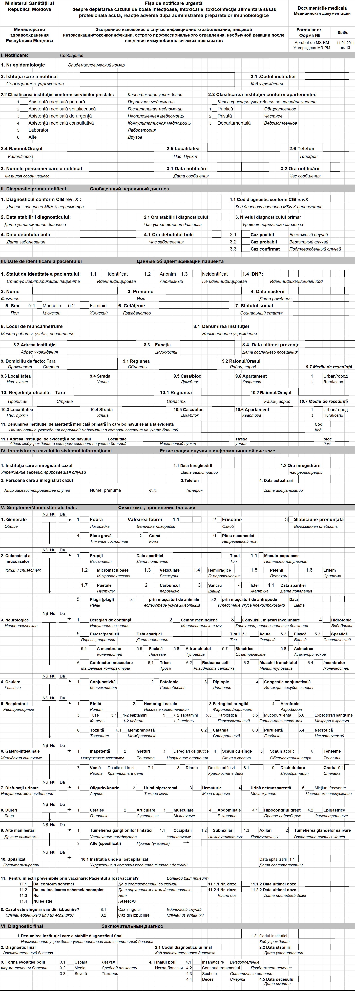

Annex 2, F2
Statistical report F-2
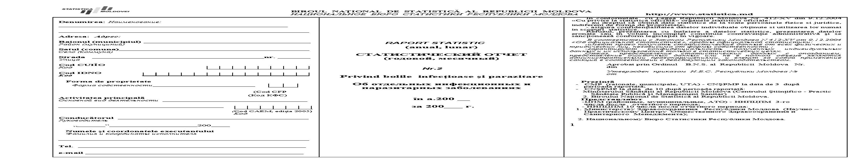
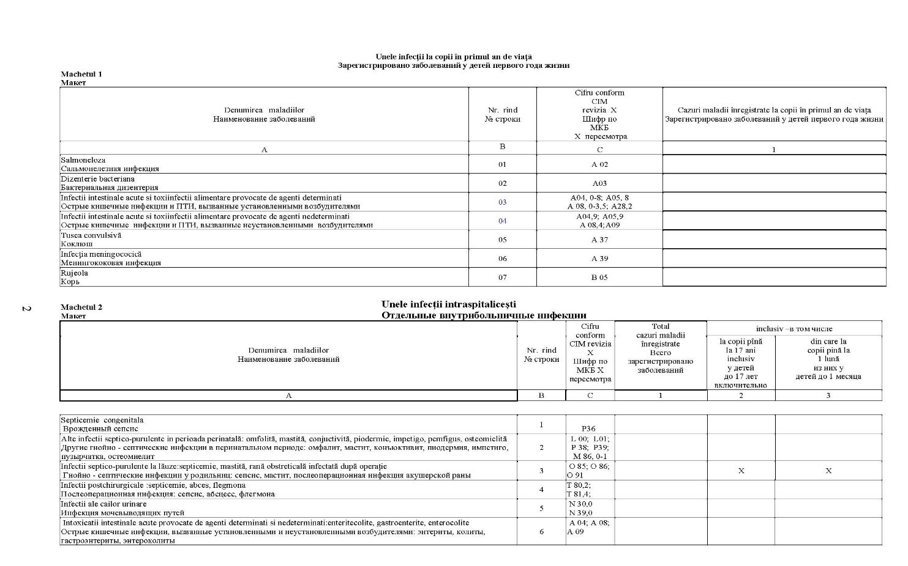
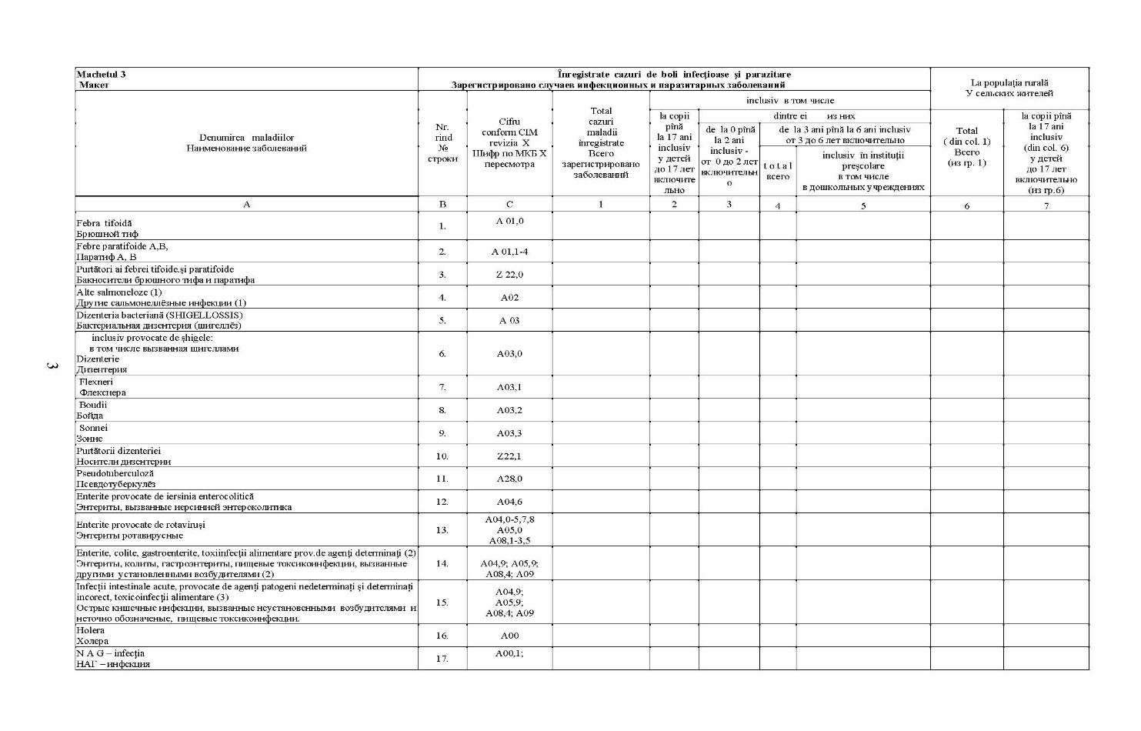
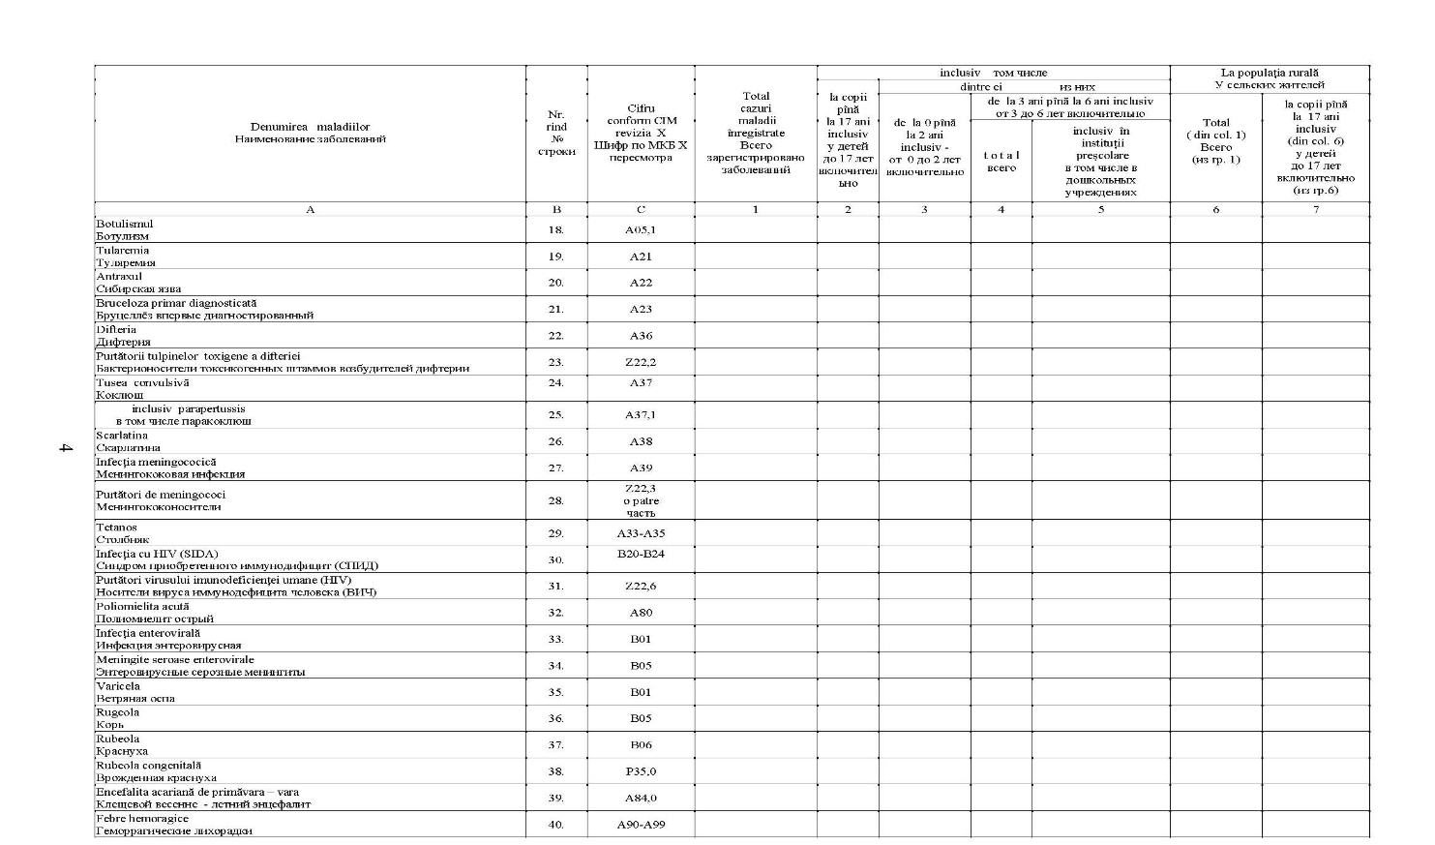
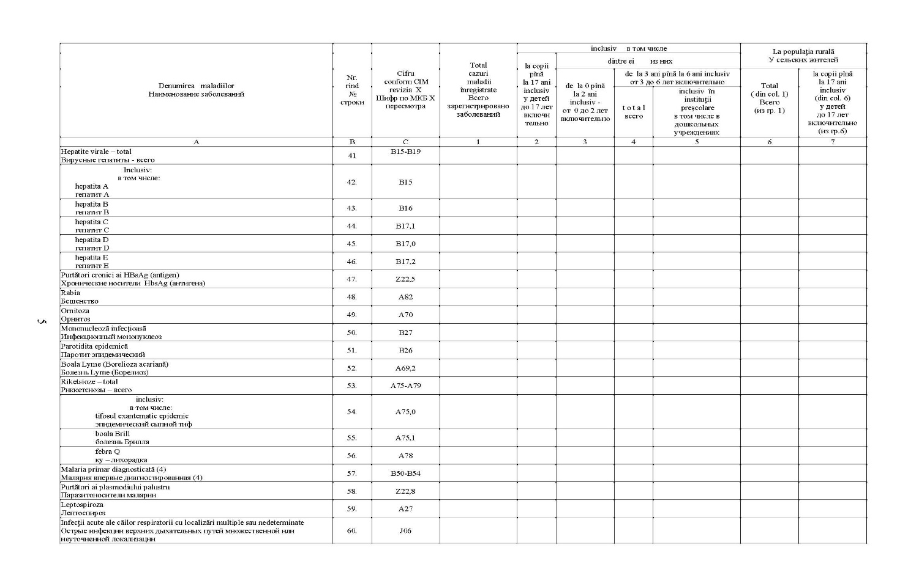
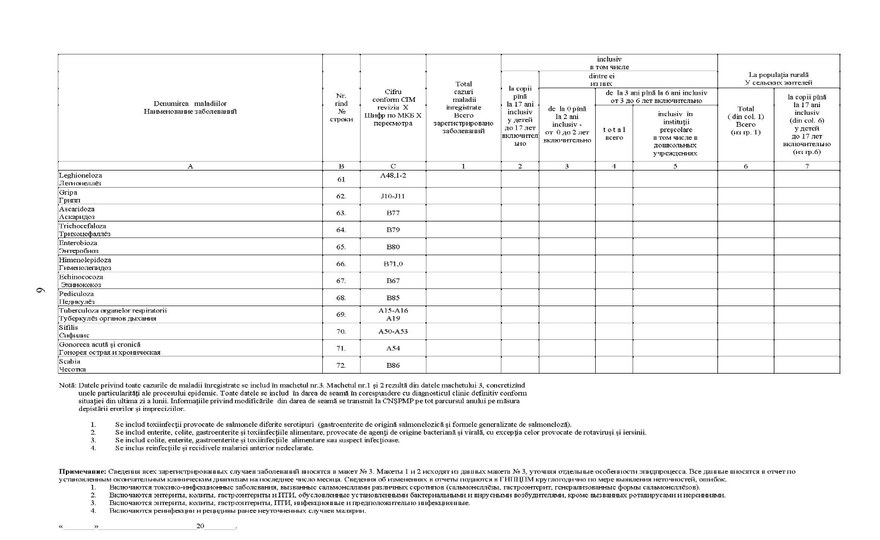

Annex 3 Epidemiological investigation conclusions
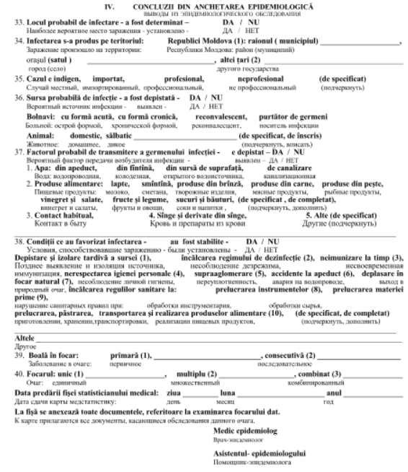

Nomenclatures
Actions that can be taken with reference to the nomenclatures:
- Adding new values;
- Changing the existing values;
- Inactivation of records;
- Export in editable format;
- Printing;
The actions listed above can be performed only from the system interface, and are accessible only to the user as a “Global Administrator”.
The structure and content of the nomenclatures described are minimal and it is possible that for certain purposes or for optimization, they may be modified as structure and content or even omitted in the system development process.
- Health facilities
Structure
Field name | Type | Nomenclature
Unique ID | Numeric, auto-generating | -
Facility code | Numeric | -
Facility name | Text | -
IDNO: | Numeric | -
Affiliation | Numeric | membership
Facility classification | Numeric | Classification_I
Superior facility code | Numeric | Health facilities
District code | Numeric | CUATM
Settlement code | Numeric | CUATM
Street | Text | -
Building No | Text | -
Block No | Text | -
Apartment | Text | -
Phone No | Numeric | -
Email address | Text | -
Administration | Text | -

- Affiliation
Values
Unique ID | Values
1 | Public
2 | Private
3 | Departmental

- Clasification_I
Values

Unique ID | Values
1 | Primary healthcare
2 | Hospital care
3 | Emergency healthcare
4 | Advisory medical assistance
5 | Laboratory
6 | Other

- CUATM
The Classifier of Territorial Administrative Units of Moldova will be used.
- ICD-10
The International Classification of Diseases, revision X (10) will be used.
- Level_D
Value
Unique ID | Value
1 | Possible case
2 | Probable case
3 | Confirmed case

- Country
Structure
Field name | Type
Unique ID | Numeric
Country code | Numeric
Country name | Text

- Social_S
Structure
Field name | Type
Unique ID | Numeric
Status code | Numeric
Status name | Text

- Environment_R
Value
Unique ID | Value
1 | Urban
2 | Rural

- Age
Value
Unique ID | Value
1 | Days
2 | Months
3 | Years

- Insurance
Structure
Field name | Type
Unique ID | Numeric
Insurance code | Numeric
Insurance type | Text

- Users
Structure
Field name | Type | Nomenclature
Unique ID | Numeric, self-generating | -
Name | Text | -
First Name | Text | -
PIDN | Numeric | -
Phone | Numeric | -
E-mail | Numeric | -
Facility code | Numeric | Health facilities
Role | Numeric | -
Password | - | -
Active | Numeric
Date created: | Date | -
Date cancelled | Date | -
Note | Text | -

- Rash_T
Values
Unique ID | stock
1 | Masculo-papular
2 | Micro-maculous
3 | Vesicular
4 | Hemorrhagic
5 | Petechial
6 | Erythema
7 | Pustules

- Palsy_T
Values
Unique ID | Values
1 | Acute
2 | Flaccid
3 | Spastic
4 | Limbs
5 | Facial
6 | Trunk
7 | Symmetric
8 | Asymmetric

- Contractures_T
Values
Unique ID | Values
1 | Trism
2 | Head stiffness
3 | Trunk muscles
4 | Limbs

- Cough_T
Values
Unique ID | Values
1 | 1-2 weeks
2 | > 2 weeks
3 | Paroxysmal
4 | Mucopurulent
5 | Blood sputum

- Tonsillitis_T
Values
Unique ID | Values
1 | Filmy
2 | Catarrhal
3 | Purulent
4 | Necrotic

- Evolution_T
Values
Unique ID | Values
1 | Mild
2 | Medium
3 | Severe

- Final_T
Values
Unique ID | Values
1 | Recovery
2 | Continue treatment
3 | Sequelae
4 | Death

- Case_T
Values
Unique ID | Values
1 | Indigenous
2 | Imported
3 | Vocational
4 | Non-professional

- Patient_T
Values
Unique ID | Values
1 | With acute form
2 | With chronic form
3 | Convalescent
4 | Germ carrier

- FPT_A
Values
Unique ID | Values
1 | From the water pipe
2 | From the well
3 | From the surface source
4 | Sewerage

- FPT_P
Values
Unique ID | Values
1 | Milk
2 | Cream
3 | Cheese products
4 | Meat products
5 | Fish products
6 | Vinaigrette and salads
7 | Fruit and vegetables
8 | Juices and drinks

- Conditions_T
Values
Unique ID | Values
1 | Late detection and isolation of the source
2 | Non-observance of the disinfection regime
3 | Breach of immunization schedule
4 | Personal hygiene breach
5 | Overcrowding
6 | Water pipe accident
7 | Presence in a natural hotbed
8 | Breach of sanitary rules when processing instruments
9 | Breach of sanitary rules when processing raw materials
10 | Breach of sanitary rules of processing, storage, transportation and production of food.
11 | Other (to be specified)

- Detection _T
Values
Unique ID | Values
1 | Request for medical assistance
2 | Preventive examination
3 | Examination based on epidemiologic indications

Interfaces
The attached interfaces are tentative and can be modified during the development process. The gray shaded fields in fill in automatically with the data from the nomenclatures when certain actions are performed.

Login page
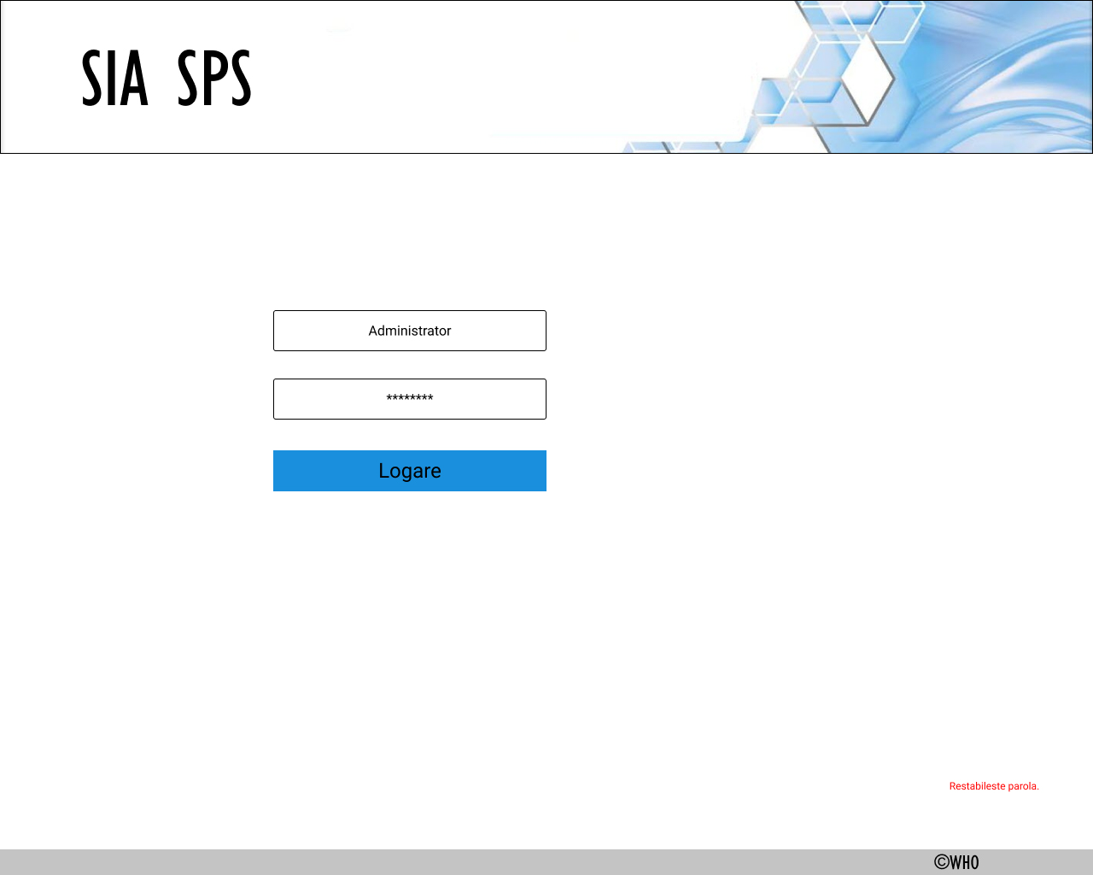

List of notifications
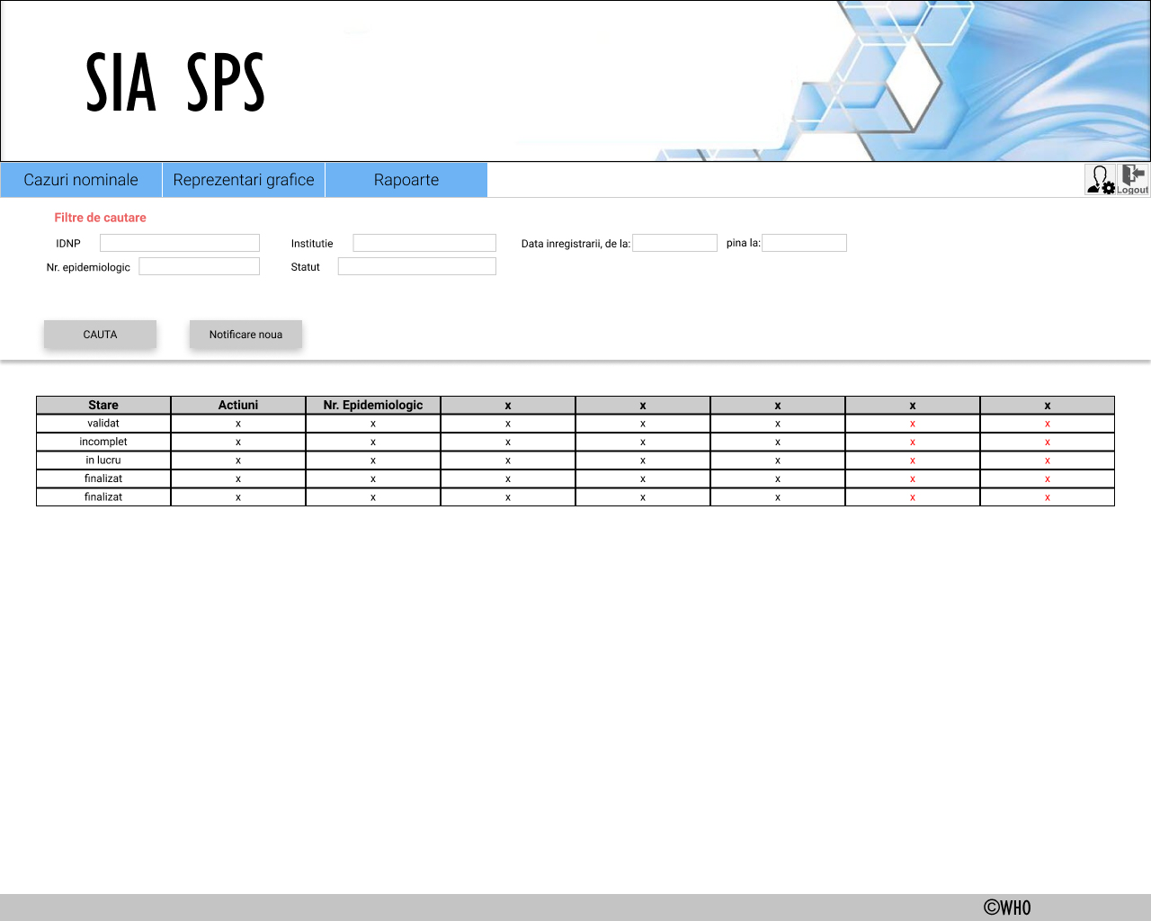

Notification
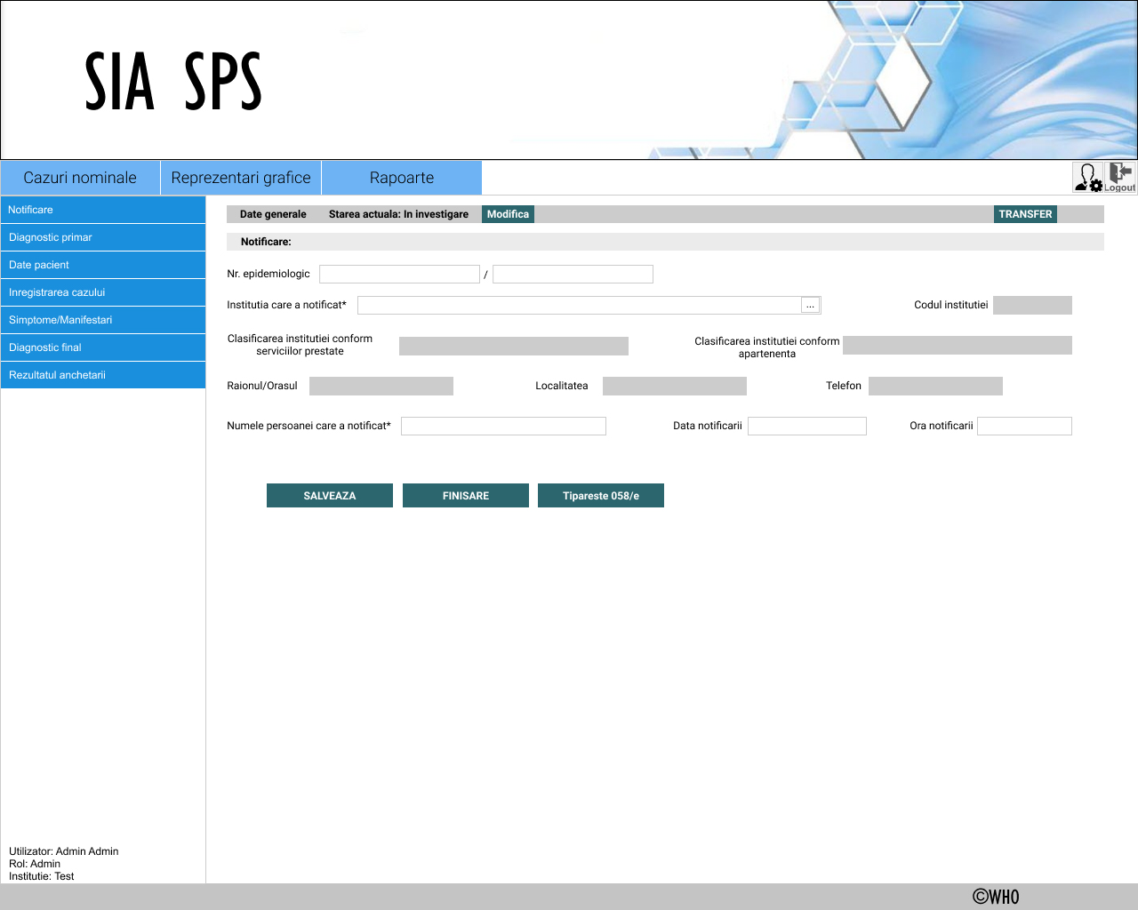

Primary diagnosis
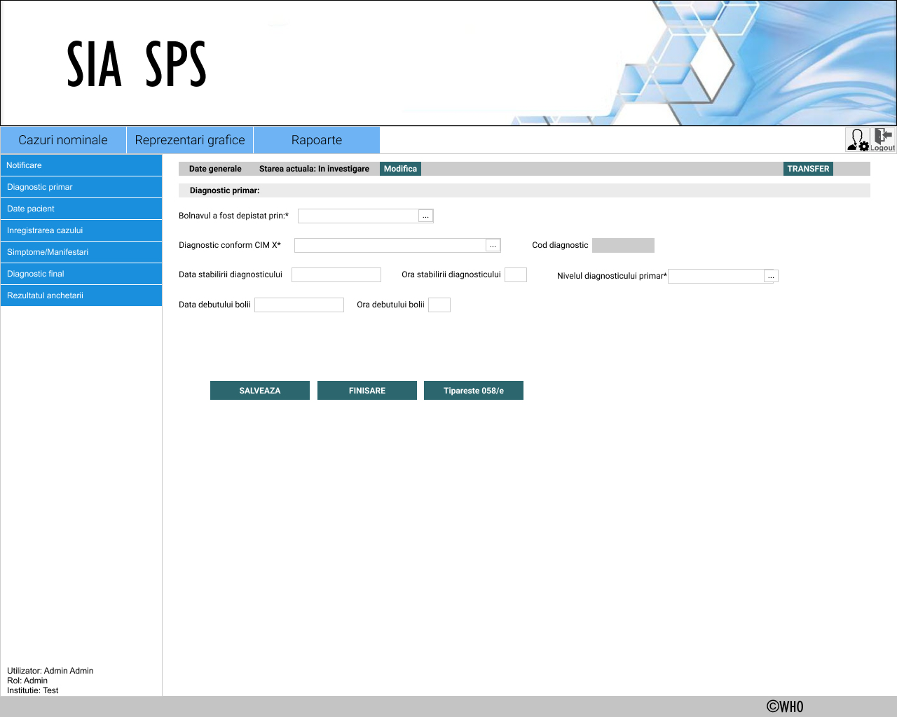

Patient data
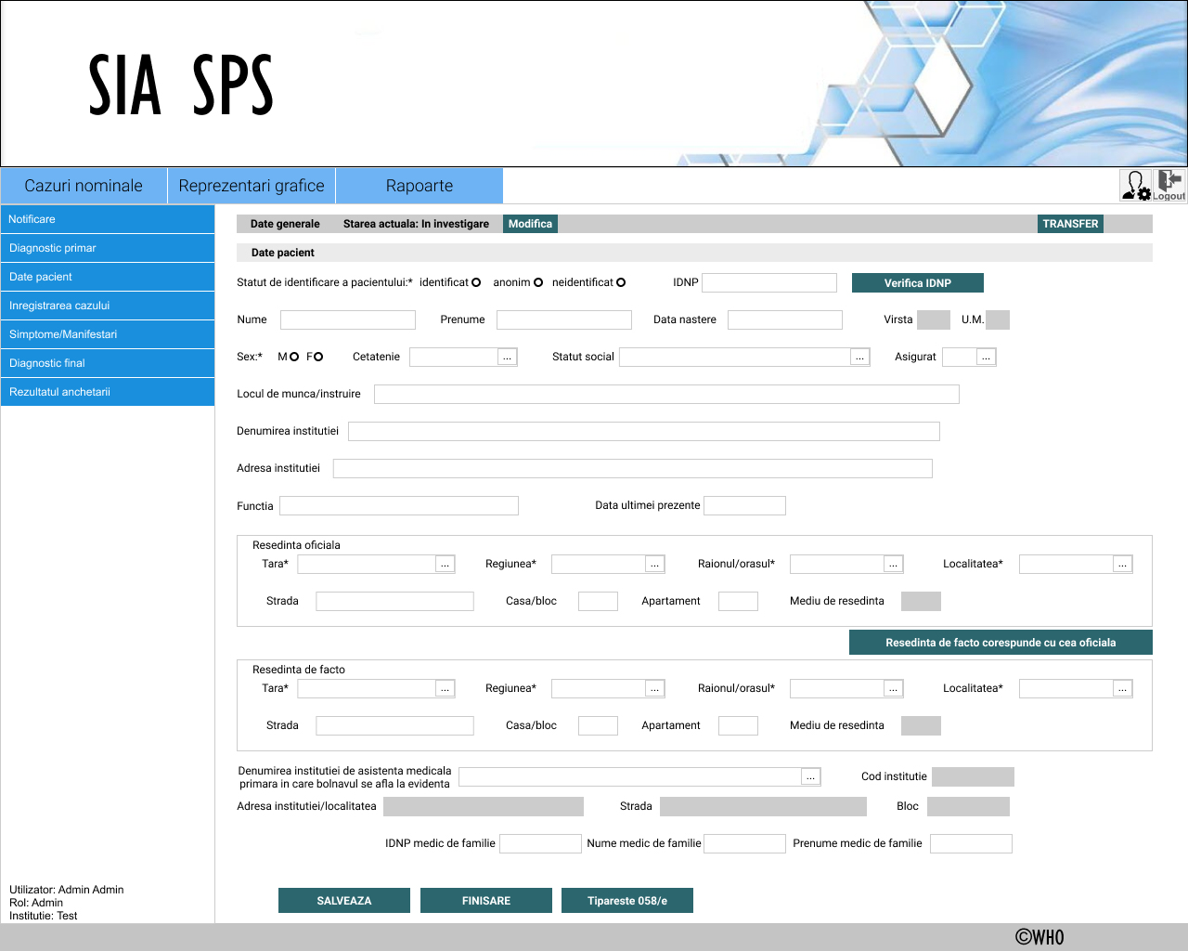

Registration of the case in the system
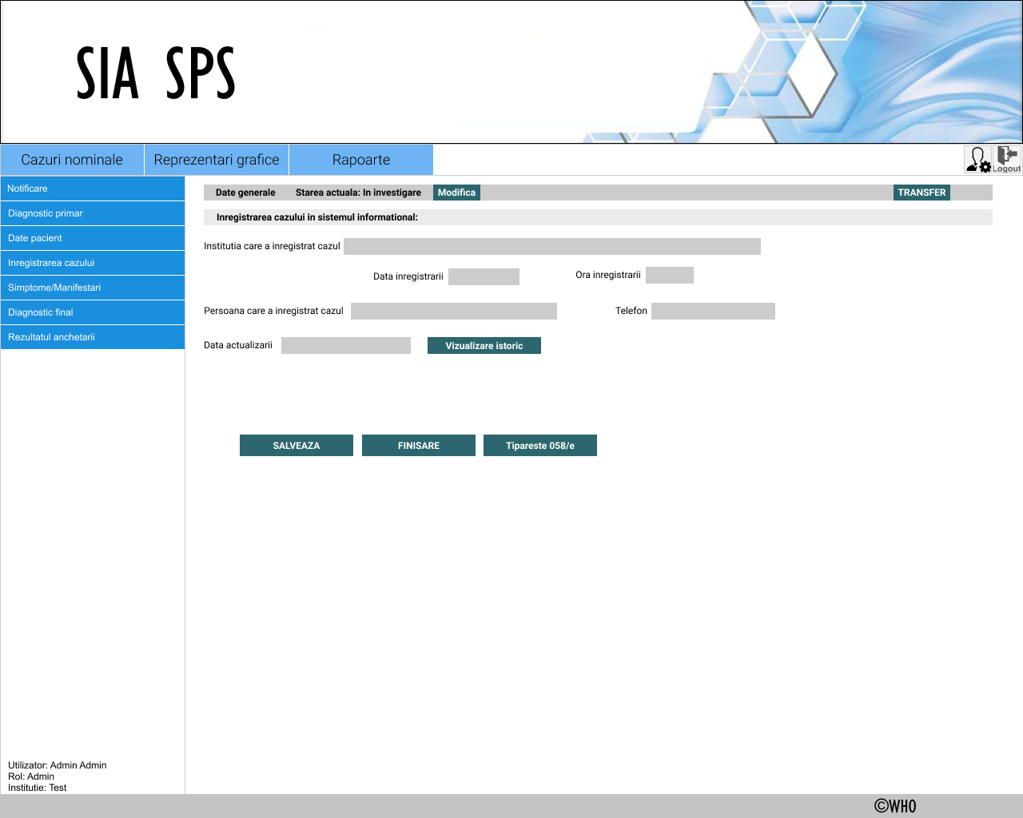

Symptoms / signs
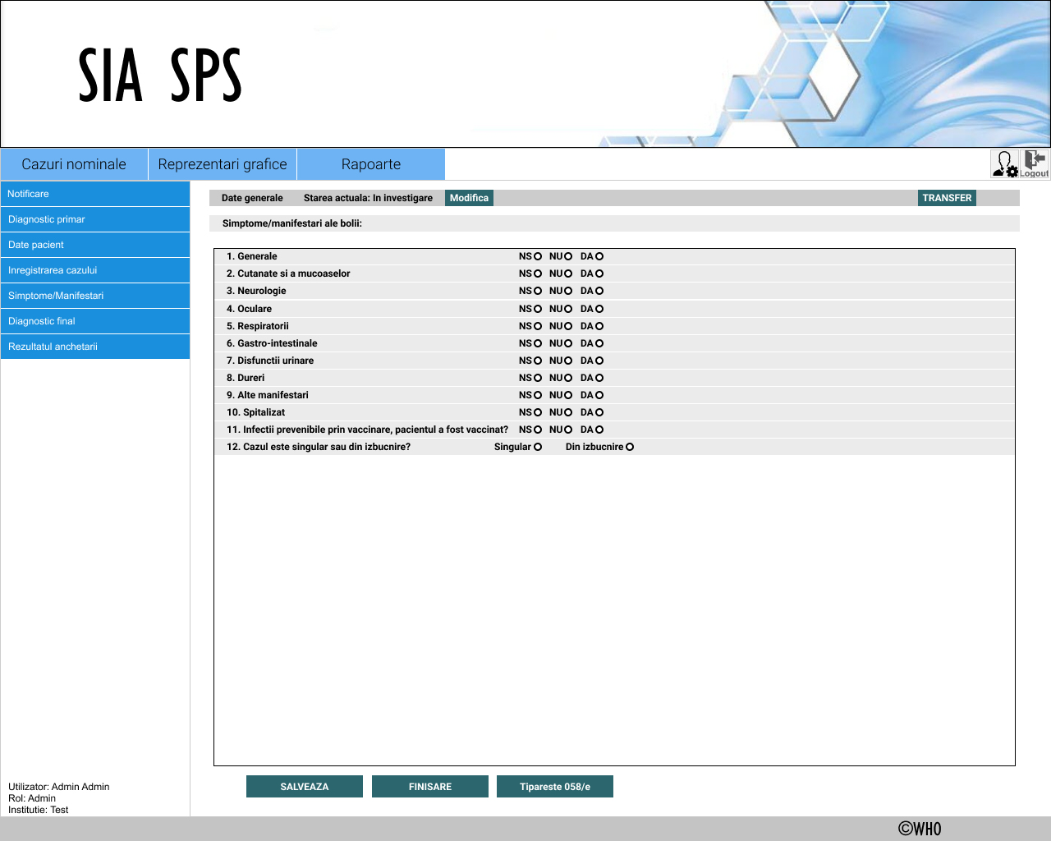

Final diagnosis
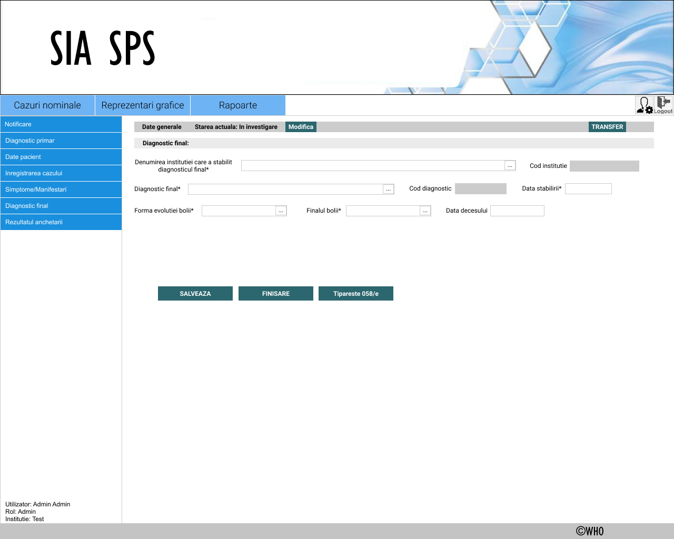

Epidemiologic investigation result
