CONCEPT NOTE AND TECHNICAL SPECIFICATIONS

for Laboratory Information System (LIS) for the public health laboratory network

Contents
TECHNICAL SPECIFICATIONS 1
1. Software definition and its components: 1
2. The specifications of the works performed, services provided and supplied software: 3
3. Regulatory framework. 3
4. Software components list: 5
5. Works completion time: 6
6. Technical, functional and other requirements for software components, system configuration and set up requirements 6
7. Warranty obligations. 10
8. LIS technical support requirements 10
9. Requirements for LIS integration with External Systems 13
10. LIS safety requirements 14
11. Information protection requirements 14
12. Requirements for the interoperability of LIS with the laboratory equipment 15

The concept describes the general technical requirements for the supply and implementation of the Laboratory Information System (LIS) for the public health laboratory network which is a software suite designed to automate laboratory processes, manage the quality of laboratory research and optimize the work of medical personnel. The requirements for the software, quality and technical characteristics are described in detail in the technical specifications (TS).

Software definition and its components:
Laboratory information system (LIS) should be designed specifically for public health laboratory (network) that provides collection, processing and storage of information, automation of technological processes, as well as management processes and communication, improving the quality of the health care.
Development of the LIS should provide the necessary operations:
- Sampling scheduling;
- Registration and labeling (bar coding) with the assignment of a unique number for both planned and unscheduled samples;
- Assigning to each sample a list of parameters defined with an indication of a specific analysis method;
- Distribution of samples with assigned analyzes for specific production units, performers, devices;
- Input of analysis results;
- Checking the entered results by comparing them with the specified criteria, preventing technical errors in entering the results;
- The connection of each result obtained with the relevant quality management and quality assurance procedures (verification, calibration of measuring equipment, quality control and admission to analysis of consumables, availability and validity of reference materials, control charts record keeping);
- Authorization of the entered results in accordance with the established access rights and responsibility of employees;
- Issue of protocols (reports) with test results in accordance with the established requirements;
- Creation of various reports on the results of activities.
- Assure data exchange and interoperability with other electronic information system.
Implementation of LIS should ensure:
- Minimizing number of errors when performing laboratory investigations (mainly related to the patient's identity), as well as cases of loss of data and related replication studies;
- Ensuring security and confidentiality requirements when using information systems;
- Improving functionality and capability such as registration of patients and their samples received for analysis, with possibility of manual registration and entering the data by the operator, automatically retrieving data from other information systems, as well as specialized readers;
- Registration of laboratory investigation tasks for each sample and distribution of sample tasks between laboratory workplaces, receiving from another information system (IS) or from a specialized readers and transmission the data to automatic aliquoting;
- Registration of laboratory investigation results, automatic receiving of data from analyzers, as well as entering the results manually;
- Providing the answer-forms with research results with the possibility of sorting the printed reports, indicating the research results, the limits of the norm of each indicator in accordance with the normative group of the patient and deviation of the indicator from the norm to facilitate the interpretation of the results;
- Conducting quality control statistics of laboratory allowing the receiving the results of test measurements directly from the analyzer, conforming the quality control methodology with existing regulatory framework;
- Ability to track the lab investigation process by the senior staff;
- Automatic creation of various reports, a set of standard reports, individual reports, preferably using the report generation module, that allows the user to independently develop the required reporting forms, including different types of analyses, different time frames, comparison of different data depending of the end user needs etc.;
- Archiving in a format that guarantees the continuity of data over a long period of time, tracking technological developments such as changes in reagents and changes in indicator standards;
  - The ability to exchange data with other departments of the medical institution and information systems.
  - The LIS should be elaborated with non-exclusive (end-user) license grant for software, with its subsequent configuration for a group of target laboratories.
The LIS components:
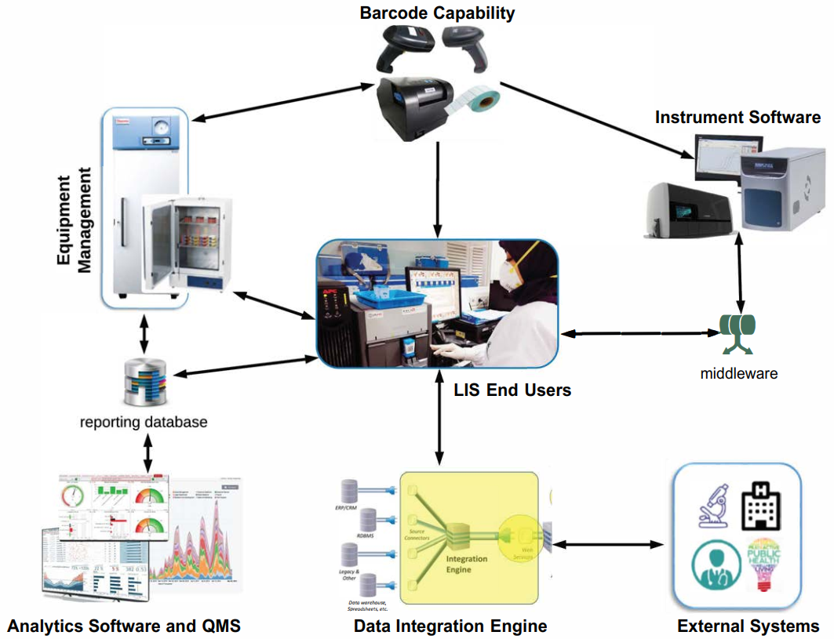

LIS addresses the needs of all three analytical phases:
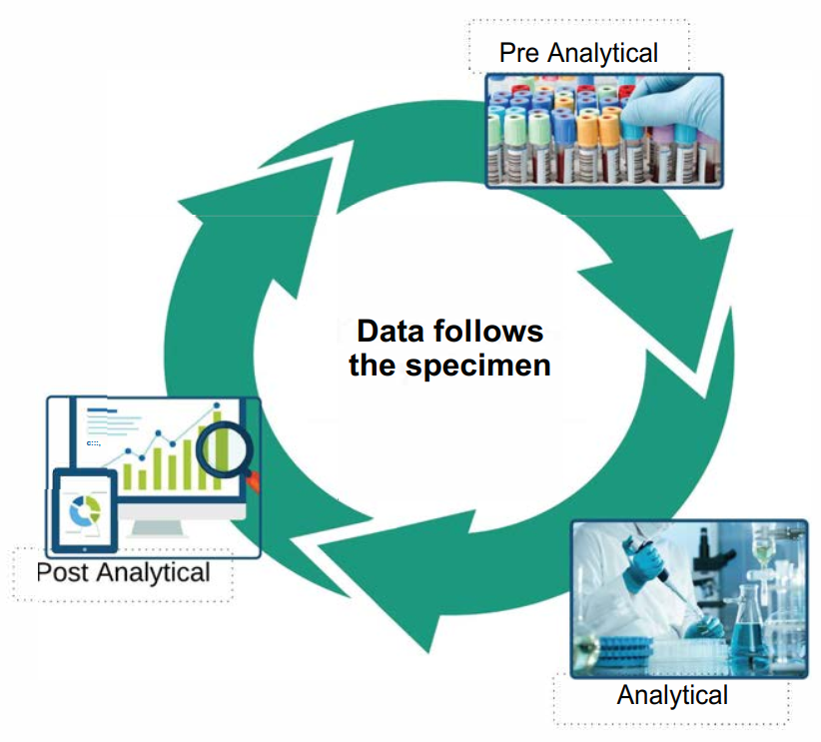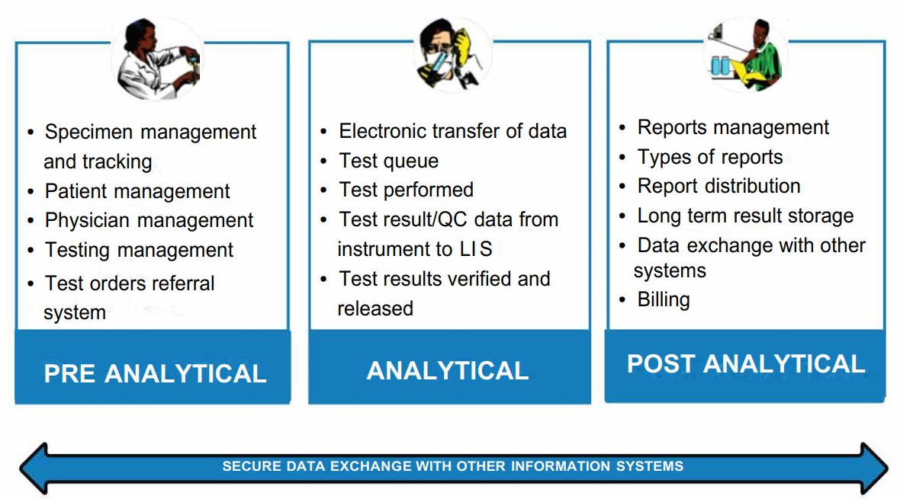

The specifications of the works performed, services provided and supplied software:
Non-exclusive license grant – a simple (non-exclusive) license for the use of LIS software with its subsequent implementation and configuration in accordance with the requirements specification.

Regulatory framework.
- LAW No 982-XIV of 11 May 2000 on Access to Information;
- LAW No 467-XV of 21 November 2003 on Computerization and State Information Resources;
- LAW No 241 of 15 November 2007 on Electronic Communications;
- LAW No 133 of 8 July 2011 on Personal Data Protection;
- LAW No 142 of 19 July 2018 on Data Exchange and Interoperability;
- ORDER of the Ministry of Information Development No 78 of 07/01/2006 on the Approval of the Technical Regulation ‘Software life cycle processes’ RT 38370656-002;
- ORDER No 94 of 17 September 2009 of the Ministry of Information Development on the approval of some technical regulations (procedure of recording electronic public services, provision of electronic public services, ensuring information security upon the provision of electronic public services, determination of the cost of development and implementation of automated information systems);
- ORDER No 688 of 10 June 2013 on the implementation of the Program for the development of a network of laboratories under the State Public Health Surveillance Service of the Republic of Moldova.
- ORDER No 184 of 25 March 2016 on the modernization and reorganization of the network of laboratories of the State Public Health Surveillance Service.
- ORDER No 133 of 13 March 2018 on the Approval of the General Regulation of Legal Metrology RGML 09:2018
- Government Decision No 1128 of 14 October 2004 Approving the Concept of Integrated Medical Information System;
- Government Decision No 562 of 22 May 2006 on the Creation of State Automated Information Systems and Resources;
- Government Decision No 1113 of 14 December 2010 approving the Requirements for the Assurance of Personal Data Security and their Processing in Personal Data Information Systems;
- Government Decision No 710 of 29 September 2011 Approving the Strategic Program for Technological Modernization of Governance (e-Transformation);
- Government Decision No 128 of 20 February 2014 on Common Government Technological Platform (MCloud)
- Government Decision No 708 of 28 August 2014 on Government Electronic Recording Service (MLog);
- Government Decision No 405 of 2 June 2014 on the Integrated Government Electronic Signature Service (MSign);
- Standard of the Republic of Moldova MS ISO/IEC 27002: 2014 ‘Information technology. Security techniques. Code of good practice for information security management’;
- Standard of the Republic of Moldova SM ISO/IEC 12207: 2014 ‘Systems and software engineering. Software life cycle processes’;
- Standard of the Republic of Moldova SM ISO/CEI/IEEE 15288: 2015 ‘Systems and software engineering. System life cycle processes’;
- Government Decision No 586 of 24 July 2017 Approving the Regulation on the Procedure for Maintaining the Medical Register.
- Government Decision No 201 of 28 March 2017 Approving the Mandatory Minimum Cyber Security Requirements;
- Government Decision No 211 of 04 March 2019 on the Interoperability Platform (MConnect);
- The current standards of the Clinical and Laboratory Standards Institute (CLSI) on laboratory information systems: LIS3: ‘Standard Guide for Selection of a Clinical Laboratory Information Management System’, LIS4: ‘Standard Guide for Documentation of Clinical Laboratory Computer Systems’, LIS8: ‘Standard Guide for Functional Requirements of Clinical Laboratory Information Management Systems’, AUTO8: ‘Managing and Validating Laboratory Information Systems’ , GP19: ‘Laboratory Instruments and Data Management Systems: Design of Software User Interfaces and End-User Software Systems Validation, Operation, and Monitoring’;
- Current CLSI standards on the Interaction with lab instruments: LIS1: ‘Standard Specification for Low-Level Protocol to Transfer Messages Between Clinical Laboratory Instruments and Computer Systems’, LIS2: ‘Specification for Transferring Information Between Clinical Laboratory Instruments and Information Systems’, AUTO3: ‘Laboratory Automation: Communication with Automated Clinical Laboratory Systems, Instruments, Devices and Information Systems’, AUTO5: ‘Laboratory Automation: Electromechanical Interfaces’;
- Current CLSI standards on the Interaction with external information systems: LIS5: ‘Standard Specification for Transferring Clinical Observations Between Independent Computer Systems’, LIS9: ‘Standard Guide for Coordination of Clinical Laboratory Services within the Electronic Health Record Environment and Networked Architectures’, AUTO3: ‘Laboratory Automation: Communication with Automated Clinical Laboratory Systems, Instruments, Devices and Information Systems’;
- Current CLSI standards on Reliability and information security in the laboratory: LIS6: ‘Standard Practice for Reporting Reliability of Clinical Laboratory Information Systems’, AUTO4: ‘Laboratory Automation: Systems Operational Requirements, Characteristics, and Information Elements’, AUTO9: ‘Remote Access to Clinical Laboratory Diagnostic Devices via the Internet’, AUTO11: ‘IT Security of In Vitro Diagnostic Instruments and Software Systems’;
- Current CLSI standards on the Bar coding technology: LIS7: ‘Standard Specification for Use of Bar Codes on Specimen Tubes in the Clinical Laboratory’, AUTO2: ‘Laboratory Automation: Bar Codes for Specimen Container Identification’, AUTO7: ‘Laboratory Automation: Data Content for Specimen Identification’;
- Current CLSI standards on the Organisation of an automated laboratory: AUTO1: ‘Laboratory Automation: Specimen Container/Specimen Carrier’, AUTO10: ‘Autoverification of Clinical Laboratory Test Results’, GP18: ‘Laboratory Design’.

Software components list:

S.p No | Name | Amount
Software end-user license grant (simple non-exclusive license)
1. | Laboratory Information System. Automated workplace. | 25
2. | Laboratory Information System. Laboratory analyzer driver. | 1
3. | Laboratory Information System. Integrated Standard data interface module for uploading information to the External Systems | 1
4. | Non-exclusive right to use software: Laboratory Information System. Integrated Standard Data interface module for downloading information from the external system. | 1
LIS software platform
5. | Protected software package ‘Laboratory Information System’* | 1
6. | Server license (if necessary) | 1
7. | Other licenses and client access licenses (if necessary) | 25
LIS configuration works
8. | LIS configuration and deployment works | 1
9. | LIS configuration for communicating with the external systems | 1
10. | LIS users training | 1
Comprehensive maintenance of LIS
11. | Comprehensive maintenance of the LIS within the period of one year immediately following the LIS launching | 1
* Note: ensuring compatibility with the Customer's equipment is mandatory.

Works completion time:
Granting of non-exclusive rights to use the LIS software and the LIS software platform – within 1 month from the date of the conclusion of the contract. Performance of LIS configuration works – within 1 month from the date of conclusion of the contract. Performance of LIS comprehensive technical maintenance works – within 12 months from the date of signing the act of completed works on LIS configuration and deployment with the possibility of extension.

Technical, functional and other requirements for software components, system configuration and set up requirements

Automated workplace
Pre-analytic phase
Accounting for all incoming referrals for laboratory investigation
Ensuring the processing of incoming referrals and specimens and the formation of data sets to be registered in the system
Checking the completeness and correctness of filling in the required data set of demographic information about the patient
Identification of biological specimens using the traditional system of sequential numbering, the bar coding technology
Creation and maintenance of electronic laboratory registers and quality control logs
Investigation tasks routing by structural units of the laboratory
Distribution of tasks by laboratory workstation
Manual registration of referrals and specimens
Registration of referrals and specimens through a data interface with the external medical information system
Mechanism for controlling the correctness of filling in the required data set of demographic information about the patient (Check form)
Biological specimen identification technology backup using the sequential numbering system
Biological specimen identification technology backup using bar coding in accordance with standard LIS 7 (ASTM E1466-92)
Automatic real-time task distribution
Automatic setting of reference standard ranges for verifying the test results, in accordance with the sex, age and physiological characteristics of the patient
Construction by users of a forms template system for test results
Analytic phase
Provision of information support for analytical investigation
Monitoring of the status of the laboratory test specimen. Investigation Status.
Manual entry of test results and notes
Automatic transmission of test results and notes from analyzers
Post-analytic phase
Generation of approved test results forms
Generation of pre-configured statistical reports
Generation of personalized reports on the services provided by the laboratory
Provision of up-to-date information and established reporting data on the tests performed and the results of statistical processing, according to the laboratory passport
Archives maintenance
Display of test results highlighting normal ranges, pathologies and dangerous limits, indicating what equipment was used and the test result date
Manual validation of test results
Automatic validation of test results
Control of individual variability of patient’s test results
Printing of test results, laboratory registers and reports
Printing of ‘Rejected Specimens Records’ register.
Generation and printing of patient’s map of test result changes dynamics
Possibility to export reports in Word, Excel, PDF format
registration of control measurements results in the electronic quality control register
Display of quality control results
Quality level assessment generation
Visualization on the screen of several test results obtained from different laboratory instruments or at different times for the purpose of dynamic observation or retrospective analysis
Simultaneous visualization on the screen of all test results for the purpose of proper evaluation and approval of the test results
Automatic calculation of the test results
General requirements
Optimized interface for performing operations
Supports keyboard shortcuts
Supports the mouse
Communication between workstations and the laboratory information system server using standard network communication protocols
Logging of all events that occur in the process of registration and performance of a laboratory test
Access to all basic commands for manipulating data by the operator of the Laboratory Information System from one workstation
Archive information retrieval
Obtain information about previously performed tests for a registered patient with the possibility to set filters
Database queries using a single parameter or a set of parameters
Possibility of restricting the access to certain components for the users of the Laboratory Information System
Modification of the laboratory test database (adding/changing/deleting a directory item) should be done from the main LIS module and not require quitting or reinstalling the software
Supports a thermal printer for barcode label printing
Supports a hand-held barcode scanner for barcoded data entry
Supports the State Register of Measurement Standards for test results
Techniques and work instructions for operations on LIS workstations
Requirements for protecting information from unauthorized access
- Authorization of users and of the service personnel of the Laboratory Information System using individual passwords
- Different levels of user rights and levels of access to available operations and stored information
Protection of software modules from unauthorized copying using a hardware key
Accompanying documents for the software product
- LIS Registration Certificate (software for clinical diagnostic laboratories)
- User’s manual in the official language
Period of validity of the non-exclusive right to use
Analyzer driver.
The analyzer driver provides communication between analyzers/analytical systems and the Laboratory Information System in accordance with the following list (the list of equipment installed or planned to be install in Laboratories:
____________________________________________________________________________

____________________________________________________________________________

____________________________________________________________________________

____________________________________________________________________________
The analyzer driver interacts with the LIS components through the application server.
Adding, replacing or deleting an analyzer driver from LIS is performed without reinstalling the LIS application software
Automatic interpretation of the data received from the analyzer.
LIS allows automatic interpretation of specific values obtained from the device:
- translation of text results into Russian and English,
- conversion of quantitative values of results into qualitative ones,
- decoding of analyzer specific marks
Protection of software modules from unauthorized copying using a hardware key
Data exchange with automated diagnostic equipment (analyzers) takes place via standard interfaces (RS-232 protocol or equivalent), or via a TCP/IP network protocol (or equivalent), provided that the analyzer supports it, based on LIS1 standards (ASTM E1381-02), LIS2 (ASTM E1394-91) and communication protocols for the respective analytical equipment
The driver recognizes measurement data acquired from the patient specimen or the control material
Possibility of uploading information to the External systems
Certificate of conformity for the software platform
Compliance with the requirements of the Law of the Republic of Moldova ‘On Access to Information’ No 982-XIV of 11 May 2000
Technical deployment

General requirements for deployment works:
- Deployment of server software (DBMS, Application Server, cloud service), if any;
- Deployment of Client Software
- Loading into LIS of the Customer's database of rules and regulations
- Connection of analyzers to LIS and their configuration
- LIS adjustment to the specifics of the laboratory operation.
- Training laboratory staff in using LIS
- Configuring modules for data exchange with External Systems
- LIS commissioning

Deployment and configuration works

Requirements for configuring the basic LIS functionality:
- Configuring user roles and access levels
- Filling out the laboratory tests database in accordance with the laboratory investigation nomenclature
- Tests configuration
- Setting reference (normal) values, taking into account the investigation method
- Setting up internal laboratory quality control.
- Setting up an automatic validation mechanism for test results
- Setting up automatic interpretation of the results acquired from the analyzers
- Setting up a software leukocyte counter.
- Setting up print templates
- Setting up statistical reports generation according to Customer's parameters

Analyzer connection procedure:
- Connect the analyzer and Laboratory Information System using an interface cable in accordance with analyzer’s technical specifications
- Analyzer configuration: data transfer mode to LIS
- Analyzer configuration: query mode (if the analyzer supports this mode)
- Analyzer configuration: transfer of the control material test results to the LIS internal laboratory quality control module
- Testing the data transfer mode
Comprehensive technical maintenance

The procedure for training employees:
- Conducting trainings individually, at the workplace
- Instruction taking into account the specifics and directions of investigation
- Work instructions and guidelines for investigation areas

Technical assistance:
• Providing updated versions of LIS
• Diagnostics and elimination of errors in LIS operation
• Correction of errors identified by Users in LIS that impede the functioning of the system
• Setting up, diagnostics and elimination of errors in the operation of analyzers (in terms of interaction with LIS)
• Counseling on issues related to the operation of LIS by phone, as well as using Internet technologies

Warranty obligations.

The software modules of the Laboratory Information System shall be provided with warranty obligations. The provider must guarantee that critical software bugs identified within this period are fixed free of charge. The warranty period must be at least 12 months.

LIS technical support requirements
  - LIS technical assistance must be performed throughout the entire service life of the LIS running in a public health institution.
  - General requirements for technical assistance and support service:
    - For the proper provision of services, the Contractor on his own and at his own expense must organize his technical assistance service.
    - The number and responsibilities of the Contractor's employees engaged in the provision of services are determined independently by the Contractor. The number and responsibilities of the Contractor's employees engaged in the provision of services must be sufficient to meet the requirements set out in the TS.
    - The Contractor's personnel must be familiar with the content and comply with the requirements of operational, methodological and regulatory documentation developed by the Contractor in accordance with the requirements of this TS, as well as with the content of technical and user documentation for LIS.
    - The Contractor independently trains and checks personnel qualifications.
    - The Customer has the right to check the qualifications of the Contractor's personnel that provides services.
    - The qualification of the Contractor's employees engaged in the provision of services must ensure:
- the monitoring of the LIS application software operability;
- the maintenance of LIS user accounts;
- the optimization of the functioning of LIS databases in terms of response time, data access speed;
- the analysis of data for run-time errors (analysis of LIS logs);
- identification of LIS malfunction or failure causes
- finding and resolving the bugs in the LIS application software;
- restoration of LIS performance after malfunction or failure;
- consulting on working with the LIS application software.
8.2.7 The verification of the Contractor’s personnel qualifications, performed on the Customer’s initiative, is carried out in line with a joint protocol.

  - Requirements for protection against erroneous actions of personnel
8.3.1 In order to ensure the recovery of information lost as a result of erroneous actions of authorized personnel, a backup copy of the LIS data must be provided. The procedure for making a backup should be described in the Regulations for the provision of LIS support and technical assistance services, developed by the Contractor.
8.3.2 When troubleshooting the LIS, the Contractor must analyze the actions of the personnel using the OS and LIS log files to exclude incorrect personnel actions from the causes of the malfunction, as well as to prevent the recurrence of incidents that occurred for reasons related to the actions of personnel.

  - Procedure for responding to cases related to information security breaches
8.4.1 When providing services, an analysis of the system operation should be carried out based on the data of the LIS monitoring subsystem in order to detect unauthorized access attempts.
8.4.2 For each case of unauthorized access, the Contractor must:
      - make a preliminary assessment;
      - communicate the information to the Customer for further analysis of the situation.
8.4.3 The response time shall not exceed 2 hours from the moment of detection.

  - The priorities and types of requests are presented in Table 1
Table 1 Priorities and types of requests
Request priority | Troubleshooting-related cases and related tasks | Modifications requests and related tasks | Maintenance requests and related tasks
Critical | Complete unavailability of the functionality of the provided service to all users for a duration of 60 minutes. | Completing modifications tasks related to eliminating or preventing Critical Priority Troubleshooting-related Cases. | Execution of maintenance and consultation requests, and requests for the provision of information related to the resolution of Critical priority incidents.
High | Complete unavailability of the functionality of the provided service at the same time to all users within one institution.  Or  Lower quality of the provided service in the case of all users. | Completing modifications tasks related to eliminating or preventing High Priority Troubleshooting-related Cases. | Execution of maintenance and consultation requests, and requests for the provision of information, which are subject to Customer's administration oversight.
Medium | Complete unavailability to one user of the functionality of the provided service. | Default priority.  Executing high priority modifications tasks on Customer’s demand. | Execution of maintenance and consultation requests, and requests for provision of information on Customer’s demand, with the possibility to increase the priority level at the user's request to speed up its execution and reaction time.
Low | Malfunction of the functionality of the provided service in the case of one user. | Completing modifications tasks as part of the schedule maintenance works and works on users’ demand. | Default priority.  Execution of maintenance and consultation requests, and requests for provision of information on Customer’s demand.

  - Requirements as to the type and content of LIS support services
The table below provides the description, type and parameters of LIS support services provided by the Contractor.

USER SUPPORT | – Solving troubleshooting-related cases and/or related tasks;
SERVICES PROVIDED | – Execution of maintenance requests and/or of related tasks;
 | – Making modifications and/or related tasks;
 | – Performing schedule maintenance;
 | – maintaining configuration units.
 | Solving troubleshooting-related cases and/or of related tasks:
 | – Elimination of glitches leading to a LIS crash
 | – Elimination of LIS run-time errors that do not lead to system’s crash
 | Execution of maintenance requests and/or of related tasks:
 | – Providing a general overview on using LIS
 | – Providing technical support during the schedule and preventive maintenance works performed by the customer
 | – Generation of data queries on the customer’s demand
 | – Works related to granting access to LIS
 | – Advising the customer and participating in the analysis of results in the development, coordination and implementation of business processes in related systems in terms of interaction with LIS
 | Execution of modifications requests and/or of related tasks: |  |  |  |  |  |  | Requires
 |  |  |  |  |  |  |  | coordination
 | – LIS optimization activities related to  changes in the software configuration due to a change in the operating conditions of LIS and an increase in the load |  |  |  |  |  |  | Yes
 | – Modernization of LIS application functions and architecture* |  |  |  |  |  |  | Yes
TYPE OF SERVICE WORKS PROVIDED | The name of the works performed to support users and carry out scheduled maintenance works:
 | – LIS Administration
 | – Provision of consultations to the customer's specialists
 | – Requests management
 | – LIS monitoring
 | – Modernization of application functions and architecture on customer’s demand
 | – Generation of data queries on customer’s demand
– Keeping the service manual up-to-date
In the process of executing requests (troubleshooting-related cases, maintenance requests, modifications requests), they can be reclassified (category and priority changed) as a result of additional clarifying information provided by the user, of running diagnostics in relation to the request-related works.
SERVICE PROVISION SCHEDULE | SERVICE HOURS:
- Execution of requests – in accordance with the priority;
- Execution of schedule maintenance – in accordance with the work plan.
 | SERVICE HOURS ACCORDING TO PRIORITY:  - low;  - medium;  - high. |  | MO | TU | WE |  | TH | FR |  | SA | SU
 | 8 x 5 (8 hours a day from Monday to Friday, excluding holidays, taking into account holiday rescheduling) |  | 08:00  - 20:00 | 08:00- 20:00 | 08:00- 20:00 |  | 08:00- 20:00 | 08:00- 20:00 |  | - | -
 | SERVICE HOURS ACCORDING TO PRIORITY:  – critical. |  | MO | TU | WE |  | TH | FR |  | SA | SU
 | 24 x 7 (day and night, except for holidays, taking into account holiday rescheduling) |  | 00:00  23.59. | 00:00  23.59. | 00:00  23.59. |  | 00:00  23.59. | 00:00  23.59. |  | 00:00 23.59. | 00:00  23.59.
SERVICE QUALITY INDICATOR | 98% | The Contractor guarantees the execution (resolution) of 98% of requests and repair works transferred from the previous period and registered in the current period entirely under the Contract, within the time-frames specified in this section (Application and RW processing time)
REQUEST PROCESSING TIME ACCORDING TO THE  TYPE OF WORKS | TYPE OF WORKS | Request
 |  | Low/Medium |  |  |  | High/Critical
 |  | RESPONSE TIME  (hour) | TIME FOR DECISION  (hour) |  |  | RESPONSE TIME  (hour) |  |  | TIME FOR DECISION  (hour)
 | Solving troubleshooting-related cases  and related tasks | 4/2 | 48/24 |  |  | 1/0.5 |  |  | 4/2
 | Execution of maintenance requests and of related tasks | 8/4 | 52/36 |  |  | 2/1 |  |  | 16/8
 | Execution of maintenance requests and of related tasks | 8/4 | 120/80 |  |  | 4/1 |  |  | 48/24
 | Execution of  schedule maintenance works | According to the work plan | According to the work plan |  |  | According to the work plan |  |  | According to the work plan
The processing time does not include (with the mandatory indication of the periods below in the request itself):
- time spent by the Contractor waiting for access to LIS when processing the Request;
- time spent on obtaining additional information from the Applicant, which is necessary in order to perform the works specified in the Request;
- time spent on fixing equipment failures and malfunctions on which LIS is installed;
- time spent on fixing network infrastructure failures and malfunctions;
- time for coordination and execution of technical and preventive maintenance works limiting the availability of LIS.

Requirements for LIS integration with External Systems
The massive volume of data created in laboratories, coupled with increased business demands and focus on profitability should increase attention to how LIS handles electronic data exchanges. Attention must be paid to instrument's input and output data to be managed, remote sample collection data to be imported and exported, and mobile technology integrates with the LIS. The successful transfer of data files in spreadsheets and other formats is a pivotal aspect of the LIS development. It could be solution of standardized database management system such as MySQL or analog. In addition to mobile and database electronic data exchange, LIS should support real-time data exchange.

LIS safety requirements

10.1 LIS must be in line with the requirements of the Law of the Republic of Moldova No. 133 of 8 July 2011 on ‘personal data protection’.
10.2 In accordance with the Government Decision No. 1123/2010 on ‘the approval of the Requirements for ensuring security of personal data at their processing within information systems’, information security tools must be developed in accordance with a certain level of LIS security.
10.3 The protection of information transmitted through open communication channels must be performed in accordance with the requirements of the Regulations on Licensing of Activities for Technical Protection of Confidential Information of 7 October 2017 using cryptographic protection tools certified for information security requirements.
10.4 LIS has to provide the possibility of role-based differentiation of user and administrator access rights to information resources in accordance with the access matrix.
10.5 LIS must provide the possibility to maintain centralized administration of a single list of users, containing the rights of users to access LIS.
10.6 LIS should provide the opportunity to monitor and log user actions when working with LIS functions, built-in LIS tools.
10.7 When writing software code, the Contractor must apply secure programming methods, including:
    - manual and automated verification of code for its undocumented capabilities (UDC);
    - use in the development of a trusted hardware platform with anti-UDC protection functions at the system and application levels;
    - source code/version control;
    - LIS penetration testing (pen tests).
10.8 Based on the results of these works, the Contractor shall draw up the following documents:
- System Classification Act;
- Information security requirements.

Information protection requirements
11.1 The detailed/technical design must define and reflect the requirements and solutions for ensuring LIS information security and for the hardware-software platform that must support the deployment of LIS and its components. The specified requirements and solutions have to determine the information protection measures in terms of:
- authentication mechanisms (methods) for service users;
- protection of identifiers assigned to LIS users;
- provision and control of access rights to protected resources and information;
- minimization of access rights;
- LIS authentication mechanisms (methods) when interacting with external information systems;
- ensuring confidentiality and integrity of information transmitted/received via communication channels;
- control access to protected information and personal data;
- backup and recovery of protected information;
- anti-virus protection;
- role-based differentiation of access rights
- firewall use;
- integrity control of the LIS processed and technical data and its components.
11.2 LIS must be capable to prevent the loss of and unauthorized access to information at the stages of its transfer and storage through the use of certified cryptographic protection and regular data backup operations with subsequent archiving.
11.3 LIS must execute the following set of measures aimed at protecting against unauthorized access to the functions of LIS administrative interface:
- the possibility to restrict access to the administrative interface through:
- mandatory 2-factor authentication;
- regular password changing;
- the use of anti-bot protection.
- the ability to keep an action log of LIS users and its components in the administrative interface and an authentication log.
11.4 To configure the rights of LIS users, separate user roles should be created, with the assignment of permissions to perform certain functions and restrictions on access to information processed in the LIS and its components. When forming the roles of users of the LIS and its components, it is necessary to be guided by the principle that restricts the authority to access information and resources for processing information at the minimum level necessary to fulfill certain, documented, user responsibilities when working with LIS.
11.5 It is necessary to ensure the mandatory maintenance of the event log in LIS with the following values for each event in LIS:
- unique sequence number of the event record;
- date and time of the event;
- user account name;
- name of the event (the action to be performed).

11.6 It is necessary to ensure the inaccessibility of changing the log entries for all LIS users, including all categories of attending personnel. The function of clearing the log should automatically be accompanied by a mandatory recording of this event after clearing in the event log.
11.7 The following are subject to entry into the event log:
- all events of administrative nature: creation, modification, deletion of a user and his access rights to LIS resources;
- information about the errors that occurred in LIS;
- all events related to changes in LIS parameters and information protection means:
- creation, modification, deletion of a user and his access rights to LIS resources;
- password changing;
- disable or change two-factor authentication settings.

Requirements for the interoperability of LIS with the laboratory equipment
12.1 LIS has to support the protocols of data exchange with laboratory analyzers that are installed and planned to be installed in targeted laboratories;
12.2 LIS has to provide the possibility of information interoperability with laboratory analyzers that can be connected using standard connectors (RS232, RS422, USB, RJ45, RJ25);
12.3 LIS must have the necessary drivers to ensure interoperability with connected laboratory analyzers;
12.4 The LIS must support unidirectional and bidirectional interoperability with the laboratory analyzer, depending on the type of connected laboratory analyzer;
12.5 The LIS has to be capable to receive quality control results from laboratory analyzers that have a quality control function.

