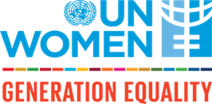

Annex 3

Declaration by the Authorized Representative of the Applicant Organization:
Through submitting this application, I confirm that:

- The Organization expresses its commitment to become a vocal advocate for gender equality and supporting women’s leadership and political participation.
- The Organization is not on the Consolidated UN Security Council Sanctions List;
- The Organization is not being investigated for fraud, corruption, sexual abuse, sexual exploitation or other wrongdoing;
- The Organization is not currently engaged as a Partner of UN Women through a Project Cooperation Agreement;
- The proposal for the small grant does not aim to cover the Support Costs of a project implemented by the Organization;
- The Organization will not make a direct profit from the small grant;
- The Organization is not proposing to cover costs incurred or committed prior to a signed Small Grant Agreement.

Date:

Name:

Stamp and signature:

