SCHEDULE OF REQUIREMENTS
Visibility materials production services for UN Women in Moldova

Location: Republic of Moldova

Duration of the contract: 1 year

Rationale:
Communications is a key component of UN Women work and constitutes a means for ensuring visibility for successful UN Women initiatives, results and programmes as well as for raising awareness about key impact areas. Effective communications also contribute to mobilizing resources as donors would like to see value for money.
Yearly UN Women is conducting regular communication campaigns that need to be secured with quality visibility materials. Therefore, UN Women is looking to subcontract specialized local entities with adequate human and material resources to provide the respective services.

Scope of Work:
Under the overall guidance of UN Women Communication’s Officers, the selected company will be responsible to produce visibility materials required during the implementation of UN Women programme in Moldova. The company should consider the limitations and risks for implementation imposed by COVID-19 pandemic and reflect them in the proposed estimation of costs.
- Summary of Requirements

Requirements are comprised of the following Lots:
- Lot 1: Paper
- Lot 2: Textiles
- Lot 3: Miscellaneous

B. Technical Specifications for Goods

Lot No. 1: Paper
No | Minimum Technical Requirements | Unit | Quantity | Delivery Lead Time, Days | Tentative Delivery Deadline | Example
1. | A1 Poster  Format: A1 (594 mm x 841 mm)  Paper: coated, 200-250 gsm, matt lamination  Print: UN Women logos and text, 4+0 | Pc | 7000 | 7 | Every 2 months | 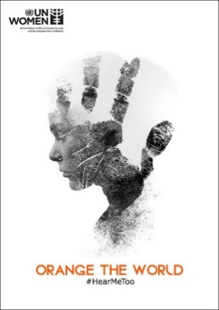
2. | A3 Poster  Format: A3 (297 mm x 420 mm)  Paper: coated, 200-250 gsm  Print: UN Women logos and text, 4+0 | Pc | 200 | 7 | Every 2 months | 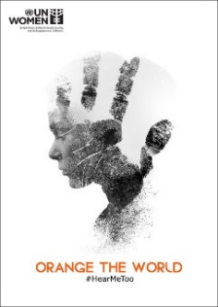
3. | Card  Size approx.: 150 mm x 130 mm  Paper: 200 gsm, coated  Print: UN Women logos and text, 4+1 | Pc | 1350 | 7 | August 221 | 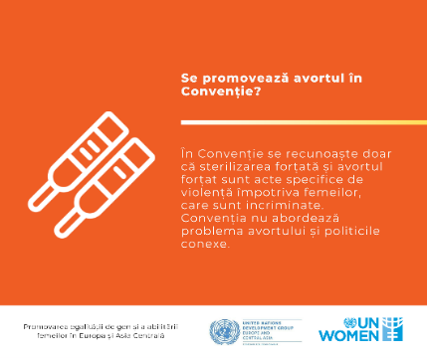
4. | Card Pocket  Size approx.: 155 mm x 135 mm  Paper: 250 gsm, coated  Color: 4+4 | Pc | 150 | 7 | August 2021
5. | Gift Paper Bag  Nature: custom made, with soft rope, reinforced chipboard bottom and top  Size: 320 mm x 230 mm x 100 mm  Paper: recycled, 250 gsm, laminated  Print: UN Women logos and text, 4+0 | Pc | 100 | 7 | August 2021 | 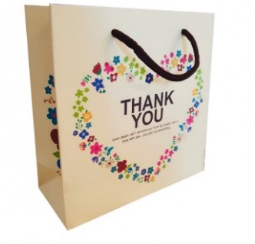
6. | Paper Bag  Nature: with paper handles  Size approx.: 30 cm x 40 cm x 10 cm  Material: recycled paper  Color: beige or white  Print: UN Women logo, 4+0 | Pc | 1000 | 7 | August 2021 | 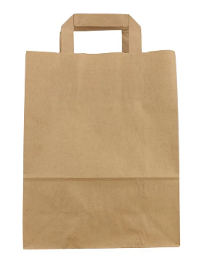
7. | Flyer  Format: B5 (176 mm X 250 mm)  Paper: coated, 90 gsm  Print: UN Women logos and text, 4+4 | Pc | 1000 | 7 | Every 2 months | 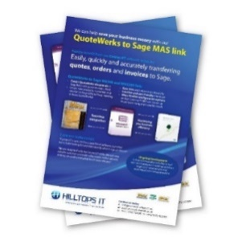
8. | A4 Peel and Seal Envelope  Size: 324 mm x 229 mm  Paper: 120 gsm  Print: UN Women logos and text, 4+0 | Pc | 200 | 7 | August 2021
9. | A6 Peel and Seal Envelope  Size: 114 mm x 162 mm  Paper: 120 gsm  Print: UN Women logos and text, 4+0 | Pc | 200 | 7 | August 2021
10. | Brochure  Format: A4 (210 mm x 297 mm)  Pages: 24 pages (4-page cover, 20 pages inside)  Covers  Paper: matt, 300gsm  Print: UN Women logos and text, 4+0  Interior  Paper: matt, 115gsm  Print: UN Women logos and text, 4+4  Binding: saddle stitched | Pc | 1000 | 7 | Every 2 months | 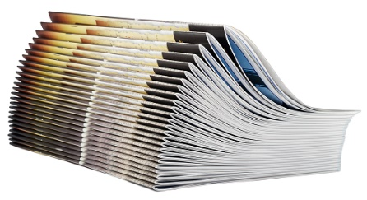
11. | A4 Book  Format: A4 (210 mm x 297 mm)  Pages: up to 91 (4-page cover, 87 pages inside)  Covers  Paper: laminated matt, 300 gsm  Print: color 4+0,  Interior  Paper: coated paper, 90 gsm  Print: images and text, 4+4  Binding: sewing thread with thermal glue | Pc | 100 | 7 | August 2021 | 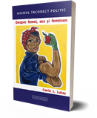
12. | Folder  Format: 230 x 320 x 15 mm, double folded with one internal pocket  Color: natural  Paper: recycled, coated, 500 gr/ m2  Print: UN Women logos and text, 1+0 | Pc | 550 | 7 | Every 2 months | 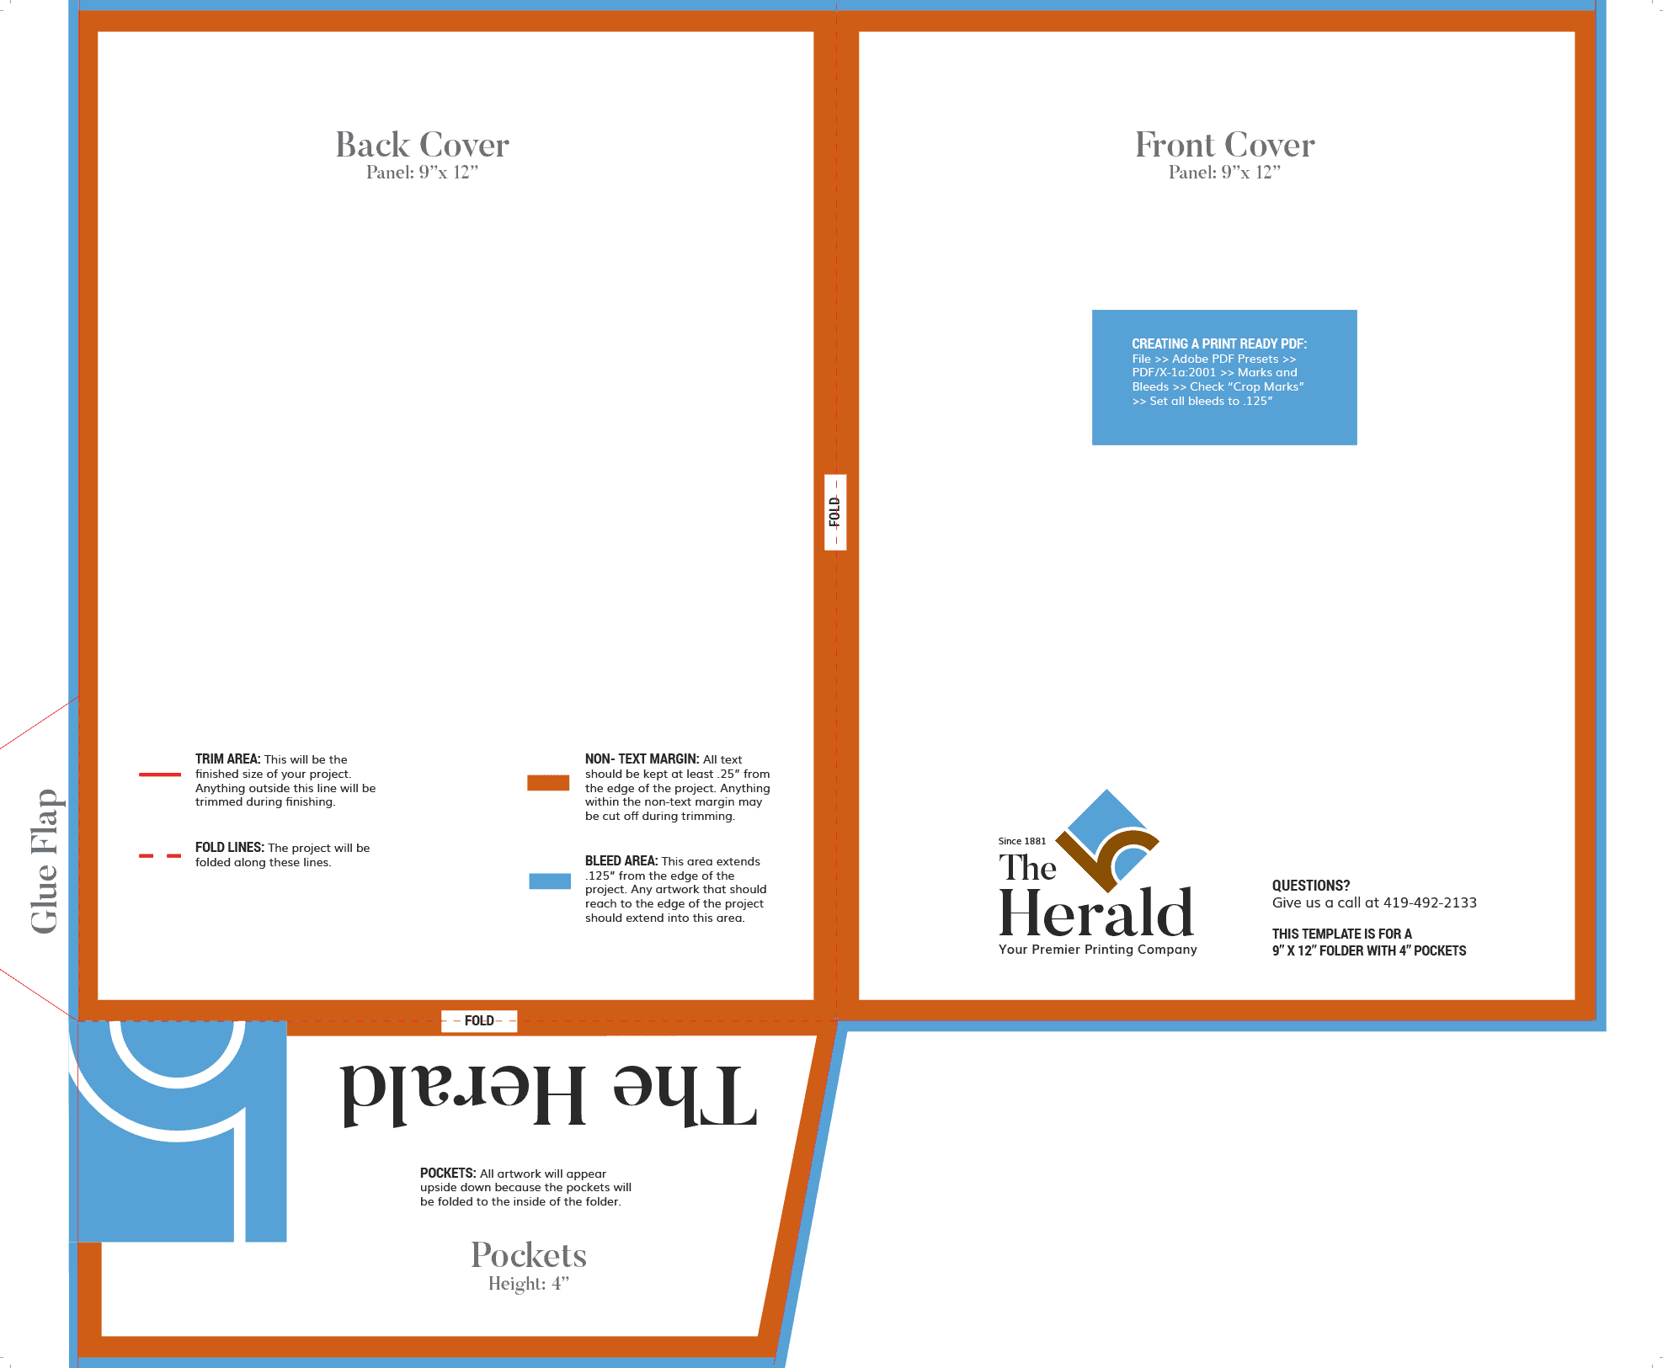
13. | Sticker  Nature: removable, kiss-cut vinyl stickers, super durable and water-resistant white border around each design  Paper: 3.2 mm, matt finish  Print: UN Women logos and text, 4+0 | Pc | 1300 | 7 | Every 2 months | 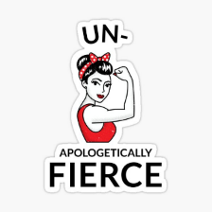  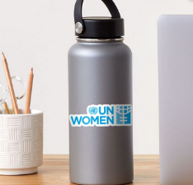
14. | Spiral Notebook with Pen  Nature: A5, notebook, elastic pen loop including recycled paper ballpoint pen with blue refill  Interior: 60 squared pages, recycled paper, natural color  Paper: matte, 100 gsm  Print: UN Women logo on front and back covers, 4+0  Binding: spiral | Pc | 1000 | 7 | Every 2 months | 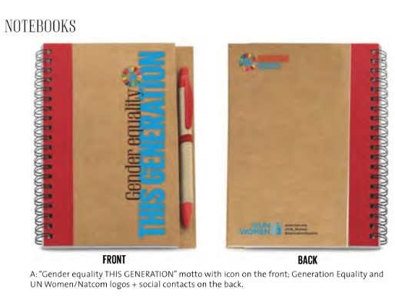
15. | Dated Agenda  Nature: squared pages, dated 2021, adapted for Moldova  Size: A5 format, hard cardboard cover  Color: black  Paper: 100 gsm  Print: UN Women logo and text on front and back covers, 4+0, matt  Binding: sewed and glued | Pc | 200 | 7 | November 2021 | 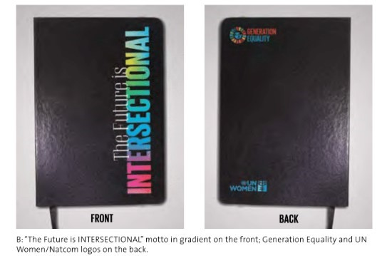
16. | Non-Dated Agenda  Nature: squared pages, dated 2021, adapted for Moldova  Size: A5 format, hard cardboard cover  Color: black  Paper: 100 gsm  Print: UN Women logo and text on front and back covers, 4+0, matt  Binding: sewed and glued | Pc | 1000 | 7 | Every 2 months
17. | Motivational Quotes Notebook  Nature: squared pages, not dated  Size: A5 format, hard cardboard cover  Color: black, blue, orange  Paper: 100 gsm  Print: UN Women logo and text on front and back covers, motivational quotes on pages, 4+0, matt  Binding: sewed and glued | Pc | Black – 300  Blue – 100  Orange - 100 | 7 | Every 2 months | 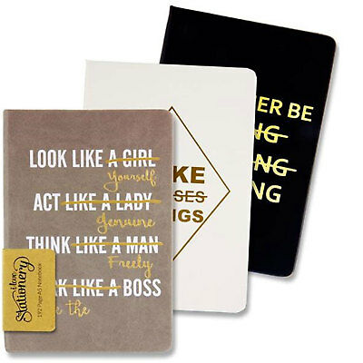
18. | Metal Pen  Nature: minimalistic click pen  Size approx.: 145 mm x 9 mm  Color: silver  Print: UN Women logo, text or motivational quote engraving on the front side | Pc | 500 | 7 | Every 2 months | 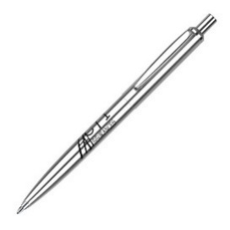
19. | Table Calendar  Size: 210 mm x 150 mm x 90 mm, 14 pages  Paper: 300 gsm  Print: UN Women logo and text, 4+0, matt  Binding: spiral | Pc | 330 | 7 | November 2021
20. | Wall Calendar  Size: 297 mm x 420 mm, 14 pages  Paper: 300 gsm  Print: UN Women logo and text, 4+0, matt  Binding: spiral | Pc | 500 | 7 | November 2021
21. | Cardboard Picture  Size: A3 (297 mm x 420 mm)  Paper: cardboard, 1.9mm  Print: image, 4+0, glossy  Packaging: polyethylene | Pc | 35 | 7 | August 2021 | 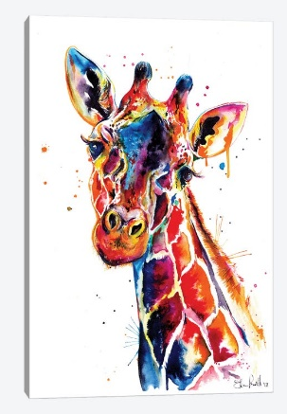
22. | Canvas Picture  Size: A3 (297 mm x 420 mm)  Paper: canvas  Print: image, 4+0  Packaging: polyethylene | Pc | 35 | 7 | August 2021 | 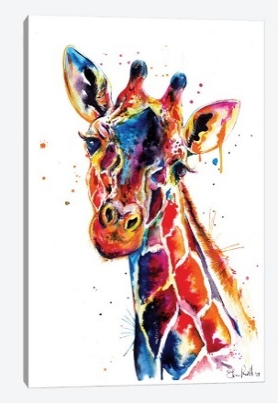
23. | Puzzle  Size: 210 mm x 297 mm  Number of pieces: up to 120 pieces  Shape: rectangular  Material: cardboard, 1.9mm  Print: children’s drawings, image, 4+0, glossy  Additional features: adaptation of a drawing or image to puzzle  Packaging: paper box | Pc | 1000 | 7 | August 2021 | 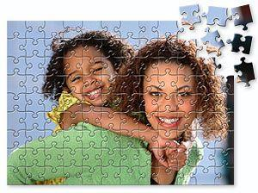
24. | Bookmark  Size approx.: 55 mm x 210 mm  Paper: 300-350 gsm  Print: UN Women logo or text, 4+4 | Pc | 700 | 7 | Every 2 months | 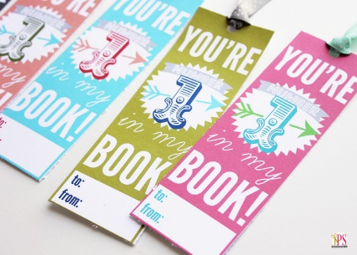
25. | Paper Drink Coaster  Shape: round or rounded square  Paper: absorbent paper, 400-1000 gsm  Print: 4+4 | Pc | 600 | 7 | Every 2 months | 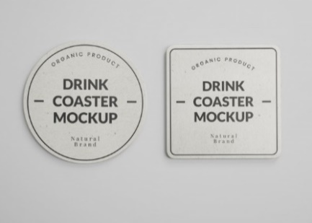
26. | A5 Document Folder  Document folder with lined sheet notepad, business card and pen holder  Size: A5  Color: black  Material: PU leather  Print: UN Women logo or text, 1+0 | Pc | 300 | 7 | August 2021 | 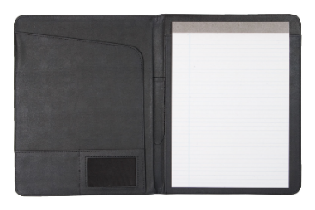
27. | A4 Document Folder  Document folder with lined sheet notepad, business card and pen holder  Size: A4  Color: black  Material: PU leather  Print: UN Women logo or text | Pc | 300 | 7 | August 2021 | 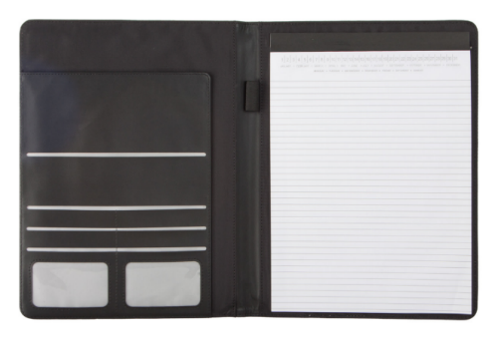

Lot No. 2: Textiles
No | Minimum Technical Requirements | Unit | Quantity | Delivery Lead Time, Days | Tentative Delivery Deadline | Example
1. | Shirt  Sizes: S, M and L  Fit: regular or unisex for men, slightly fitted for women  Color: black, white  Fabric: 100% soft cotton, 180 gsm  Print: UN Women logo, 1+0, on the left side, 10x3 cm  Produced in Moldova | Pc | Black, S (Men) - 25  Black, M (Men) - 25  Black, L (Men) - 25  White, S (Men) - 25  White, M (Men) - 25  White, L (Men) - 25  Black, S (Women) - 25  Black, M (Women) - 25  Black, L (Women) - 25  White, S (Women) - 25  White, M (Women) - 25  White, L (Women) - 25 | 14 | Every 2 months | 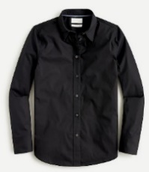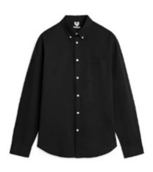
2. | Hoodie  Sizes: S, M and L  Fit: regular or unisex for men, slightly fitted for women.  Color: black, light grey  Fabric: 100% soft cotton, 320 gsm  Print: UN Women logo, 1+0, on the left side, 10x3 cm  Produced in Moldova | Pc | Black, S (Men) - 150  Black, M (Men) - 150  Black, L (Men) - 150  L.grey, S (Men) - 150  L.grey, M (Men) - 150  L.grey, L (Men) - 150  Black, S (Women) - 150  Black, M (Women) - 150  Black, L (Women) - 150  L.grey, S (Women) - 150  L.grey, M (Women) - 150  L.grey, L (Women) - 150 | 14 | Every 2 months | 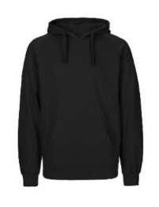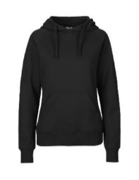
3. | Polo Shirt  Sizes: S, M and L  Fit: regular or unisex for men, slim fit for women.  Color: black, white  Fabric: 100% soft cotton, 240 gsm  Print: UN Women logo, 1+0, on the left side, 10x3 cm  Produced in Moldova | Pc | Black, S (Men) - 200  Black, M (Men) - 200  Black, L (Men) - 200  White, S (Men) - 200  White, M (Men) - 200  White, L (Men) - 200  Black, S (Women) - 200  Black, M (Women) - 200  Black, L (Women) - 200  White, S (Women) - 200  White, M (Women) - 200  White, L (Women) - 200 | 14 | Every 2 months | 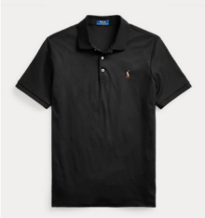  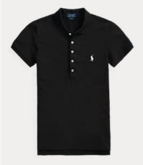
4. | T-shirt  Sizes: S, M and L  Fit: regular or unisex for men, slim fit for women.  Color: black, white, orange, green, dark blue  Print: UN Women logo, 1+0, on the left side, 10x3 cm  Fabric: 100% soft cotton, 180 gsm  Produced in Moldova | Pc | Black, S (Men) - 300  Black, M (Men) - 300  Black, L (Men) - 300  White, S (Men) - 100  White, M (Men) - 100  White, L (Men) - 100  Black, S (Women) - 125  Black, M (Women) - 125  Black, L (Women) - 125  White, S (Women) - 125  White, M (Women) - 125  White, L (Women) - 125  Orange, S (Women) - 50  Orange, M (Women) - 50  Orange, L (Women) - 50  Green, S (Women) - 50  Green, M (Women) - 50  Green, L (Women) - 50  D.blue, S (Women) - 50  D.blue, M (Women) - 50  D.blue, L (Women) - 50 | 14 | Every 2 months | 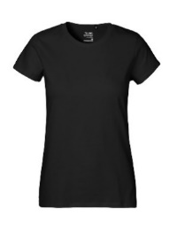  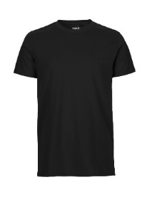
5. | Fluorescent Safety Vest for Children  Nature: with reflective bands and elastic bands on vest sides  Fabric: 100 % polyester, machine washable, 220 gsm  Color: yellow, green or pink  Print: up to 3 UN Women logos, 4+0  Produced in Moldova | Pc | 50 | 14 | August 2021 | 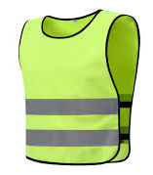
6. | Scarf  Size approx.: 40 cm x 120 cm  Color: orange  Composition: cotton, viscose or silk  Fabric: light, drapey, 30-150 gsm  Print: UN Women logo, symbol or text up to 5x5 cm, 4+0  Produced in Moldova | Pc | 500 | 14 | September 2021 | 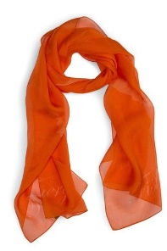
7. | Vertical Canvass Bag  Nature: canvass bag with long handles  Size: 36 cm x 40 cm  Color: black  Fabric: 100% cotton, 180 gsm  Print: 2 UN Women logos, 4+0  Produced in Moldova | Pc | 1200 | 14 | July 2021 | 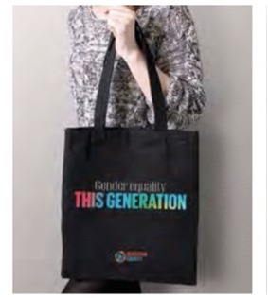
8. | Horizontal Canvass Bag  Nature: canvas bag with long handles and thick bottom  Size: 42 cm x 38 cm  Color: beige  Fabric: 100% cotton, 180 gsm  Print: UN Women logos and/or text on one side, A4 size of printed image, 4+0  Produced in Moldova | Pc | 1000 | 14 | July 2021 | 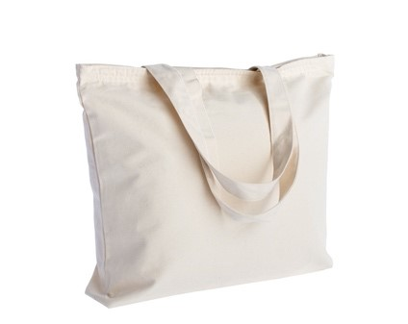
9. | Baseball Cap  Size: adjustable  Fabric: 100% cotton or combination with any other breathable material  Color: black, white  Print: UN Women logo, 4+0  Produced in Moldova | Pc | Black – 300  White - 300 | 14 | July 2021 | 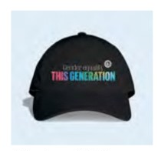
10. | Washable Face Mask  Nature: two layers of cotton and one anti-bacterial layer, adjustable ear straps to fit all face shapes and sizes  Fabric: 100% cotton, breathable, comfortable, dust-proof  Color: black  Print: UN Women logo, 4+0  Produced in Moldova | Pc | 6000 | 14 | July 2021 | 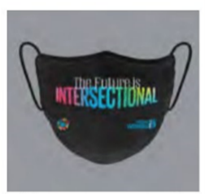
11. | Backpack  Nature: minimalistic and clean, zip gusseted patch pocket at bottom, padded shoulder straps adjusted with plastic buckles, reinforced back, padded and quilted, reinforced bottom, inside patch pocket  Closure: metal zipper at top  Size approx.: 30 cm x 42cm x12cm, 9 cm handle length  Fabric: rigid canvas, nylon, polyester  Color: black, blue, green, orange  Print: UN Women logo or text, 4+0 | Pc | Black - 200  Blue - 200  Green - 200  Orange - 200 | 14 | July 2021 | 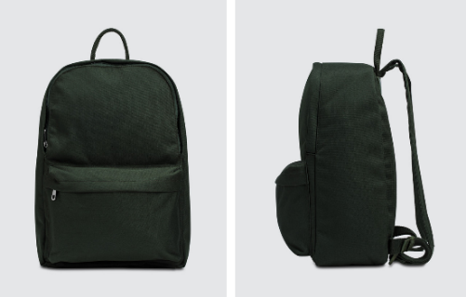
12. | Premium Laptop Backpack  Nature: minimalistic and clean, one main compartment, one padded laptop compartment to hold up to 16 inches laptop, one accessory compartments, roomy for iPad, mouse, charger, portfolio, books, clothes, wallets etc, ergonomic back, padded shoulder straps, luggage belt and earphone outlet.  Size approx.: 30 cm x 46.5cm x19cm  Fabric: sturdy and water-resistant heavy-duty material, resistant to tear and abrasion, offering a long-lasting usage  Color: black  Print: UN Women logo or text, 4+0 | Pc | 50 | 14 | July 2021 | 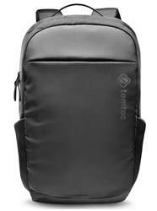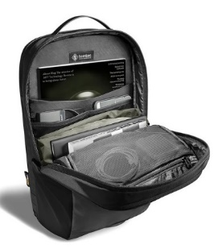
13. | Laptop Sleeve  Nature: zipped sleeve, foam padding, polyester cover protects from scratches and minor impacts, black edging, black zip, and black plush padding inside, easy clean with a damp cloth  Size: 16 inch  Color: black or white  Print: UN Women logo, 4+0 | Pc | 200 | 14 | July 2021 | 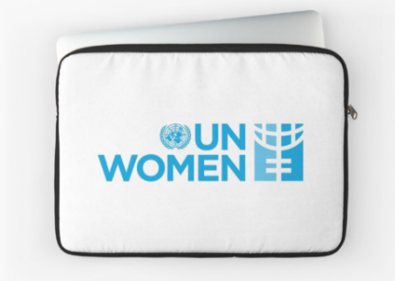
14. | Tablecloth  Shape: rectangular  Size: 180 cm x 270 cm  Fabric: polyester, 180 gsm, durable, machine-washable, wrinkle-resistant  Color: white  Print: UN Women logo or text, 4+0 | Pc | 50 | 14 | July 2021

Lot No. 3: Miscellaneous
No | Minimum Technical Requirements | Unit | Quantity | Delivery Lead Time, Days | Tentative Delivery Deadline | Example
1. | Thermo Cup  Design: leak proof cap  Size: 500 ml  Color: black  Material: stainless steel  Print: UN Women logo on the front side and on the back side, 4+0 | Pc | 600 | 14 | July 2021  October 2021 | 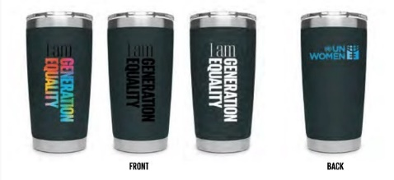
2. | Water Bottle  Design: with a strap and protection case, leak proof cap  Size: 500 ml  Color of the case: black and orange  Bottle material: PP plastic glass  Case material: neoprene or polyester  Strap material: polyester  Lid material: metal  Print: UN Women logo on the front side of the case, 4+0 | Pc | Black – 300  Orange - 300 | 14 | July 2021  October 2021 | 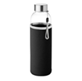
3. | Food Container  Design: leakproof lid, removable sections, microwave and dishwasher safe  Size approx.: 22 cm x 17 cm x 9 cm  Capacity: up to 1L  Material: stainless steel or 100% BPA-free food safe plastic  Color: yellow, blue, green or pink  Print: UN Women logo or text on the front side of the case, 4+0 | Pc | 300 | 14 | July 2021
4. | Mug  Color: white  Material: ceramic, matte finish  Capacity: 300 ml  Print: UN Women logo or text, 4+0 | Pc | 600 | 14 | July 2021  October 2021 | 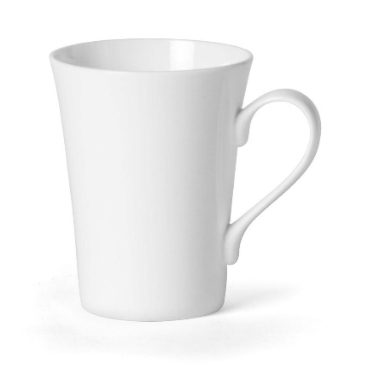
5. | Power Bank  Dimensions approx.: 147 x 71.2 x 14.2 mm  Weight: up to 400 g  Battery capacity: 20000 mAh  Accumulator type: Li-Pol  Color: black, blue, orange, white, silver or gold  Connector: MicroUSB / USB type C  Warranty: 12 months  Print: UN Women logo, 4+0 | Pc | 200 | 14 | July 2021
6. | Memory Stick Bracelet  Type: USB flash memory drive 32GB  Weight: up to 20 g  Bracelet material: silicone  Compatibility: Windows 8+, Mac OS 10.x+  Color: black, blue, white or orange  Warranty: 12 months  Print: UN Women logo and text on the front side, 4+0 | Pc | 1000 | 14 | July 2021  October 2021 | 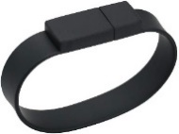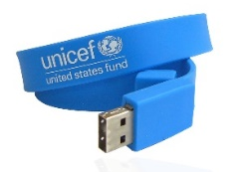
7. | Bluetooth speakers  Features: microphone, volume control, built-in rechargeable battery including USB charger cable with hands-free call function and FM radio  Color: black, white, yellow, blue or green  Print: UN Women logo, 4+0 | Pc | 600 | 14 | July 2021  October 2021 | 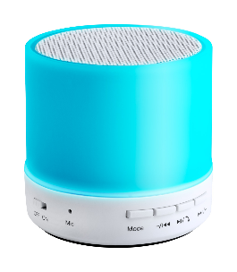
8. | Personal Protective Kit  Hand sanitizer: 1 unit, up to 100 ml  N95 face masks: 2 units  Disposable gloves: 1 pair  Wet disinfectant wipes: up to 20 pieces  Packaging: sealed paper box | Pc | 1000 | 14 | July 2021  October 2021 | 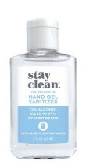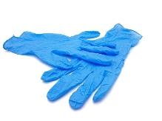  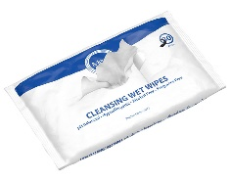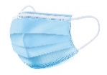
9. | Recyclable Plastic Bag  Size approx.: 34 cm x 43 cm  Material: recyclable plastic  Color: white  Print: UN Women logo, 4+0 | Pc | 1000 | 7 | August 2021 | 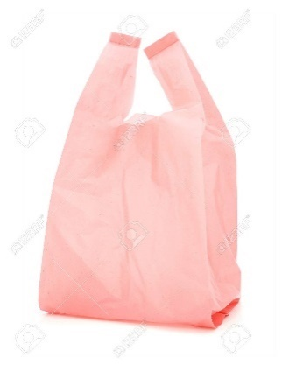
10. | Collapsible Umbrella  Design: foldable, 3-fold umbrella, 8 panels, durable zinc plated steel shaft, black ribs with 2 sections fiberglass and chrome metal tips, black rubberized handle with doming, automatic opening/closure, matching colored pouch.  Size approx.: Ø97X50cm  Material: polyester 190T pongee with PU coating, impermeable  Color: black, blue and orange  Print: UN Women logo and text, 1+0  Print size approx.: 200 mm x 150 mm | Pc | Black – 200  Blue – 200  Orange – 200 | 14 | September 2021 | 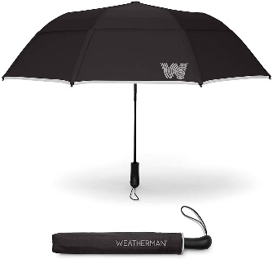
11. | Umbrella  Design: automatic opening/closure, zinc plated steel shaft, black ribs with 2 sections fiberglass and chrome metal tips, durable, strong.  Size approx.: Ø97X50cm  Material: polyester 190T pongee with PU coating, impermeable, wooden handle  Color: black  Print: UN Women logo and text, 1+0  Print size approx.: 200 mm x 150 mm | Pc | 50 | 14 | September 2021 | 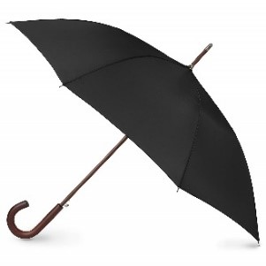
12. | Pin  Rectangular and/or round shaped pin  Material: metal  Print: UN Women logo, 4+0 | Pc | 100 | 14 | August 2021 | 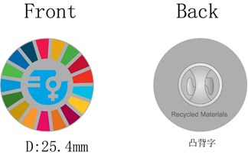
13. | Mouse Mat  Design: round  Material: recycled or eco-friendly  Size: 8,5 inches or 21,59 cm  Print: UN Women logo, 4+0 | Pc | 600 | 14 | July 2021  October 2021 | 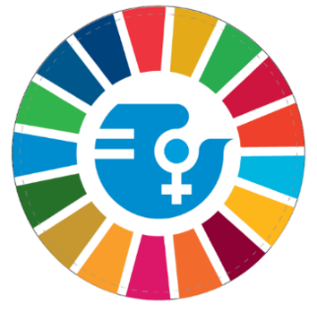
14. | Phone Ring  Size approx.: diameter 35mm x height 8mm  Material: metal  Color: silver  Print: UN Women logo on the front side, 4+0 | Pc | 600 | 14 | July 2021  October 2021 | 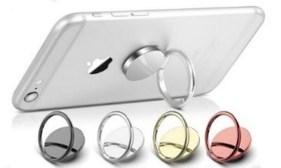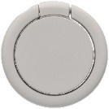
15. | Wooden Desk Mobile Holder  Nature: Suitable for iPhone and Android phones in 4-8 inches and 11-inch tablets, lightweight, portable and durable  Size approx.: 80 mm x 120 mm  Material: bamboo or wood, smooth finish  Color: natural wood  Print: UN Women logo, text or motivational quote engraving on the front side, 1+0 | Pc | 100 | 14 | July 2021  October 2021 | 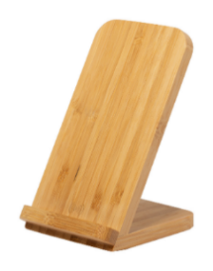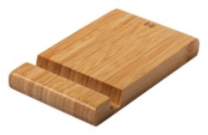
16. | Keyring with LED Flashlight  Shape: round or square  Material: plastic, stainless steel  Print: UN Women logo, text or motivational quote engraving on the front side, 4+0 | Pc | 500 | 14 | July 2021  October 2021 | 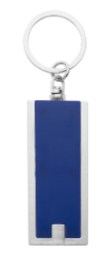  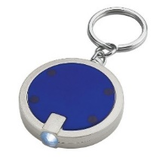
17. | Handbag Table Holder  Design: minimalist and clean  Material: metal  Color: silver  Weight to hold: at least 5 kg  Print: UN Women logo engraving on the front side | Pc | 50 | 14 | July 2021 | 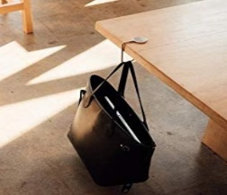  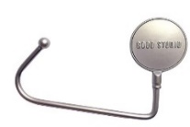
18. | Lanyard  Size: 2 cm x 50 cm  Color: light blue  Material: polyester with metal carabiner  Print: UN Women logo or text, 1+0 | Pc | 100 | 14 | July 2021 | 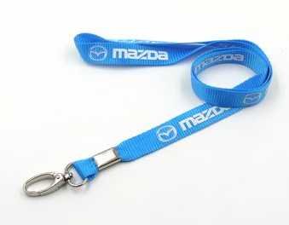
19. | Premium Gift Set  Ballpoint pen, business card holder and keyring in gift box  Size approx.: 17 cm x 16 cm x 3,2 cm  Color: silver and black  Material: metal and PU leather  Print: UN Women logo or text, 1+0 | Pc | 60 | 14 | July 2021 | 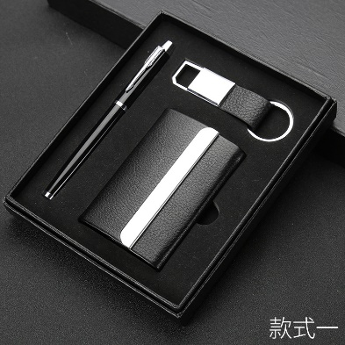
20. | Trophy  Size approx.: 20 cm x 8 cm x 8 cm  Form: star or similar  Material: metal or glass, glossy finish  Packaging: gift box  Print: UN Women logo or text, 1+0 | Pc | 10 | 14 | July 2021 | 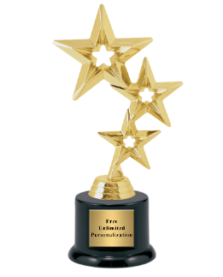
21. | Roll-up Banner  Design: X stand  Size approx.: 80cm x 200 cm, easy to install, secured against falling back (water base or other solutions)  Material: durable aluminum and fiberglass  Print: UN Women logo and text, 4+0 | Pc | 8 | 14 | September 2021 | 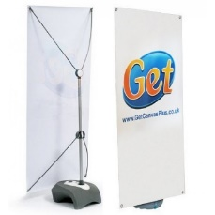  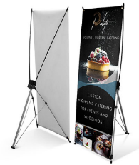
22. | Volumetric Letter  Size: 80 cm x 40 cm x 10 cm  Material: foam carton covered with glossy oracal  Print: 4+0 | Pc | 11 | 14 | July 2021
23. | Volumetric Installation  Size: 200 cm x 100 cm  Print: UN Women logo or text, 4+0 | Pc | 2 | 14 | July 2021
Design, logos, text and other needed materials will be provided by the UN Women for each product.
Other things being equal, products made in Moldova will be preferred.

C. Delivery Requirements
Delivery date | Vendor shall deliver the goods in accordance with the delivery schedule indicated above.
Delivery place / terms  (INCOTERMS 2010) | DAP Chisinau, Kentford
Customs clearance (must be linked to INCOTERM) | ☐ Not applicable  Shall be done by:  ☐ Click or tap here to enter text.  ☒Supplier/Vendor  ☐Freight Forwarder
Consignee details | UN Women Moldova, Chișinău, 202, Ștefan cel Mare și Sfînt Boulevard
Distribution of shipping documents (if using freight forwarder) | No
Special Packing requirements | No
Mode of transport | ☐ Air | ☒ Land
 | ☐ Sea | ☐ Other: specify
D. Management Arrangements
The selected company(ies) will work under overall guidance of the UN Women Communication Officers.
The contractor is expected to:
- Receive a brief from UN Women containing branding policy, design, logos, text or other needed materials for every specific product.
- Submit a preliminary layout for discussion with UN Women.
- Revise the selected layout as per feedback/discussions.
- Submit the final layout to UN Women for approval.
- Obtain a final sign off from UN Women before printing.
- Print a few samples and submit them to UN Women for final approval, where applicable.
- Receive final approval.
- Finalize the production of the product within the above-mentioned delivery lead time.
- Create and submit to UN Women electronic file with final electronic version approved for printing, including PDF printing size with the original design program that it has been prepared. The file must also contain a copy of the material in a PDF format with low-resolution for UN web posting.
Branding Policy
The contractor must comply with the branding policy of UN Women, including the specific requirements for logo, identity policies, etc. The respective guidelines will be shared with the winning company(ies) upon contract signature.
Intellectual Property
All information pertaining to this assignment (documentary, audio, digital, cyber, project documents, etc.) belonging to UN Women, which the company may come into contact with in the performance of its duties under this assignment shall remain the property of UN Women who shall have exclusive rights over their use. Except for purposes of this assignment, the information shall not be disclosed to the public nor used in whatever form without written permission of the UN Women in line with the national and International copyright laws applicable.
Duration of the Work
The work under this contract will be provided within the period of 1 year from the contract signature in accordance with delivery deadlines and locations indicated above.
UN Women will require at least 2 days to review the outputs, approve and certify acceptance of deliverables.
Location of work
The company will not be in the UN Women Offices for the implementation of the assignment.
The company must ensure full access of UN Women staff or consultants to its premises if required to ensure that the production is finalized as per requested specifications.
The company must be in position to visit or send couriers to UN Women premises when and if required to present proposals and discuss any details.
Travel and other logistic arrangements
The company should envisage in the submitted financial offer all costs related to production of the products listed above, including but not limited to travel to different districts in the Republic of Moldova and other logistic arrangements. The company will also be responsible for all administrative issues associated with undertaking this assignment.
COVID-19
The company should ensure all the protective measures against COVID-19, including but not limited to the provision of Personal Protection Equipment for the personnel involved.
Performance evaluation
Company’s performance will be evaluated against such criteria as: timeliness, responsibility, initiative, communication, creativity, innovation, and quality of the products delivered.
Financial arrangements
Payment will be disbursed in six instalments every 2 months upon submission and approval of all deliverables per each specific period certified by the UN Women Communication Officer, indicating that the services have been satisfactorily performed. Payment will be done based on actual number of delivered products.
E. Requirements to Organisations
- Be officially registered legal entity as per Republic of Moldova’s regulations with full capacity to act in the field relevant to this assignment.
- Have at least 2 years of stated experience in provision of printing services.
- Have at least 2 similar successful projects.
- Have positive Liquidity. The ratio Average current assets / Current liabilities over the last 2 years must be equal or greater than 1.
- Previous positive experience of work with UN Women will be considered an asset.
Portfolio
The companies should provide a Portfolio presenting the company (company structure, areas of activity, human resources, partners, awards, competitions, certifications, etc.) and accomplished printing projects of similar size and nature.
Organization Architecture/key staff
The participating company must provide a thorough description of its employed human resources that will be used for the provision of the requested services. The description should contain names of employees, their degrees, level of experience and other relevant information.
The company must have a Task Manager employed with the minimum qualifications as listed below. It must attach to the proposal the CV that demonstrates Task Manager’s educational background and professional experience in this specific field.
1. Task Manager
- Two years of experience in printing services or any other relevant field.
- Experience in managing of at least 2 projects of similar size and nature.
- Previous work experience with the public organisations, NGOs or UN on similar assignments will be considered an asset.
The Task Manager will be in charge of the coordination and administrative tasks of the assignment, as well as be responsible for contacting and informing UN Women Communications Officer with regard to all aspects related to the execution of the contract. The Task Manager shall provide UN Women with frequent updates on the progress of the assignment and other relevant aspects of the work.
Other partners/ personnel shall be recruited/sub-contracted as needed to ensure completion of tasks and included in the proposal.
F. Documents to Be Submitted
- Proposal submission form;
- Company`s Registration Certificate and Extract;
- Portfolio;
- CV of the Task Manager and short description of the other team members;
- Copies of relevant contracts for printing services proving company’s expertise;
- Copies of relevant contracts for projects of the similar size and nature proving company’s ability to perform;
- 3 (three) recommendation or confirmation letters proving company’s ability to perform;
- Preferably audited balance sheets for the last 2 years;
- Joint Venture Form, if applicable;
- Technical Proposal;
- Financial Proposal.

